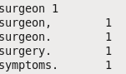

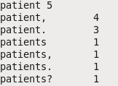

C:\Users\Student.MS-40\Documents\NC\prog\Screenshot 2022-10-11 182556.png

C:\Users\Student.MS-40\Documents\NC\prog\Screenshot 2022-10-11 182503.png

C:\Users\Student.MS-40\Documents\NC\prog\Screenshot 2022-10-11 182450.png

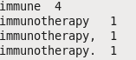

C:\Users\Student.MS-40\Documents\NC\prog\Screenshot 2022-10-11 182348.png

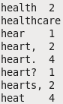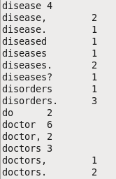

C:\Users\Student.MS-40\Documents\NC\prog\MEd.png

C:\Users\Student.MS-40\Documents\NC\prog\SD.png

C:\Users\Student.MS-40\Documents\NC\prog\Mean.JPG

