Jeremy DeHaan

CSS422

Lab 1 Report

Part 1:

Writing the program for Part 1 was relatively simple once you go through the tutorial code a couple of times. It doesn’t do much more than load the beginning of a string into an address register, print it, and then terminate.

The output for my program look like this:

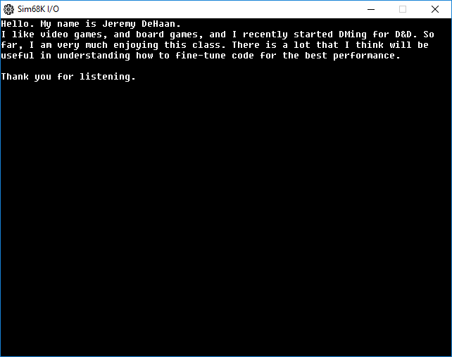

Part 2:

Part 2 was much more complex than Part 1. It involves a lot more operations and working on the registers. Some of the code started to mimic what I think of as if/then type statements, and it involved a lot of jumping around to various parts of the program.

The output looks like this:

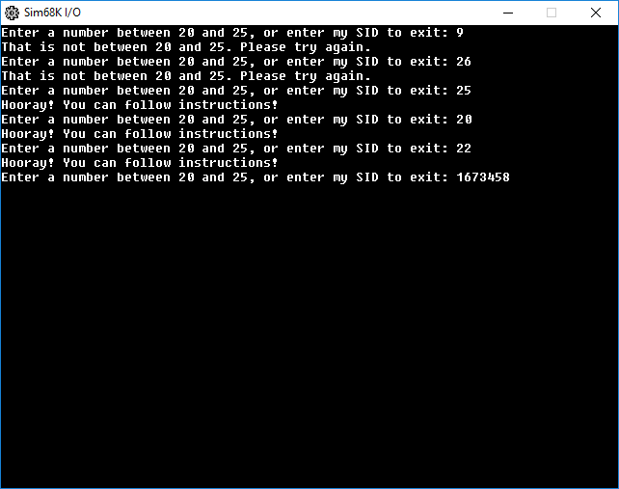

Conclusion

I learned many things from this lab. First and foremost, I learned more about assembly in general, and how to recognize what certain commands mean when I read them. In terms of the specific things I learned about assembly, they include how to perform basic I/O, how to perform comparisons between data, and how to control the flow of the program using branch statements.

This lab was a great first step in writing code in assembly.