STL File Repair and Optimization for 3D Printing
Ilyass Jebraoui
1 Project Overview
This document provides detailed information about the STL File Repair and Optimization for 3D Printing project, focused on transforming a raw 3D scanned STL file into a smooth, watertight, and print-ready model.
2 Description
In this project, I transformed a raw 3D scanned STL file into a smooth, watertight, and print-ready model. The process involved repairing mesh errors, optimizing geometry for 3D printing, and ensuring the model met industry standards for additive manufacturing.
3 Original Raw 3D scanned STL File

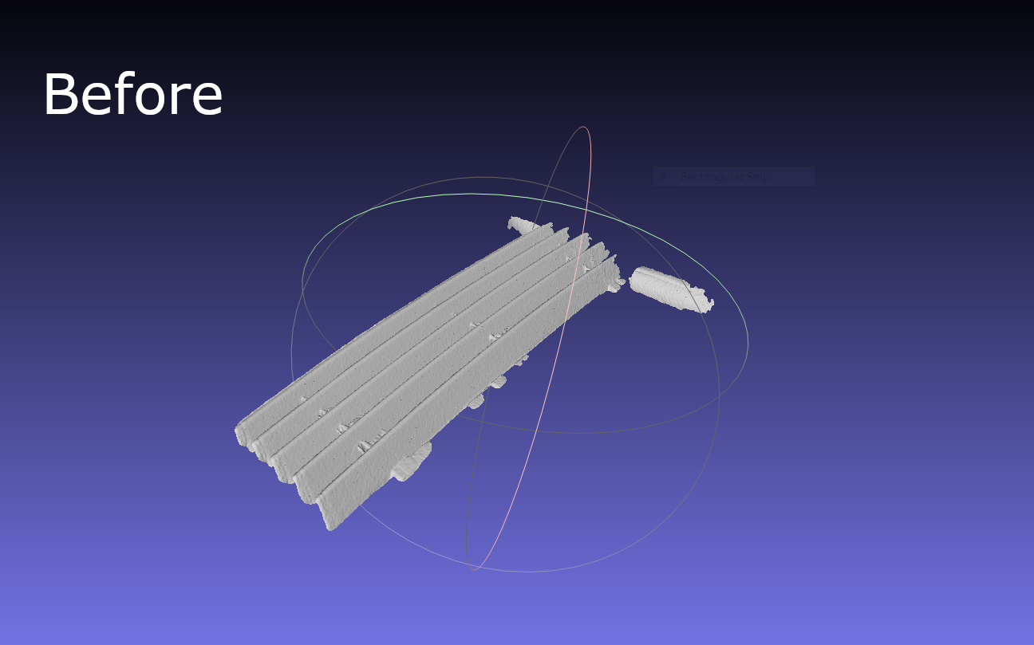

As we can see on the image upwards of the original raw 3D scanned STL file, The original scan contained gaps, irregular surfaces, and extra surfaces.
4 After 3D Model Optimization
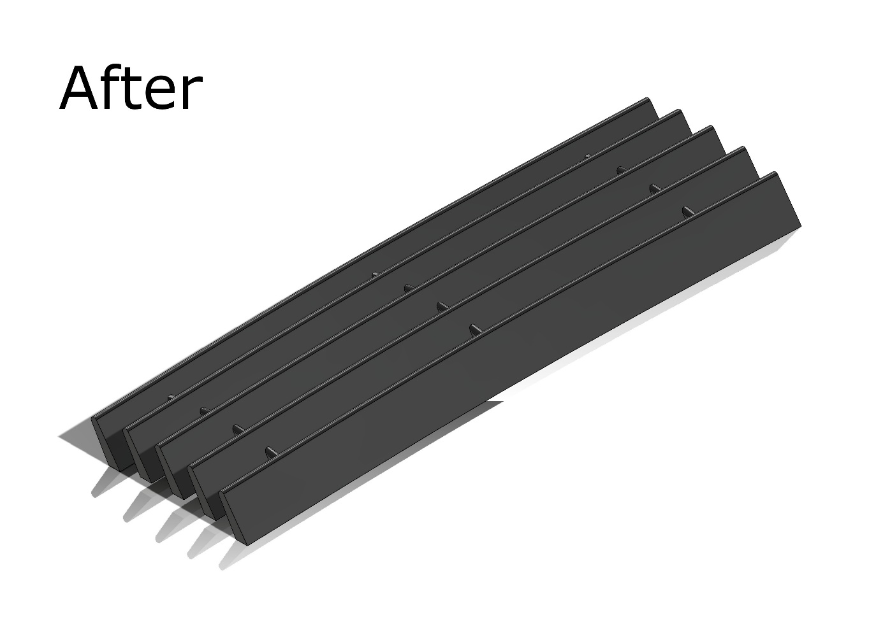

The picture above is the final version of the model, after repair and refinement, ensuring clean and smooth geometry ready for 3D printing.
5 Technologies Used
- Software: Solidworks, Meshlab, and Meshmixer.
- Techniques: Mesh repair, topology optimization, slicing.

6 Outcomes
The project resulted in a high-quality, print-ready STL model that was successfully printed with minimal defects. The optimized file reduced printing time by 15% and material usage by 10% compared to the original scan. The workflow developed is reusable for similar 3D scanning projects.

