Alkademy.com
Google PageSpeed Insights — Audit Report
Prepared July 28, 2026 | Tool: Google PageSpeed Insights (Lighthouse 13.4.0)

1. Executive Summary
This report summarizes the results of a Google PageSpeed Insights audit of alkademy.com, covering both Mobile and Desktop experiences. The site scores well on Best Practices and SEO, but Performance is the critical weak point — especially on mobile, where load speed is currently poor enough to hurt both user experience and search rankings. The sections below list every issue identified, grouped by category, with the original report screenshots attached as evidence.
Mobile Scores
38  Performance | 82  Accessibility | 96  Best Practices | 92  SEO | 1/2  Agentic Browsing
Desktop Scores
62  Performance | 85  Accessibility | 100  Best Practices | 92  SEO | 1/2  Agentic Browsing

2. Mobile — Issues to Fix

2.1 Performance (Score: 38 — Poor)
- First Contentful Paint (FCP) is 4.5s — far above the ~1.8s target.
- Largest Contentful Paint (LCP) is 15.2s — critically slow; target is under 2.5s.
- Total Blocking Time (TBT) is 820ms — target is under 200ms.
- Speed Index is 9.9s — target is under 3.4s.
- Render-blocking requests: fix could save an estimated 3,270 ms of load time.
- Cache lifetimes are not efficient: an estimated 728 KiB could be saved with proper cache headers.
- Image delivery is not optimized: an estimated 729 KiB could be saved (compression/modern formats/responsive sizing).
- Legacy JavaScript is being shipped to modern browsers: an estimated 23 KiB could be saved.
- Font display is not optimized: an estimated 40 ms could be saved.
- Forced reflow detected during page load, adding to main-thread delay.
- LCP breakdown and LCP request discovery flagged — the largest element is being discovered/rendered too late.
- Network dependency tree shows a long critical request chain delaying render.
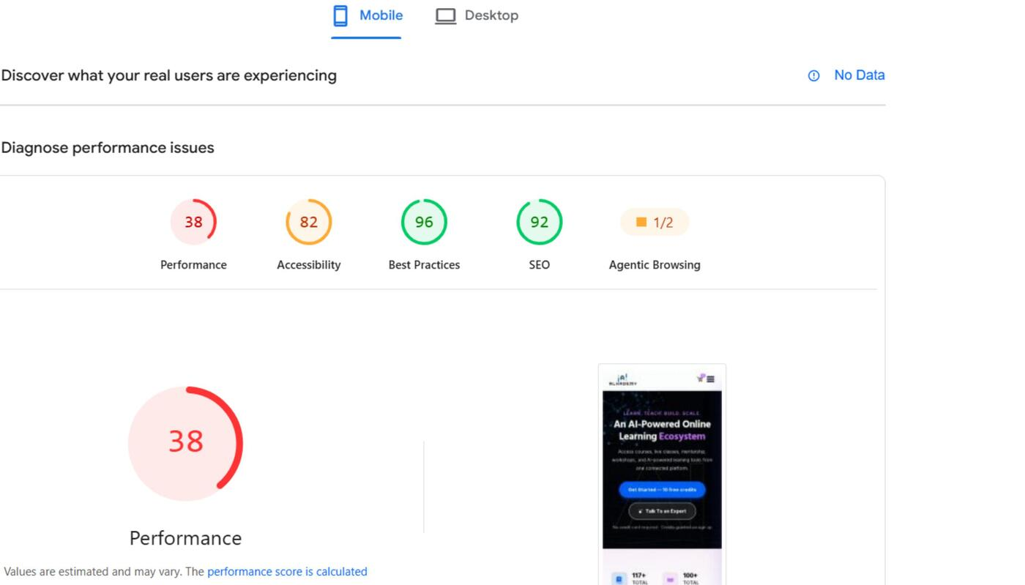
Fig. 1 — Mobile score summary (Performance 38, Accessibility 82, Best Practices 96, SEO 92, Agentic Browsing 1/2)
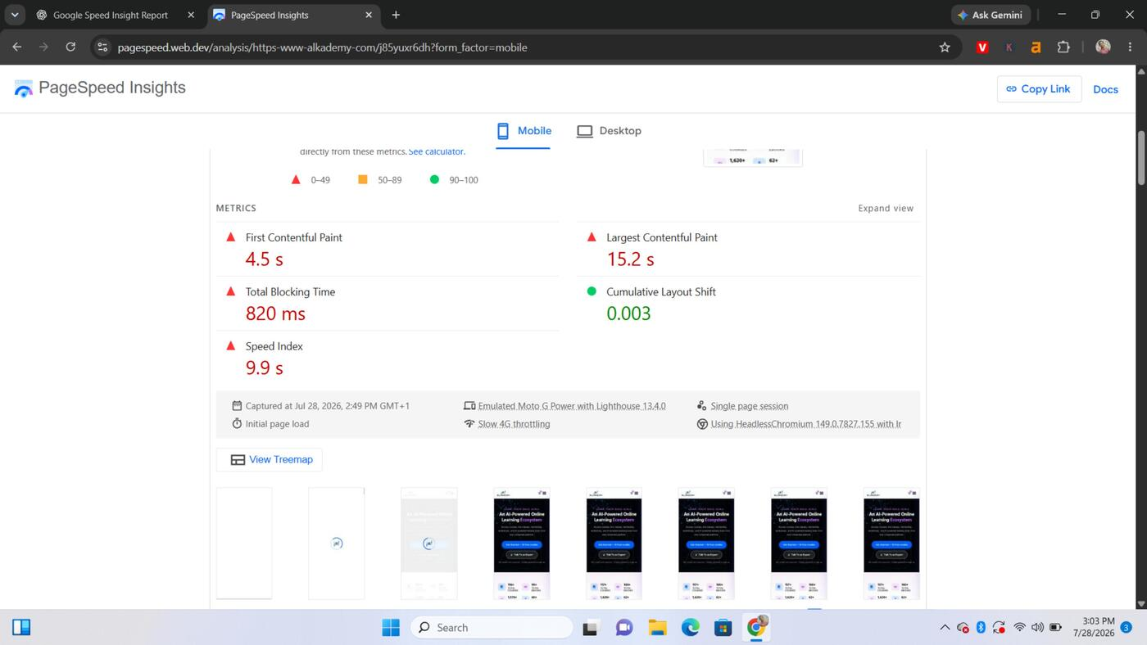
Fig. 2 — Mobile Core Web Vitals: FCP 4.5s, LCP 15.2s, TBT 820ms, CLS 0.003, Speed Index 9.9s
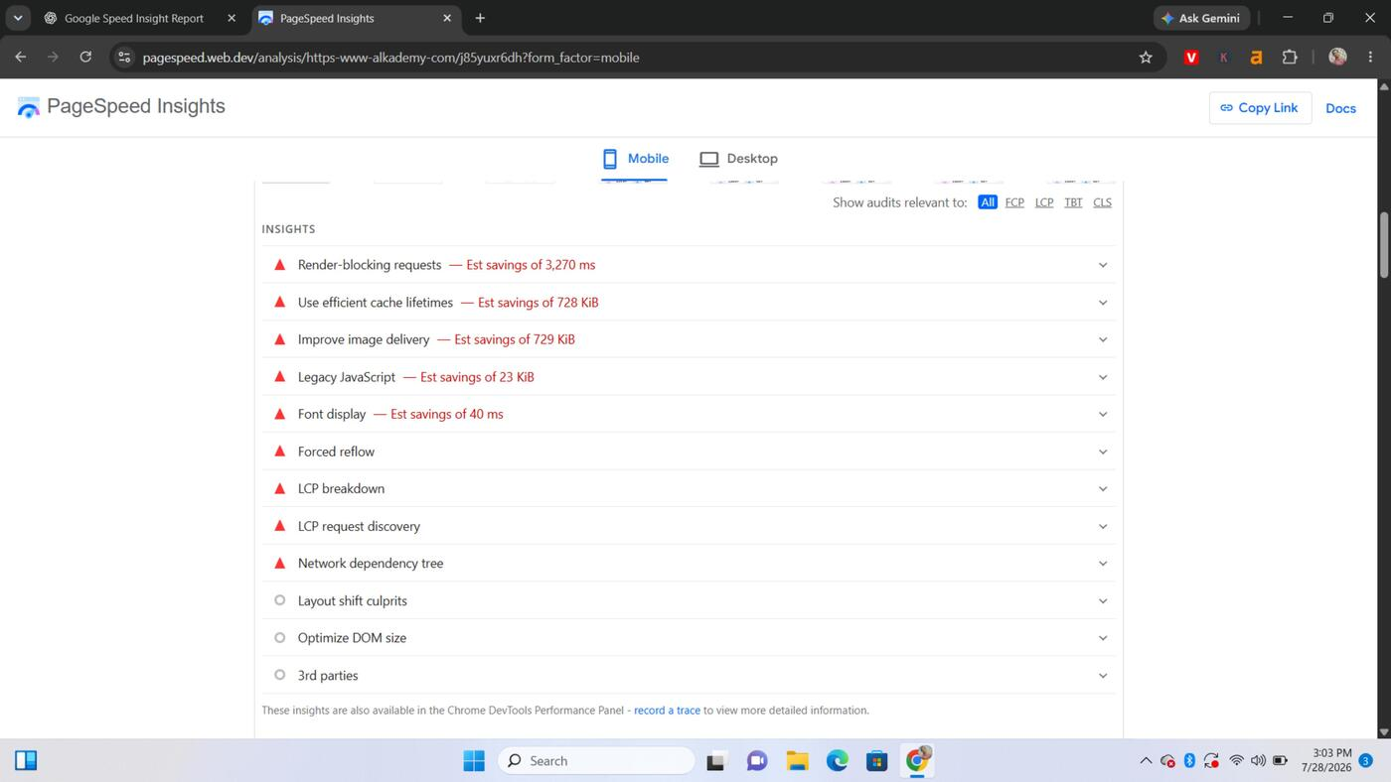
Fig. 3 — Mobile performance insights (render-blocking requests, cache lifetimes, image delivery, legacy JS, font display, LCP breakdown)

2.2 Diagnostics (Mobile)
- Reduce JavaScript execution time — currently costing 2.4s.
- Minimize main-thread work — currently costing 4.8s.
- Reduce unused CSS — an estimated 50 KiB could be saved.
- Reduce unused JavaScript — an estimated 411 KiB could be saved.
- Avoid enormous network payloads — total page weight is 3,123 KiB.
- 12 long main-thread tasks were found, blocking interactivity.
- 12 non-composited (janky) animated elements were found.
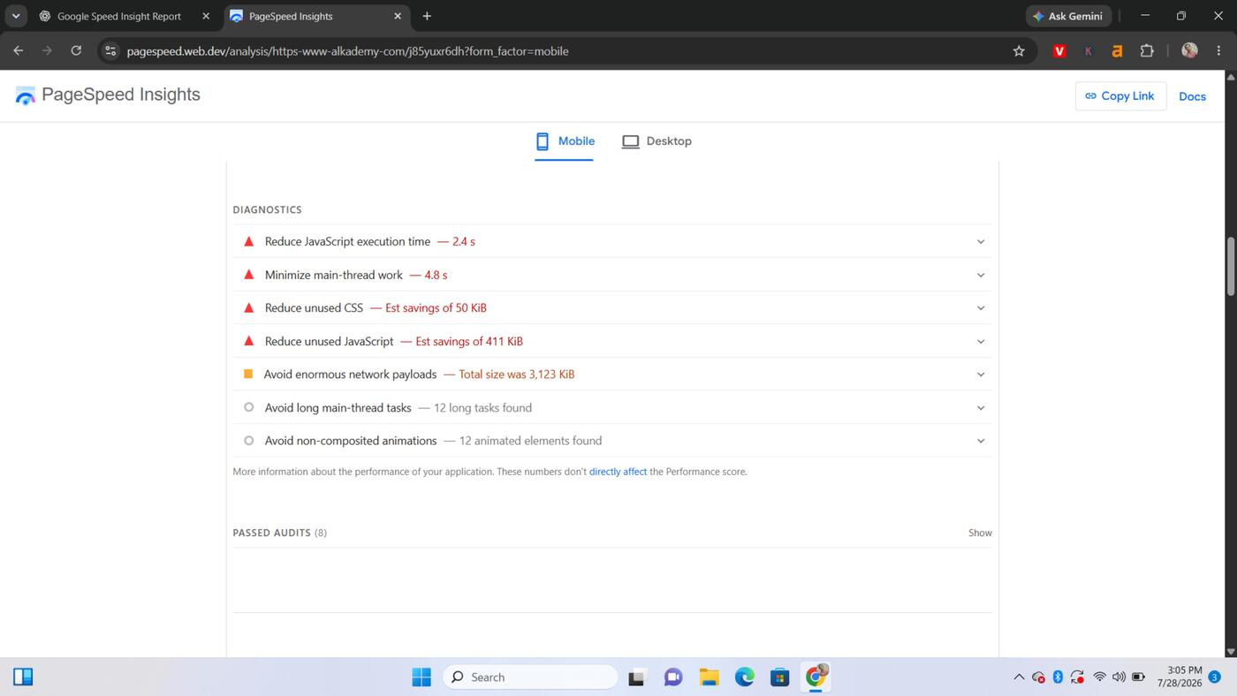
Fig. 4 — Mobile diagnostics: JS execution time, main-thread work, unused CSS/JS, network payload

2.3 Accessibility (Score: 82)
- Buttons do not have an accessible name (screen-reader users can't tell what they do).
- Links do not have a discernible name.
- Elements use prohibited ARIA attributes.
- Heading elements are not in sequentially-descending order, hurting keyboard/screen-reader navigation.
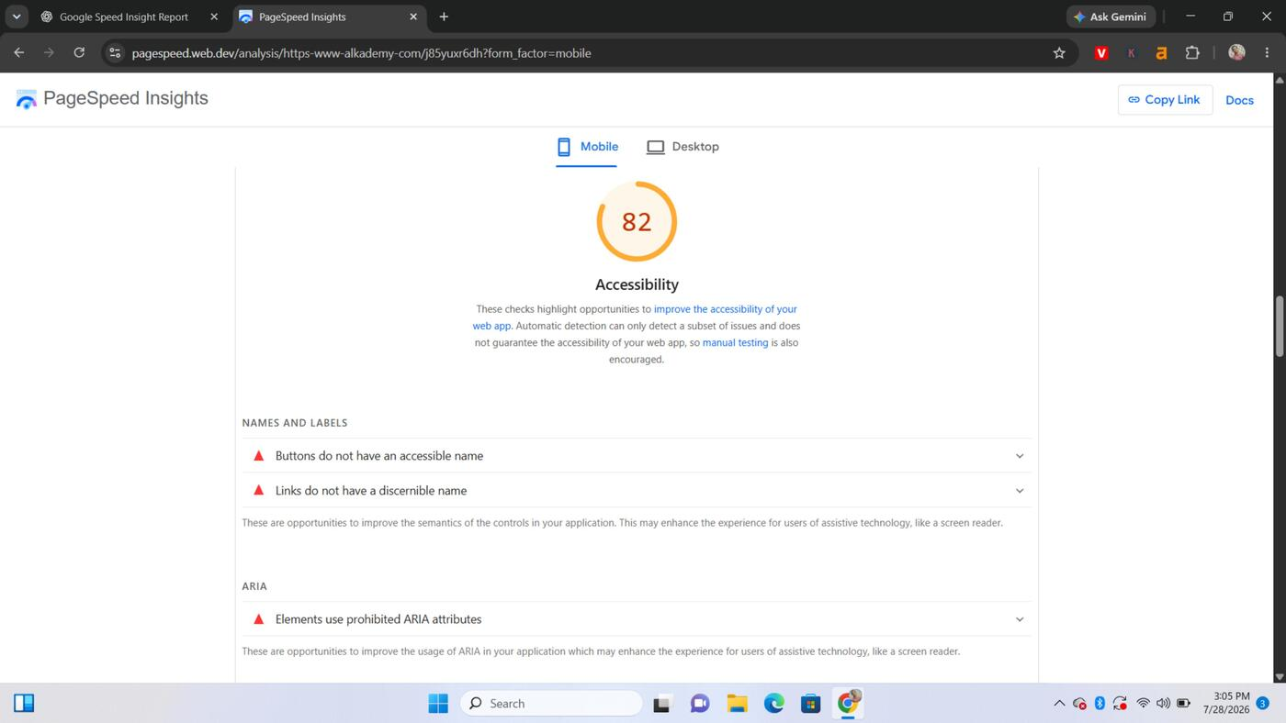
Fig. 5 — Mobile accessibility: missing accessible names on buttons/links, prohibited ARIA attributes
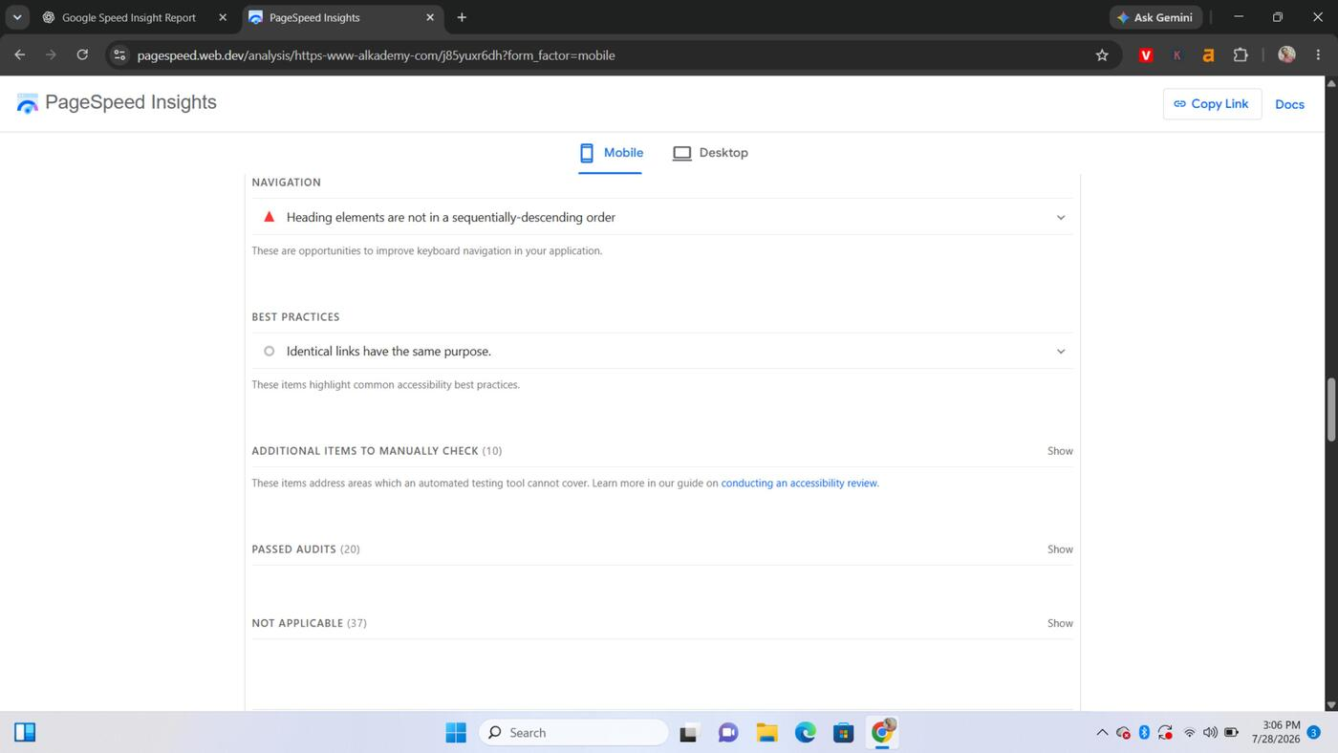
Fig. 6 — Mobile accessibility: heading order issue and best-practices navigation checks

2.4 Best Practices (Score: 96)
- The site serves images with low resolution, which can look blurry on high-density mobile screens.
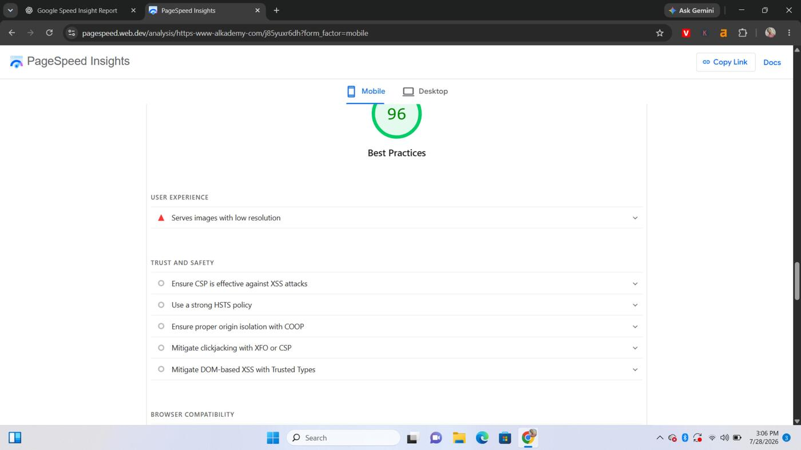
Fig. 7 — Mobile best practices: low-resolution images flagged under User Experience

2.5 SEO (Score: 92)
- 6 links do not have descriptive text, making it harder for crawlers (and users) to understand where they lead.
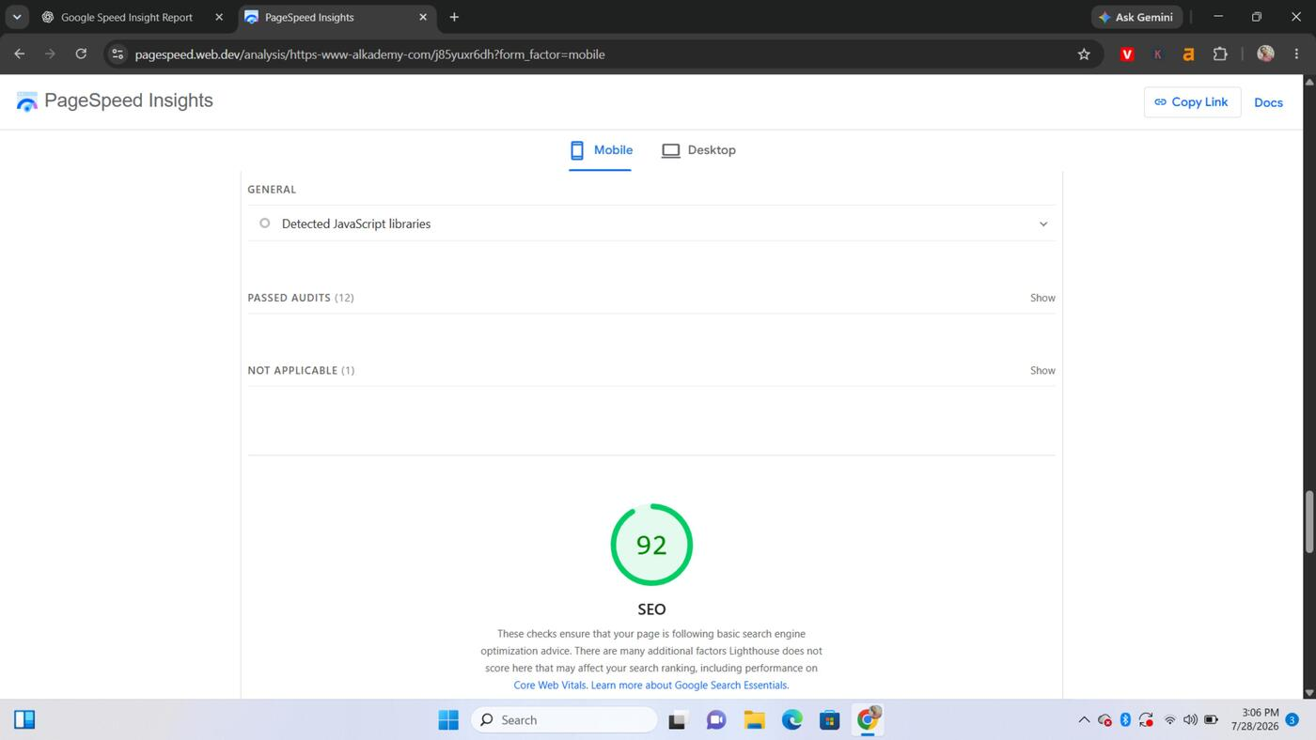
Fig. 8 — Mobile SEO overview and detected JavaScript libraries
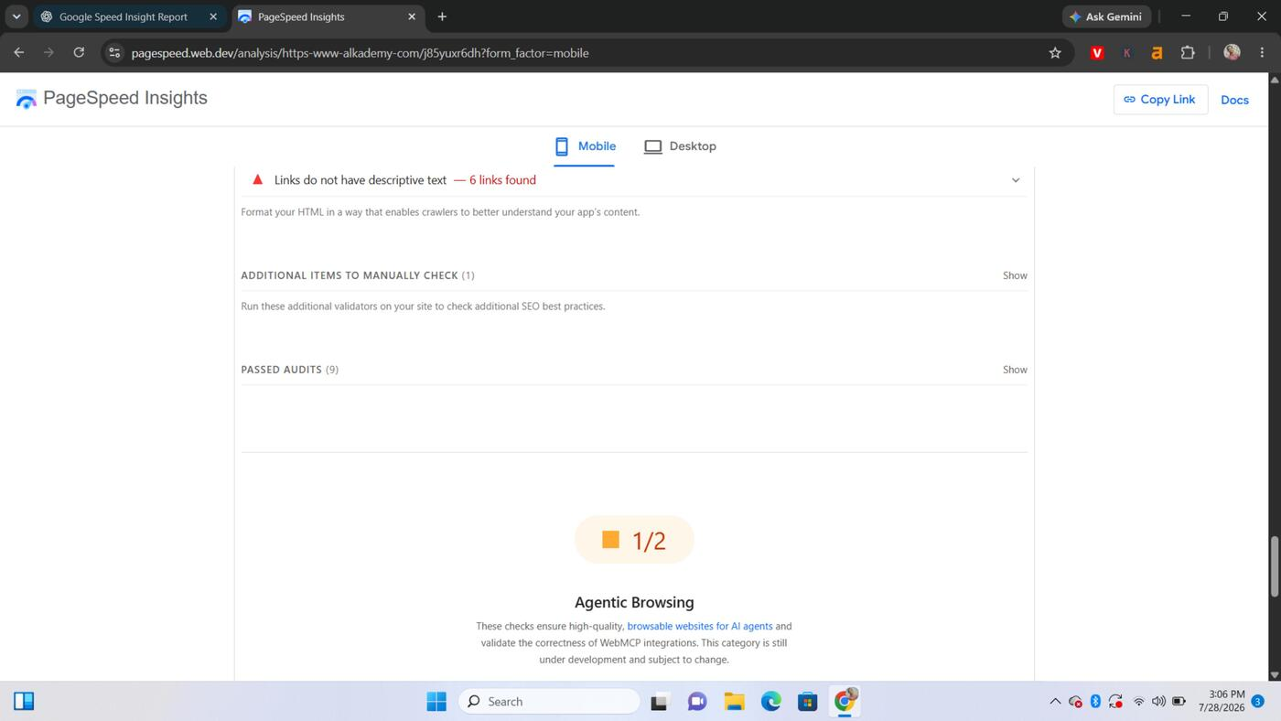
Fig. 9 — Mobile SEO: 6 links found without descriptive text

2.6 Agentic Browsing (Score: 1/2 — experimental)
- The accessibility tree is not well-formed, which will hurt how well AI browsing agents (and assistive tech) can parse and interact with the page. This category is still in development at Google but worth tracking.
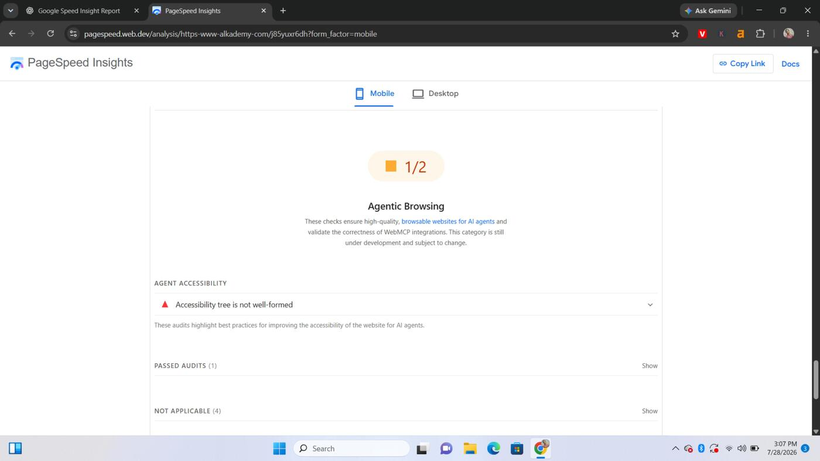
Fig. 10 — Mobile Agentic Browsing overview (1/2 checks passed)
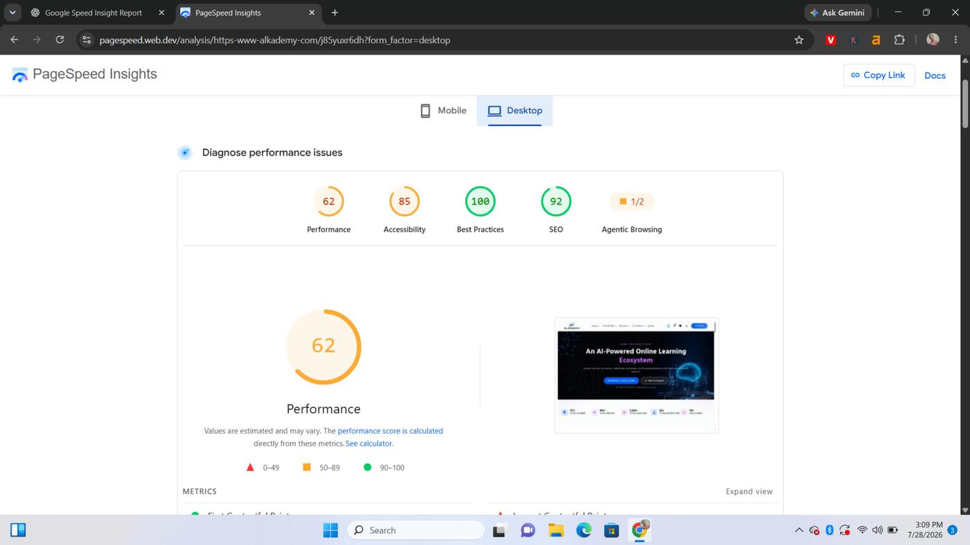
Fig. 11 — Mobile Agent Accessibility: accessibility tree is not well-formed

3. Desktop — Issues to Fix

3.1 Performance (Score: 62 — Needs Improvement)
- Largest Contentful Paint (LCP) is 3.5s — above the 2.5s target (FCP, at 0.3s, is good).
- Total Blocking Time (TBT) is 330ms — above the 200ms target.
- Speed Index is 2.2s — borderline, close to the 3.4s upper threshold.
- Cache lifetimes are not efficient: an estimated 1,052 KiB could be saved.
- Render-blocking requests: fix could save an estimated 290 ms.
- Font display is not optimized: an estimated 120 ms could be saved.
- Image delivery is not optimized: an estimated 755 KiB could be saved.
- Legacy JavaScript is being shipped to modern browsers: an estimated 23 KiB could be saved.
- Forced reflow, LCP breakdown/request discovery, and a long network dependency tree are all flagged.
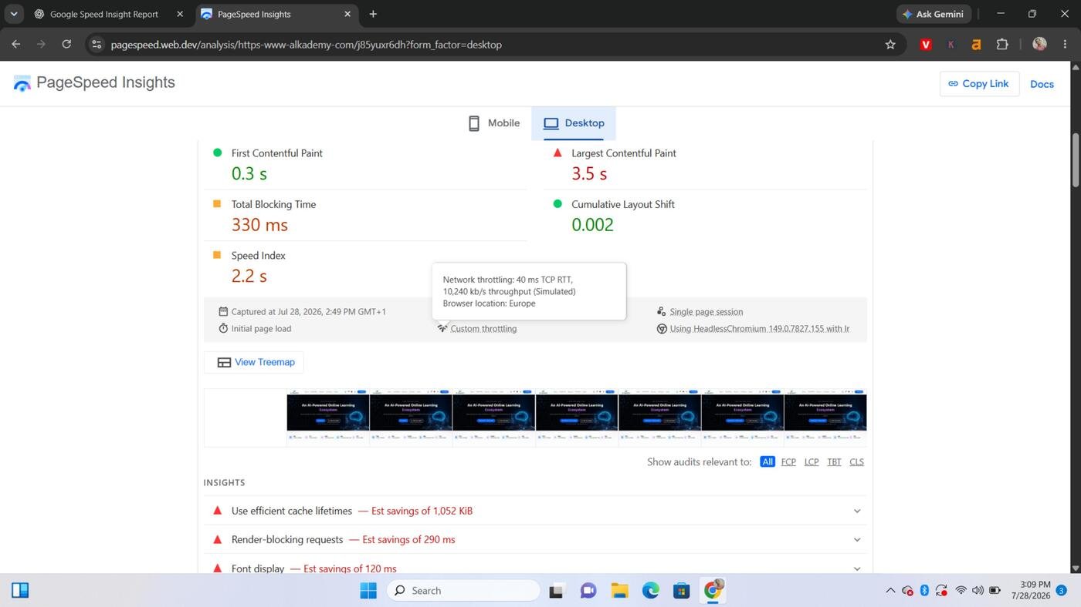
Fig. 12 — Desktop score summary (Performance 62, Accessibility 85, Best Practices 100, SEO 92, Agentic Browsing 1/2)
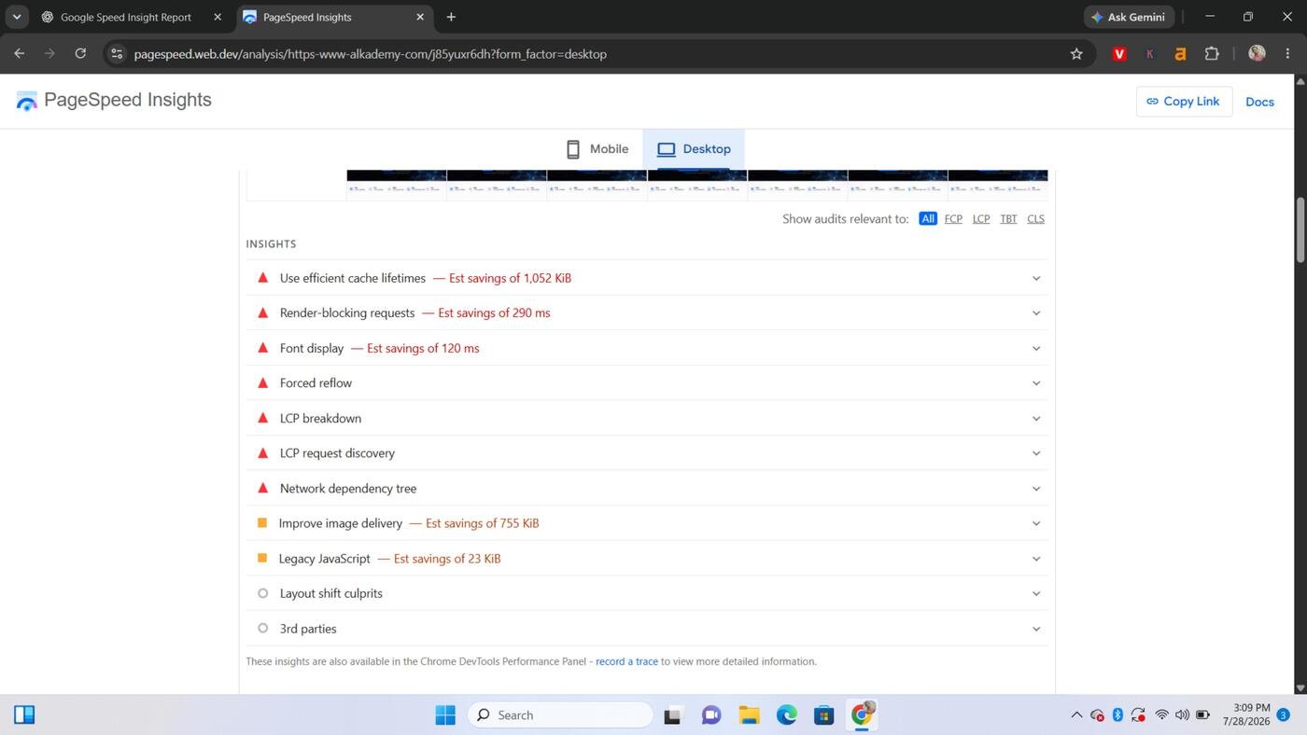
Fig. 13 — Desktop Core Web Vitals: FCP 0.3s, LCP 3.5s, TBT 330ms, CLS 0.002, Speed Index 2.2s
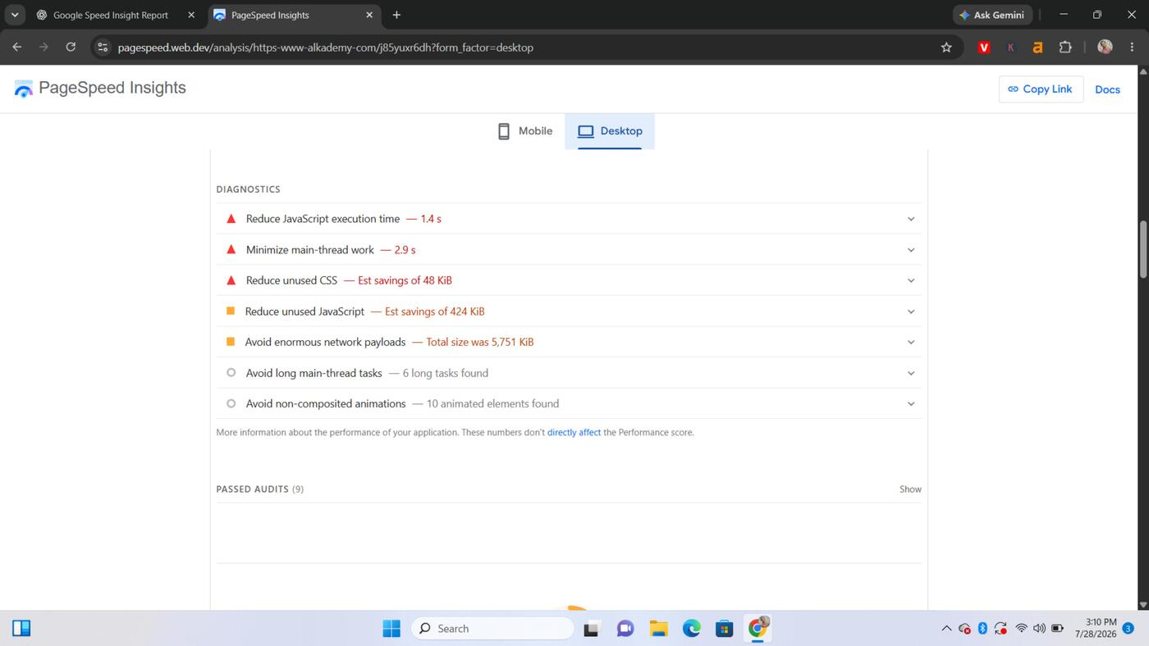
Fig. 14 — Desktop performance insights (cache lifetimes, render-blocking, font display, image delivery, legacy JS)

3.2 Diagnostics (Desktop)
- Reduce JavaScript execution time — currently costing 1.4s.
- Minimize main-thread work — currently costing 2.9s.
- Reduce unused CSS — an estimated 48 KiB could be saved.
- Reduce unused JavaScript — an estimated 424 KiB could be saved.
- Avoid enormous network payloads — total page weight is 5,751 KiB (largest of all views measured).
- 6 long main-thread tasks were found.
- 10 non-composited (janky) animated elements were found.
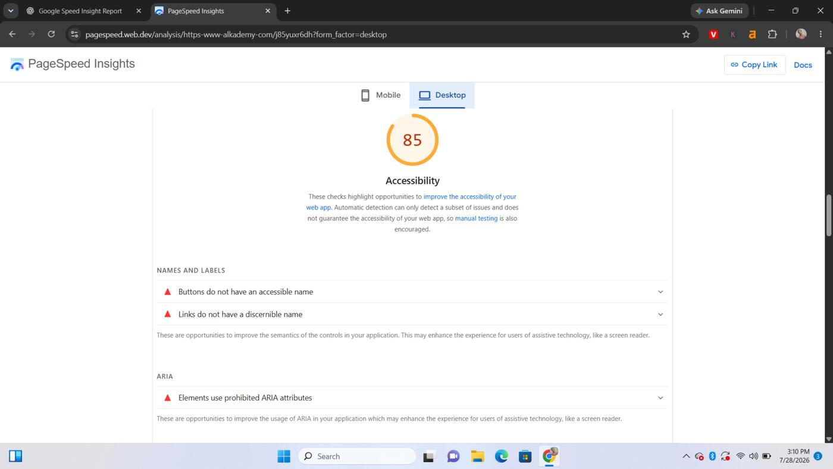
Fig. 15 — Desktop diagnostics: JS execution time, main-thread work, unused CSS/JS, 5,751 KiB total payload

3.3 Accessibility (Score: 85)
- Buttons do not have an accessible name.
- Links do not have a discernible name.
- Elements use prohibited ARIA attributes.
- Heading elements are not in sequentially-descending order.
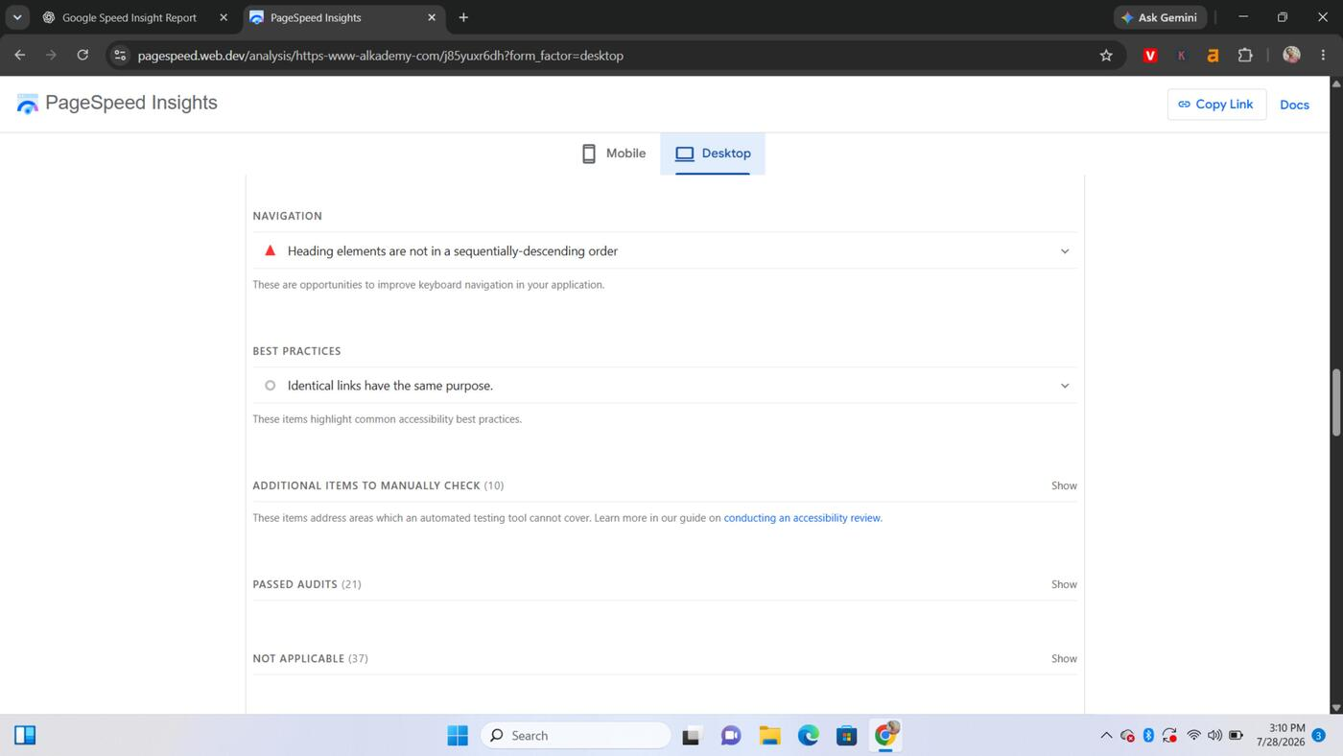
Fig. 16 — Desktop accessibility: missing accessible names, prohibited ARIA attributes
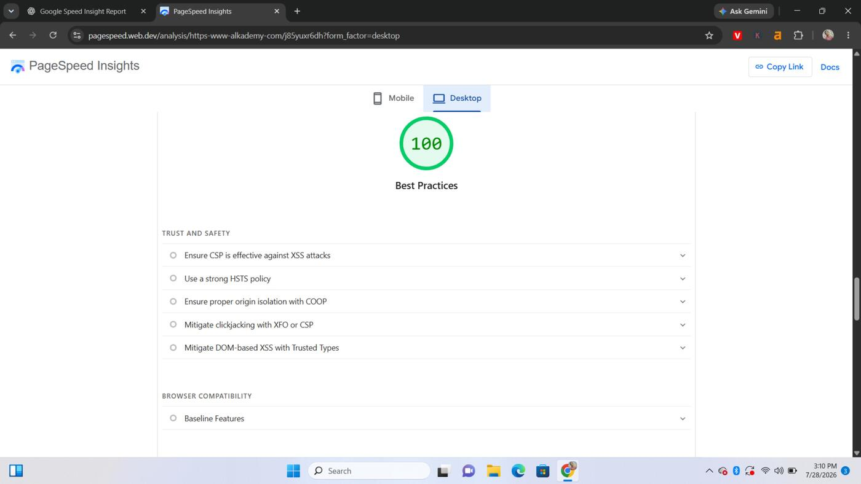
Fig. 17 — Desktop accessibility: heading order and best-practices navigation checks

3.4 Best Practices (Score: 100)
- No issues found — desktop passes all Best Practices checks (trust & safety, browser compatibility).
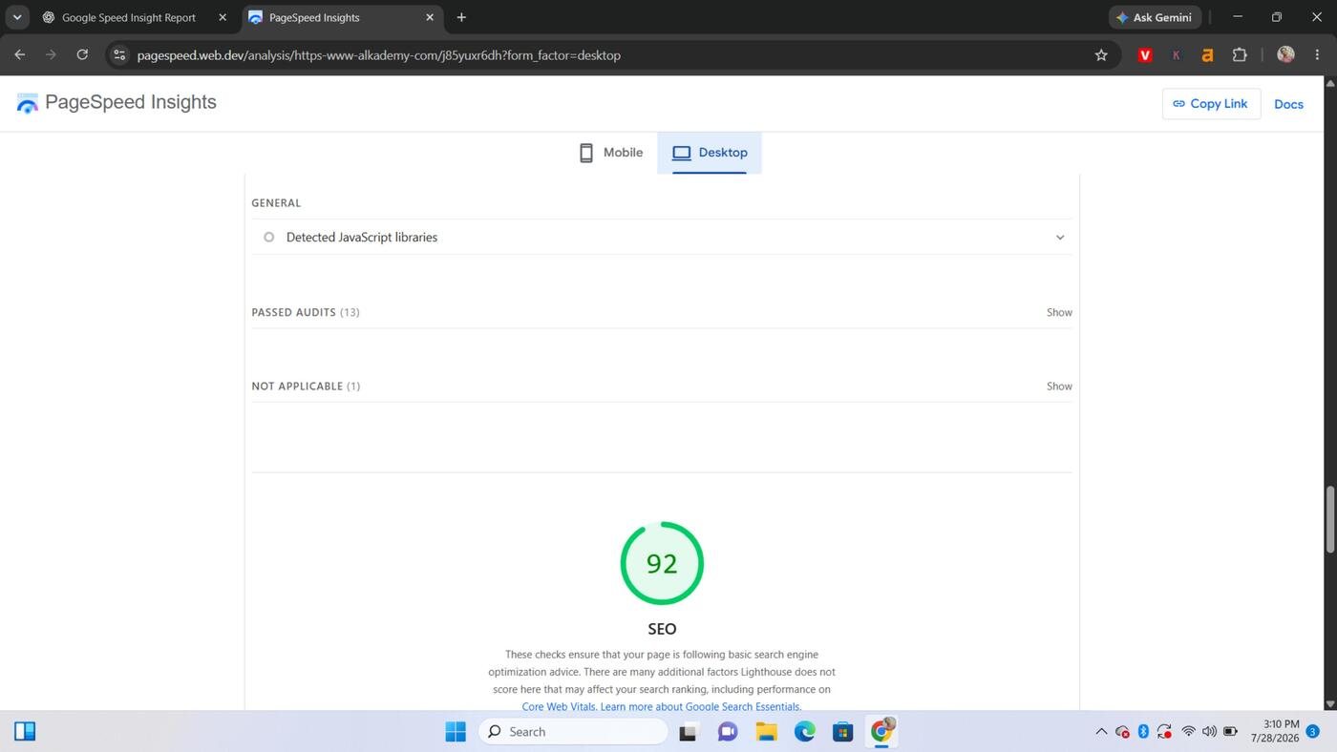
Fig. 18 — Desktop best practices: 100/100, all trust & safety checks passed

3.5 SEO (Score: 92)
- 6 links do not have descriptive text (same issue as on mobile).
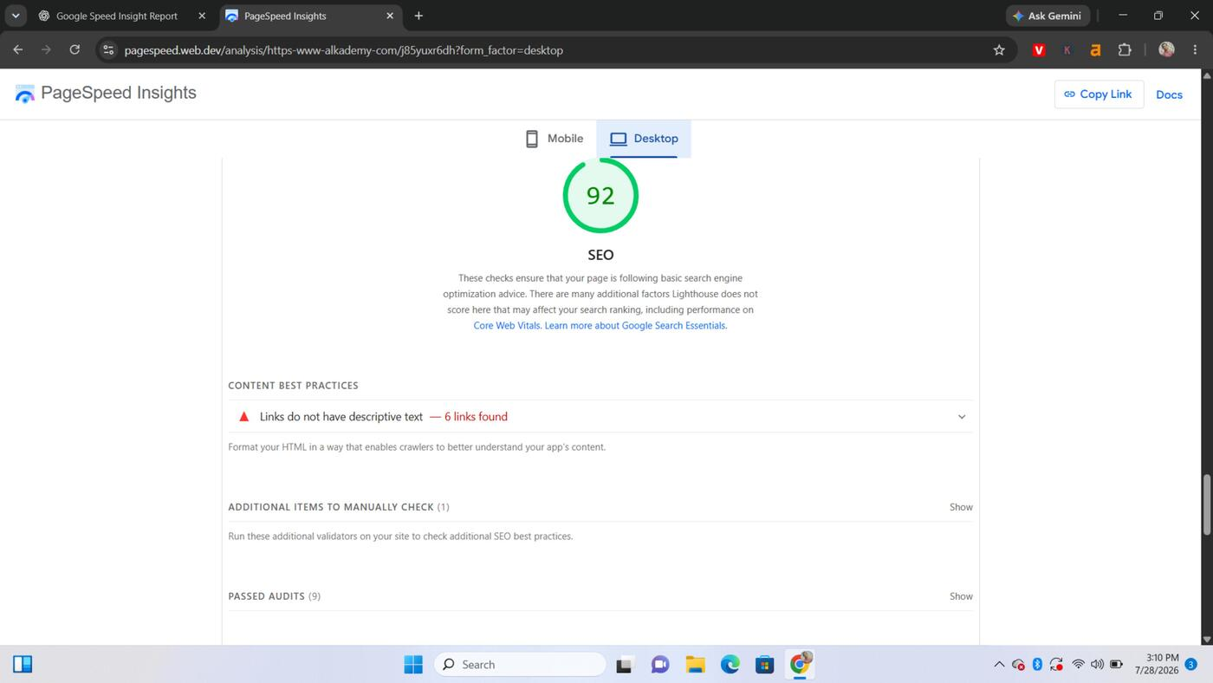
Fig. 19 — Desktop SEO overview and detected JavaScript libraries

3.6 Agentic Browsing (Score: 1/2 — experimental)
- The accessibility tree is not well-formed on desktop as well, the same root cause as on mobile.
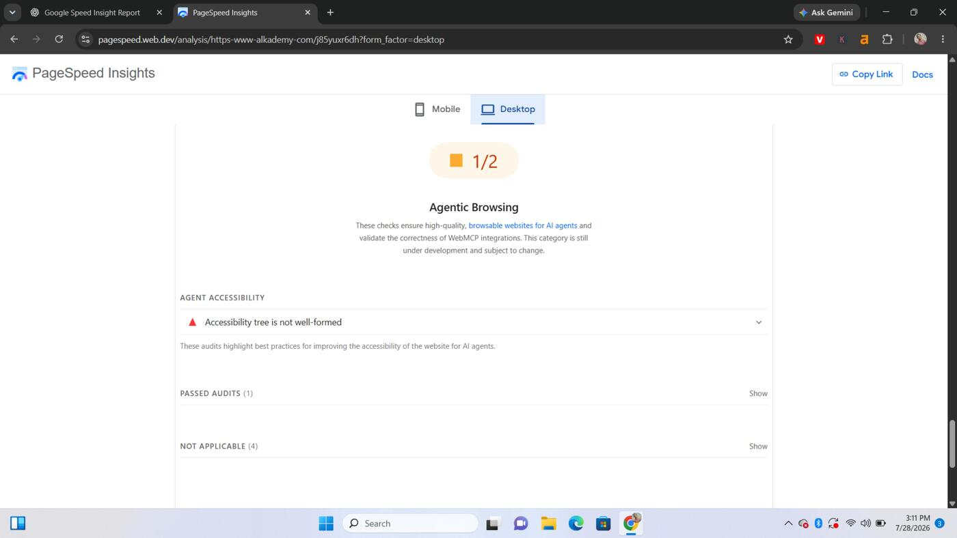
Fig. 20 — Desktop SEO content best practices and Agent Accessibility: accessibility tree not well-formed

4. Priority Recommendations
Suggested order of attack, highest impact first:
- Fix mobile LCP (15.2s) first — likely the single biggest win. Check the LCP breakdown/request-discovery flags: the largest element is probably a late-loading, unoptimized hero image or web font.
- Compress and modernize images (WebP/AVIF, responsive sizing) — addresses the 729–755 KiB "Improve image delivery" and low-resolution-image findings on both mobile and desktop.
- Set long, efficient cache lifetimes for static assets (JS, CSS, images, fonts) — worth up to 1,052 KiB in savings on desktop alone.
- Eliminate render-blocking CSS/JS (defer, async, or inline critical CSS) — worth 290 ms to 3,270 ms depending on device.
- Trim unused CSS and JavaScript, and drop legacy JS transforms/polyfills not needed for modern browsers.
- Add accessible names to all buttons and links, fix prohibited ARIA attributes, and correct heading order — improves the Accessibility score and also fixes the SEO "links lack descriptive text" finding.
- Investigate the malformed accessibility tree — this affects both assistive technology and the emerging "Agentic Browsing" checks that measure how well AI agents can use the site.
Report compiled from the attached Google PageSpeed Insights (Lighthouse) results, captured July 28, 2026.

