**Git Quick commands**

**Git Rebase**

Ensure your master is upto date with the project master on the remote

Do that by:

* git checkout master
* git pull –all

When this is done, the master is now upto date.

Check out your branch by:

* git checkout <your branch name>

You are now on your branch.

Ensure you dont have any unstaged files by checking the status

* git status

If any files are still marked in red color when you query status, stage them all by:

* git add .
* Git commit -m “your commit message here”

When done you can now rebase master by:

* git rebase master

Ensure to resolve any conflicts then do:

* git rebase –continue

Do this until you see the message “No rebase in progress”

When all this is done, work on your branch until your task for that branch is done then push your work by:

* git push -u origin <branch>

**Git Squash**

This helps combine all your commits into one before pushing.

To do this you have to initiate an interactive a rebase process by:

* git rebase -i HEAD~N

Where N is the number of commits you want to combine into one.

You must know the number of commits you have but you have to do this manually.

You can do:

* git log –oneline

This command list the commits log and enables you to count the number of commits you have.

Alternatively, you can push your branch to the remote repo and on the project branch list under your branch name is the column with the number of commits you have for that branch, which is the N number we are looking for.

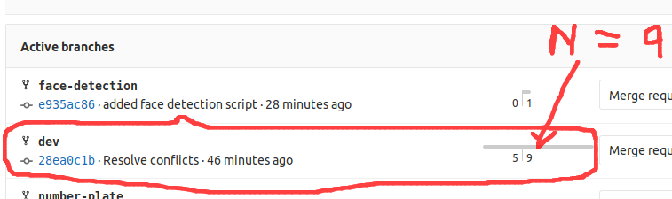

In this case your squash command will be:

* git rebase -i HEAD~9

This will pop up with your commits on an editor in most cases nano editor.

Edit by replacing pick with s for squash except the first commit at the top in which you will replace pick with r for reword.

When done, save the changes then another window will open with a single commit. Edit that single commit to reflect your task since its the single commit you will push.

Save and exit.

When done you can now push your changes by:

* git push -u origin <branch>