Jade P. Aniñon
BSIT-4R11

Activity 3: User & Group Creation with Permissions
Instructions:
This activity is a continuation of your previous Hands-on Activities (Installation, Initial Configuration, and Post-Installation of Windows Server 2008 R2). After setting up and configuring your server, you will now practice user and group management with folder permissions.
- Open your Windows Server 2008 R2 virtual machine.
- Create at least two new user accounts (ex., user1, user2) using Active Directory Users and Computers (ADUC).
- Create a new group (ex., LabGroup).
- Add the two users into that group.
- Create a folder named Shared_Files on your server.
- Set folder permissions so that only members of LabGroup can read/write inside it.
- Test by logging in as each user to verify permissions:
  - Members of LabGroup should have access.
  - Non-group members should be denied access.

Expected Output (Screenshots):
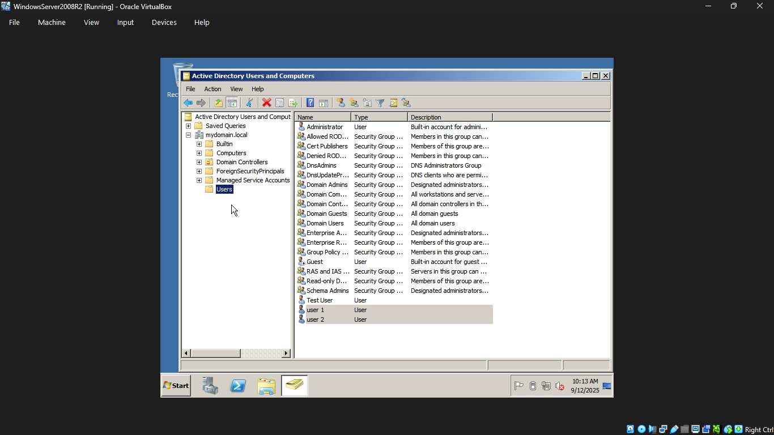
- Screenshot of user accounts created in ADUC.

- Screenshot of group creation and membership.
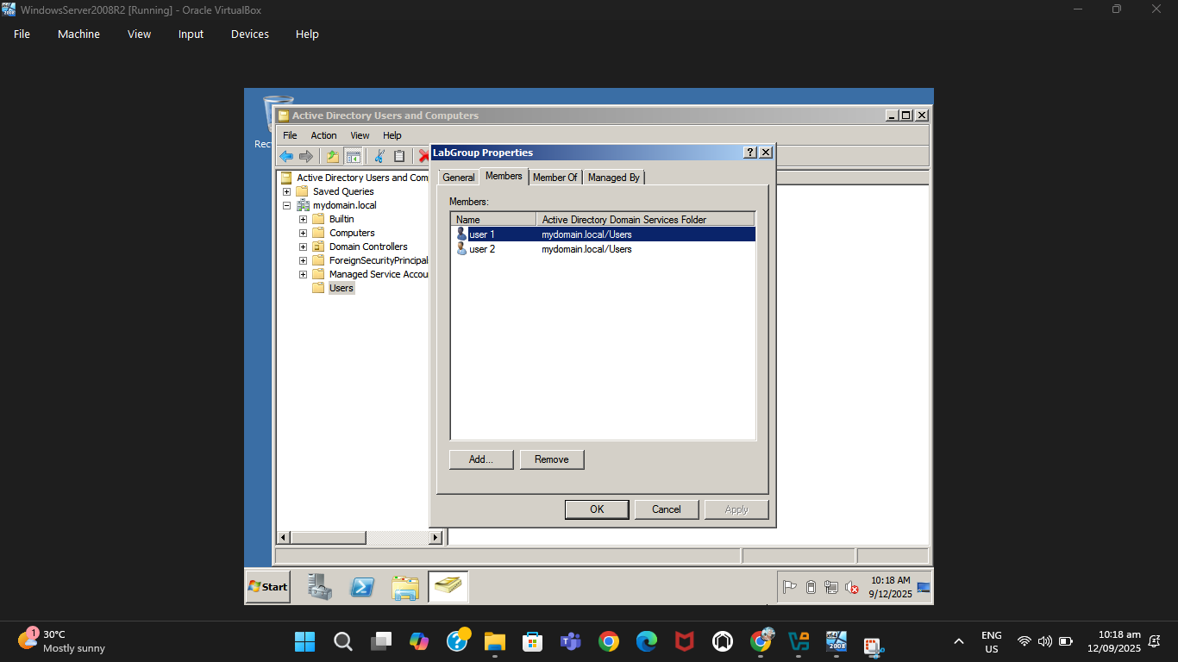

- Screenshot showing permissions applied on the Shared_Files folder.
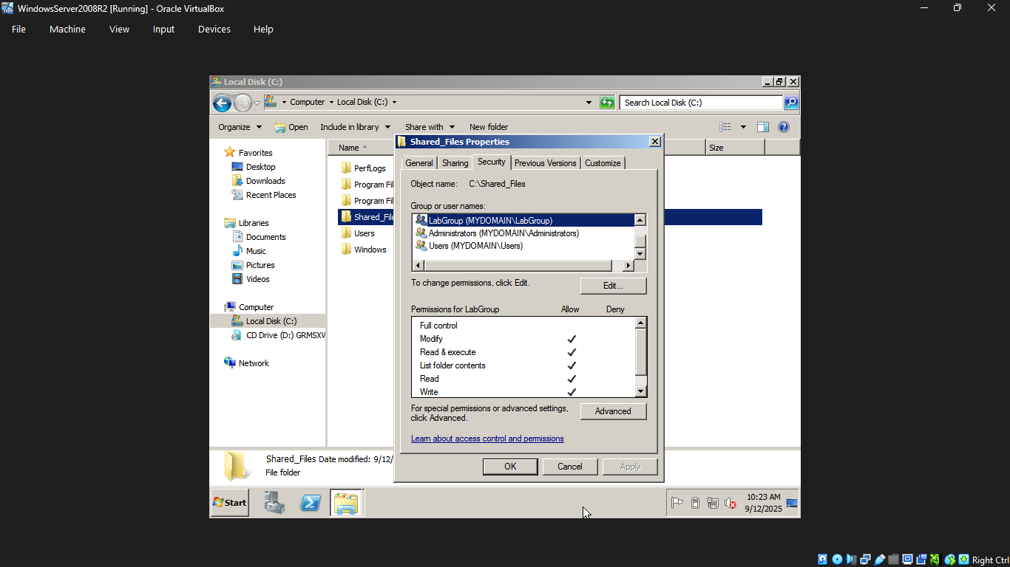
- Screenshot of successful access by a group member.
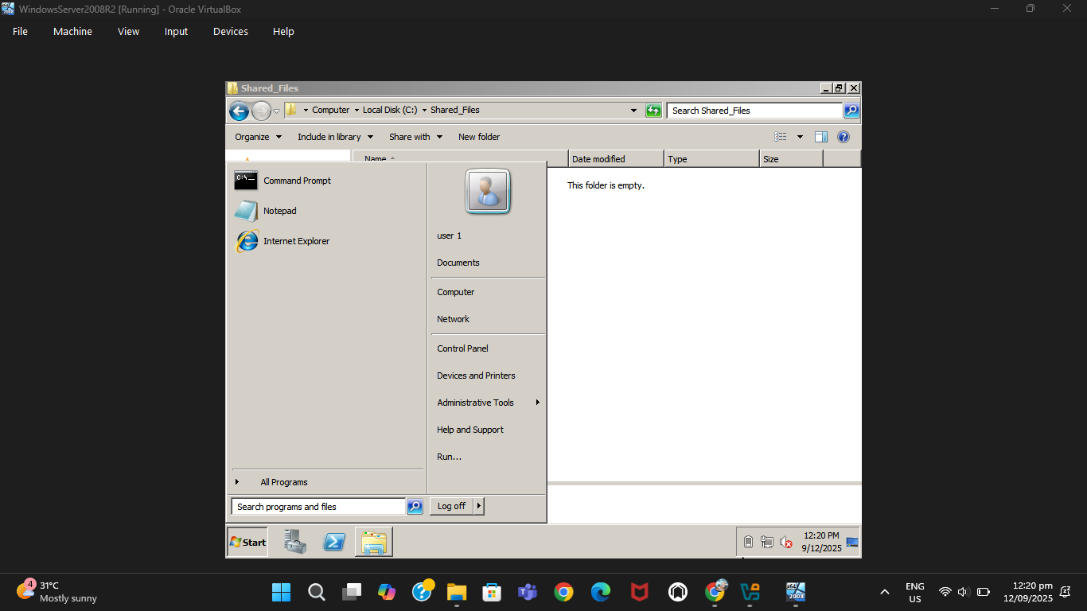

- Screenshot of denied access by a non-group member.
