Chapter 3
METHODOLOGY

The development of the "PaperTrail" system adopts the Agile Software Development methodology, which emphasizes iterative progress, stakeholder collaboration, and responsiveness to change. Agile is well-suited for software projects where user feedback and requirements evolve over time (Agile Alliance, n.d.).
Agile allowed the development team to deliver features in incremental cycles called sprints, each consisting of planning, development, testing, and feedback. This approach supported continuous improvement and helped align the system closely with real needs of users such as students and faculty members.
Agile offers several key benefits for this project. It enables frequent feedback loops, ensuring that the product evolves based on user input. The methodology also provides the flexibility to incorporate changes even in the later stages of development. Additionally, Agile enhances visibility into progress through regular sprint reviews and fosters stronger team collaboration (GeeksforGeeks, 2024).
3.1 Data Gathering
To guide the design and development of the PaperTrail system, a series of data gathering activities were conducted to determine user requirements, understand existing issues, and define system specifications. These efforts were aimed at collecting meaningful insights from key stakeholders — such as students, thesis advisers, and department staff — who are actively involved in the processes of submission, evaluation, and tracking of undergraduate theses. Special focus was given to identifying features that support real-time document collaboration and effective thesis defense scheduling, which were found to be essential for improving the current workflow. Initial observations of the manual thesis tracking process within the Environmental Science Department involved shadowing staff and students to identify bottlenecks, delays, and inefficiencies. This revealed frequent misplacement of physical documents, unclear submission statuses causing feedback delays, and the time-consuming nature of manually encoding updates. In addition, semi-structured interviews were conducted with department heads, faculty advisers, and administrative staff to uncover common frustrations with the current system and gather suggestions for digital enhancements. Sample questions addressed challenges in tracking progress, current monitoring methods, desired features for a digital platform, and the potential benefits of a shared editing environment.

3.3 Design Phase
3.3.1 System Architecture

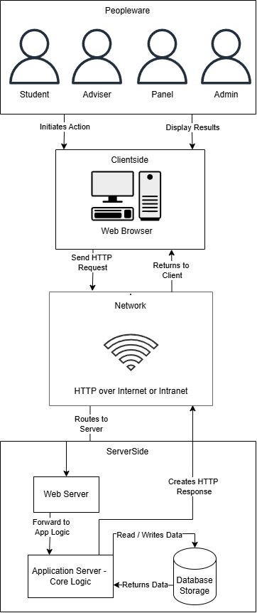

Figure 1. System Architecture of PaperTrail
Figure 1 illustrates the high-level system architecture, outlining the various layers and components involved in the PaperTrail system's operation. At the apex is the Peopleware layer, comprising the end-users (Student, Adviser, Panel, Admin) who initiate all interactions. Their actions, such as logging in or submitting documents, trigger a request from their Clientside device, typically a web browser. This request is then transmitted over the Network, utilizing HTTP over Internet or Intranet as the communication protocol, to the Serverside infrastructure. The Web Server receives these requests and forwards them to the Application Server - Core Logic. This core logic component embodies the system's business rules and functionalities, performing the actual processing of user requests. During this processing, the Application Server frequently interacts with the Database Storage to read and write persistent data, ensuring information is stored and retrieved effectively. Once the processing is complete, the Application Server creates an HTTP response, which is routed back through the Web Server, across the Network, and finally displayed on the user's Clientside device, completing the communication cycle. This architecture highlights PaperTrail as a typical web-based, client-server application.

3.3.2 Context Diagram
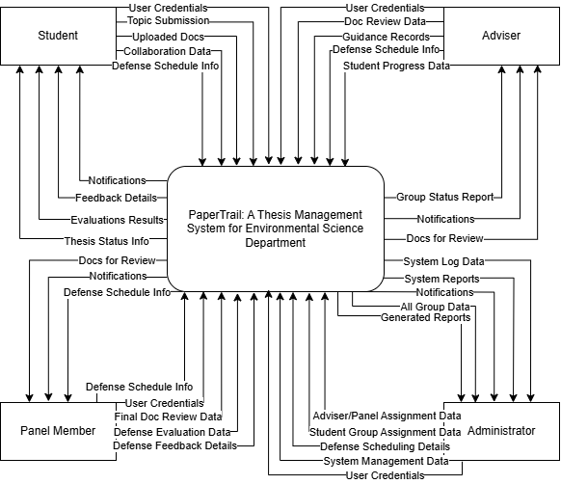
Figure 2. Context Diagram of PaperTrail
Figure 2 illustrates the Context Diagram for the PaperTrail Thesis Management System, representing the system as a single central process and detailing its high-level interactions with external entities. The external entities interacting with the PaperTrail system include the Student, Adviser, Panel Member, and Administrator. Each of these entities exchanges distinct sets of data with the system. For instance, the Student provides "User Credentials" and "Thesis Topic Submission Details" to the system, while receiving "Notifications," "Feedback Details," and "Evaluation Results." Similarly, the Adviser exchanges "Doc Review Data" and "Guidance Records," and the Panel Member provides "Defense Evaluation Data" and "Defense Feedback Details." The Administrator manages the system by sending "Adviser/Panel Assignment Data," "Student Group Creation Data," and "Defense Scheduling Details," and receives "System Log Data" and "Generated Reports."

3.3.3 Data Flow Diagram
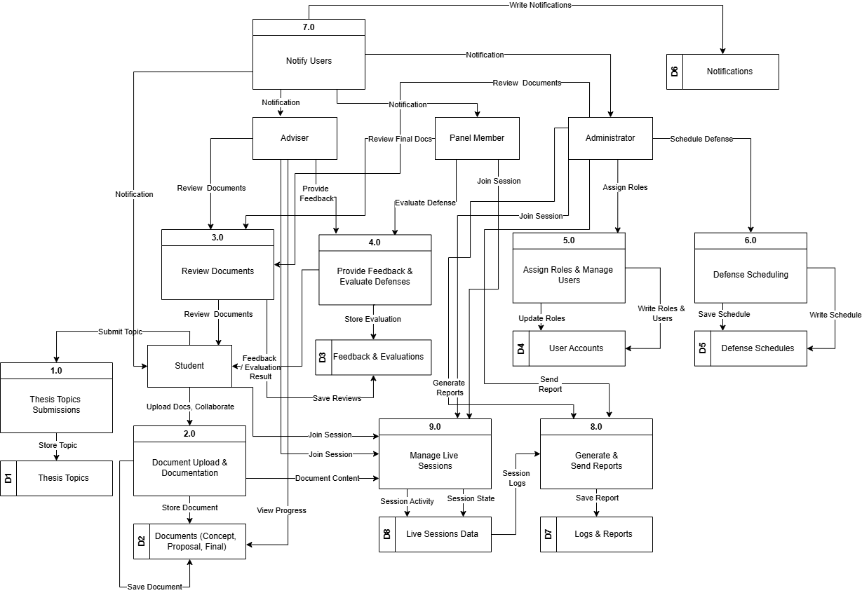

Figure 3. Data Flow Diagram of PaperTrail
Figure 3 illustrates the Data Flow Diagram (DFD) of PaperTrail, a comprehensive system managing the thesis process from topic submission to final reporting. This DFD provides a macro-level view of how information flows between external users, internal processes, and data stores, showcasing the system's core functionalities.
Key external entities include the Student (submitting topics, uploading, collaborating), Adviser (document reviews), Panel Member (defense evaluations), and Administrator (user/schedule management). Notifications (D6) also represents outgoing system alerts.
The system's processes include: 1.0 Thesis Topics Submissions (to D1), 2.0 Document Upload & Documentation (to D2, enabling progress tracking), 3.0 Review Documents (Adviser feedback to D3), 4.0 Provide Feedback & Evaluate Defenses (Panel Member evaluations to D3), 5.0 Assign Roles & Manage Users (Administrator updates D4), 6.0 Defense Scheduling (Administrator updates D5), 7.0 Notify Users (sends system-wide notifications from D6), and 8.0 Generate & Send Reports (compiles data to D7). A new process, 9.0 Manage Live Sessions, facilitates real-time user interaction, accessing D2 and recording activity in D8.
Core data stores are: D1: Thesis Topics, D2: Documents, D3: Feedback & Evaluations, D4: User Accounts, D5: Defense Schedules, D6: Notifications, D7: Logs & Reports, and D8: Live Sessions Data. PaperTrail's DFD depicts the systematic handling of thesis management, integrating user interactions, processes, and data storage, now augmented by a real-time collaboration feature.

3.3.4 Database Schema
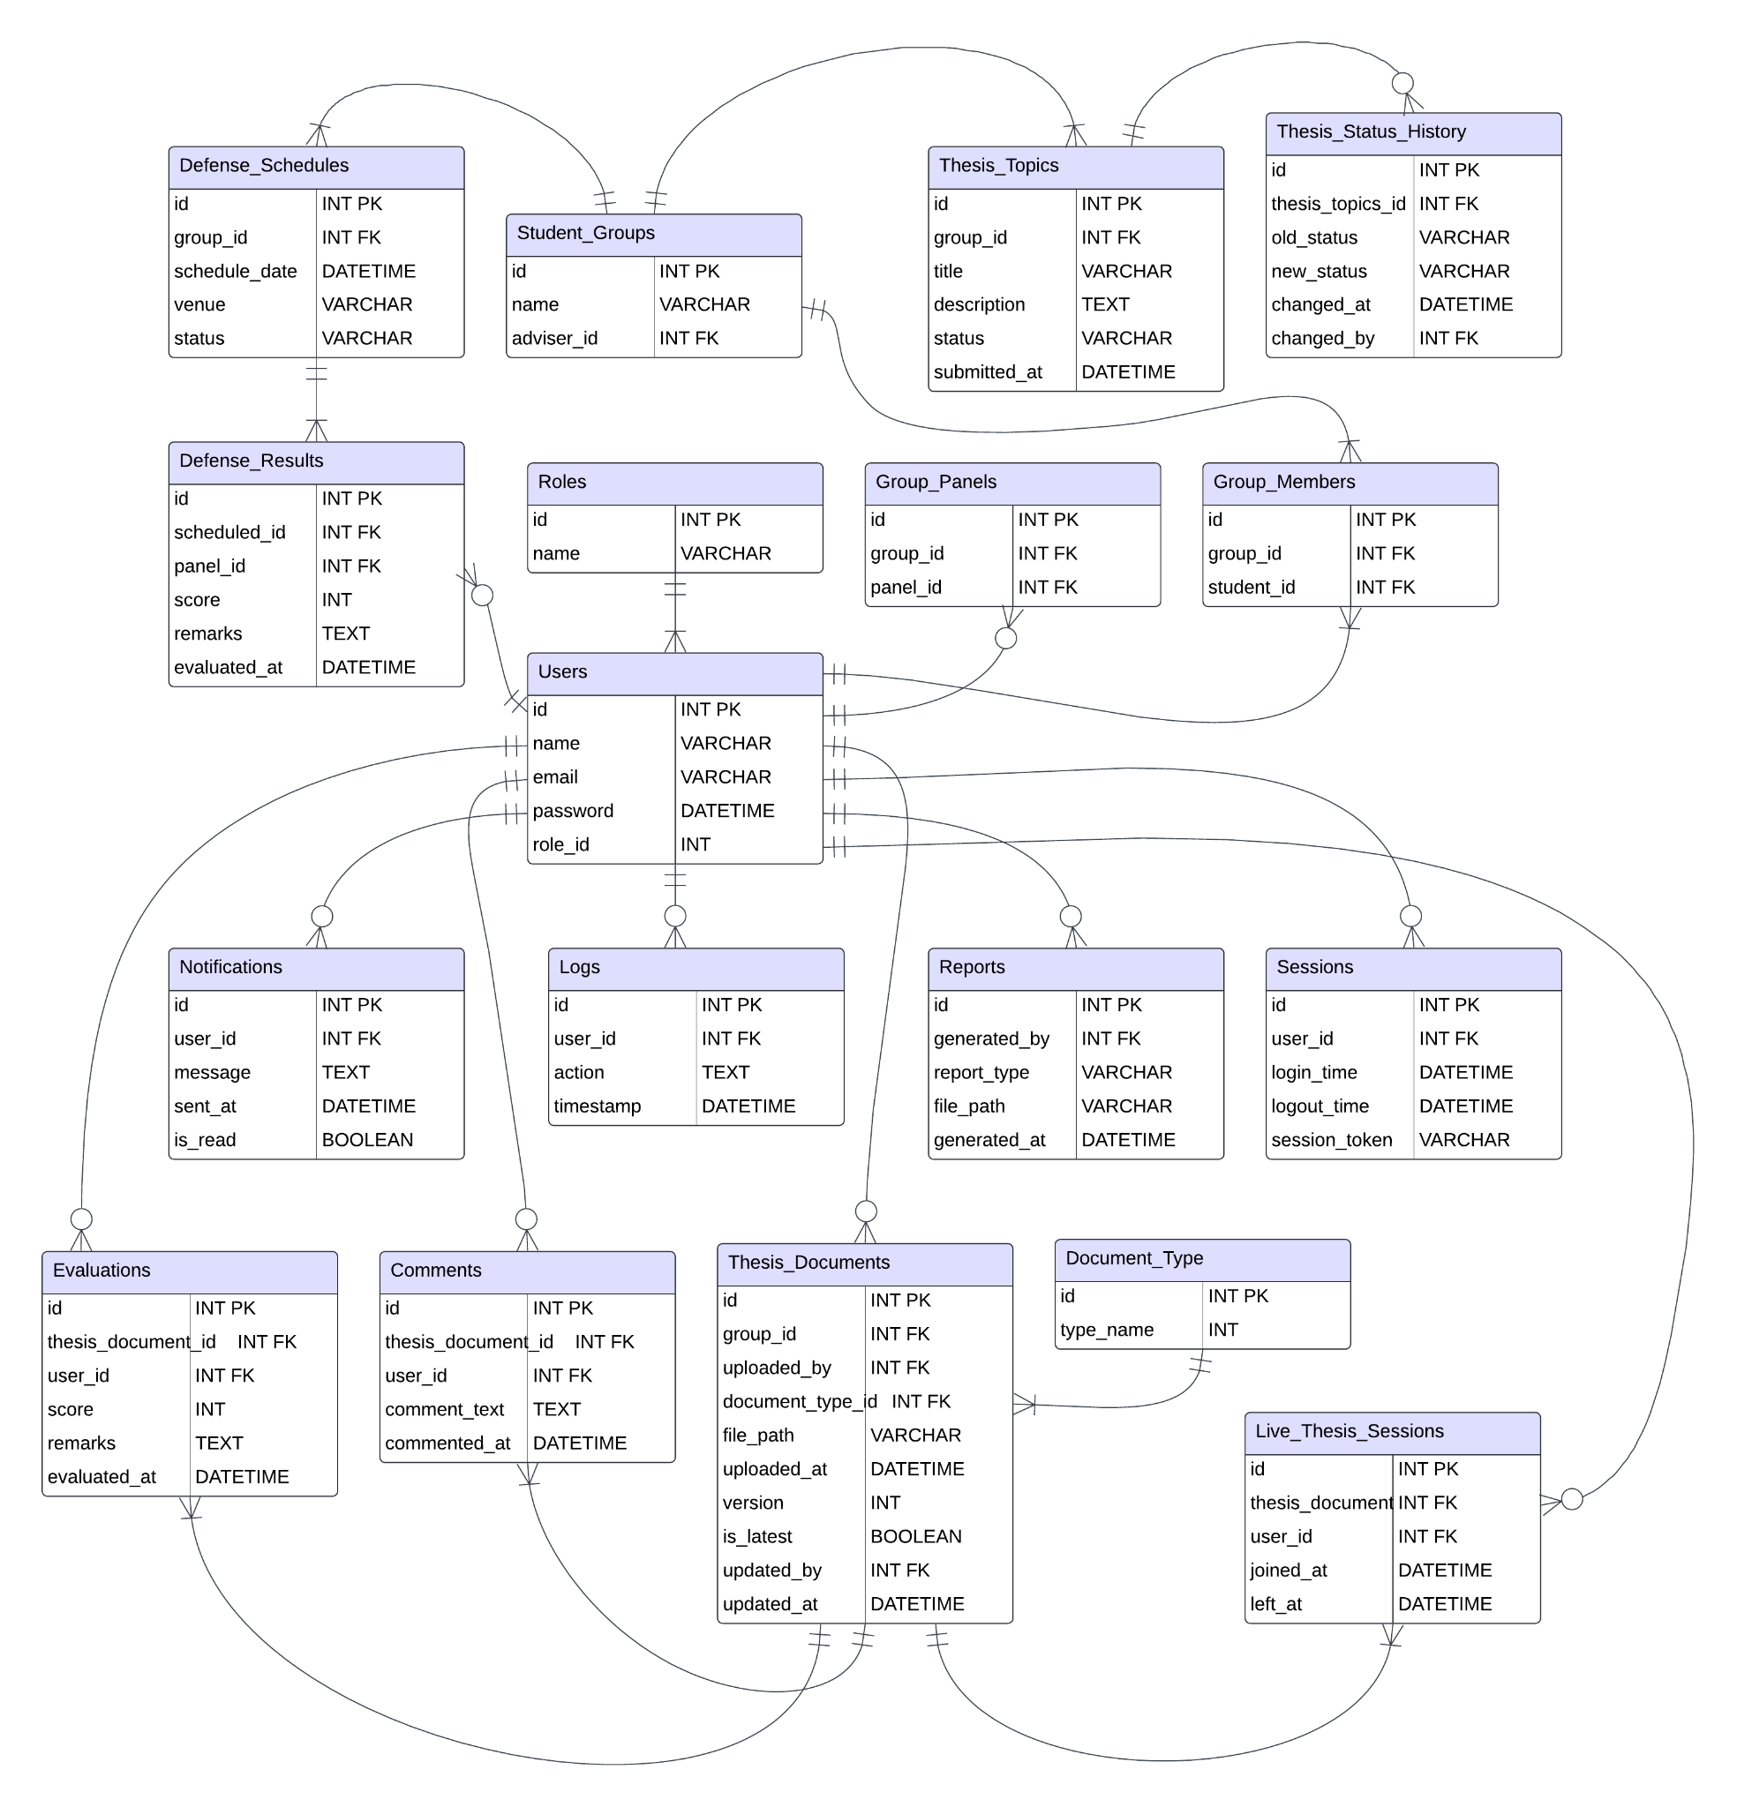
Figure 4. Database Schema of PaperTrail
Figure 4 shows the database schema of the PaperTrail system, it outlines the structured data model and the relationships between tables that collectively support the platform’s full functionality. Central to the schema is the Users table, which stores account information such as name, email, and role. User roles Student, Adviser, Panel, and Administrator are defined in the Roles table and linked to users through a foreign key relationship. Students are grouped via the Student_Groups table, which also assigns each group an adviser. Group memberships are tracked using the Group_Members table, while Group_Panels assigns evaluation panels to student groups.

Thesis-related data is managed through the Thesis_Topics table, capturing each topic’s title, description, and status. The Thesis_Status_History table logs status changes over time for auditing purposes. Document management is a key feature, handled primarily through the Thesis_Documents table. This table supports document versioning by storing multiple versions of each uploaded file, with metadata such as version number, upload timestamps, and flags indicating the latest version, enabling users to review and restore previous versions as needed. Document types are referenced via the Document_Type table.

In addition to versioned uploads, the platform supports real-time collaborative document editing, allowing multiple users—such as students and advisers—to simultaneously edit thesis drafts through a shared online editor. To facilitate this, the system incorporates live editing sessions tracked in a dedicated Live_Thesis_Sessions table, recording which users are actively collaborating on documents and their session durations. Periodic snapshots of the live document state are saved in Thesis_Documents as new versions to maintain a robust history of changes.

User feedback and remarks are recorded in the Comments table, while evaluations and defense outcomes are stored in the Evaluations and Defense_Results tables, respectively.

For administration and accountability, the schema includes tables such as Logs (tracking user actions), Sessions (managing user login/logout events), Reports, and notifications. Defense scheduling is handled through the Defense_Schedules table, linking student groups to venues and defense dates. This schema supports the core features of submission, version-controlled review, real-time collaboration, scheduling, and evaluation within a normalized, scalable, and consistent relational data structure.

3.3.5 Use Case Diagram
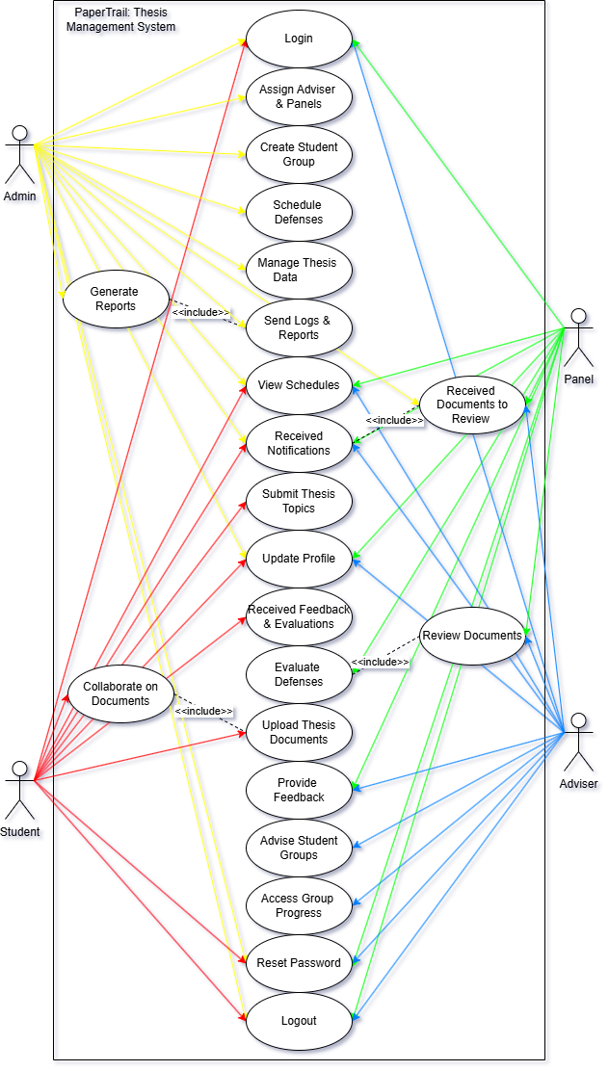
Figure 5. Use Case Diagram of PaperTrail
Figure 5 illustrates the Use Case Diagram for the PaperTrail Thesis Management System, providing a high-level view of the system's functional requirements from the perspective of its users. This diagram identifies the primary actors interacting with the system and the specific functions (use cases) they perform, outlining the boundaries and scope of the application.
The key actors in the PaperTrail system are the Admin, who possesses comprehensive system management control, including login, assigning advisers and panels, creating student groups, scheduling defenses, managing thesis data, generating reports (which includes sending logs and reports), viewing schedules, receiving notifications, and resetting passwords, as well as logging out. The Student is the central user in the thesis process, with use cases such as login, submitting thesis topics, updating profile, receiving notifications, receiving feedback and evaluations, collaborating on documents (which includes uploading thesis documents), accessing group progress, and resetting passwords, along with logging out. The Adviser provides academic guidance, performing actions like login, viewing schedules, receiving notifications, receiving documents to review (which includes reviewing documents), providing feedback, advising student groups, and resetting passwords, besides logging out. Lastly, the Panel (Panel Member) is involved in evaluating theses, with use cases covering login, viewing schedules, receiving notifications, receiving documents to review (including reviewing documents), evaluating defenses, and resetting passwords, in addition to logging out.
The use cases, depicted as ovals, represent distinct functionalities offered by PaperTrail. These functionalities span from fundamental actions like login, logout, and reset password (common to all actors) to more specialized, role-based operations. For instance, the Admin uniquely handles user group management and defense scheduling, while the Student focuses on thesis submission and document management. Both Adviser and Panel share common review processes, indicated by the 'Received Documents to Review' use case including 'Review Documents'. The connections between actors and use cases are represented by lines, showing which actor initiates or participates in each system function. The <<include>> relationships further clarify that certain use case functionalities are integral parts of other, more complex use cases, promoting modularity in the design. This Use Case Diagram clearly delineates the functional scope of the PaperTrail Thesis Management System, precisely defining each user's role and the operations they can perform to ensure a streamlined and efficient thesis workflow.
3.4 Testing

3.4.1 Usability Test
To evaluate the usability of "PaperTrail: A Thesis Management System for the Environmental Science Department," the System Usability Scale (SUS) will be employed. Developed by John Brooke in 1986, SUS is a reliable and widely-used tool comprising a 10-item questionnaire with five response options ranging from "Strongly Disagree" to "Strongly Agree." It provides a quantitative measure of a system's perceived usability, yielding a score between 0 and 100. This method is particularly effective for identifying usability issues and benchmarking user satisfaction. In alignment with ISO 9241-11:2018 standards, which emphasize evaluating usability within the context of specific user roles, tasks, and environments, the SUS will be administered to a diverse group of participants, including students, thesis advisers, and department staff. These participants will perform representative tasks such as submitting thesis documents, scheduling defenses, and providing feedback. Following task completion, they will complete the SUS questionnaire to assess the system's effectiveness, efficiency, and satisfaction levels. The collected data will inform iterative improvements, ensuring that PaperTrail meets the practical needs of its users and enhances the overall thesis management process.

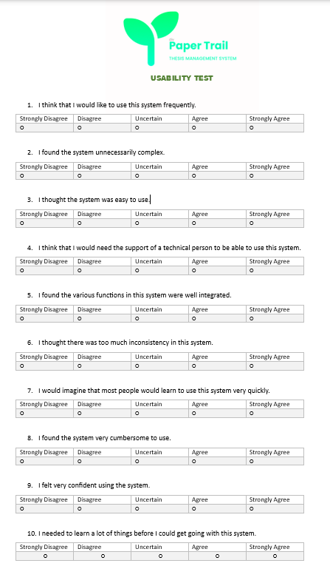
Figure 7. Usability Testing Form

3.4.2 Functionality Test
The Functionality Test for the PaperTrail system, also referred to as Beta Testing, is conducted to thoroughly assess whether all system features operate according to their intended design and logic. This phase is critical to determine the system’s readiness for deployment within the Environmental Science Department. It enables the identification of potential issues by simulating real-world usage by actual users—students, advisers, and administrative staff. The test evaluates how the system handles edge cases, adheres to expected behaviors, and meets the functional requirements specified during development.
The primary objectives of the Functionality Test include ensuring that each feature performs according to its technical and functional specifications, identifying and documenting bugs, crashes, performance issues, and unexpected behaviors, and validating the complete user journey—from logging in to thesis submission, monitoring, and approval. It also involves assessing the functionality and interaction of different user roles (student, adviser, admin), as well as gathering both qualitative and quantitative feedback from users to further refine the system before deployment.
Beta testers engage in various test activities to simulate both normal and critical use-cases. These activities include logging in and authenticating user credentials for different roles, uploading thesis documents along with metadata like title and abstract, and collaboratively editing a thesis in real time, including commenting and tracked changes. Users also test the management of thesis progress using defined status indicators such as “Submitted,” “Under Review,” “Needs Revision,” and “Approved,” as well as the scheduling of thesis defense dates using the built-in calendar and availability checker. Additional tasks include receiving and responding to automated notifications, replying to inline comments within the shared document interface, downloading reviewed or approved versions for offline use, and verifying session timeout behavior for security purposes. These activities are designed to validate both the system’s functionality and usability under realistic user conditions, ensuring that PaperTrail supports effective thesis collaboration and scheduling workflows.
The expected output from these usability tests is that each task is completed successfully with accurate, real-time system responses. For instance, files should upload and display without corruption, real-time edits must synchronize across all collaborators, and thesis status changes should reflect immediately after user actions. Scheduling features must accurately reflect availability and save events without conflicts, while notifications must be delivered promptly with correct content. Comments and feedback should appear in the correct document sections and remain synced, and document downloads must always retrieve the latest version. Any malfunction or delay will be logged, classified by severity (Critical, Major, Minor), and addressed before the system's final release.
The Accuracy Test, on the other hand, ensures that PaperTrail produces precise and dependable outputs across all system functions, thus reinforcing academic integrity and administrative accountability. This test validates stored data, collaborative editing logs, thesis scheduling entries, and document versioning. Its objectives include verifying the accuracy of input data—such as thesis titles, names, and schedules—ensuring that workflow status changes reflect actual user actions, and confirming that real-time edits are saved and visible without data loss. Additionally, the test checks that comments and annotations remain correctly linked to document sections, defense dates are stored without conflicts, and document downloads consistently provide the most recent version. Ultimately, the Accuracy Test guarantees that PaperTrail serves as a reliable platform for managing sensitive academic documents and tasks.
3.5 Technology Stack

Frontend
● React.js + TypeScript – A modern JavaScript library combined with TypeScript for building a scalable, type-safe, and maintainable user interface.
● Bootstrap – A responsive front-end framework that ensures a visually appealing and mobile-friendly design.
● Fetch API – A native JavaScript API for making asynchronous HTTP requests to interact with backend services.
● React Router – A client-side routing library that enables seamless navigation between different views or pages within the application.

Backend
● Django + Django REST Framework (DRF) – Django provides a high-level,
secure, and scalable web framework, while DRF extends it to build RESTful
APIs efficiently.
● MySQL – A robust and scalable relational database management system
(RDBMS) used for storing structured data securely.
● Django QR Code – A Django library used for dynamically generating QR
codes for various application functionalities.
● Firebase – A cloud-based backend-as-a-service (BaaS) that provides
real-time database capabilities, authentication, and cloud functions for
seamless backend integration. It can be used for:
○ Real-time Database / Firestore – Synchronizing and storing real-time data.
○ Firebase Cloud Functions – Serverless backend logic execution.
○ Firebase Authentication – Additional authentication support.

Storage & Authentication
● Django Authentication – The built-in authentication system in Django that
manages user logins, permissions, and access control.
● JWT (JSON Web Token) or Django Sessions – JWT ensures secure and stateless authentication for API-based authentication, while Django Sessions handle session-based authentication for web
applications.
● Django Storages – A flexible storage backend that integrates with cloud storage providers (e.g., AWS S3, Google Cloud Storage) or file-based storage for securely managing uploaded documents and media files.
3.6 Gantt Chart

The Gantt Chart shows the planned timeline for our PaperTrail project, starting from February 2025 and ending with our Final Defense in December 2025. It outlines our month-by-month progress and future plans for completing the system.
February 2025:
We began with Observation and Interviews to understand the real-world problems users experience. These early insights helped us define the core purpose of our system and gave us direction for development.
March 2025:
We conducted a Survey Questionnaire to gather more specific data, which helped shape the system's planned features. During this time, we also identified a potential employer or end-user, which made our project goal more realistic and aligned with actual needs. Simultaneously, we began preparing the necessary project documents.
April 2025:
This month focused on finalizing our proposal and completing all required paperwork for our title defense. We also created initial system designs and workflow diagrams based on the gathered data.
May 2025:
Although our title wasn’t officially approved yet, we got a head start by beginning work on the frontend. This included designing and setting up the basic structure of the web to save time later.
June 2025:
We are now in the process of proposing our project title, and we’re confident it will be approved. Once we receive approval, we will move forward with full development, especially backend integration and adding core functionalities.
July to October 2025:
These months are reserved for complete system development, along with rounds of testing and refinement. We’ll use this time to fix bugs, improve performance, and polish the user interface based on feedback.
November 2025:
This phase is for final polishing and deployment preparation. We’ll also finish the full documentation and start rehearsing our presentation.
December 2025:
We will hold our Final Defense. At this point, the system will be complete and fully functional. We will present it to the panel, explain how it was developed, and share the impact and experience gained throughout the project.

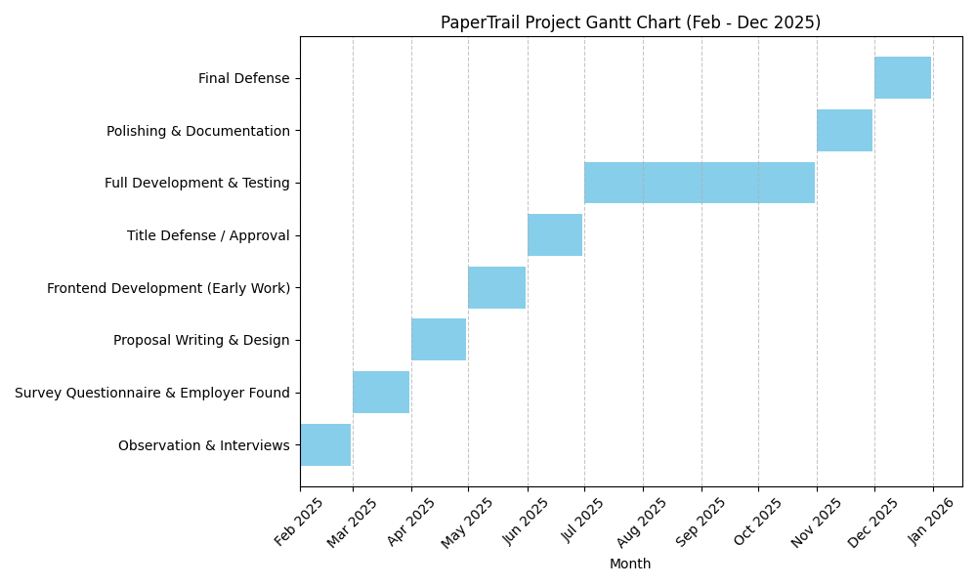
Figure 8. Gantt Chart of PaperTrail

3.7 Prototype

3.7.1 Web-based Application of Paper Trail

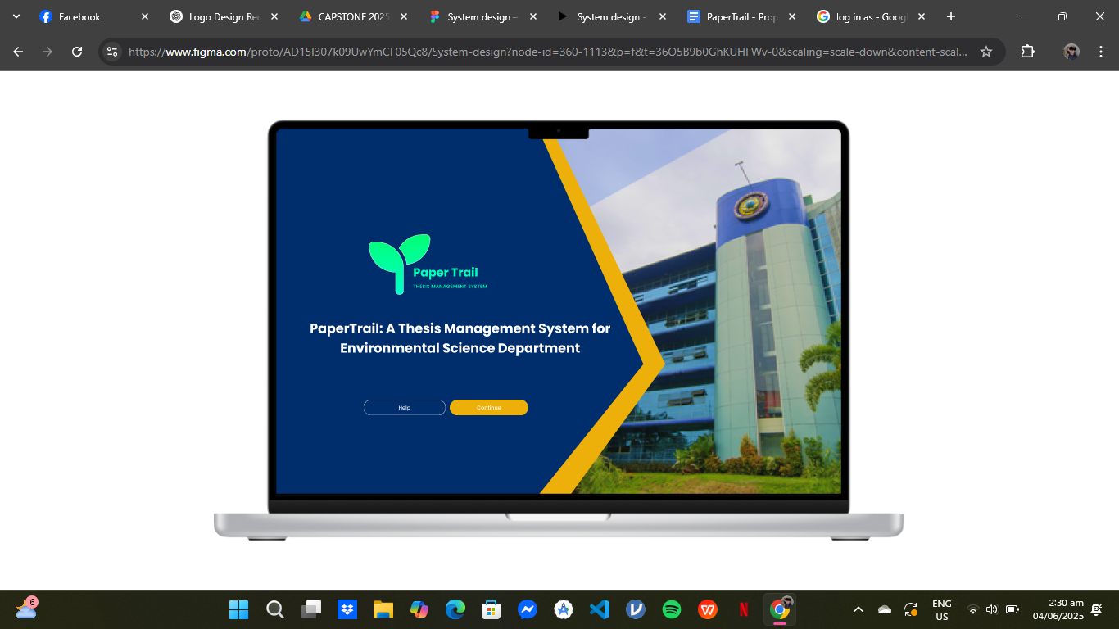
Figure 9. Landing page of the system.

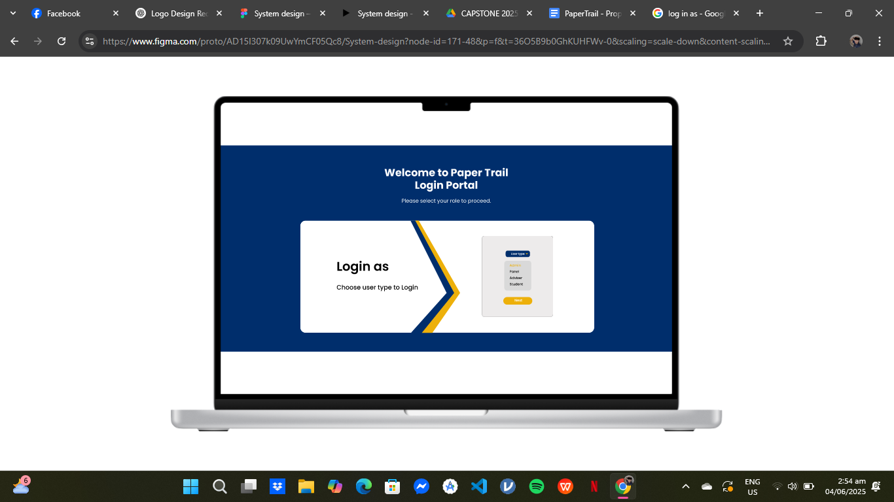
Figure 10. This is the login portal of the system
were the user can choose usertype to login
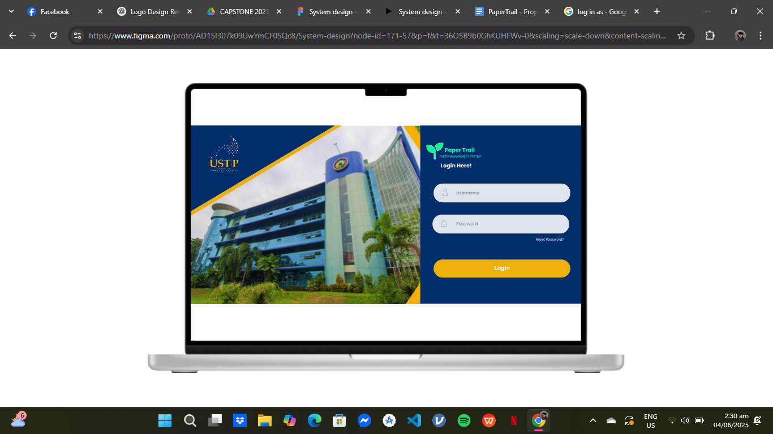
Figure 11. Login Screen

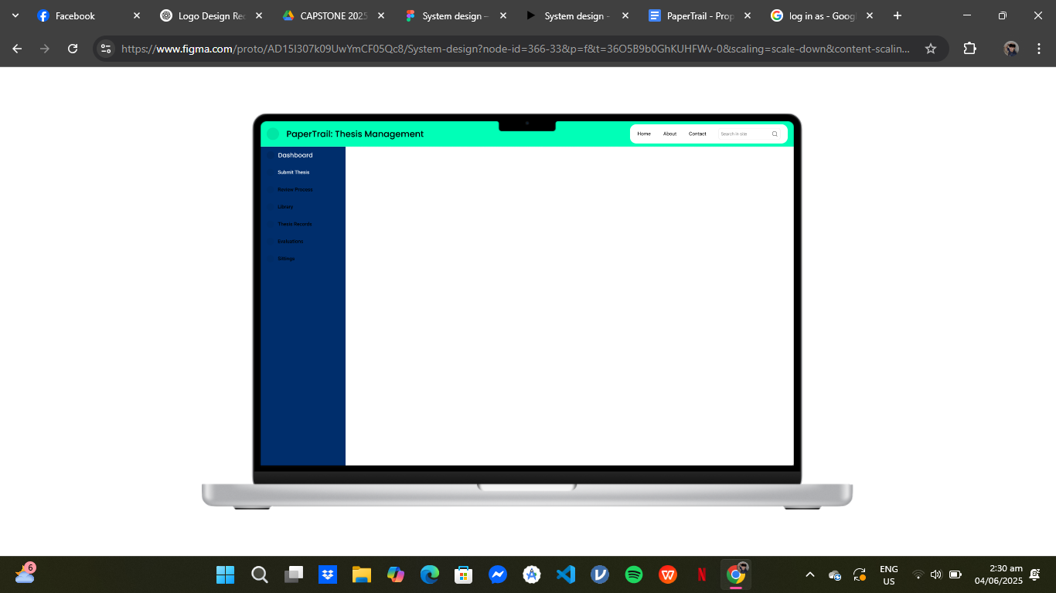
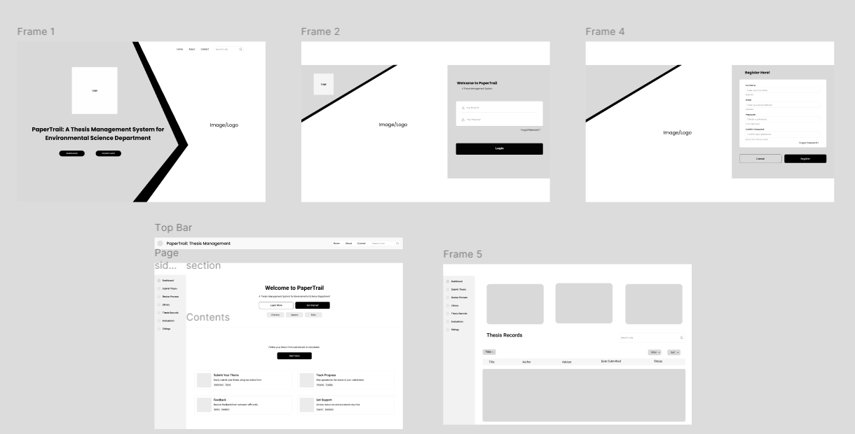
Figure 9. Prototype of PaperTrail
Udasco, D. (2025). PaperTrail: A Thesis Management System for Environmental Science Department [Prototype]. Figma. https://www.figma.com/design/AD15I307k09UwYmCF05Qc8/System-design?node-id=0-1&p=f&t=2IFmXQdFV67xS5e4-0

