Aniñon, Jade P.
Aseñero, Rochelle
BSIT – 4R11

Artificial Neural Network Implementation

Lab Workflow
Step 0: Setup
- Download the Kaggle dataset using either the Kaggle API or manual download.
Step 1: Load Data
- Inspect the dataset and identify the available columns.
- Output: List of column names
- import pandas as pd

- df = pd.read_csv("Android_Permission.csv")

- # Inspect dataset
- print("Shape:", df.shape)
- print("\nColumn names:\n", df.columns.tolist())
- df.head()
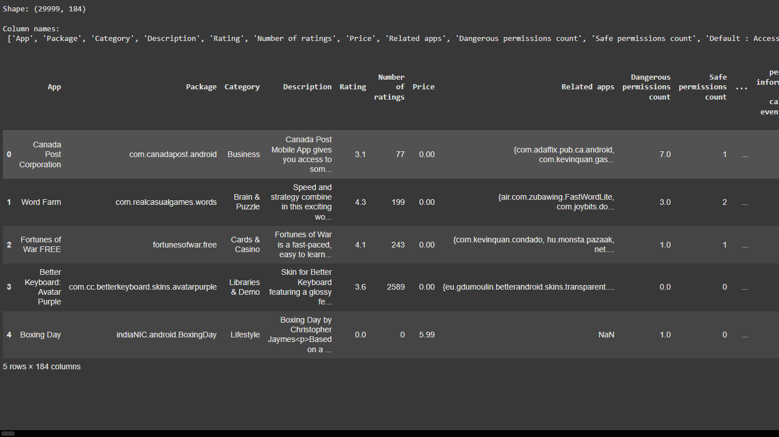

Step 2: Data Cleaning
- Remove unnecessary non-numeric columns (app names, descriptions, package IDs, etc.).
- Keep only numeric features and the target label (Class).
- Columns with all zeros or constants add no value, drop them.
- Handle missing values and remove duplicates.
  - Output: List of column names
- Ensure the target is binary (0 = Benign, 1 = Malware).
- # Drop unnecessary non-numeric columns
- non_numeric_cols = ['App','Package','Category','Description','Related apps']
- df_clean = df.drop(columns=non_numeric_cols, errors='ignore')

- # Drop constant/all-zero columns
- df_clean = df_clean.loc[:, (df_clean != df_clean.iloc[0]).any()]

- # Handle missing values and duplicates
- df_clean = df_clean.dropna().drop_duplicates()

- # Ensure target is binary
- df_clean = df_clean[df_clean['Class'].isin([0,1])]

- print("Final columns:\n", df_clean.columns.tolist())
- print("Final shape:", df_clean.shape)

Step 3: Train/Test Split
- Split data into training and test sets using a stratified split.
- from sklearn.model_selection import train_test_split
- from sklearn.preprocessing import StandardScaler

- X = df_clean.drop(columns=['Class'])
- y = df_clean['Class']

- # Stratified split
- X_train, X_test, y_train, y_test = train_test_split(
- X, y, test_size=0.2, stratify=y, random_state=42
- )

- # Normalized version
- scaler = StandardScaler()
- X_train_norm = scaler.fit_transform(X_train)
- X_test_norm = scaler.transform(X_test)

- print("Train size:", X_train.shape, " Test size:", X_test.shape)

Step 4: Modeling
- Conduct experiments in three phases of dataset preparation:
  - Raw dataset (unprocessed numeric values).
  - Normalized dataset (apply scaling such as MinMaxScaler or StandardScaler).
- For each dataset version, train the following ANN models with different hidden layer configurations:
  - ANN – Model 1 (6 layers): 128 → 64 → 32 → 16 → 8 → 1
  - ANN – Model 2 (5 layers): 64 → 32 → 16 → 8 → 1
  - ANN – Model 3 (4 layers): 32 → 16 → 8 → 1
  - ANN – Model 4 (3 layers): 16 → 8 → 1
- from tensorflow.keras.models import Sequential
- from tensorflow.keras.layers import Dense
- from sklearn.metrics import accuracy_score, precision_score, recall_score, f1_score, confusion_matrix

- architectures = {
- "Model 1": [128,64,32,16,8],
- "Model 2": [64,32,16,8],
- "Model 3": [32,16,8],
- "Model 4": [16,8]
- }

- def build_and_train(arch, X_train, y_train, X_test, y_test, epochs=10):
- model = Sequential()
- model.add(Dense(arch[0], input_dim=X_train.shape[1], activation='relu'))
- for units in arch[1:]:
- model.add(Dense(units, activation='relu'))
- model.add(Dense(1, activation='sigmoid'))

- model.compile(optimizer='adam', loss='binary_crossentropy', metrics=['accuracy'])
- history = model.fit(X_train, y_train, epochs=epochs, batch_size=32,
- validation_split=0.2, verbose=0)

- y_pred = (model.predict(X_test) > 0.5).astype(int)

- metrics = {
- "Accuracy": accuracy_score(y_test, y_pred),
- "Precision": precision_score(y_test, y_pred),
- "Recall": recall_score(y_test, y_pred),
- "F1": f1_score(y_test, y_pred),
- "ConfusionMatrix": confusion_matrix(y_test, y_pred)
- }
- return model, history, metrics

Run 8 experiments (4 models × 2 dataset versions):

- import seaborn as sns
- import matplotlib.pyplot as plt

- results = {}
- for version, (Xtr, Xte) in {"Raw": (X_train, X_test), "Normalized": (X_train_norm, X_test_norm)}.items():
- for name, arch in architectures.items():
- print(f"\n🔹 Training {name} - {version}")
- model, history, metrics = build_and_train(arch, Xtr, y_train, Xte, y_test, epochs=10)
- results[f"{name} - {version}"] = metrics

- # Plot confusion matrix for one strong model (Model 1 Normalized as example)
- if name=="Model 1" and version=="Normalized":
- cm = metrics["ConfusionMatrix"]
- sns.heatmap(cm, annot=True, fmt='d', cmap='Blues',
- xticklabels=["Benign","Malware"], yticklabels=["Benign","Malware"])
- plt.title(f"Confusion Matrix - {name} ({version})")
- plt.show()

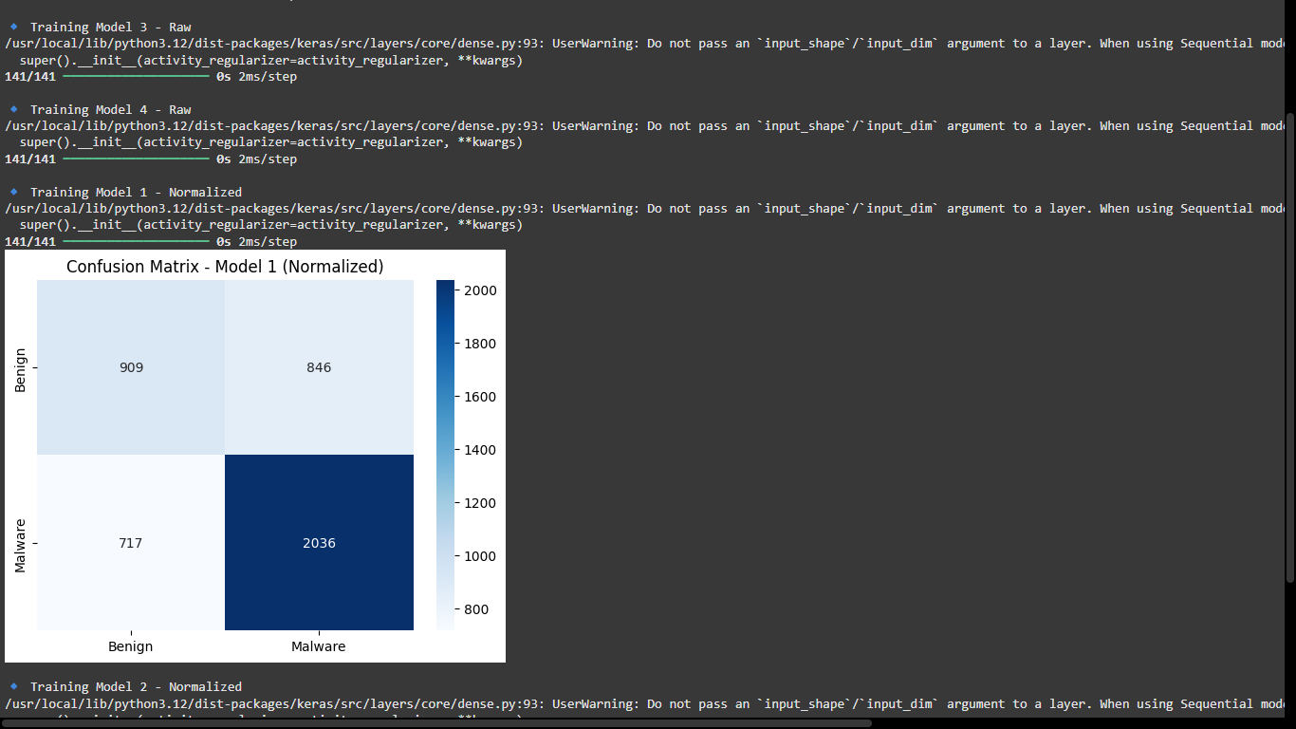

Step 5: Evaluation & Comparison
- Evaluate each trained model using the following performance metrics:
  - Accuracy
  - Precision
  - Recall
  - F1-score
- Generate a Confusion Matrix for at least one of the strongest models.
- Identify the best-performing model across all runs. Display its performance on both training and testing sets, and provide a discussion of results, including:
  - How raw vs. normalized vs. modified datasets affect performance.
  - Trade-offs between model complexity (number of layers/units) and evaluation metrics.
- summary = pd.DataFrame({
- k: {m: round(v[m],4) for m in ["Accuracy","Precision","Recall","F1"]}
- for k,v in results.items()
- }).T

- print("Model Comparison:\n")
- display(summary)

