BizPulse Project Documentation
Small Business Management Application
Team BIZPULSE
CT-MAD-213: Mobile Application Development
Bulacan Polytechnic College
Project category: Business Applications
Version: 1.0.0
Platform: Android 8.0 and later
Submitted by: Team BIZPULSE
Course / year / section: BSIS 2C
Jedediah Ebalobo, Irene Trinidad, Rochelyn Bacsal,
Ralph Jayrhard Amor and Alexander Bacaran
Submitted to: Kyle Fabian
Submission date: ______________________________________
GitHub repository: https://github.com/Jedfromanotherworld/BizPulse
Report contents: 1. Project Overview; 2. Objectives, Scope and Features; 3. System Design; 4. UI/UX and Implementation; 5. Testing and Evaluation; 6. Conclusion and Recommendations; Appendices and evaluator forms.

1. Project Overview
BizPulse is a local Android application that brings inventory, sales transactions, receipts and business summaries together for small retailers. The target users are business owners who maintain records and cashiers who process everyday sales.

Problem statement and proposed solution
Separate paper-based stock and sales records make it difficult to track deductions consistently and reconcile daily transactions. BizPulse records sales and stock changes together, keeps historical receipt details, and presents summaries from stored records. It supports a single-device workflow that does not depend on an internet connection after installation.

2. Objectives, Scope and Features
General objective: provide a practical mobile workflow for consistent inventory and sales recording.
Specific objectives: validate product and payment inputs; maintain local accounts, products and categories; complete sales with atomic stock deductions; produce receipts and analytics; enforce owner and cashier permissions; and support backup, import and audit review.
Major features: login and registration, dashboard, inventory search, product/category management, POS cart, camera barcode scanning, cash/change calculation, payment-method recording, receipt printing, analytics, low-stock alerts, audit records, and JSON backup/import.
Scope and limitations: all data is stored on one device. Card and GCash choices record externally collected payments and do not process transfers. There is no cloud synchronization or push notification service. The submitted version uses the original icon and does not generate barcode labels automatically. Demo authentication and unencrypted backups are unsuitable for production use without further work.

3. System Design — Application Architecture
Compose screens display reactive state from ViewModels. Repositories validate data and enforce role permissions. Room persists six record types in SQLite, while DataStore maintains local preferences and session state. AppStore combines database streams for the interface.
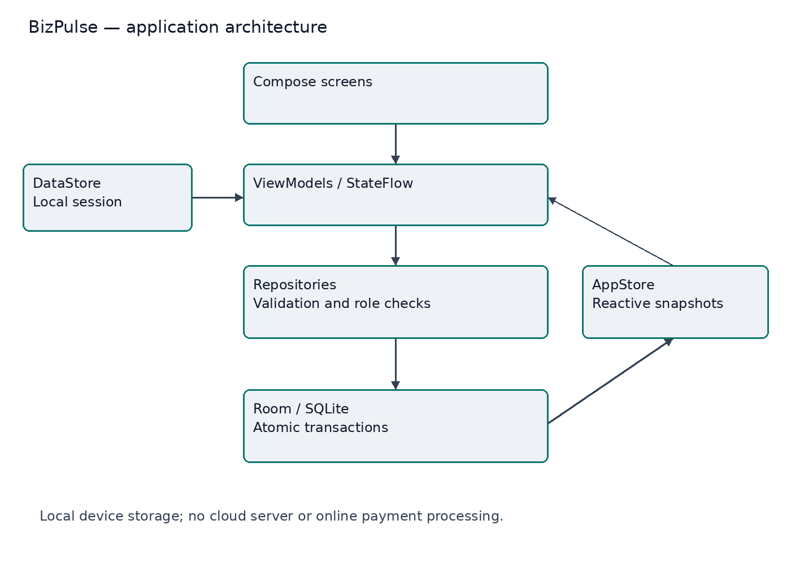
Checkout rechecks stock and products before saving the transaction, receipt lines, stock deduction and audit event inside a Room transaction. Invalid payment or failed writes roll back the operation rather than leaving a partial sale.

3. System Design — Use Cases
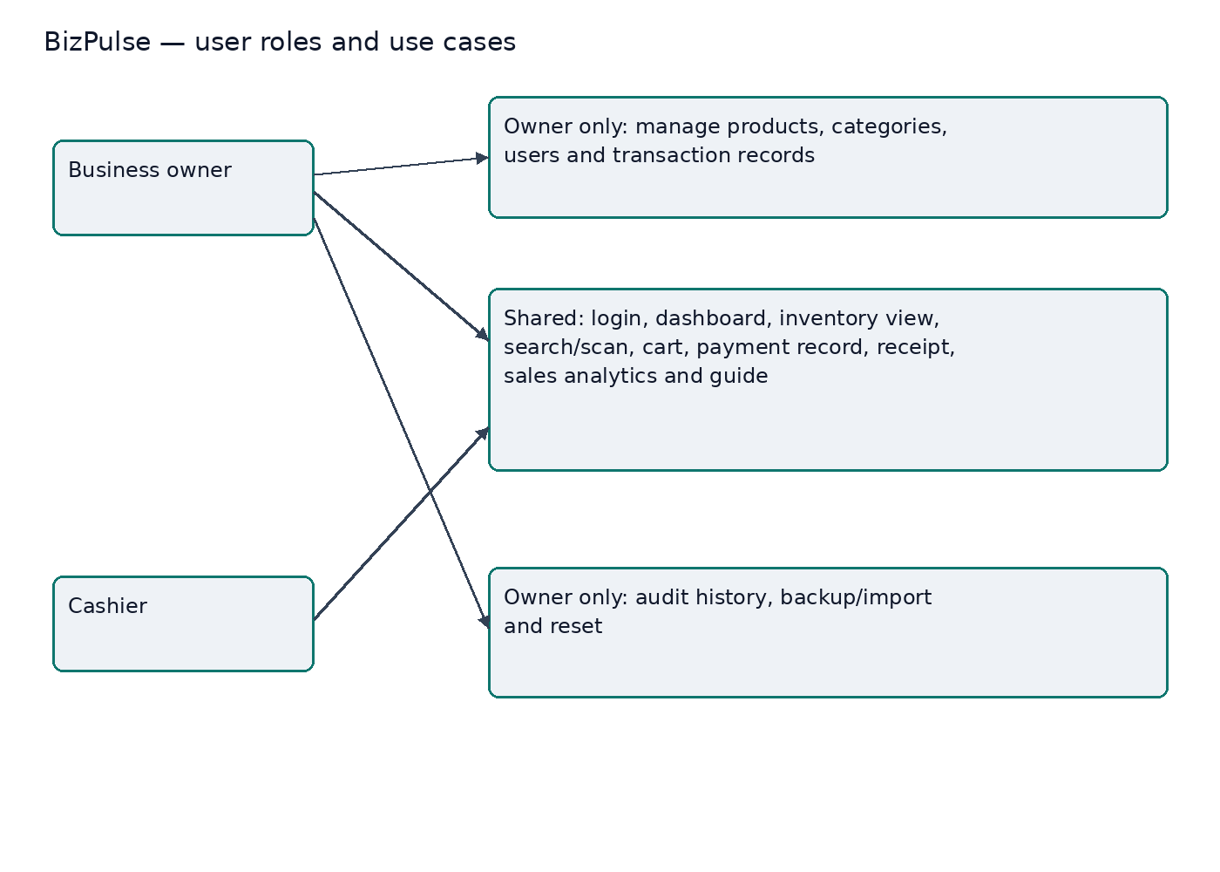
Both roles can view inventory and process sales. Owner-only actions are protected in repository methods as well as the interface. A cashier cannot gain modification rights simply by opening a hidden screen. The active owner cannot delete or demote their own account, and at least one owner must remain.
Main interaction flow: log in, review the dashboard, search or scan products in POS, review the cart, choose a recorded payment method, validate payment, complete the transaction, and view or print the receipt. Owners also maintain business records from Inventory and Manage.

3. System Design — Database
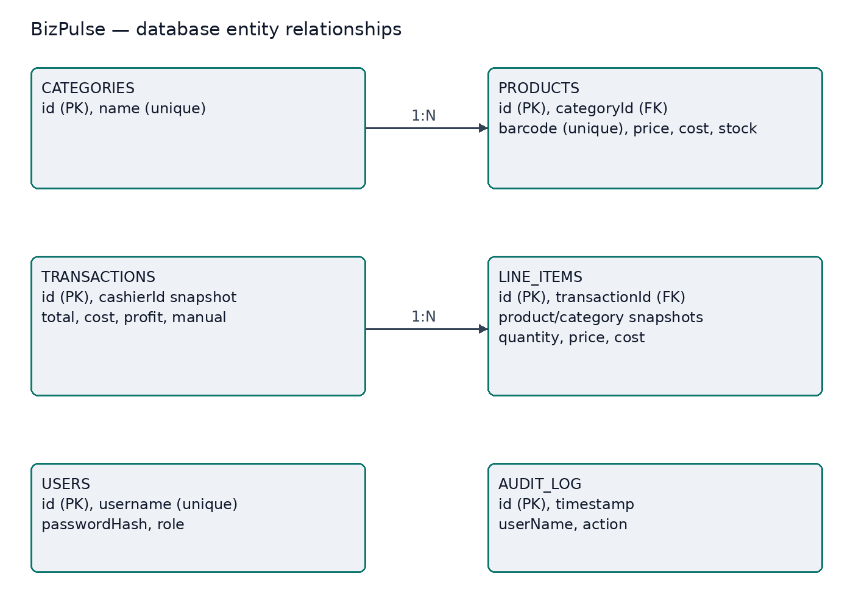
The explicit foreign keys are products.categoryId to categories.id, with deletion restricted, and lineItems.transactionId to transactions.id, with cascading line deletion. Other IDs and names on receipts are historical snapshots, allowing live records to change without destroying past sale details. Users and audit records have no direct foreign-key edge in this diagram.

4. UI/UX and Implementation
The interface uses emerald #10B981 for primary emphasis, slate #0F172A for contrast, #EEF2F6 for light backgrounds, and white cards. Dark mode uses navy surfaces and light text. The design uses readable typography, labeled inputs, rounded cards, consistent spacing and minimum 48 dp primary touch targets. Typography in the app follows the Compose theme: 24 sp and 20 sp headings, 14 sp body text and 11 sp captions.
Navigation covers login, dashboard, inventory, POS, analytics, Manage and guide. Manage is owner-only. The POS screen places products and cart information together; the dashboard prioritizes current sales and stock exceptions. Validation messages explain input errors. Destructive reset and import actions require confirmation. Scrollable layouts and insets support smaller displays, but device and large-font checks are still needed.
Actual screenshots are included in Appendix D and 04-UIUX/screenshots. Two additional images were extracted from the submitted video to show the cashier dashboard and analytics. Wireframes remain in 04-UIUX/wireframes.svg.
Technology | Use
Kotlin 1.9.22 / Compose | Application logic and declarative UI
Room 2.6.1 / SQLite | Persistent records and atomic operations
Hilt 2.50 / Coroutines | Dependency injection and background work
Navigation / DataStore | Screen routing and local preferences
ZXing Android Embedded 4.3.0 | Camera barcode scanning
JDK 17 / Gradle 8.2 / AGP 8.2.2 | Build toolchain; Android SDK 34
Implementation records payment methods without an external gateway. Prices are before VAT; the demo applies 12% VAT at checkout. Displayed profit follows the supplied demonstration rule of collected revenue minus cost, rather than a certified accounting definition.

5. Testing and Evaluation
The supplied version 1.0.0 reports record the following historical automated checks. These reports were preserved from the uploaded project and were not rerun while preparing this submission package.
Check | Recorded result
Debug APK compilation | Passed in the supplied historical build log
JVM unit tests | 15 tests; zero failures and errors
Instrumentation APK compilation | Passed; device execution not recorded
Android lint | Zero errors, seven warnings; partial Compose lint coverage
Actual-device acceptance | Device report and evidence supplied; barcode scanning failed; see TESTING.md
User evaluation | No completed responses supplied
The unit suites cover cart logic, currency formatting, password hashing, profit calculations and validation. Test reports are in 05-Testing/Verification. The 20-case acceptance matrix covers login, invalid input, CRUD, stock limits, insufficient cash, checkout, receipts, roles, offline operation, imports, analytics and reset.
Jedediah Ebalobo tested version 1 on a POCO X8 Pro running Android 16 on October 19, 2026. He reported that account creation, passwords and other functions worked, except barcode scanning, which did not respond properly. Screenshots show completed sales and print preview; they do not establish every acceptance case. Detailed evidence and remaining checks are recorded in 05-Testing/TESTING.md.
The bundled APK SHA-256 is 6c1cc070b8134430d5f92a2952426228cd7cdbd095018c87322fdff196c4240d. It matches the APK documented in the supplied verification file. The alternate build-output APK in the upload was not substituted.

6. Conclusion and Recommendations
BizPulse links inventory, sales, receipts, analytics and audit history in a local business workflow. Submitted device evidence shows owner and cashier interfaces, completed checkout and receipt print preview. Barcode recognition remains an unresolved device-test issue.
Key challenges include historical receipt snapshots, stale cart validation and consistent stock updates. Historical build checks and the October 19 device demonstration support parts of the implementation. Broader edge-case testing and user evaluation remain to be completed.
Prioritize diagnosing and correcting barcode scanning, then retest with a known product barcode. Further improvements include controlled owner enrollment, stronger password hashing, exact monetary storage, encrypted backups, production signing and broader device/accessibility testing.

Appendix A — Team and contributions
Full name | Actual responsibilities / evidence
Jedediah Ebalobo | Programmer
Irene Trinidad | Assistant Programmer
Rochelyn Bacsal | Documentation
Ralph Jayrhard Amor | Researcher
Alexander Bacaran | Analyst

Appendix B — Supporting material and acknowledgments
Source code and README: 02-Source-Code/BizPulse. Screenshots and wireframes: 04-UIUX. Device findings and historical checks: 05-Testing. Demonstration outline and video with password-entry sections covered: 06-Presentation. Repository URL: 07-GitHub.
Development used AI assistance and third-party libraries. Students must understand and explain the submitted code and their own contributions. AndroidX, Kotlin/Coroutines, Dagger/Hilt and ZXing retain their applicable licenses; see Documentation/THIRD-PARTY.md and LICENSE in the source project. Instruction references: new mad instruction.docx and the CT-MAD-213 Complete Instructions, sections V, VII–IX and XIV–XV.

Appendix C — Final Score Summary
For the instructor/evaluator to complete.
Criteria | Maximum | Score
Functionality and Features | 25 | _____
UI/UX Design and Usability | 20 | _____
Technical Implementation | 20 | _____
Testing and Reliability | 10 | _____
GitHub and Source Code Management | 10 | _____
Documentation | 5 | _____
Presentation and Demonstration | 10 | _____
TOTAL | 100 | _____ / 100
Raw score: ______ / 100
Equivalent grade: ______________________________
Evaluator's overall comments:
______________________________________________________
______________________________________________________
______________________________________________________

Project Evaluation Decision
[ ] APPROVED
[ ] APPROVED WITH MINOR REVISIONS
[ ] FOR REVISION
[ ] NOT ACCEPTED
Required revisions:
1. ____________________________________________________
2. ____________________________________________________
3. ____________________________________________________
4. ____________________________________________________
Evaluated by: _________________________________________
Signature: ____________________________________________
Date: ________________________________________________

Appendix D Actual App Screenshots
POCO X8 Pro • Android 16 • October 19, 2026 • Dark mode
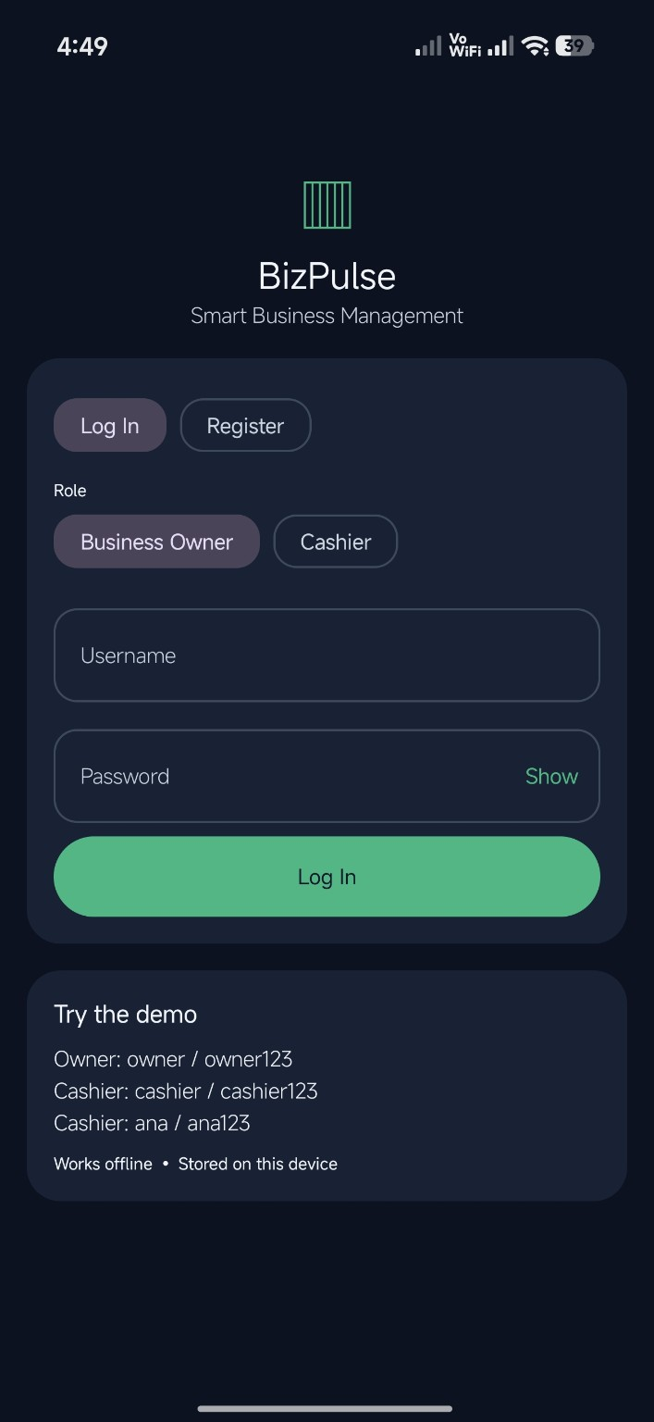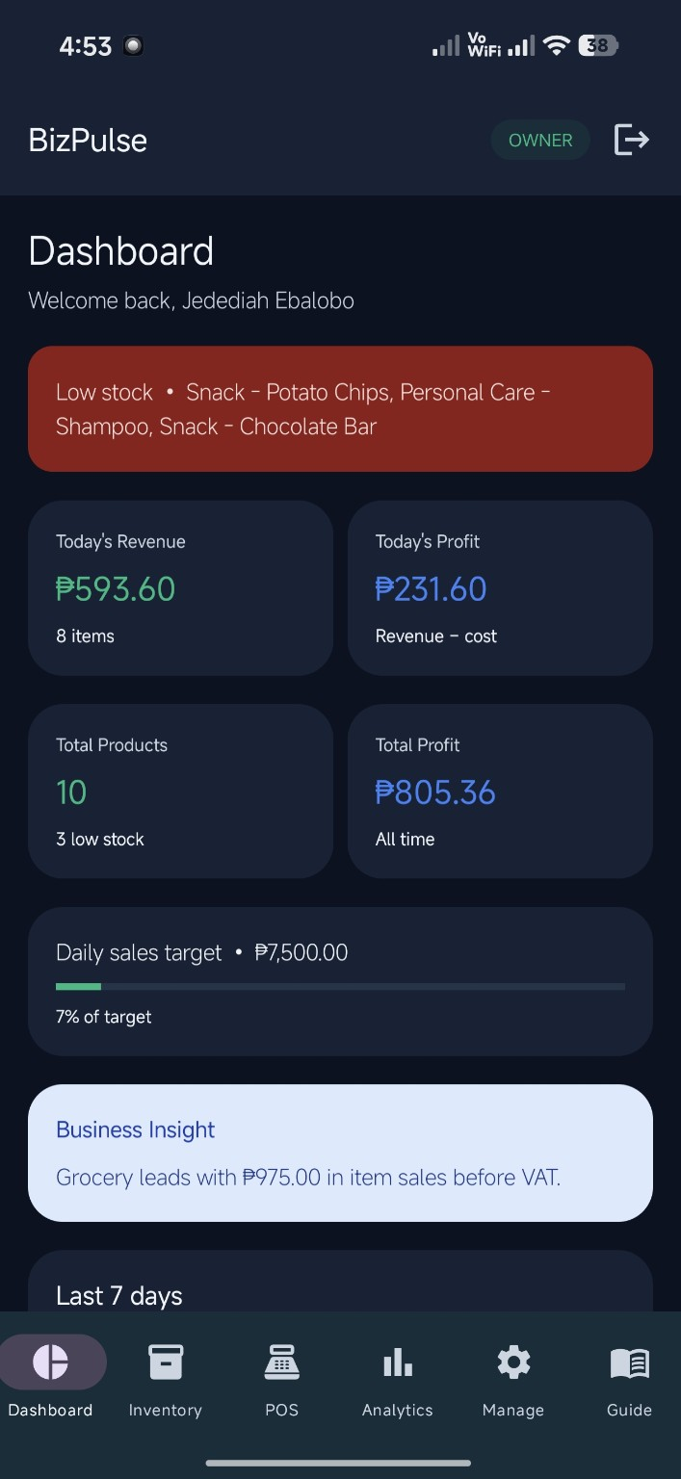
Left: Login screen. Right: Owner dashboard.

Appendix D Actual App Screenshots Continued
POCO X8 Pro • Android 16 • October 19, 2026 • Dark mode
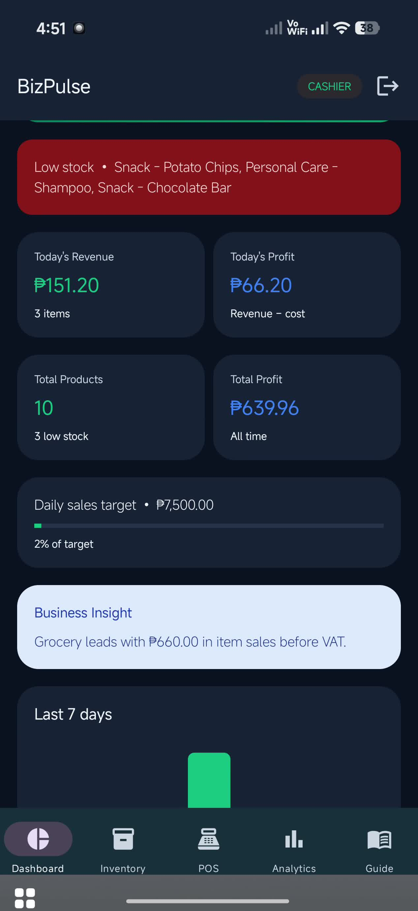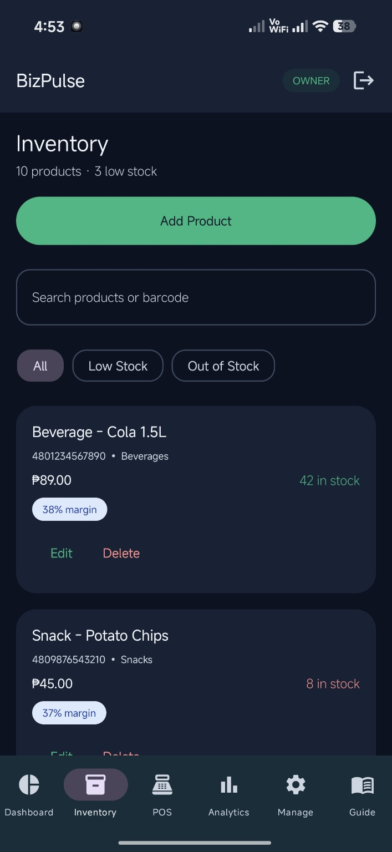
Left: Cashier dashboard from video. Right: Inventory.

Appendix D Actual App Screenshots Continued
POCO X8 Pro • Android 16 • October 19, 2026 • Dark mode
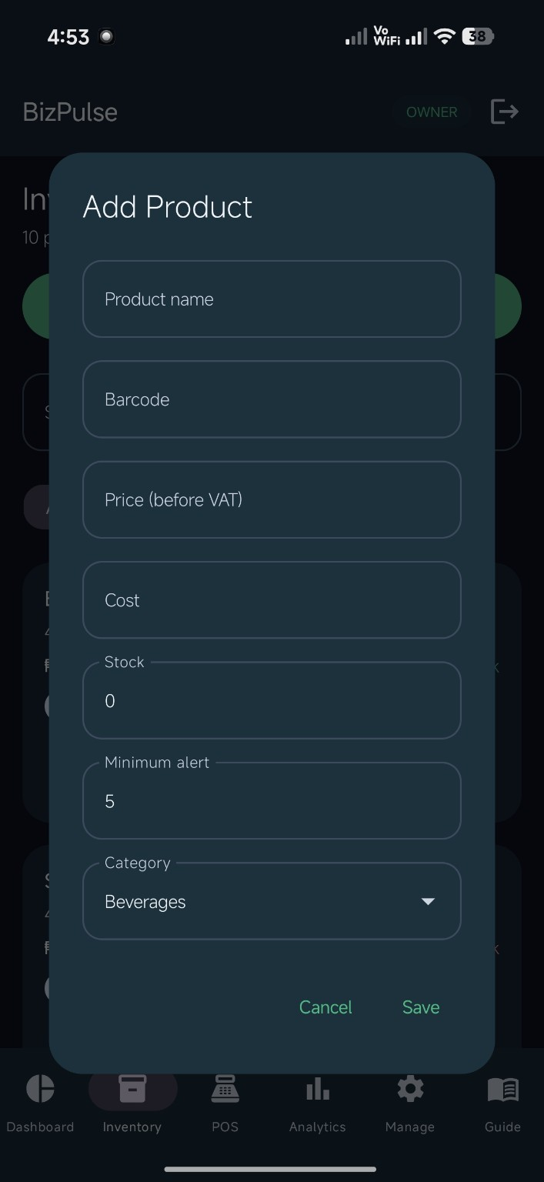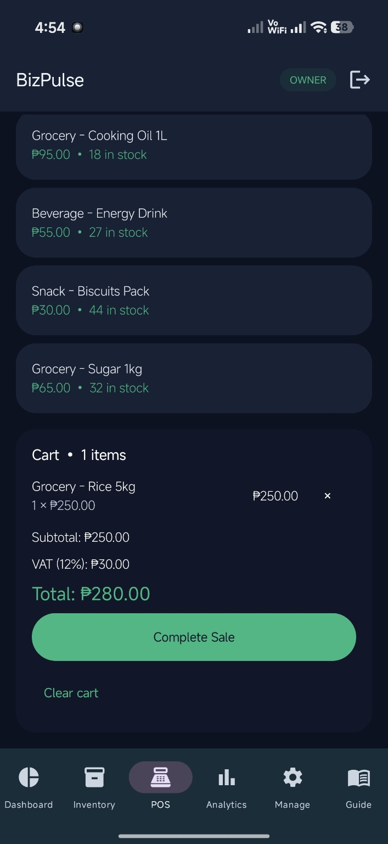
Left: Add product form. Right: POS cart and calculated totals.

Appendix D Actual App Screenshots Continued
POCO X8 Pro • Android 16 • October 19, 2026 • Dark mode
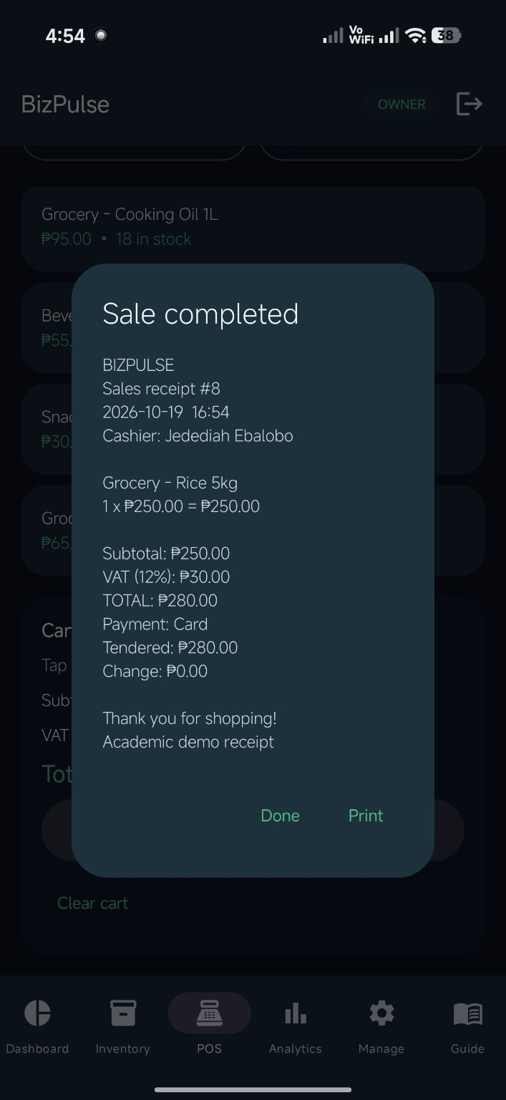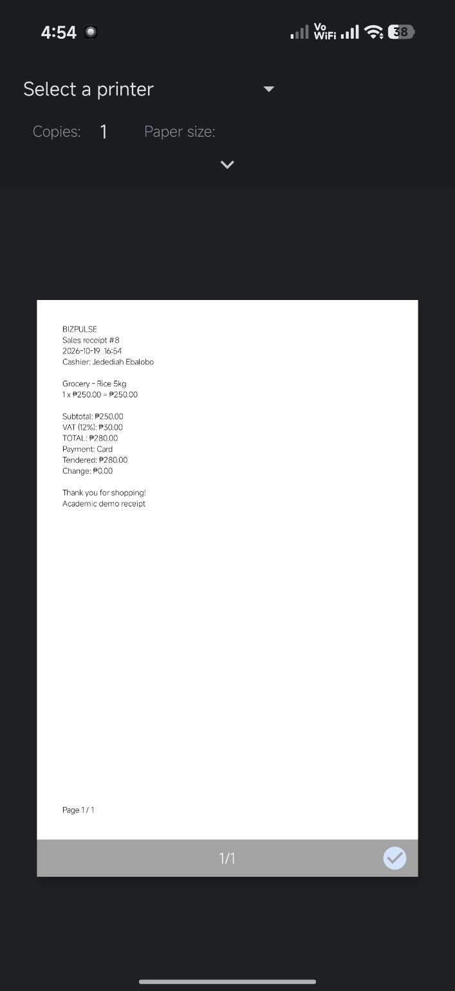
Left: Receipt after sale. Right: Android print preview.

Appendix D Actual App Screenshots Continued
POCO X8 Pro • Android 16 • October 19, 2026 • Dark mode
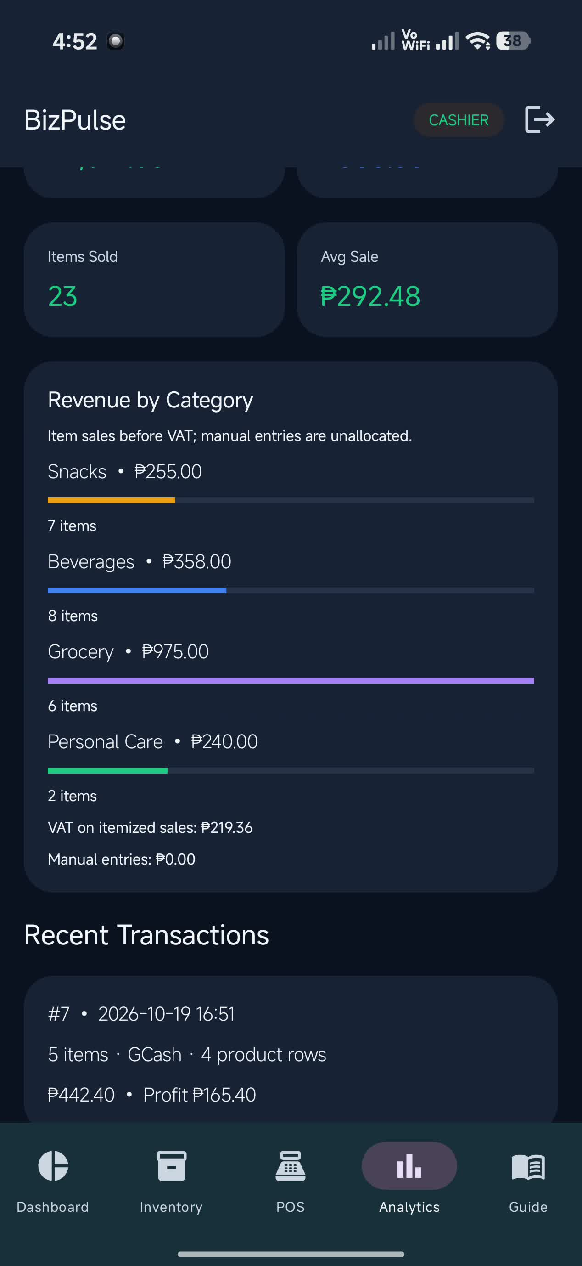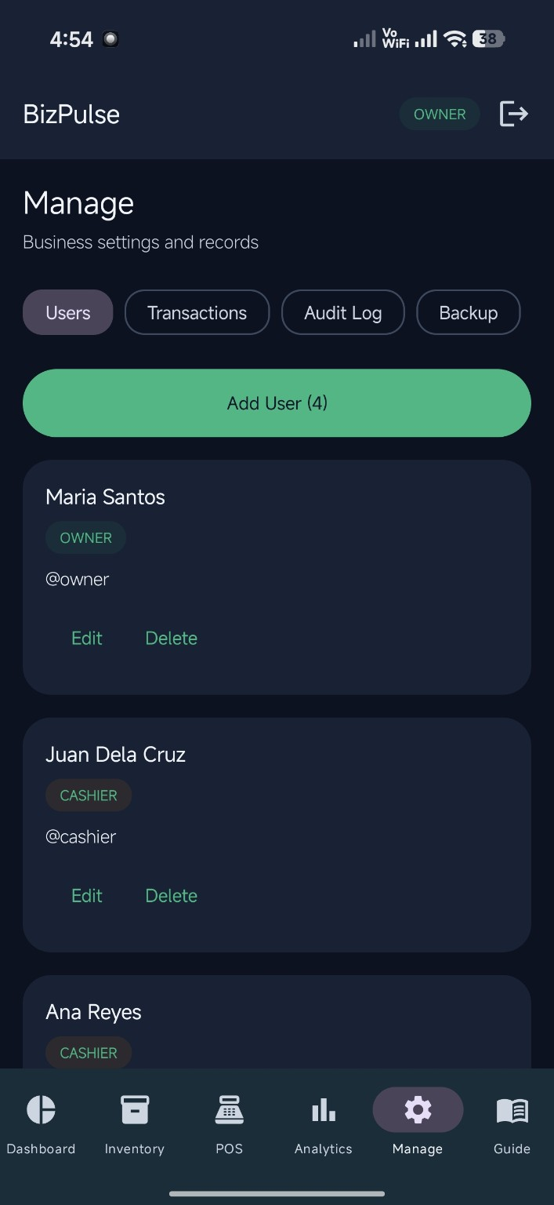
Left: Analytics from video. Right: Owner management.

