4. Managing application pools
Let’s face it, as an administrator your biggest concern with IIS is this: will it keep running your sites and applications reliably? Have you ever had a misbehaving application, one the leaks memory and starts to slow down your computer? Without dealing with the situation, your computer will eventually crash and need to be rebooted. Websites and applications are no different. Some of them are well-behaved little children running on your web server. Others are nightmares eating up memory and hogging processing. Without the ability to separate the good from the bad, you’d find yourself going to the office in the middle of the night to restart your web servers.
Application pools provide isolation to each website on a server, preventing one site from harming (crashing) another. Using them increases the web server’s reliability and the availability of each website. Think of the virtual machines you’re using for the labs for this book; each one has its own memory and processing allocation. If one VM crashes, it has no effect on the others, nor does it crash the host operating system.
You can use application pools to isolate websites and applications in several scenarios, such as the following:
- Isolating well-behaved applications from unstable ones
- Increasing security by preventing one application from accessing the resource of another
- Increasing security by assigning unique identities to pools
- Grouping websites and applications that have the same pool configuration settings
In this chapter I show you how to work through such scenarios, using the bicycle shop website your started building in chapter 3. You’ll focus on creating and configuring new application pools, setting the best security for the pools, and managing the recycling and cleaning of the pools.
So open your lunch sack and let’s get started with creating and configuring application pools.

4.1 Creating and configuring standard application pool settings
Application pools have basic configuration settings that will work for most websites and applications right out of the box. Some applications – for example, misbehaving ones that crash often – need to have their settings tweaked to increase their reliability. I show you what to look for after examining the default settings. This section focuses on the basic application pools settings, understanding which ones to use and alter for the websites, and applications that comprise the environment of the bike shop.

4.1.1 Locating application pools and settings
When IIS was installed, it created the default website we explored and began adding the bike shop to in the last lunch. Fortunately it also created a default application pool we can explore. In this section I show you where to find the application pools used for your websites and web applications, both in the graphical manager and using PowerShell.
FINDING APPLICATION POOLS IN THE GUI TO MANAGE SETTING AND CONFIGURATION
In figure 4.1 you can see Application Pools under the navigation pane. When you select this, the center pane lists all the currently defined application pools and the basic settings for them. You’ll create new application pools for new websites and new web applications for the bike shop here. You’ll view both basic and advanced settings in the action pane.
FINDING APPLICTION POOLS USING POWERSHELL TO MANAGE SETTINGS AND CONFIGURATION
In PowerShell using the WebAdministration module, you can gather the same information. Much of the IIS information is stored under a PowerShell drive called IIS:. You can access that drive and its information by navigating the directory system or directly using the Get-Item cmdlet.
To navigate the IIS: PowerShell drive, do this:
PS> Set-Location IIS:\appPools
PS> Get-ChildItem
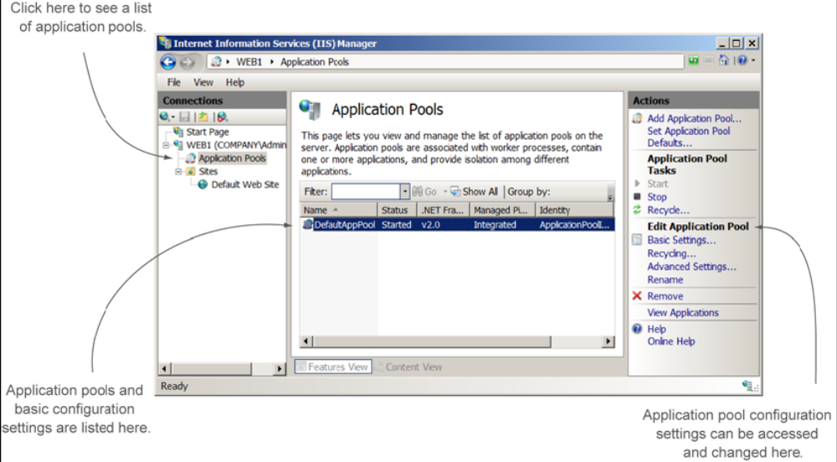
Figure 4.1 Locating application pools and the configuration settings
TRY IT NOW Put down your sandwich for a minute and open the IIS manager. Navigate to the default application pool and examine the basic settings by viewing them in the center pane or selecting Basic Settings in the actions pane. While you’re at it, open up a PowerShell console, import the WebAdministration module, and locate the default application pool using filesystem.
Now that you’ve located the default application pool and its basic settings, let’s decipher what those settings do. You’ll understand those settings better if we start by creating a fresh, new application pool.

4.1.2 Creating a new application pool
Placing websites, and sometimes applications, in their own application pools is the most reliable and most secure option. Application pools are isolated from each other to prevent one application from bringing down another. As an added security benefit, application pools also prevent one application from sneaking into another pool and stealing information. The best practice is to place new websites into their own application pools.
CREATING AN APPLICATION POOL WITH THE GUI
You don’t have multiple websites ye for WebBikez (you’ll do that in chapter 5), so rather than use the default application pool, let’s experiment with one of our own using both the GUI and PowerShell. You create a new application pool in IIS manager by selecting Add Application Pool from the actions pane. A menu pops up prompting for a new name for the application pool, plus some addition settings, as shown in figure 4.2.
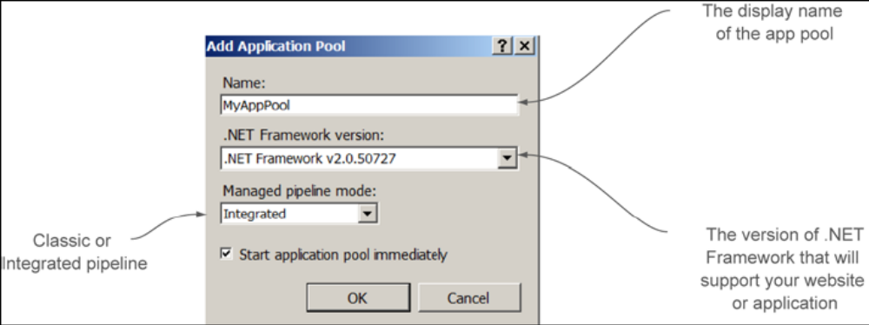
Figure 4.2 Basic application pool settings
Let’s look at each of these details, starting with the name.
NAME
The application pool name can be any unique alphanumeric name of your choice. The best practice is to name your application pool the same as the website or application that will run inside the pool, adding the suffix pool. That makes it easy to keep track of which pool goes with which website or application.
As an example, in chapter 5 you’ll be creating several new websites and applications. One of the websites might be named WebBikezBags. A great name for the application pool would be WebBkezBagsPool. I prefer not to add spaces, dashes, or underscores to an application pool name. Although it may be easier to read visually, it’s harder to deal with when using PowerShell or other command-line utilities.
In figure 4.2 I named the pool MyAppPool because I’m not using it for an application yet. You can always rename an application pool later.
.NET FRAMWORK VERSION
Many of the applications and websites that you’ll host on IIS require a special library called the .NET Framework. Developers use this library to provide functionality for their applications. The application pool will load the library so that the applications will work properly.
Above and beyond
An application pool can only support one version of the .NET Framework. All applications that run inside the pool must support the same version. If you need to have two applications that need two different framework versions, create a new web application and application pool for each.
You’ll need to select the correct version of the .NET Framework for your application. How do you know what is the correct version? You need to check the application installation documentation to know for sure. For this bike shop, the developers are developing the sites using .NET 4.0. Not all applications require the .NET Framework – in fact you may have several that don’t. You’ll explore those types of applications in later chapters.
Here are the options you’ll see when you click the .NET Framework dropdown:
- No Managed Code – Select this if your application or website doesn’t require .NET Framework support.
- V.20 – Use this version of the framework to support applications written with .NET Framework versions 2.0, 3.0, or 3.5.
- V4.0 – use this version of the framework to support applications written with .NET Framework versions 4.0. Note also that you may not initially see this option; if that happens, it’s because the .NET Framework 4.0 has not yet been installed on your web server (this is common with IIS 7). After you download and install the latest framework version from Microsoft (our short URL is http://mng.bz/HnLw), the selection will appear.
MANAGED PIPLINE MODE
Starting with IIS 7 and IIS 8, a new method of handling requests, known as the Managed Pipeline, was developed to make ASP.NET applications faster than in IIS 6. The Integrated mode is the best selection almost every time. The only time you should change it to Classic mode is if you have an old IIS 6 application that won’t use the new mode.
CREATING AN APPLICTION POOL USING POWERSHELL
To create a new pool for the bike shop, use the New-WebAppPool cmdlet to create an application pool with PowerShell and the WebAdministration module:
PS> New-WebAppPool –Name BikeTestPool
The view the properties using Get-Item:
PS> Get-Item –Path IIS:\appPools\BikeTestPool | Format-List –Property *
The New-WebAppPool cmdlet doesn’t provide parameters to adjust the .NET Framework version or pipeline mode. You can use the Set-ItemProperty cmdlet to change the properties after the application pool is created. The names, shown in figure 4.3, are a little different than in the IIS manager.
Viewing is easy, but changing the properties of the .NET Framework version or the Managed Pipeline is a little strange using PowerShell. There’s no cmdlet (such as Set-WebAppPool) to change the properties. Instead – and this is common with IIS – you access the properties through the WebAdministration provider IIS: drive and use Set-ItemProperty. For the bike shop the application pools need to use .NET Framework version 4.0. To change the value, do this:
PS> Set-ItemProperty –Path IIS:\appPools\TestBikePool –Name
ManagedRuntimeVersion –Value v4.0
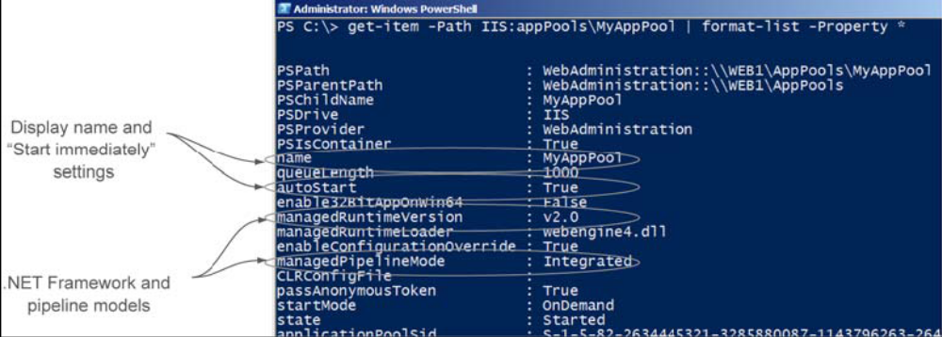
Figure 4.3 viewing the application pool settings in PowerShell
TRY IT NOW if you’ve been following along, you may be so excited that you’ve already created a new pool using PowerShell. If not, create your own application pool named WebBikezBagPool using the GUI or PowerShell. It should support the .NET Framework v4.0. Remember, if you don’t see the selection for v4.0 you’ll need to download it from Microsoft.
You can remove an application pool using the IIS manager or the Remove-WebAppPool cmdlet.
Now that we have a new application pool, let’s move the default website into the new custom pool so we can work on some advanced pool settings.

4.1.3 Moving a website or application into an application pool
There will be times when you want to create a custom application pool (as we just did) and then test a website or application in that pool. Many commercial web applications get updated to the latest .NET Framework version. Even in-house built apps get updates, like our bike shop. You’ll want to create a new pool with a new configuration and test those updated applications. Being able to move the website into the pool and then back to its original pool if something goes wrong is an important part of the testing process.
MOVING A WEBSITE USING THE GUI
The website or application Basic Setting link in the actions pane handles the application pool selection. To move a website to a different pool, select it from the dropdown list, as shown in figure 4.4.
MOVING A WEBSITE USING POWERSHELL
Here’s what you do to move the bike shop default website to a new application pool using PowerShell and the WebAdministration module:
PS> Get-ItemProerpty –Path “IIS:\Sites\Default Web Site” –Name ApplicationPool –Value BikeTestPool

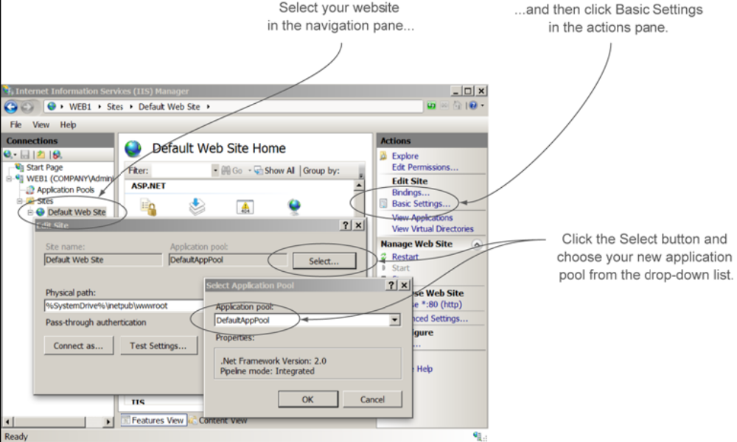
Figure 4.4 moving a website to a different application pool
TRY IT NOW move the default website from its original pool to the new pool you created earlier using either the IIS manager or PowerShell.
With a website in our newly created application pool, let’s take a look at how an application pool keeps your websites clean and working smoothly.

4.2 Application pool recycling: increasing reliability and availability
Even the best websites and applications can have small problems that cause them to become memory bloated or performance lethargic or even crash. One of the benefits of application pools is that they isolate applications so that they can only hurt themselves and no other applications. In our bike shop example, if the WebBikezBags site should fail, it won’t crash the WebBikez site because it’s running in a separate pool.
Application pools also have the benefit of being able to reset themselves, cleaning up the fragmented memory and stalled processes of a misbehaving application and then restarting the application in a clean environment. This process is known as recycling. But many times you’ll need to recycle a website or application immediately (on-demand) or change the configuration settings to something that suits the application better.
Recycling can occur for three primary reasons:
- On-demand – You determine there’s a problem and decide to manually recycle.
- Configuration changes – Changes to the IIS configuration can cause recycle events.
- Unhealthy website or application – IIS monitors applications, and if one begins leaking memory or causes a problem, it can be automatically recycled.
This section focuses on recycling an application pool and changing the recycle settings. Let’s start by examining what’s happening when an application pool recycles. Then you’ll get a chance to try it for yourself.

4.2.1 Recycling an application pool
Every application pool you create has its own worker process. Think of a worker process as similar to a waiter in a restaurant. The waiter takes your order, goes back to the kitchen to place the order, and then brings the food to you. Similarly, the worker process in an application pool handles your request for a website (“Get me the web application”), passes the request information to the application for processing, and then gathers the response from the application and returns it to you in the form of a web page.
Above and beyond
You can see a worker process in action using the process view in Task Manager. Look for a process named w3wp.exe. This is the worker process for your application pool. Each application pool gets its own worker process.
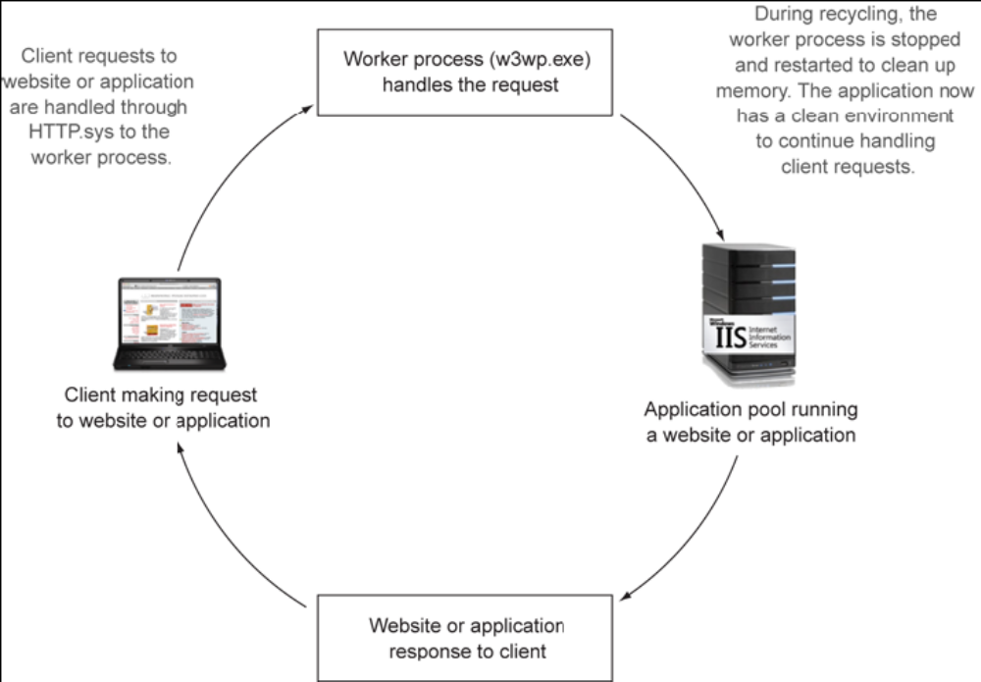
Figure 4.5 the recycling process
When a recycling event occurs, the worker process is restarted, memory gets cleaned up, and then web application is refreshed. This process helps keep problematic applications – those that corrupt memory and hang processes – running smoothly (see figure 4.5). The web administrator can force a recycle event, or the recycle can occur on a timed basis.
Recycling (also known as process recycling) can cause the website or application to appear to be offline until a new process is started. To compensate for this, during a recycle, before the old w3wp.exe process is stopped, a new one is create to handle incoming requests. This overlap of processing helps to ensure that the website appears normal during the recycle.
Overlapping recycles seem to be the perfect solution to cleaning up a bad web application, but sometimes they aren’t. Some of your applications hold information about the user (such as shopping cart content), and a recycle will lose the session state containing this information (the shopping cart suddenly clears its items). Well-developed application tend to store session-related information so that this isn’t an issue, but some application aren’t written to handle the recycle. Each application you host will need to be tested to see how it handles a recycle. I’ll show you the default recycle setting that I prefer for most applications.
RECYCLING AN APPLICATION POOL ON DEMAND USING THE GUI
Suppose you’re sitting at your desk when the phone rings. It’s one of the bike shop managers complaining that the website isn’t letting customers buy products. After checking the worker process, you determine the website has hung. Rather than reboot the serves, you decide to try to recycle the website application pool. This is recycling on-demand.
You can recycle an application pool and its worker process by selecting the application pool from IIS manager and clicking Recycle in the actions pane. Figure 4.6 shows a view of the w3wp.exe process in Task Manager. For a brief moment, there will be two w3wp.exe processes listed for the application pool. This is the overlap occurring in real time to handle requests while the old process is stopped.
If you fail to see any worker process (w3wp.exe) it’s because the website has cooled down – not been accessed – for some time. Worker processes, like waiter, only need to process orders when there are customers. If a website or application has no activity (requests) for 20 minutes, the worker process stops. A new worker process starts as soon as a new request comes to the website or application.
RECYCLING THE APPLICTION POOL ON DEMAND USING POWERSHELL
In PowerShell you can view w3wp.exe processes for the bike shop and restart the application pool with certain commands.
Here’s how to view a list of w3wp.exe processes running on your web server:
PS> Get-WmiObject –Class Win32_Process –Filter “name=`w3wp.exe’”
You may be familiar with using Get-Process to retrieve process information. The preceding code snippet could be achieved with Get-Process –Name w3wp. The reason I’m not using that and instead using WMI class is because I want to more information about the process than Get-Process provides. The next example is one of many cases where the WMI class is more useful although a little more complicated.
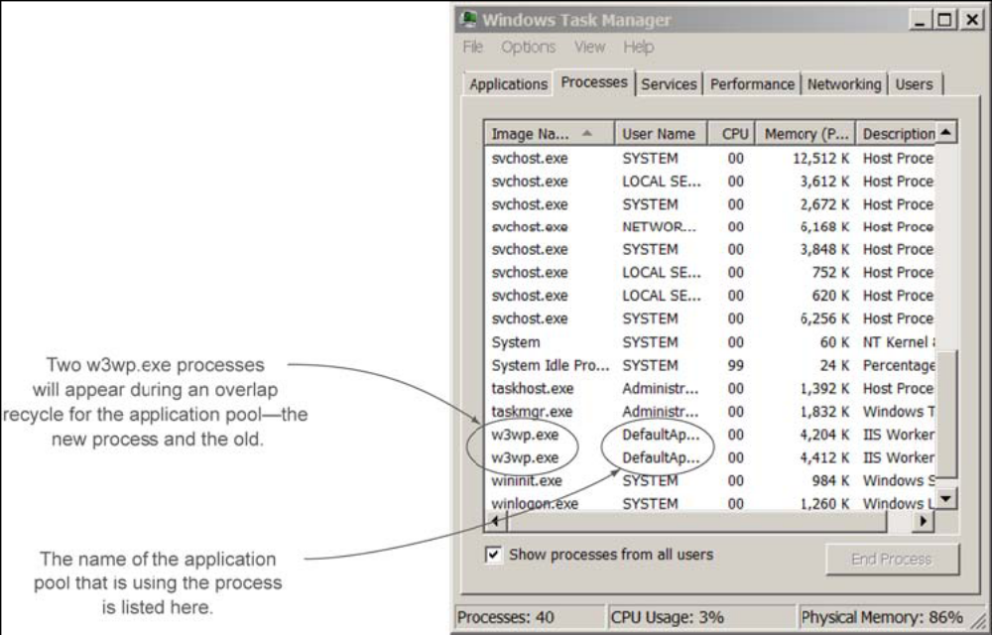
Figure 4.6 the overlap recycling of a worker process
Here’s how to view a list of w3wp.exe processes and the application pools they’re assigned to:
PS> Get-WmiObject win32_process –filter “name=’w3wp.exe’” | Select-Object Name, ProcessId, @{n=’AppPool’;e={$_.GetOwner().user}}
To restart an application pool, do this:
PS> Restart-WebAppPool –Name BikeTestPool
TRY IT NOW let’s recycle the application pool running the default website. Start a w3wp.exe process by launching your browser and opening the default page (this could be your custom page from chapter 3). Open Task Manager or use PowerShell to view the w3wp.exe process. Try to notice the second w3wp.exe process start when you recycle the pool.

4.2.2 modifying the default recycle settings
Remember the bike shop website that hung in the last section? Let’s say it happens when you’re not around – perhaps you’re on vacation. Or suppose you know from your past experience with the application that it will hang after every five days if not recycled. Wouldn’t it be nice to configure an automatic recycle to occur in four days – before the crash? Default settings control the automatic recycling of application pools to keep your applications running smoothly. In situations where an application becomes slow or stops responding to requests, see if a recycle solves the problem. If it does you can modify the automatic recycle settings to handle the cleanup process for you. I’ll show you how to do that now.
CHANGING THE RECYCLE SETTINGS IN THE GUI
You can access the recycle settings using the IIS manager after selecting an application pool. In the actions pane click Recycling. Two screens will appear one after the other. The first contains options for configuring the automatic recycling of the application pool, as shown in figure 4.7.
These default settings are generally best left alone unless you understand how a specific application can benefit from making changes. Let me give you an example: I don’t want the bike shop’s application pool to recycle during the normal business day because it might cause an issue with customers connecting. I set a specific recycle time of 9:00 p.m. rather than the default of every 1,740 minutes (29 hours).
Another example is if the finished, developed web application turn out to be well behaved and don’t need to recycle often, I set the interval to a few weeks rather than every day.
Doesn’t sound like I’m being helpful, but each misbehaving application may need a different setting to keep it running smoothly. Keep in mind that most applications will be fine with the default, but you’ll have a few that you’ll need to customize.
The second window that appears after clicking the Next button in the Edit Application Pool Recycling Settings dialog box is the logging options, shown in figure 4.8. What do you want to log about your recycles?
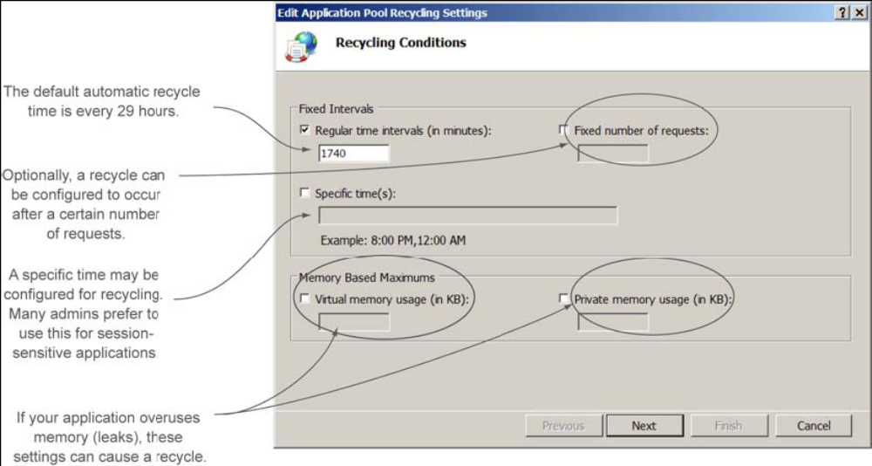
Figure 4.7 Setting the conditions when an application pool recycles.

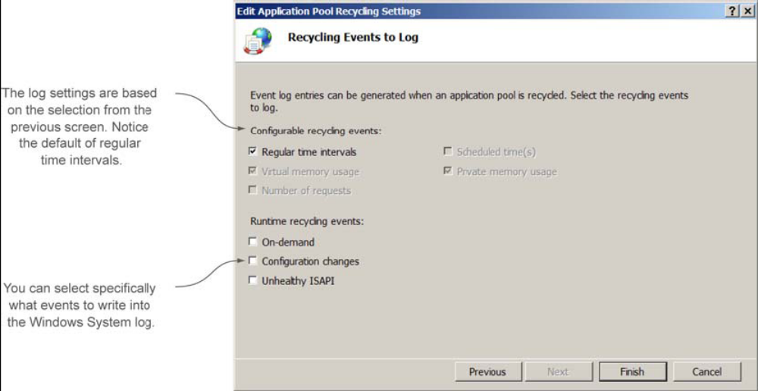
Figure 4.8 Setting the logging options for application pool recycling
I don’t normally log on-demand recycles because I’m the guy that does them. But if you’re in a shop with several other web administrator, you should log this to keep track of how often others are recycling a pool. If it’s happening frequently that’s an indication that you should optimize your recycle settings and see if there’s a fix for your application.
Configuration changes that you make to the website or its applications using the GUI manager or PowerShell will also cause recycling. I like to log these so I know whether changes are being made. Keep this in mind and its worth repeating: if you make configuration changes to a website or application, it will recycle the application pool. For some applications recycling may make them appear to go offline for a brief moment, and that will affect your customers.
Many developers write their applications using Internet Server Application Programming Interface (ISAPI) so that IIS can monitor the health of the application. The application can look at itself, determine it isn’t working well, and request a recycle event. I like to monitor for the event, so I enable the unhealthy ISAPI logging.
Jason’s recycle defaults for most applications
I have a set of preferred recycle settings that I use for applications pools. I generally start with these settings and then adjust them if necessary:
- Turn off or Regular Time intervals to 0.
- Turn off or set Fixed Number of Requests to 0.
- Set the recycle a specific time parameter to late at night or during the time of least use (such as 3:00 a.m.).
- Enable all logging events (okay, not the on-demand if I’m then only web guy).
For a single application pool, setting the recycle settings using the IIS manager is quick and easy, but later – when you have several pools – PowerShell is the way to go. Take a look at the PowerShell commands for recycling before you try the lab at the end of this chapter.
SETTING RECYCLING USING POWERSHELL: YOU’RE GOING TO WANT TO USE THIS METHOD!
Most admins stick to the GUI when setting recycle options. The reason they avoid PowerShell is because they don’t see any easy-to-use cmdlets like Set-Recycle. However, there’s a way to configure the recycle settings with PowerShell. Let me tell you a secret: when you have 30 application pools on 15 web servers that all need new recycle settings, the last thing you want to use is the GUI. You’re going to want to automate those change with a script. Later in this book I show you how to make the script for the ever-growing bike shop. For now you should know how to make a single change using PowerShell.
This is may be different from what you would expect, but most of web server’s configuration can be done through the IIS: PowerShell drive mentioned in chapter 3. Here are two examples to view and change the recycle properties.
To view and change the default interval time, do this:
PS> Get-ItemProperty –Path IIS:\AppPools\DefaultAppPool –Name
recycling.periodicRestart.time
PS> Set-ItemProperty –Path IIS:\AppPools\DefaultAppPool –Name
recycling.periodicRestart.time –Value 3.00:00:00
And here’s how to view and change a scheduled time:
PS> Get-ItemProperty –Path IIS:\AppPools\DefaultAppPool –Name
recycling.PeriodicRestart.schedule.collection
PS> Clear-ItemProperty –Path IIS:\AppPools\DefaultAppPool –Name
recycling.PeroidicRestart.schedule.collection
PS> Set-ItemProperty –Path IIS:\AppPools\DefaultAppPool –Name
recycling.PeroidicRestart.schedule.collection
–Value @{value=’06:00:00’}
TRY IT NOW Take one of your existing application pools (or create a new one) and change the recycle and logging settings. Set the recycle interval to 24 hours instead of 29 and turn on the logging for on-demand events and unhealthy ISAPI
VIEWING THE RECYCLING LOGS
You can use the Event Viewer to look for recycle events in the System log, but PowerShell is faster:
Here’s how to check for recycle events using PowerShell:
PS> Get-Eventlog –LogName System –Source WAS
Perfect! Now you can monitor for recycling events. If an application begins recycling more frequently than normal, you’ll know something is wrong with the application. Try to configure recycle intervals to minimize outages to your customers but still clean the pools so the applications run smoothly.
There are more recycling options that you can set using the Advanced Setting in the IIS manager, and you’ll get to those in later chapters as we run into them. For now let’s try a lab before we break from our lunch.

4.3 Lab
I want to your to prepare several application pools for the beta applications that come from the development team working on the bike shop. Normally the applications would run in the same application pool as the website, but initially, for testing, separating them is good practice.
In this lab you’ll create new application pools for the applications, move the applications into those pools, and configure the recycle settings. After testing and recycling the pools, I want you to check the logs for the recycle messages.
TRY IT NOW
If you didn’t get a chance to perform the Try It Now sections, I’ve repeated them here for your convenience. Once complete, you can start the lab with task 1.
- Navigate to the default application pool and examine the basic settings by viewing them in the center pane or selecting Basic Settings from the actions pane. While you’re at it, open up a PowerShell console, import the WebAdministration module, and locate the default application pool using the filesystem.
- Create your own application pool named WebBikezBagPool using the GUI or PowerShell. It should support the .NET v4.0 Framework. Remember, if you don’t see the selection for v4.0, you’ll need to download it from Microsoft and install it.
- Move the default website from its original pool to the new pool WebBikezBagPool. Again, you can use either the IIS manager or PowerShell.
- Time to test the recycling of the new pool. Start a w3wp.exe process by launching a browser and opening the default page. Open Task Manager or use PowerShell to view the w3wp.exe process. Recycle the pool and try to notice the second w3wp.exe process start when the pool is recycled.
- Change the recycle settings and log of the WebBikezBagPool. Set the recycle interval to 24 hours instead of 29 and turn on the logging for on-demand events and unhealthy ISAPI.
TASK 1
Create two new application pools for the web applications you created in the last lunch. Name the first pool WebBikezShoppingPool and the second WebBikezCartPool. Each pool should support the .NET 4.0 Framework and an integrated Managed Pipeline.
TASK 2
Set the recycle settings for the default app pool to an automatic recycle every 48 hours. Because the applications are in beta and may quickly memory leak the environment during testing, set the automatic recycle settings for the WebBikezCartPool and WebBikezShoppingPool to 4 hours.
TASK 3
Turn on the logging for all the application pools. Make sure to log on-demand as well as configuration changes and unhealthy ISAPI.
TASK 4
While the applications are in beta, it’s best to protect the environment by moving them into their own application pools. Move the Shopping application into the WebBikezShoppingPool and the Cart application into the WebBikezCartPool
TASK 5
Time to test the application pools and the recycle logging. Verify using Task Manager or PowerShell that there are worker processes for each application pool. (Remember, they’ll stop after 20 minutes of inactivity.) If you need to start a worker process, open your browser and access the site.
Perform an on-demand recycle of each application pool. After the recycle events have occurred, use PowerShell (or Event Viewer) to view the recycle events in the logs.

4.4 Ideas to try on your own
If you have an existing web server environment in production, carefully examine the website application pools and recycle settings. Examine the logs to see if recycling has been occurring on the configured schedule, or if an application has been recycling more often. That could indicate an issue.

