5. Adding more websites to your server
From time to time every IIS admin will need to create additional websites for new applications that the business needs to run, including applications for new product launches and internal help desk ticking applications. You’ll create and configure websites to support many internal products like Microsoft System Center and SharePoint.
You may be wondering, “Why do I need additional websites? Can’t I create more web applications in the default site? What’s the big deal?” Back in chapter 3 you learned that it’s best to put new applications in their own application pools for isolation purpose: if something bad happens to one application, other applications won’t be affected. You get those new application pools by creating new websites.
But there’s another, even more important, reason for creating new websites: it’s all about the name, the URL. Often you want to a unique URL – hopefully a simple one, easy for people to remember – that clients will use to access a specific web application. Here’s an example: let’s say you have a website dedicated to customers wanting information about cool bicycles. The current URL for these customers is www.WebBikez.com. Now consider that the business has added a new repair line called WebBikezRepair, as show in figure 5.1. Instead of directing customers who need repairs to the original link, you can direct them to www.WebBikezRepair.com. This is one of several reasons for a new, unique site.
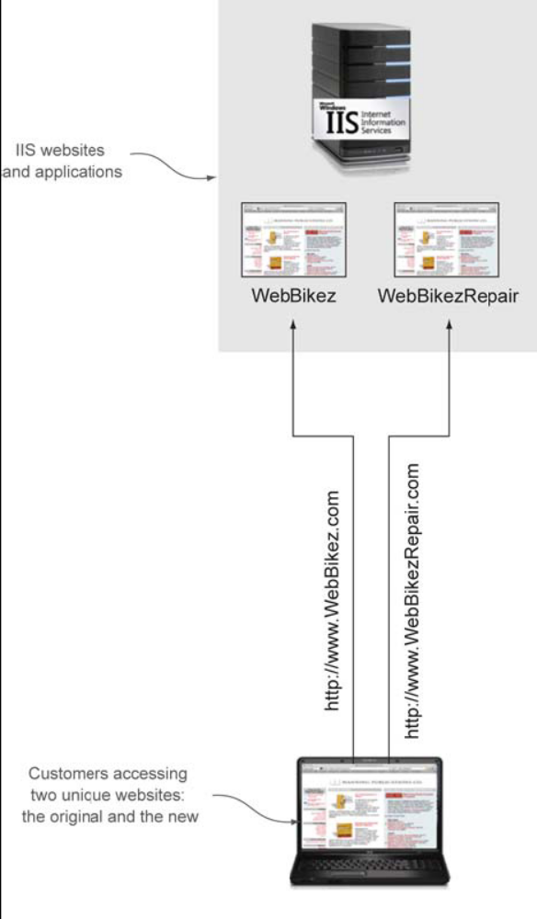
Figure 5.1 Hosting multiple websites, each with a unique name
Another reason? You may want to have different customers with websites on the same server, such as www.BikeCompetitor.com. You want the unique name and the website isolation.
Creating new sites is an important part of being the web administrator and supporting the needs of the business. Also important is the way additional websites and traffic can change the performance of your IIS server. By the time you’re done with this chapter, not only will you be able to create new websites, you’ll be able to test their performance. You’ll start off using the IIS manager to create new websites and bindings. After you’ve had a chance to work with the concept, I show you how to do it with PowerShell.
At first you may think that adding a new website is straightforward. And it is, for the most part – but only once you understand all the components. Many administrators attempt to create a website without understanding all the parts, and that usually ends in failure. Take a look at figure 5.2 to see why – several of the steps are rather complex. One final note before we begin: I need you to bear with me through this lunch and much on your sandwich for the first two sections. Don’t jump into your VM yet – until you finish learning the setup, you’ll wind up with errors. I’ll show you everything you need to know to make additional websites. Then you can try it for yourself.

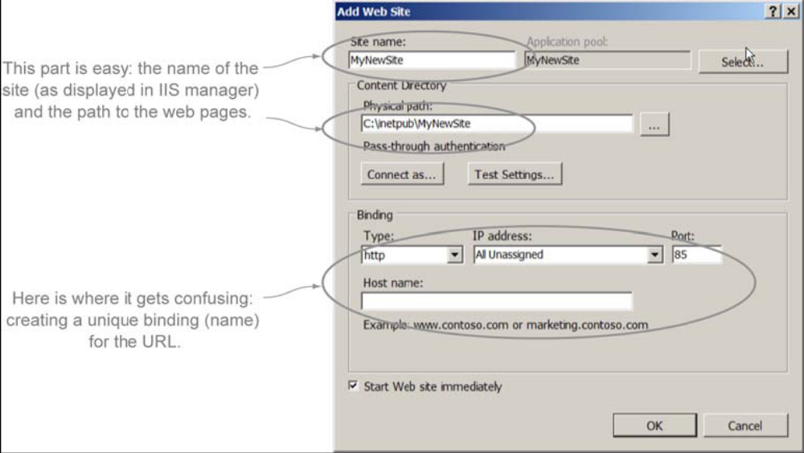
Figure 5.2 Creating a new website isn’t as simple as it first seems. You’ll need several pieces of information, and there are hidden traps to avoid.

5.1 Phase 1: Adding a new website using the IIS manager
You can create a new website using the IIS manager or PowerShell. PowerShell requires that you have complete understanding of the process, so I focus on the IIS manager in the next two sections so that you have all information you need to create new websites. Then you’ll be able to appreciate the ease with which you can accomplish the process with PowerShell.
When you’re adding a new site, you start with the main GUI view, as shown in figure 5.3. In the navigation pane under your web server, you’ll see the Sites container used to organize all your websites. This is where you’ll create additional websites and see them displayed.
To get started on the first phase, either right-click Sites in the navigation pane or click Add Web Site in the actions pane. A website form will launch that’s designed to make creating a new website fast and simple if you know what to do. As mentioned earlier, the form is also confusing until you understand all the little settings.
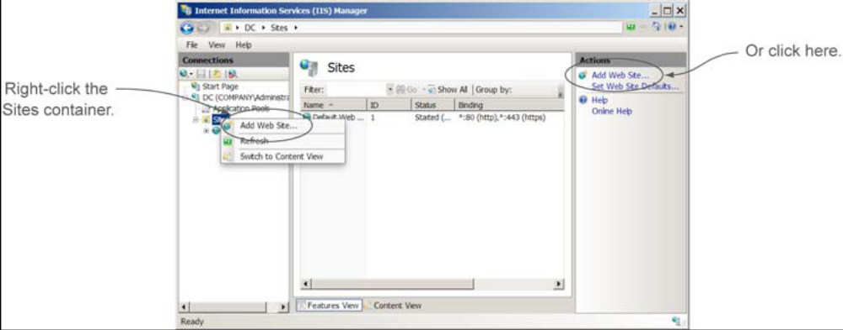
Figure 5.3 Creating a new website using the IIS manager
With this form open, you’re ready to begin phase 1, which happens in three steps:
- Enter a new site name
- Create a new application pool for the site
- Specify the physical location of the web pages.
Figure 5.4 illustrates the portion of the form we’re working on now. So get that lunch sack open and let’s make some websites.

5.1.1 Step1: Enter the site name
The first step in creating a website is to give it a friendly and descriptive name. Unlike the applications you created in chapter 3, this name won’t be used in the URL to identify and locate the site. It’s a name for your own organizational purposes. The unique URL customers will use to access the website will be designated by the binding and DNS discussed later in this chapter.
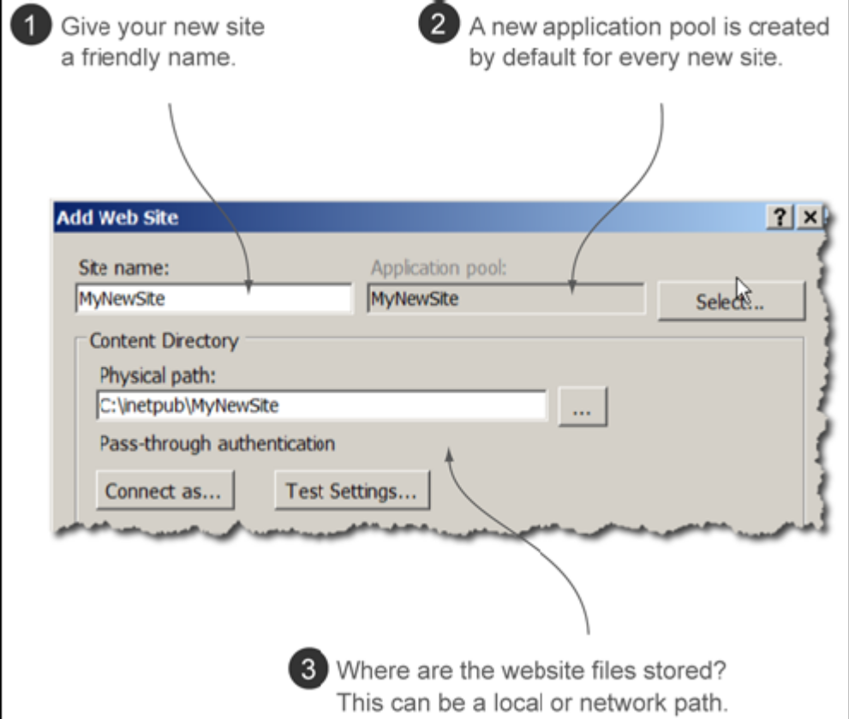
Figure 5.4 Phase 1: Adding a site name, application pool, and physical path for your new website
I know you want to try this out, but don’t open your VM yet. Let me explain what will happen when you enter the name. The GUI will take over and you may not like what it does.
When you enter the name into the form, you’ll notice that a name for a new application pool is also entered for you automatically. The GUI tool is trying to help you perform both the first step and the second step all at once. I personally don’t care much for this, as I explain in step 2 when you prepare to create the application pool.
The website name is fairly simple to handle, but I still need to discuss the application pool and physical path.
Above and Beyond
Remember that the site name is for organizational purposes. It has no bearing on the URL that customers will use to connect to the website. I prefer to use a site name that describes the contents of the website. If the website contains bicycle parts, then I might name the site BicycleParts. I prefer not to use spaces, dashes, or underscores because those make it harder to use command-line tools later.

5.1.2 Step 2: Create the application pool
When creating a new website, you may be a bit puzzled because the application pool field is greyed out by default. I get this question often: “Why is field greyed out and how do I fix it?” The field greyed out because it auto fills whatever name you typed for the website. When the form is complete, a new pool is created automatically for your website. This is a feature that helps you keep track of your websites and application pools by naming them all the same.
Remember back in chapter 4, when you create a new application pool for the bike shop and moved a website into it? You can do the same thing here. I prefer to create the application pool first and add the suffix pool to the pool name. Then later, when you’re working with the site, you can use the Select button to choose the application pool that has the name you want instead of the one with the automatically generated name. This is how you’ll add application pools in the lab for the bike shop’s website. For now, you can leave that default-created application pool and move on.
Next up, let’s talk about how you set the physical path of the website and where it can be located.

5.1.3 Step 3: Set the physical path
The physical path of the site is where your application files are stored. Remember back to chapter 3 when you created a new web page for the default site? Then path for the default site was C:\inetpub\wwwroot. When you make a new website, you can choose an existing path or create a new one to locate those web files.

Figure 5.5 Pass-through authentication settings for network shares
Many administrators, me included, prefer to create a new folder structure for the web pages of new websites. I like to make a folder under C:\sites with the same name as the website – it’s easier for me to keep track of the folder that way.
You may have noticed the sub-setting called Pass-through authentication, which is used to test communication to a path not located on the local server but on a remote server (see figure 5.5).
Having a website on a network share makes it easier to deploy it across multiple web servers in a load balance and faster to update with changes. We’ll explore this option later in the book, when you have multiple web servers.
Above and Beyond
A website’s physical path to the web pages doesn’t have to be located on the local server. In fact, later in this book I show you how to store and access your web pages from a network share. When you have multiple web servers running the same website to provide redundancy, it helps to have the web pages located in a single location for faster updates and changes to the web pages.
Up to this pointer everything seems fairly simple, but we aren’t done yet. Now it’s time to give your website a unique name the rest of the world can use for a URL. Time to dig into binding and uniquely identify your sites to the outside world.

5.2 Phase 2: Uniquely identifying your websites with bindings
What if everyone in the world had the first name of John? A conversation might go like this: “John told me that John and John were going to the convert, but John didn’t want to see John playing guitar, he wanted to see John.” This doesn’t make any sense. People have different names: John, Mary, Frank, Bob. But even that may not be good enough if too many people are named Frank. So we also have last names, and even middle names. This makes for a conversation that goes something like this: “Bob told me that Mary and Frank were going to the concert, but Bob didn’t want to see Frank Alves playing guitar, he wanted to see Frank Moore.”
In the same way websites must also have different – unique – names so that servers know where to send requests. If they each had the same name, you wouldn’t know which website you were going to get. To avoid that confusion you create a unique name, or binding, for each website so that the URLs are different.
A protocol binding is a set of communication rules that define a path between tow computers so they can communicate. A simple example is the internet. Everyone in the world has agreed to use the protocol TCP/IP version 4 (that’s the binding rule). Because that rule and use a different protocol, like Novel NetWare’s IPX/SPX, they wouldn’t be able to take to anyone else. As amazing as it sounds, binding is one of the most important concepts of a web server, any web server, and because it’s confusing it’s one of the most misunderstood and misconfigured website settings, causing web admins everywhere needless heartburn.
How do you set a unique binding? Like humans, who use a first name, middle name, and last name to differentiate ourselves in the world, a binding uses four parts that, combined, uniquely identify a site:
- Type
- IP address
- Port
- Host name
Figure 5.6 illustrates the format (syntax) of the four parts. Each website on a single web server must have something in the binding that makes the website unique.
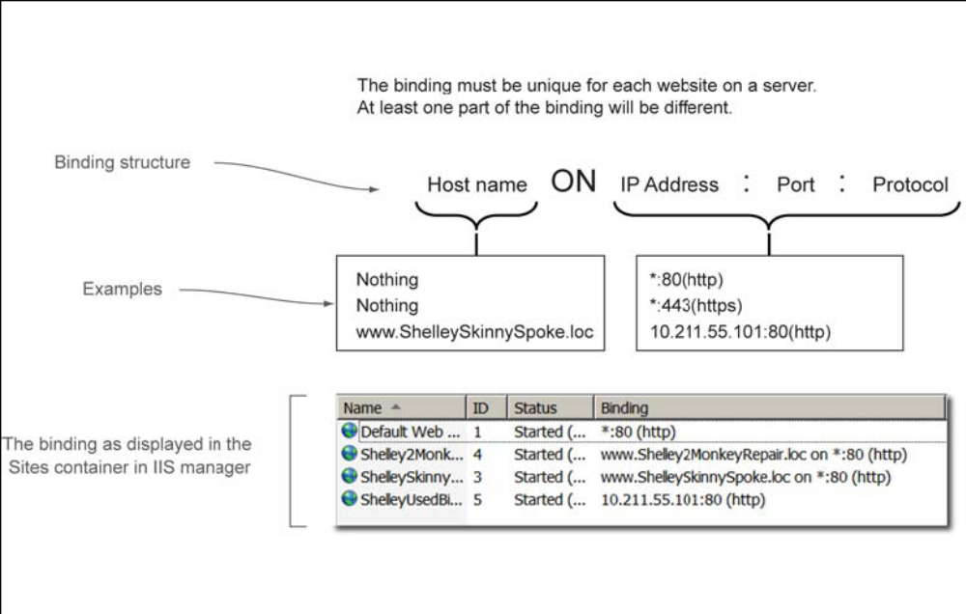
Figure 5.6 Giving a website a unique name using the four parts of a binding

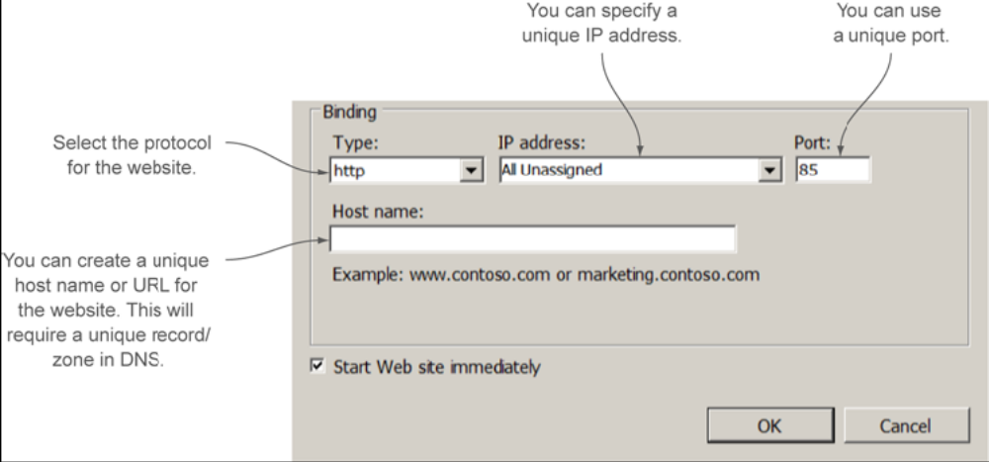
Figure 5.7 Each website must have something unique in one of these four parts to set the binding.
You configure the binding in the IIS manager (or PowerShell). Figure 5.7 shows you where you set the bindings on the bottom half of the Add Web Site form.
Each website you create must have something different in its name from every other website you host on a server – in at least one of those four parts. Bob Smith and Bob Jones have the same first name, but unique last names. Same thing goes with websites: as long as one binding part is unique, your website will be unique.
In the next four sections, I walk you through setting the type, IP address, port, and host name for the bike website. This information will also work for every website you create in the future. I show you how to do it through the GUI first; you’ll learn how to do it using PowerShell in the last section of this chapter.

5.2.1 Defining a unique name by type
The first part of every website’s name begins with the type, or protocol, that browser use to access it (figure 5.8). The type is most commonly HTTP or HTTPS, but you’ll see other in IIS, such as FTP and WCF.
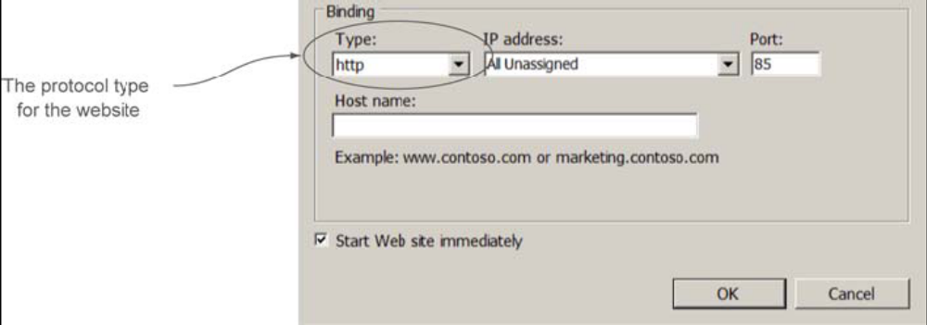
Figure 5.8 The type specifies the protocol to use for client connections.
Because several of your websites will contain the same type or protocol, type usually isn’t enough to make a unique name. Let’s look at IP address and see if it helps.

5.2.2 Defining a unique name by IP address
A common method of creating a unique name for your website is to assign it a unique IP address. In DNS, you can then create a host (A) record (such as www) that points to that unique IP address. This is the second best method to create a unique binding for multiple websites on the same server. The other best method is the host name, discussed shortly.
Most administrators ignore the IP address option because they think they have only one IP address for the entire web server. You can create virtual addresses in the advanced network properties of your network adapter, adding as many unique IP addresses as you like. When you create a binding using that unique address for a website, anyone that makes a request of your server on that IP address is directed to the correct site (see figure 5.9).
The virtualized IP method of making a binding unique is one of the most common, along with host names, which we’ll get to. But first there’s another, non-so-common option you should be aware of: ports.
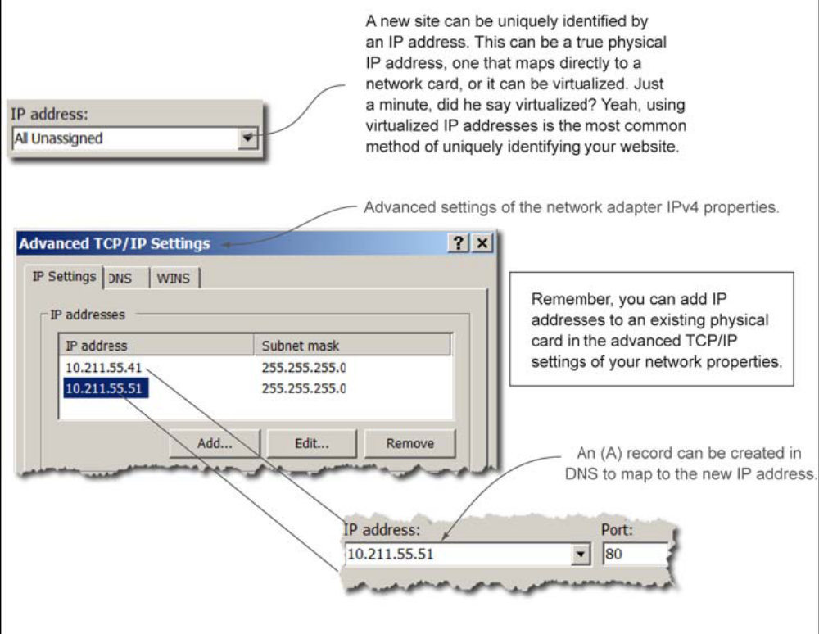
Figure 5.9 Defining a unique IP address for your website

5.2.3 Defining a unique name by port
The practice of using port numbers to uniquely identify a binding for a website is an old one riddled with many problems. In fact, virtualized IP addresses and host names were created to replace the old port method. Why do we still have it? There may be a rate time when you want to use it for something; it’s still common for developers to use ports for internal website redirection – such as the shopping cart application switching to the credit card authorization application. Another reason we still have port numbers as part of the binding is because no one wants to get rid of them.
You can see the Port option on the Add Website form in figure 5.10. I’ll only talk about ports briefly because it’s not a good idea to use them for unique identification. There are two problems with using port numbers. I’ll explain them, and then you can play with the port yourself.
- The URL will be weird – you website is listening on a unique port, so a customer use that port number in the URL to access your site. They must tack on a colon followed by the port number, leading to a URL like this: http://mySite:85. And this scheme assumes the customer knows to do that.
- Every time you use a unique port number, a firewall somewhere will need to be configured for that port – Read that again. Security folks don’t like to open ports; sometimes the only way to get them to do it is to buy them dinner. There’s a good reason for that; it gets harder every day to protect against hackers. The normal ports to have open port 80 for HTTP and port 443 for HTTPS. We don’t want to open more ports that we need to.
TRY IT NOW As an interesting test of ports, create a new site with the name TestSite and a physical path of C:\Sites\TestSite. Change the port to 85. Copy the test page you made in chapter 3 into the website’s physical path (C:\Sites\TestSite) and access the site using the proper URL, which will be something like http://<Server>:85? Not a pretty URL, and certainly not one most customer will remember.
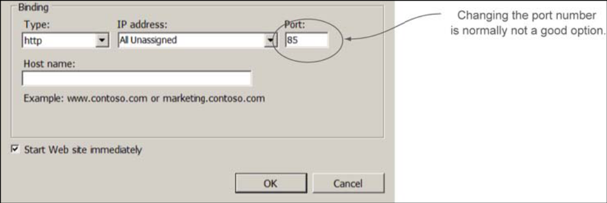
Figure 5.10 Assigning a port number for your binding
Now you can see why to avoid changing the port whenever possible. I don’t want you to think that there’s never a time to use the port number, but it’s rare and generally only for internal sites that don’t have firewalls in between them. Let’s try to avoid this option altogether.

5.2.4 Defining a unique name by host name
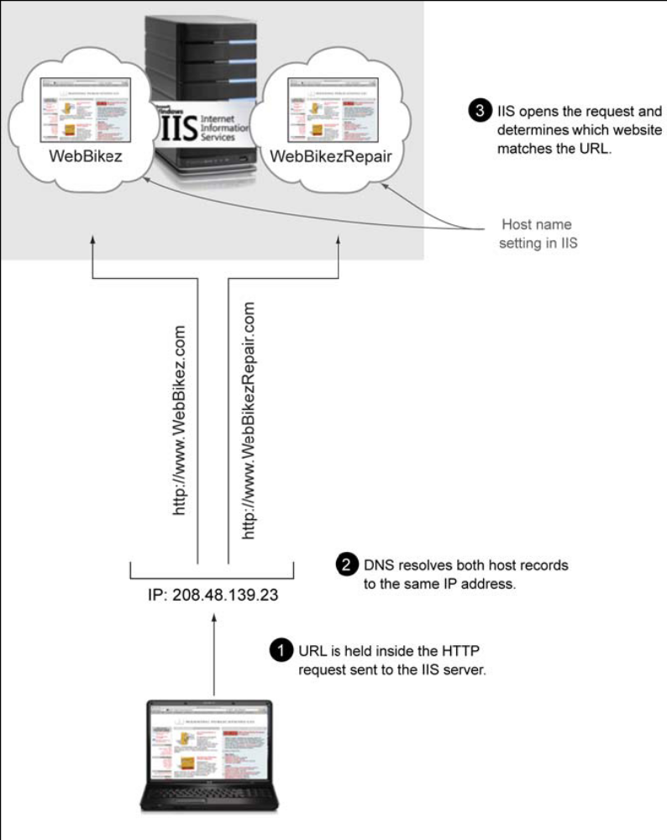
Figure 5.11 Using a single IP address with different host names: how IIS determines which website a client request should be sent to when using a single IP Address.
Host name (also known as host header) is probably the hardest of the binding settings to understand. Host names were all the rage a long time ago, before virtualized IP addresses were big. Take a look at figure 5.11, pretending that you only have one IP address and need to have several websites.
In figure 5.11 the web server has a single IP address. To uniquely identify a binding for two or more websites using the host name, one website many contain www.WebBikez.com in the host name, and the other www.WebBikezRepair.com. In DNS both (A) rerecord point to the same IP address of the single web server. When the web server receives a request, it looks at the requested URL and attempts to match it to the list of host names. If a customer type http://www.WebBikzRepair.com, the web server matches it to the host name you created and sends the request to the correct website. Figure 5.12 shows how this process plays out.
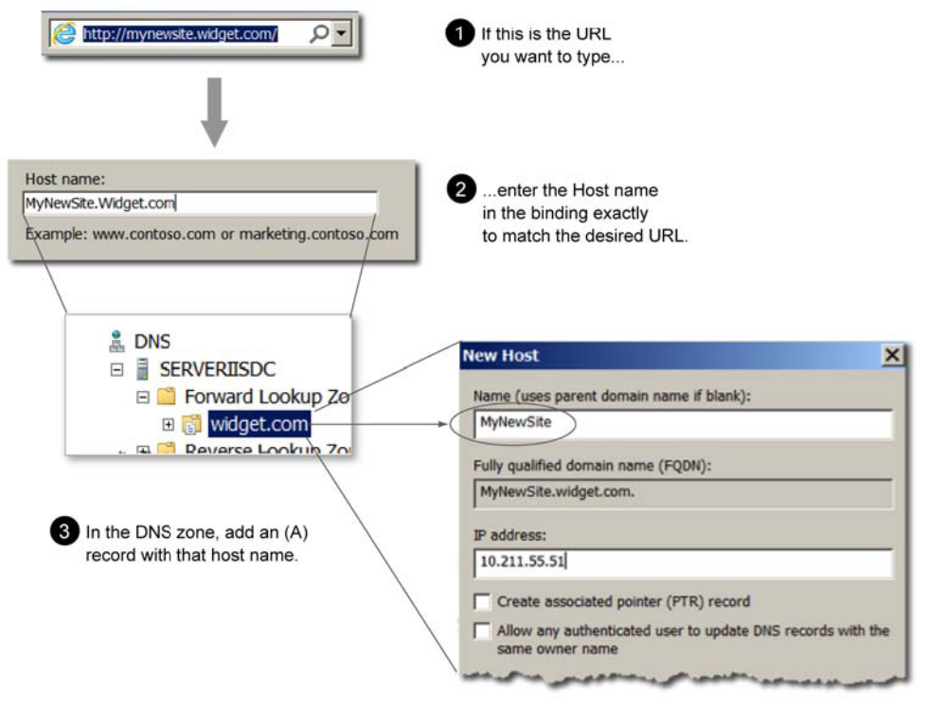
Figure 5.12 Configuring a host name binding
Using host name and DNS, you can create bindings for website that use entirely different internet domain names, such as www.widget.com and www.MyCompany.com, but point to the same website! As long as they’re registered and you have access to DNS for the domains, you can host websites for anyone. You’ve started your own hosting company on a single web server!
I know at first this may seem like an overwhelming amount of information merely to make a new website. The important point is that each website needs to be uniquely identified. The site name that you type into the top of the Add Website form is for organizational purpose – it’s the bindings that truly identify the website. Something in the binding must be unique. Figure 5.13 provides examples of valid bindings for several websites on the same IIS server.
Bindings can be confusing at first, so you’ll want to practice creating them in the lab for the WebBikez website. WebBikez will need new websites, and you’ll get a chance to try three of the four parts to create a unique binding for each website. You’ll change the protocol part of the binding in a later chapter when you apply certificate security.
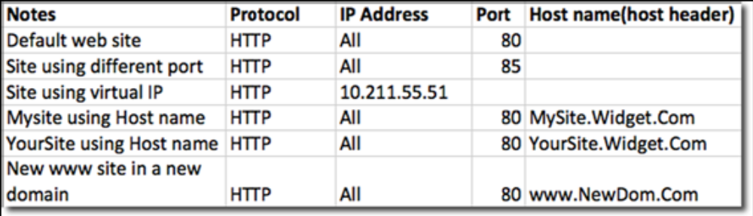
Figure 5.13 Examples of unique bindings

