A Statement of Attainment is issued by a Registered Training Organisation when an individual has completed one or more units.

This is a statement that

Arjun Patel

has attained

Unit Code | Unit Title | Date | Result
TLIF1001 | Follow work health and safety procedures | 15/05/2021 | Competent
TLID1001 | Shift materials safely using manual handling methods | 15/05/2021 | Competent

These competencies from part of TLI32416 Certificate III in Logistics

26/05/2021

Statement Number: 2114

Student ID: 51548793D

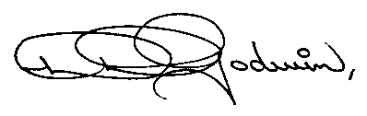

Kath Michelsen
Chief Executive Officer

Swift and Shift Training Pty Ltd
National RTO Provider Number: 3753

