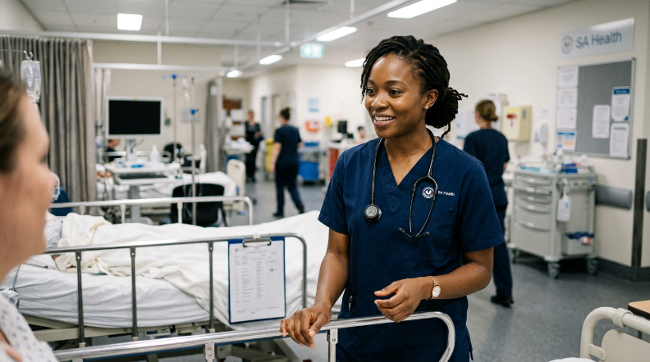
Learner #10: Danielle Okafor

About Me: | Danielle is a 36-year-old Central Sterilising Services Department (CSSD) Technician at the Royal Millbrook Hospital in Adelaide's inner north, where she has worked for the past seven years. Originally from Lagos, she migrated to Australia in 2015 and has lived in the northern suburbs with her husband and two primary-school-aged children since 2017. At Millbrook she works a rotating roster - typically two morning shifts, two afternoon shifts, and four days off - which means her availability for study and training commitments can vary significantly from fortnight to fortnight.
Professional and Learning Experience: | Danielle holds a Statement of Attainment from the CSSD pathway of HLT37015 Certificate III in Sterilisation Services (2021) and completed a further two units from HLT47015 Certificate IV in Sterilisation Services before deferring due to family commitments. She also holds HLTAID011 Provide First Aid (current), a current White Card, and internal signoffs for instrument inspection, load release authorisation, and the hospital's Outbreak Response Protocol.  In her seven years at Millbrook, Danielle has built deep practical expertise across the full CSSD workflow: decontamination and inspection, packaging and sealing to AS/NZS 4187, steriliser loading, cycle selection and release, and daily biological and chemical indicator testing. Since 2023 she has held the informal title of Senior CSSD Technician, which involves buddying new starters through orientation, signing off their initial steriliser operation competencies, and running the quarterly infection control refresher on the department floor. She has also covered the ward-based food trolley rounds on morning shift during periods of short-staffing, which involved managing cold-chain records and identifying and disposing of non-compliant items.  Danielle's anatomy and physiology knowledge is largely workplace-contextual: she is confident in the language of microbiology and contamination risk and understands disease transmission routes thoroughly in the context of CSSD work, but she has not completed formal study in human anatomy and physiology beyond what was embedded in her Certificate III units.
Career/Training Goals: | Danielle's goal is to move into the hospital's Education and Workforce Development team as a Casual Trainer, initially delivering CSSD induction content and the infection control refresher programme she already runs informally. Her ward educator (Yvonne) has encouraged her to formalise her training delivery through the Cert IV in TAE and has been a strong advocate for her secondment to the Education team on a part-time basis. Longer term, Danielle is interested in the possibility of delivering sterilisation content across the SA Health network and would consider further qualifications if they are offered through the hospital's study assistance programme.
Working Style and Preferences: | Danielle is calm, methodical, and very good at one-on-one instruction. On the CSSD floor she is known for walking new starters through each stage of the steriliser operation sequence at their pace and checking in at each step before moving on - her colleague Precious has described it as "the most patient training I have ever had." She runs the quarterly refresher using a slide deck she built herself in PowerPoint and tends to deliver it in the break room at the end of morning shift, relying heavily on photographs of real equipment rather than diagrams.  Where things become less straightforward for Danielle is in formal written work. She is confident in English conversation and instruction, but longer written tasks - reports, structured assessments, reflective summaries - take her significantly more time and effort than the practical components. She tends to draft anything important in point form first, then expand it, and she has asked her husband to read over her TAE written submissions before she lodges them. Her numeracy is solid for the recording and checking tasks in CSSD (timing cycles, reading chemical indicator parameters, calculating load batch numbers) but she finds percentage-based quality metrics and data interpretation questions in formal assessments more challenging than the equivalent task on the floor.  Danielle's rotating roster means that fixed weekly class times don't work well for her; she has asked specifically for recorded session options or flexible make-up arrangements for any face-to-face components. She uses her phone for almost all study between shifts and does most of her reading on the bus or in the break room. She has a shared family laptop at home, but it is heavily used by the children for school, which limits her access to it in the evenings.
Additional Information: | Danielle is involved in her children's primary school P&C committee and attends a Nigerian community group in the northern suburbs on alternate Saturdays. She is a confident public speaker in informal settings - she has run community health information sessions for the Nigerian Women's Network twice in the past year - but finds larger formal presentations more nerve-wracking than one-on-one delivery. She has mentioned that feedback delivered directly and specifically lands much better for her than indirect or general comments, and she prefers to know exactly what is expected of her before attempting a task rather than working from open-ended prompts. She observes Christian commitments on Sundays, which she has flagged as an availability consideration for any weekend intensive components.

