A Statement of Attainment is issued by a Registered Training Organisation when an individual has completed one or more units.

This is a statement that

James Sterling

has attained

Unit Code | Unit Title | Date | Result
BSBWRT301 | Write simple documents | 11/10/2019 | Competent
BSBITU303 | Design and produce text documents | 11/10/2019 | Competent
BSBITU312 | Create electronic presentations | 11/10/2019 | Credit Transfer

These competencies from part of BSB30415 Certificate III in Business Administration


14 October 2019

Statement Number: X23963

Student ID: JS-63982

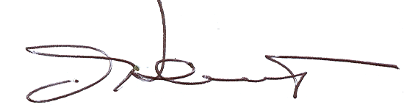

John Citizen
Chief Executive Officer

Global Training Pty Ltd
National RTO Provider Number: 00024

