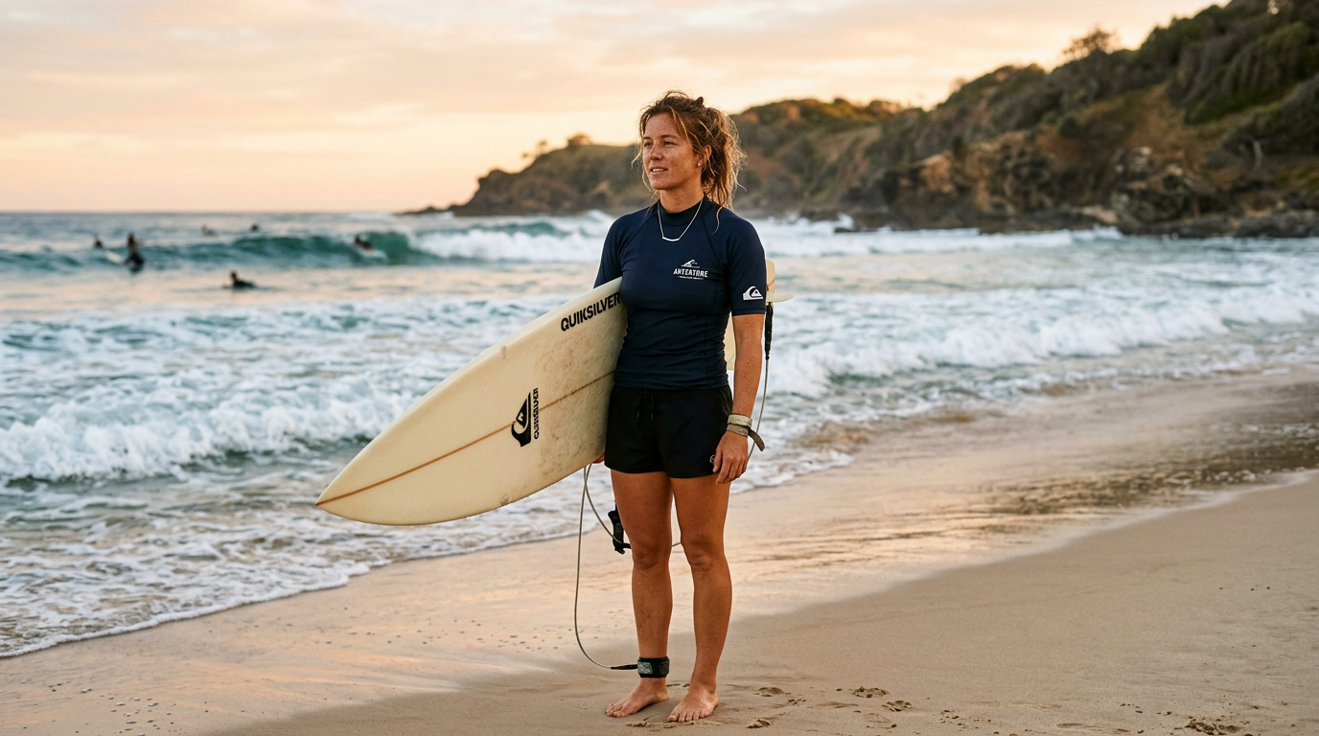
Learner #011: Jess Callahan

About Me: | Jess Callahan is 28 years old and lives at Port Elliot on South Australia's Fleurieu Peninsula, approximately 45 minutes south of Adelaide. She works as a casual surf instructor with a commercial outdoor recreation provider based at Middleton Beach and picks up lifeguard shifts at a nearby patrolled beach during summer.  Jess lives with her two young children; her partner works a rotating fly-in, fly-out roster at a mine site and is away for extended periods throughout the year.
Professional and Learning Experience: | Jess has been surfing since she was eight years old, growing up a short walk from the water on the Fleurieu coast. She was active in junior surf competition through her mid-teens and developed strong technical ability across a range of wave conditions. She began assisting with surf instruction at sixteen while still at school, initially shadowing a more experienced instructor before taking on her own groups.  She has worked casually across several surf schools and beach activity operators along the coast and has held seasonal beach patrol lifeguard positions since leaving school. She completed a Certificate III in Outdoor Leadership approximately four years ago and holds a current Senior First Aid certificate and surf rescue qualification. In practice, Jess has been the lead instructor for intermediate-level groups for the past five years, though this has not always been formally reflected in her job titles or captured in documentation by her employers.
Career/Training Goals: | Jess is undertaking this training partly at the suggestion of the owner of the surf school she currently works with, who is looking to build a more formally credentialed instruction team. She is genuinely motivated by the prospect: "I want to be able to show people something on paper that matches what I actually do out there." She has her eye on a senior instructor or programme coordinator role and is particularly keen on developing structured programmes for youth and women participants.  She is honest about the challenges – balancing study with two young children and a peak-season workload is genuinely difficult – but committed to seeing it through.
Working Style and Preferences: | On the water, Jess is decisive and highly capable. She reads conditions quickly, repositions groups without hesitation, and adjusts her instruction on the fly when things change. Her current employer describes her sessions as running on instinct – a genuine strength in the surf, but one that creates challenges when it comes to translating what she does into written records. Jess tends to plan sessions in her head rather than on paper: she knows which part of the break she will use, what each participant needs to work on, and how she will sequence progressions – but rarely writes any of this down beforehand. Similarly, she always checks in with her group at the end of a session but describes this as "a bit of a chat on the sand" rather than a documented process. She has started using the school's reporting forms but finds the written component takes considerably longer than she expects and sometimes sets it aside to finish later.  Jess does not own a laptop and handles everything digital on her phone. Her home internet connection is adequate in town, but mobile reception at the Middleton beach car park is patchy, meaning she often cannot access online content between sessions. She strongly prefers watching a demonstration or talking something through with a colleague over reading a lengthy document: "If someone shows me something I'll get it straight away. Reading four pages about it, not so much." Longer written tasks take her more time than expected and she tends to start them and return to finish them days later.
Additional Information: | Outside of work, Jess competes occasionally in local surf club events and is actively involved in her children's school and community activities. She runs an informal Sunday morning surf programme for teenage girls through the local surf club – unpaid and self-organised – which she is clearly passionate about. During the fortnights her partner is away on roster, Jess has no capacity for travel to Adelaide or evening commitments, as she is the sole carer for her children. Her preferred study arrangement is content she can break into short sessions and access on her phone rather than requiring extended time at a computer.

