Learner #022: Bree Whitlam
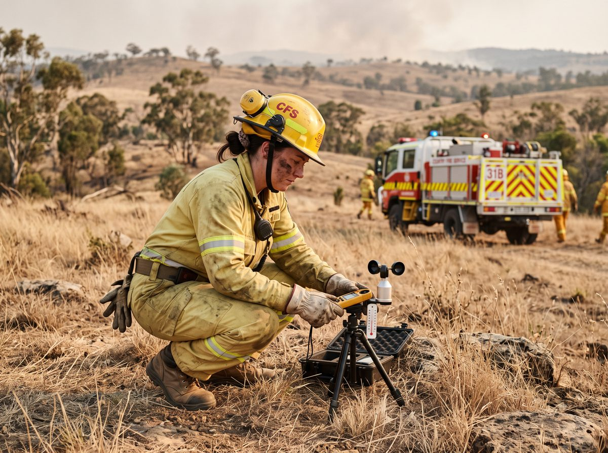
About Me: | Bree Whitlam is 31 and lives on a small block outside Kersbrook in the Adelaide Hills with her partner and two dogs. She is a veterinary nurse at a mixed practice in Gumeracha four days a week, and a volunteer firefighter with her local brigade, where she has served eight years and is now a crew leader.
Professional and Learning Experience: | Bree grew up on the block and joined the brigade at twenty-three after the fires came within two paddocks of the house. She holds her basic firefighting and crew leader qualifications through the service, has been on strike teams to the South East and the Mid North, and is one of two people at the brigade trained to take and report field weather observations on the fireground.  Weather is the part she has made her own. She carries a belt weather kit, takes observations at set intervals on any going fire her crew attends, reads the sky and the terrain as well as the instruments, and radios the numbers through to the sector commander. In the last two seasons she has been asked for by name on two campaign fires because the incident controller wanted observations he could trust from the western flank.  Her paid work is veterinary nursing: Certificate IV completed in 2016, surgical and emergency nursing, and she runs the practice's student placements, which means two or three Certificate IV students a year working alongside her for a fortnight each. She writes their placement feedback and has failed one.
Career/Training Goals: | The brigade has put Bree forward as a trainer, which in a volunteer service means teaching new members on Sunday mornings with a manual and a truck. She has been doing it unofficially for three years.  She would like the recognition, partly for herself and partly because she thinks the way new members are currently taught is not good enough and she would have more standing to change it. Her view is that the current approach relies on people already knowing things nobody ever taught them.  She has no plans to leave veterinary nursing and is not looking for the brigade work to turn into a job. She wants to be better at the part of it she has already been doing for three years without a title.
Working Style and Preferences: | Bree is precise. Her observation sheets are neat, timed to the minute, and she will re-site the kit rather than record a reading she does not trust. She notices things: the smoke lying flat when it was rising an hour ago, the wind backing before the change comes through, the difference between the ridge and the gully.  She reads and writes well and is comfortable on the radio, which not everyone is. In front of a group she is quieter than she is on the fireground and tends to speak in short sentences and then stop, which she knows and does not much like. She has said she would rather demonstrate something than explain it, and that she runs out of words when people are looking at her.  Her availability is the complication. She works four days at the practice, is on the brigade pager permanently, and in a bad summer will be out three nights a week and gone for four days on a strike team with a day's notice. She cannot tell anyone in advance which weeks those will be.  Internet at Kersbrook is fixed wireless and drops out in the heat, which is exactly when she is busiest. Anything scheduled between December and March will be missed at some point, and she would rather that be planned for than apologised for afterwards.
Additional Information: | Bree does the brigade's social media and the fundraising quiz night, keeps chickens, and is doing the slow work of putting her block back together after the 2024 fire took the fences.  The block is twenty-five minutes from Gumeracha and fifty from the city, and she does the drive twice a day four days a week, which rules out anything that would need her in Adelaide on a weeknight.  She and her partner are trying for a baby, which she has mentioned to the brigade captain and nobody else.

