Learner #021: Dean Kovacevic
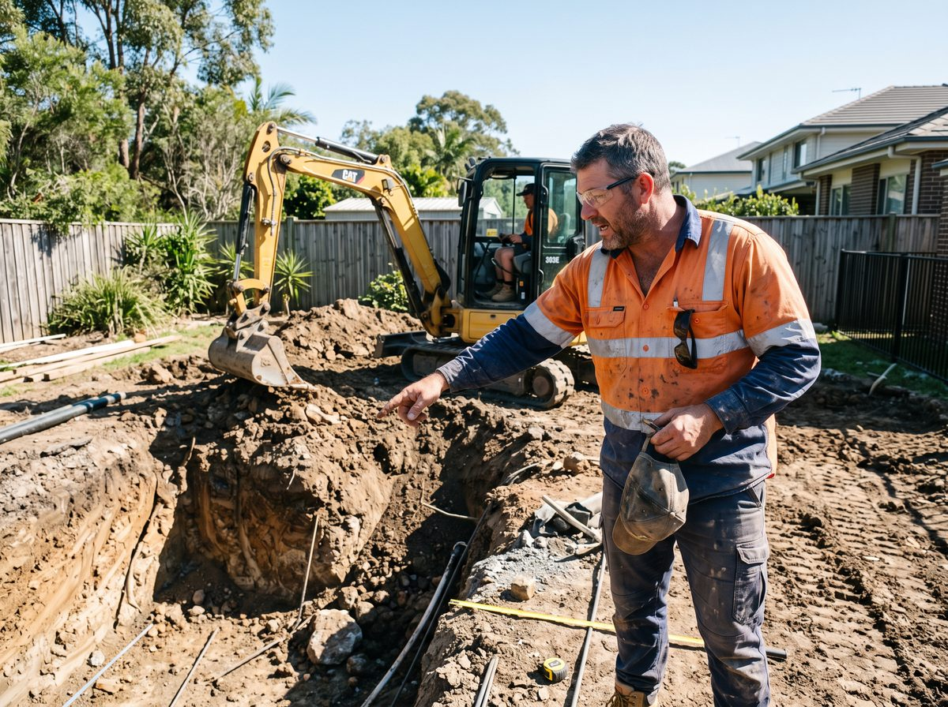
About Me: | Dean Kovacevic is 44 and lives at Golden Grove with his wife and three kids. He is the construction supervisor at Meridian Pools, a family-owned pool builder working across metropolitan Adelaide and down to the Fleurieu, and he runs two crews and the excavation program.
Professional and Learning Experience: | Dean started as a concreter's labourer at eighteen, spent eleven years on wet concrete and formwork, then moved to pools in 2012 because a mate said the work was steadier. He has been at Meridian for nine years and supervising for five.  His week is the front end of the build. He does the site investigation on every job before the excavator is booked, which means the soil, the fall and levels, the access, the services, the trees, the neighbours, the easements, and whether the thing the client has drawn on the back of an envelope will actually fit between the house and the fence with the setbacks the council wants.  He writes the site report the office quotes from, sets out the pool, and supervises the dig, standing over the trench and calling the operator off when something appears that should not be there. He deals with the client on the day, which is often the point at which they find out their pool cannot go where they wanted it.  He holds a white card and an excavator ticket, did a soil classification short course through a supplier, and has never done anything else formal. Everything he knows about clay, reactive soils, and what happens when you put a shell next to a paperbark he learned by getting it wrong early and expensively.
Career/Training Goals: | The owners are talking about Dean stepping up to construction manager when Rob retires in two or three years, and the accountant has pointed out that the company's building work licence sits with Rob personally.  Dean needs a qualification behind him for the licence question, not for the job itself, which he is already doing. He is pragmatic about it and mildly annoyed that it took the accountant to raise it rather than either of the owners.
Working Style and Preferences: | Dean is on site by 6:15 and in the office once a week, on Fridays, which he resents. He works from a tablet in the ute for the site reports and photographs everything, but the tablet is four years old, the camera app crashes, and he keeps a paper site book as the real record because it has never let him down. The office manager has asked him twice to stop doing this.  He talks through problems out loud, usually to whoever is standing nearest, and is at his best with a plan in front of him and a fence line to point at. Reading he is fine with, so long as it is a plan, a soil report, or a spec.  Long written explanations he skims, and he says himself that when he writes a report it comes out "like a text message". The office manager tidies them before they go to clients, which has been going on so long that neither of them mentions it.  He is quick with numbers on site: fall, cut and fill volumes, batter angles, and how many truckloads of spoil, mostly in his head and mostly right. Put the same sums in a spreadsheet and he slows right down and starts second-guessing himself. Reception at the Fleurieu jobs is patchy and he loses signal for hours at a time. Anything he needs during the day he downloads the night before, or it does not exist.
Additional Information: | Dean coaches under-14s basketball on Wednesday nights and does not miss it. Summer is the busy season and from October to March he works most Saturdays, so any study would need to survive being ignored for five months.  His father-in-law had a stroke in 2025 and Dean does the Sunday driving to appointments. He has not sat an assessment of any kind since the excavator ticket and says he does not much like the idea of being tested on paper for something he does every day.

