Learner #015: Donna Pastore
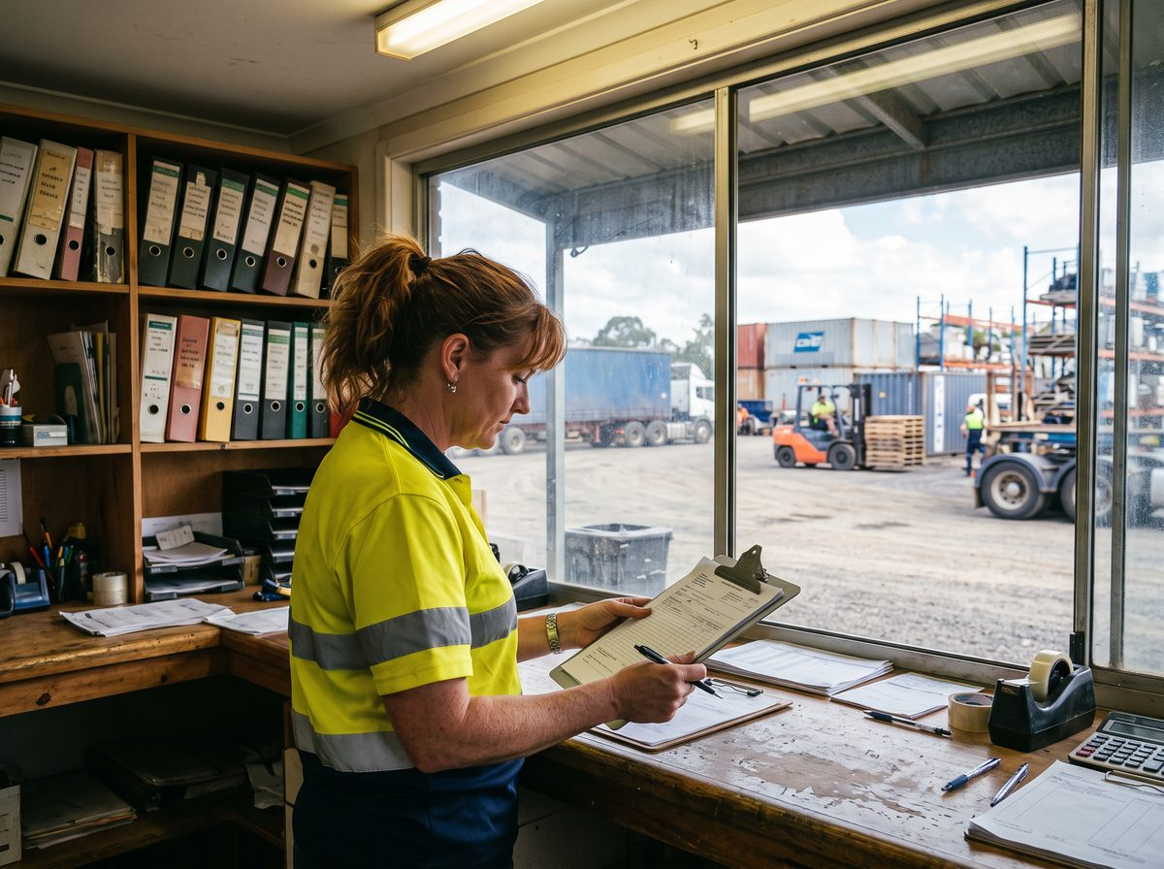
About Me: | Donna Pastore is 45 and lives at Salisbury North with her husband, a long-haul driver, and the younger two of their four kids. She has spent six years in the transport game and is the Records and Administration Officer at Fowler Crest Freight, a family-owned carrier running out of a depot at Regency Park.  The depot is a shed, a yard, and a demountable office with a window onto the hardstand, and Donna can see who has come in and who has not without leaving her desk.
Professional and Learning Experience: | Donna left school partway through Year 11 and went straight into checkout work, then office junior work at a plumbing wholesaler, where she stayed twelve years and ended up running the trade counter paperwork. She came to Fowler Crest as a casual doing data entry during a Christmas peak and never left.  These days she owns the paper trail for forty trucks: consignment notes, proof of delivery, driver run sheets, fatigue paperwork, and the maintenance records the workshop is supposed to hand in and mostly does. She chases the ones that do not arrive, which she does in person because it works and email does not.  She rebuilt the POD filing after a customer dispute in 2023 turned into three days of digging through boxes, and she is partway through sorting out the archive room, a job she describes as "archaeology". She shows every new driver how the paperwork works on their first morning, standing at the counter with a blank run sheet and a pen, and she trained the two office juniors on the freight system herself over about a fortnight each.  She started a Certificate III in Business online during COVID and finished three units before the depot got busy again. Nothing formal before or since.
Career/Training Goals: | The general manager wants the office "audit ready" after a customer's compliance review last year found gaps in the old records, and Donna has been told a qualification is part of that picture.  She is ambivalent about study for its own sake but wants the piece of paper that matches the job she already does, and she would like the pay review that has been loosely attached to it. She has also worked out that if she ever had to leave Fowler Crest she would have nothing to show for six years.
Working Style and Preferences: | Donna runs on routine. She is at her desk by 5:30am when the first trucks leave and gone by 2pm for school pickup. Mornings are for the drivers and the phones; anything needing concentration happens between 11 and 1, and she says her brain is "cooked" by mid-afternoon.  She is fast and accurate in the freight management system and can find any consignment from the last six years in under a minute, but she does it her way, from memory and muscle, and struggles to explain the steps when someone asks. When she trained the juniors she ended up sitting them in her chair and talking while they clicked, because narrating it in the abstract went nowhere.  Reading has never been her favourite thing. She gets through short documents fine but a long procedure or a dense email gets skimmed, and she will always ring someone rather than write to them. Her run sheet reconciliations, on the other hand, balance to the dollar, and she picks up a rate error on an invoice before the accounts clerk does.  She has never done online study apart from the COVID attempt, which she gave up on partly because the modules were "an hour of some bloke reading slides". Short and practical works. She watches how-to videos on her phone in the lunchroom with subtitles on because the depot is loud, and she will happily replay a thirty-second clip four times rather than read the equivalent paragraph.
Additional Information: | Donna's husband is away three or four nights most weeks, so evenings are homework, netball, and dinner, and she is firm that study cannot live there. Wednesdays she has her granddaughter from three o'clock.  There is a computer in the depot lunchroom, shared with whoever needs it, and the GM has said she can use work time after the 1pm cut-off, which she reckons is the only way any of it will get done. She does not own a laptop and has never wanted one.

