Learner #018: Gary Pemberton
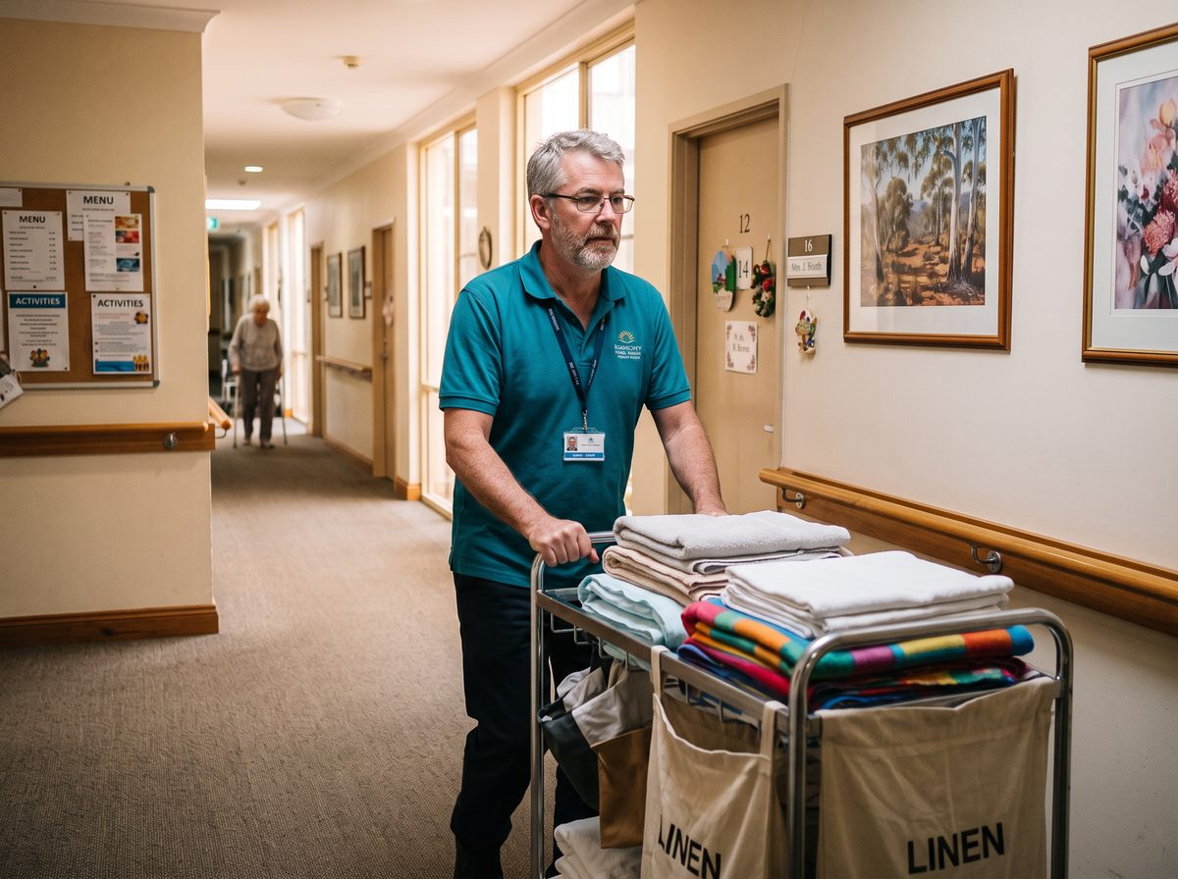
About Me: | Gary Pemberton is 54 and lives at Para Hills with his wife Lyn. He is a personal care worker at Karinya Grove, a 96-bed residential aged care home at Modbury, where he has worked for three years, mostly in the Banksia wing, which is the dementia-specific unit.  It is a second career and he came to it late, by a route he did not plan.
Professional and Learning Experience: | Gary drove buses for twenty-six years, the last fifteen on the O-Bahn. When his father developed vascular dementia, Gary dropped to part-time driving and spent four years as his dad's main carer, learning most of what he now does from district nurses and an occupational therapist who visited fortnightly.  After his father died he took redundancy, completed a Certificate III in Individual Support (Ageing) in 2022, and started at Karinya Grove three weeks after his last assessment.  On the wing he does the full scope of personal care: showering, dressing, mealtime assistance, mobility and transfers, and the daily notes. He is the Banksia wing's buddy for new personal care workers, which means the first three shifts of every new starter are spent alongside him, and he runs the wing's monthly falls huddle, standing up in front of eight or nine staff with the month's incidents and what changed.  Residents' families ask for him by name. He is careful about the edges of his role and is known for the phrase "that one's a nurse question", which the clinical care coordinator quotes at inductions.
Career/Training Goals: | Gary is not chasing a promotion. He wants to stay on the floor. What he wants recognised is the training and mentoring side, because the clinical care coordinator keeps handing him new starters and he has come to enjoy it more than he expected to.  He would also like his buddy role to be a formal part of his position rather than something absorbed into an ordinary shift, since at the moment it means doing two people's work on the same eight hours. He is not interested in study for its own sake and said so at the first conversation.
Working Style and Preferences: | Gary works a rotating roster across mornings, afternoons, and one block of nights each month, and his availability moves with it. He is a calm, unhurried presence on the wing and swears the driving years taught him everything he needs about difficult mornings.  On the care system tablet he is competent within his routine. He does his progress notes at the end of each round using the phrase shortcuts he set up with the coordinator, and reads care plans at handover. Outside the routine he is less sure. The rostering app defeats him about once a fortnight and he rings the rostering officer rather than work it out. When the mandatory training modules come around he books the computer in the staff room and does them after shift, ideally the first one alongside someone who has done it before.  He reads with glasses now and prefers print for anything longer than a screen, and he will print a policy at work rather than read it on the tablet. He talks better than he types. His notes were brief to a fault until the coordinator showed him dictation on the tablet, which he has taken to with enthusiasm and now overuses slightly.  In the falls huddles he is comfortable in front of the wing team, which surprised him. One to one with a nervous new starter he is better again.
Additional Information: | Gary and Lyn have their two grandchildren every Sunday, non-negotiable. He plays lawn bowls Tuesday evenings and is the unofficial bus for half the team.  His nights block each month means any regular weekly commitment, a class on a set evening for instance, falls over one week in four. He has not sat in a classroom since his Certificate III and describes that experience as "fine once I stopped worrying about it".

