Learner #020: Jake Trewartha
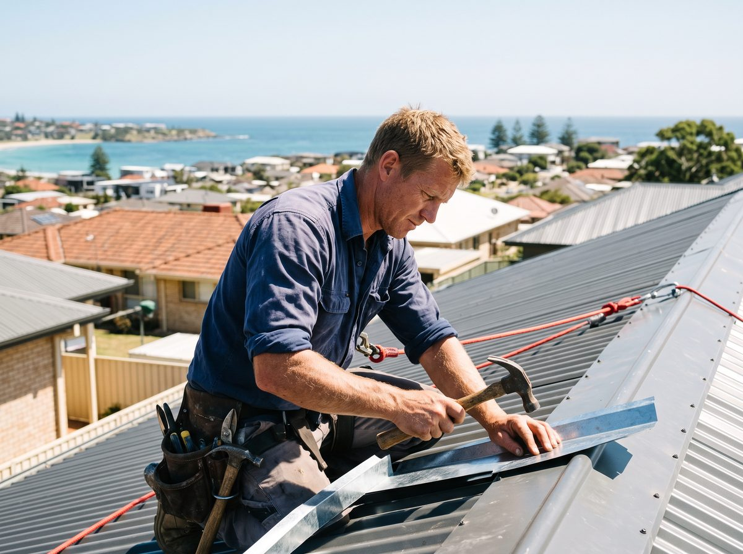
About Me: | Jake Trewartha is 38 and lives at Semaphore with his partner Ellie and their daughter. He is a licensed roof plumber and runs Trewartha Roofing & Cladding out of a shed at Port Adelaide: himself, another tradesman, and a second-year apprentice named Coop.  The business is small enough that a fortnight of bad weather is felt in the bank account.
Professional and Learning Experience: | Jake did his roof plumbing apprenticeship out of Port Adelaide, worked six years for a commercial roofing contractor across warehouses and school re-roofs, then went out on his own in 2016.  The business does residential re-roofs, box gutters, wall cladding, and a steady run of flashing and penetration work for builders and the odd solar and mechanical contractor who has cut a hole in someone's roof and would like it to stop raining inside.  He holds his SA contractor licence for roof plumbing work and supervises Coop through a group training organisation, with the GTO field officer visiting quarterly. Jake does the on-the-job instruction himself and takes it seriously. His own tradesman years, he says, were "learn by getting yelled at", and he runs it differently: he shows a task, watches Coop do it, and comes back to it a week later to see whether it stuck. He signs off Coop's logbook and has twice told the field officer that a task was not ready to be marked off yet.  He has no qualifications beyond his trade certificate and licence, and has never done any study since his apprenticeship.
Career/Training Goals: | The GTO field officer planted the idea. Jake is already training an apprentice to trade standard, and formal recognition would let him take on a second apprentice with more confidence and possibly do paid assessment work for the GTO down the track.  Jake likes the sound of the second apprentice. The business is turning work away from May to September and he is doing more of the physical work himself than he should be at 38. Paid assessment work also appeals as something he could still do at 55.
Working Style and Preferences: | Jake's day starts at 6:30 in the shed and ends when the light does. His diary is his phone. Quotes are voice memos recorded in the ute that Ellie turns into written quotes at night, because writing has been a battle since school and he long ago stopped fighting it and built the workaround instead.  He reads plans, specs, and the flashing handbook diagrams fluently. It is composing sentences he avoids, not reading them, and he can pick a detailing error on a drawing that the builder has missed.  He photographs everything. Every job gets before, during, and after shots on his phone, filed by job in a gallery app, partly for disputes and partly because it is how he shows Coop what right looks like. Show him a video and he is engaged; hand him a page of text and he will find something to go and measure.  Rain days are his free time, and there is no predicting them. Anything he commits to has to survive being dropped for a fortnight in a wet June and picked up again without him having to start over. He has a phone and Ellie's iPad; the laptop is technically his but he treats it like it might bite, and it lives in a drawer in the shed.
Additional Information: | Jake surfs before work when the bank at Semaphore is doing anything, coaches his daughter's under-8s soccer on Saturday mornings in winter, and is the person half the street asks about their gutters.  Ellie does the books, the invoicing, and increasingly the diplomacy. Jake has said that if anything needs to be written down and submitted, Ellie will end up doing it, and he does not seem to think this is a problem.

