Learner #024: Marcus Boyle
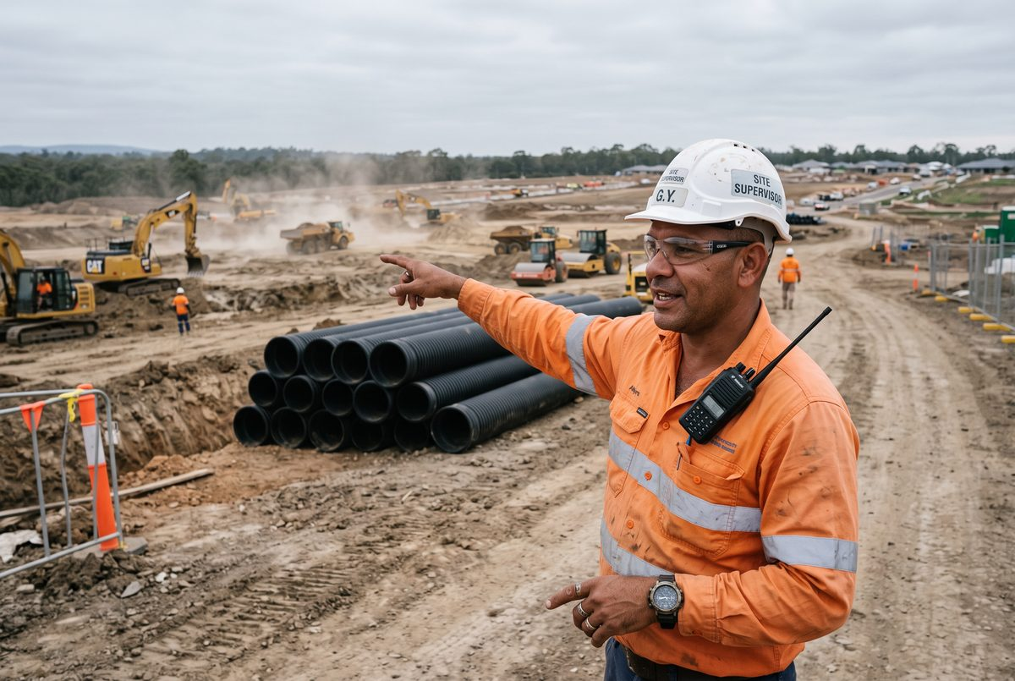
About Me: | Marcus Boyle is 41 and lives at Munno Para with his wife and three kids. He is a leading hand plant operator with Ardrossan Civil, working on a subdivision project at Angle Vale after eighteen years in civil construction across roads, subdivisions, and water infrastructure.
Professional and Learning Experience: | Marcus started as a pipelayer's labourer at twenty-three, got his tickets over the following decade, and now runs excavator, roller, and skid steer and is the leading hand for a crew of seven. He holds a Certificate III in Civil Construction Plant Operations from 2014.  The leading hand role is mostly communication and he knows it. He takes the daily brief from the site supervisor and turns it into what his crew actually does, runs the prestart, reads the drawings and the service plans and makes sure the crew read them too, and stops the job when the plan and the ground disagree.  He talks to the surveyor, the traffic controllers, the water authority inspector, and the residents who come out to ask why there is an excavator in their court at six in the morning. He negotiates the day-to-day give and take with the other trades on site, which he describes as "half my job and none of my job description".  He has taught three operators to run an excavator properly and can tell within an hour whether someone has been trained or has just been let loose on one.
Career/Training Goals: | Marcus wants to move into a site supervisor role, and the company has told him what everyone in civil gets told: the tickets are not the problem, the paperwork and the qualifications are.  He has also been asked to mentor the two young operators the company took on through a mob-specific traineeship, which he enjoys more than he expected and has no formal grounding in. He has said he does not want to do it badly and would like to know whether what he is doing is right.
Working Style and Preferences: | Marcus runs on the radio and on his feet. He is on site at 6, walks the job before the crew arrives, and by seven has told everyone what is happening in language they can use. He is very good in front of the crew, calm with an angry resident, and firm with a subcontractor trying to shortcut a set-down.  Written work is where it slows down. He fills in the prestart and the daily diary because he has to, in short lines, and the supervisor's written instructions he tends to have someone read out or he takes a photo and works through it later in the ute. He says he was "no good at school and got worse", and he learned everything he knows about drawings from a surveyor named Kev who took the time.  He is confident on the phone and the two-way, less so with the tablet the company rolled out for daily diaries last year, and openly says he preferred the paper book. He has worked out enough of the tablet to do his own entries and no more than that.  Site reception at Angle Vale is patchy in the low ground, and the ute is the only place he reliably has signal. Work is 6am to 4pm, sometimes 6, and by the time he gets home the last thing he wants is a screen.
Additional Information: | Marcus plays and now coaches in the local Aboriginal community footy carnival each year and takes a fortnight off in September for it. He drives his mother to Port Augusta most long weekends.  He has said that the last time anyone asked him to write something down and hand it in was his Certificate III, and that he got through it because the trainer let him talk it out. He remembers the trainer's name.

