Learner #026: Riley Fenton
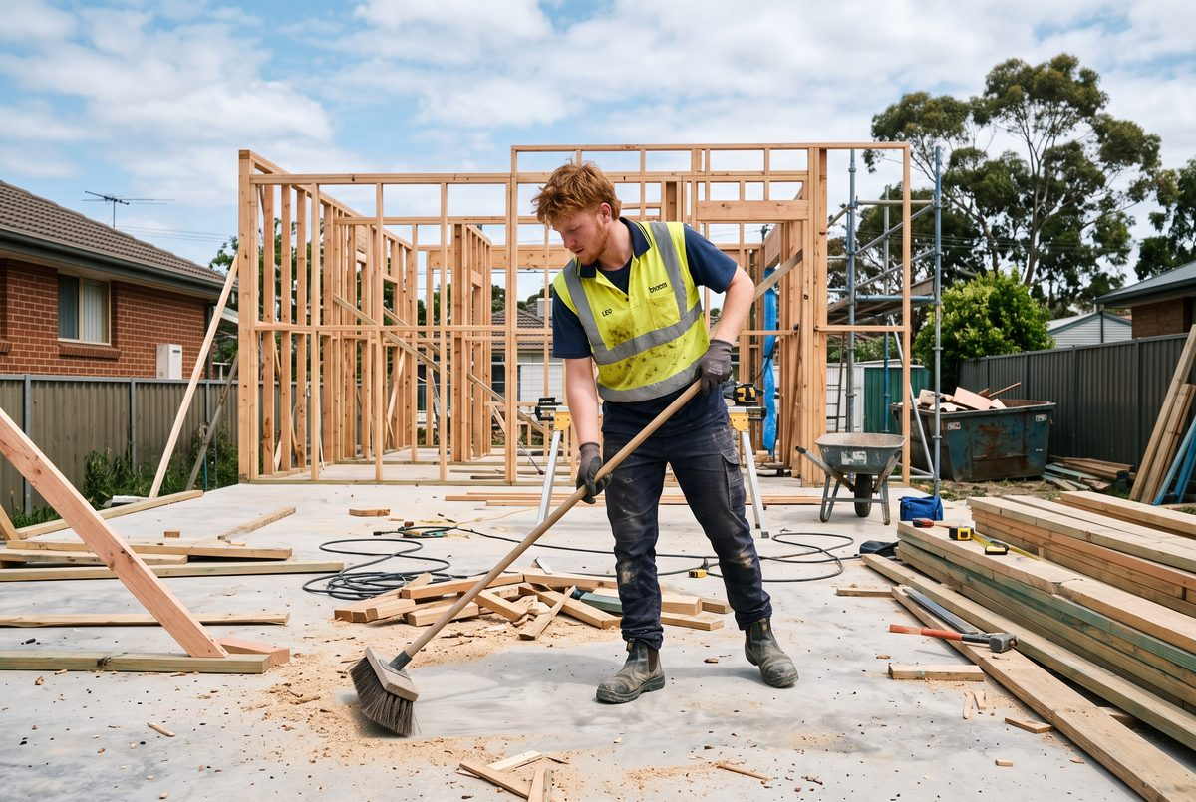
About Me: | Riley Fenton is 19 and lives at Elizabeth Vale with his mum and younger sister. He started a carpentry apprenticeship in February this year with a small residential builder and is six months in. Before that he was doing warehouse shifts through an agency and helping his uncle on weekends.
Professional and Learning Experience: | Riley left school after Year 11. From about fifteen he spent most school holidays and a lot of Saturdays with his uncle Wayne, who runs a one-man concreting and landscaping business, mostly pouring driveways, laying pavers, and building retaining walls around the northern suburbs.  Riley describes it as "helping", which mostly meant barrowing, screeding when he was allowed, cleaning tools, and being told things. He can set out a string line, mix by hand, and knows what a slab looks like when it has been finished properly, none of which he would think to mention unless asked directly.  Between leaving school and starting the apprenticeship he did about eight months of agency warehouse work, some of it nights, in three different sheds.  He has his white card and has done the first block of trade school, where he passed the practical assessments comfortably and scraped through the written ones. His employer put him forward for the recognition process because Riley told him he had "already done heaps of this stuff" with his uncle.  On the current job he is mostly on clean-up, cutting to a mark, and carrying, and he has been allowed to fix off a small amount of framing under supervision. He has not been shown how to set out anything himself yet.
Career/Training Goals: | Riley wants to finish his trade and eventually work for himself, which he says because his uncle does and it looks alright from where he is standing.  Nearer term he wants to stop being the one who sweeps up. He is doing the recognition process because his boss suggested it and he is not entirely sure what it involves, and he has not asked.
Working Style and Preferences: | Riley is willing and physically capable and turns up on time, which his boss rates highly. He learns by watching and copying and is uncomfortable asking questions in front of the other blokes, so he tends to guess and then get corrected, which he takes well but which costs time.  He reads slowly and avoids it. Trade school assessments he has been doing at his mum's kitchen table on his phone because the laptop from school stopped working and has not been replaced, and he has already had one extension. Typing on the phone is slow enough that his answers come out shorter than he means them to.  He is quick with anything hands-on and remembers a sequence after being shown twice, but written explanations of things he can do go nowhere. Nobody has ever asked him to write down what he did on a job, and when it was suggested he looked at it as though it were a trick.  When asked for evidence he produced a phone gallery, some of it his and some of it his uncle's, mostly finished work with nobody in the shot and no dates he could vouch for. He was surprised that this might not be enough and did not know what else there could be.  He answers questions in a few words and then waits. Asked the same question a second way, or asked to show rather than say, he will talk for as long as anyone wants.
Additional Information: | Riley plays basketball on Monday nights and drops his sister at school before work, which means a 6:20 start is tight and he has been late twice.  He does not have a car of his own and uses his mum's or gets a lift from a workmate. Money is tight on first-year wages and he has said he will not be paying for anything toward the qualification himself. His mum has asked twice how it is going and he has told her it is fine.

