Learner #014: Tanya Wojcik
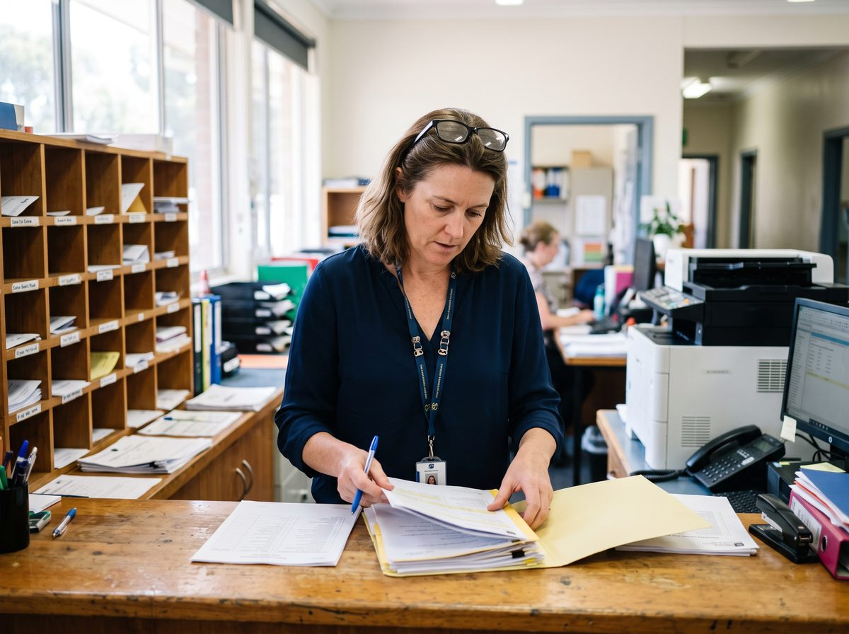
About Me: | Tanya Wojcik is 46 and lives at Woodside in the Adelaide Hills with her husband and two teenage children. She has worked in the front office at Kelston Grange College, an independent R-12 school in the eastern foothills, for seven years and is currently its Administration and Records Officer.  Her year runs on the school calendar. Term time is relentless, the counter is never quiet for long, and the fortnight either side of a break is when everything else gets done. She drives in from the Hills each morning, which is twenty-five minutes on a good day and closer to forty when the Freeway is backed up.
Professional and Learning Experience: | Tanya started as a receptionist at a Norwood accounting practice at nineteen, spent four years in accounts and administration at a corporate head office in the city, then took eight years out of the workforce while her children were small. She returned through casual relief work at the college, covering the front desk two days a week, and was made permanent within a year.  She completed a Certificate II in Business through an evening programme in 2001, and enrolled in a Certificate III in Business in 2020 but withdrew after two units when her mother became unwell. Since then her learning has been on the job and largely self-directed.  Most of what she knows about organising records she worked out herself. She designed the naming convention the college now uses, moved fifteen years of paper enrolment files into it over three sets of school holidays, and wrote the procedure the front office follows for enquiries. She manages the student database entries for enrolments and withdrawals, prepares the census returns for the Business Manager to check, and is the person the deputy principal rings when a historical file cannot be found. New administration staff and teacher aides are handed to her for their first fortnight, which she does alongside her own work with no reduction in duties.
Career/Training Goals: | Tanya wants a qualification that reflects what she already does. The Business Manager has raised a Records Coordinator position for the next budget cycle and told her plainly it would need something formal behind it.  She has also found she enjoys the induction side of the role and would like it to be part of the job rather than something squeezed between phone calls. She is realistic that the college will not pay her more for the same work under a different title unless there is a certificate attached to it.
Working Style and Preferences: | Tanya keeps a paper diary alongside the electronic calendar because she does not trust one without the other, and prints anything longer than two pages to read it properly, marking it up in blue pen as she goes. The marked-up copy goes in a manila folder and the folder goes on the shelf behind her, which is a system nobody else can navigate but which has never failed her.  She is quick inside the systems she uses daily, the student database, Outlook, and the staff Teams channels, and is the person others ask when a file has gone missing. Anything outside those she calls "the tech stuff" and approaches slowly, usually by writing the steps down as somebody talks her through them. She has never used an online learning platform and would want someone to walk her through it once before being left to it.  Writing is a strength. She drafts the front office procedures and proofreads the newsletter, and she notices when a sentence in a letter home will read badly to a parent. Numbers are not. She hands the budget spreadsheet and invoice reconciliation to the Finance Officer and describes percentages as something she "gets to eventually, with a calculator and no one talking to me".  One to one she is warm and clear and will sit beside a new starter for an hour. Asked to speak to the full staff on a Monday, she goes quiet and reads from notes. Any study would be done on her phone or on the family desktop in the lounge room, shared with two teenagers who need it for their own schoolwork. The internet at Woodside drops out and video is unreliable of an evening. She has said she would rather stay back after the last bell and use a computer at school, in half-hour blocks, and would want to print whatever she needed to read.
Additional Information: | Tanya scores for her daughter's netball team on Saturday mornings and volunteers in the canteen one day a term. Every second Sunday she drives to Murray Bridge to spend the day with her mother, who has needed more help since a fall in 2023, and that day is not negotiable.  She has not been a student since her twenties and says, only half joking, that she is "not really an academic". She mentioned once that she left the Certificate III without telling anyone she had withdrawn, and that she would not want to do that again.

