Learner #017: Theo Marinos
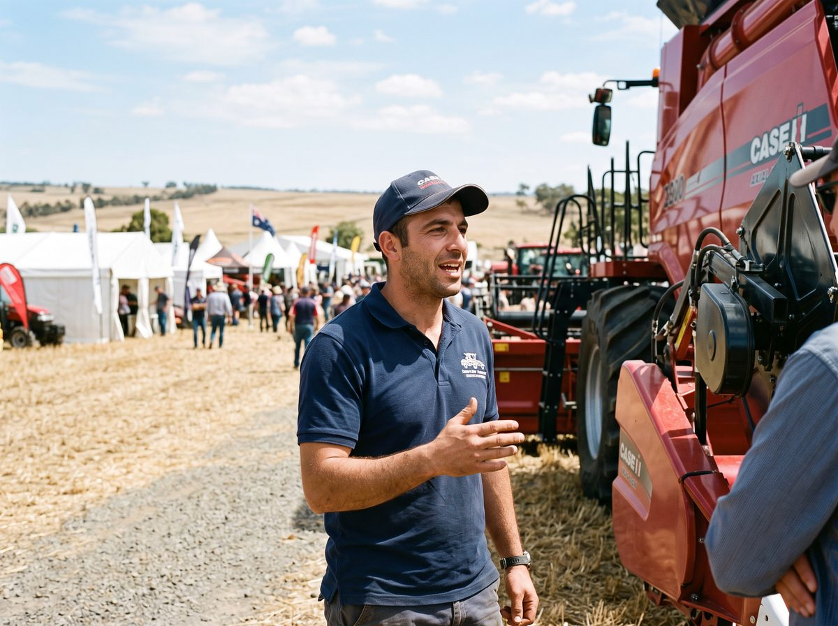
About Me: | Theo Marinos is 33, grew up on a grain and sheep property near Maitland on the Yorke Peninsula, and now lives at Largs Bay. He is the Marketing Coordinator at Copley Ag Machinery, a dealer group selling and servicing tractors, headers, and seeding gear through five branches in country SA.  He is the whole marketing department. There is no team, no agency, and no one above him who knows what he does.
Professional and Learning Experience: | Theo worked on the family farm through school and did two seasons driving a header for a contractor after Year 12. He moved to Adelaide at 21, worked in the parts interpretation team at a machinery dealer, and drifted into marketing when someone noticed the branch's social media had quietly become his.  He has been Copley's marketing coordinator for six years. He plans and runs the promotional calendar around the seasons: the field day circuit in late winter and spring, the pre-seeding parts campaigns, clearance events at the branches, and new model launches when the factories release them.  He builds the stands, orders and manages the promotional stock and signage, writes the emails and the socials, briefs the branch staff on what is running, and pulls the numbers afterwards to see what worked. He negotiates the site fees and the stand positions with the field day organisers each year, and he has learned which sites are worth paying for and which are not.  He started a Diploma of Marketing and Communication online in 2019 and completed about half before seeding season and a staff departure ate the study time. Nothing formal since. Everything else he knows he taught himself from the platform documentation, other dealers' campaigns, and a few expensive mistakes.
Career/Training Goals: | Copley's owners are opening a sixth branch and want Theo to grow into a marketing manager role with a junior under him. He has been told a completed qualification would settle the title question.  Theo's own motivation is simpler: he is self-taught, has never had anyone senior to learn from, and wants to know what he does not know. He has also thought about how he would train a junior and realised he has no idea how to do it beyond showing them and hoping.
Working Style and Preferences: | Theo's year has a shape and his workload follows it. From August to October he is on the road most weeks, running stands at field days from Paskeville to Lucindale, sleeping in motels and working off his phone and a laptop tethered to whatever reception the town has. November to January is quiet and he catches up on everything else.  He is fluent with the digital tools: the email platform, the socials scheduler, the dealer website admin, and enough of the design software to lay out a flyer that does not look homemade. New software does not worry him and he will usually work it out before reading anything about it.  He is a confident talker with farmers and reps alike, comfortable on a stand all day, and good at reading when someone is genuinely interested and when they are just after a free cap. Writing longer documents is slower going. He drafts by talking into his phone and cleaning it up afterwards, and he says school "never really took" for essays. Campaign budgets and response numbers he handles without trouble.  His diploma attempt taught him that open-ended online study dies in his hands during the busy season. He wants clear deadlines, work he can do in motel rooms on patchy internet, and material he can download ahead of the week rather than stream.
Additional Information: | Theo goes home to the farm for seeding and harvest most years to help his brother for a week or two, and Copley wear it because half their customers know the family.  He plays cricket in summer for Largs North and is the one who makes the club's Instagram mildly famous every Mad Monday. He and his partner are saving for a house, which is part of why the manager title matters to him more than he lets on.

