I am selecting the image below to use for this project (skyhawkstudios, 2012) The easiest way I can think of to determine which shapes to use would be to layout all the Items I see and map a shape or combination of shapes to each item. I am going to exclude the rock and the wine glass will count as my complex 3d object.

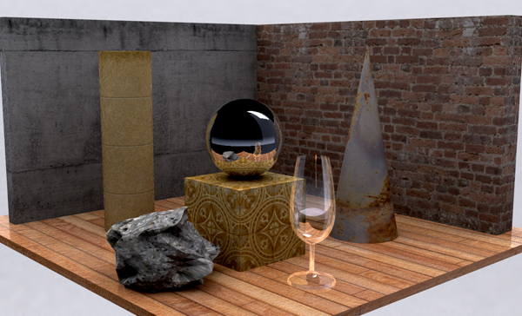
Items:
- Paper Towel Roll – Cylinder
- Cone – Cone
- Cube – Box
- Sphere – Sphere
- Wine Glass – Cylinders with rounding and transforms
- Ground – Box
- Left Wall– Box
- Right Wall – Box
The most complicated object to replicate will be the wine glass. There are several complex features that would normally come from the glass blowing process. I am going to separate it into 3 shapes, then modify each accordingly. Base, Stem, Cup.

References:

(skyhawkstudios, 2012). Wordpress.com. https://skyhawkstudios.wordpress.com/wp-content/uploads/2012/09/3darticle72.jpg

