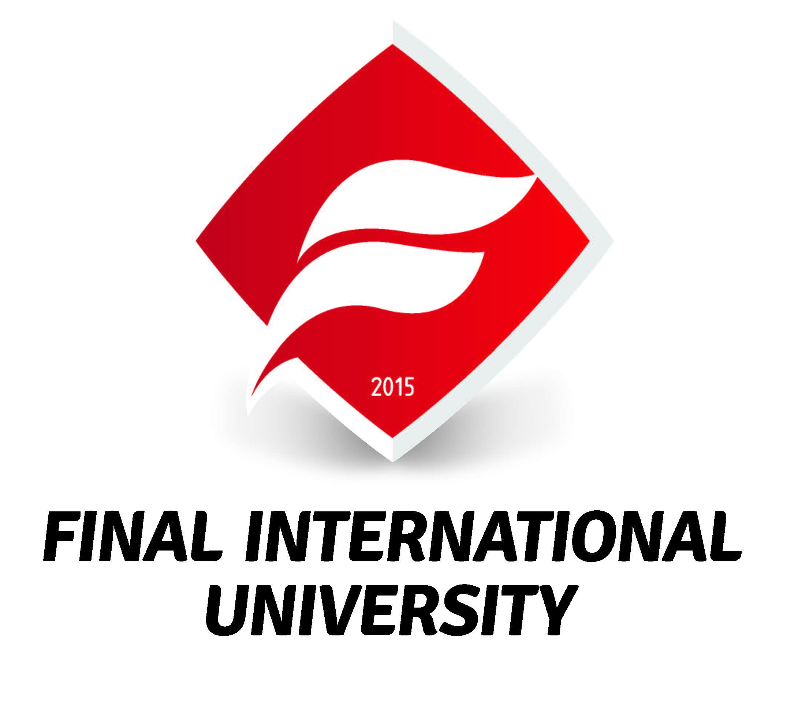

INTERNSHIP LOGBOOK

FACULTY / SCHOOL: FACULTY OF ENGINEERING

STUDENT’S NAME:

STUDENT’S NUMBER:

PROGRAM: COMPUTER ENGINEERING SOFTWARE ENGINEERING

ACADEMIC ADVISOR:

EMPLOYER SUPERVISOR:

COMPANY:

DATES OF INTERNSHIP:

Note: At the end of the internship, the logbook should be delivered to the University by the student in a sealed envelope, and a soft copy e-mailed to the academic advisor.

Introduction

The Final International University Internship aims to help you develop the knowledge and skills required for success in the twenty-first century working environment. Through your internship program, and within this logbook, we would like you to reflect on your work experience and in line with our University Learning Outcomes, your progress in improving your:

- Communication skills
- Analytic, critical thinking and problem-solving skills
- Planning, implementing and evaluating skills
- Initiative and autonomy
- Team-work and collaboration skills
- Responsibility and commitment to quality
- Understanding of professional ethics and civic and social responsibilities
- Technological skills.

We hope you enjoy and benefit from your internship experience.

Suggestions for Use

The purpose of the logbook is to record and reflect upon your work experience and the tasks and duties assigned to you by your employer / supervisor.

A well-kept, professionally presented logbook can help you in more ways than one, and may even be a resource you can use during your search for a full-time job. It is a good idea therefore to take notes during your daily training and then write these notes up fully and carefully in the logbook.

You are very welcome to add diagrams, graphs, photographs, drawings, plans and specifications and other supporting material to your logbook.

Report Format

Cover Page Contents:

1. University Name
2. Faculty / School Name
3. Program Name
4. Student Name
5. Student ID Number
6. Academic Supervisor Name
7. Employer Supervisor Name
6. Company Name
7. Dates of Training

Formatting of Text:

1.Table of contents must follow the cover page
2. Pages must be numbered (Bottom – Right).
3. All Margins (Left, Right, Top, Bottom) must be 1 inch.
4. All Headings should be written in ‘Times New Roman’, 12 pts., Bold. Text should be written in ‘Times New Roman’, 12 pts., Regular. Text should be justified.
5. All line spacing must be 1.5 points.

Regulations

The Logbook and Report should be submitted to your advisor by the end of November.

A presentation should be given regarding the experience gained and the work done during the internship by the end of December.

If the required documents are not submitted by the deadline, they cannot be resubmitted until the following academic year.

In the case of a failing grade, the internship will be repeated in full the following summer.

The logbook must be submitted in a sealed and clearly labelled envelope.

The logbooks and internship reports will receive a final grade of either “S” (satisfactory) or “U” (unsatisfactory) Final grades will be entered by the Advisor at the end of the semester.

Report Contents

Part A - Information about the company

- Name and address
- Location
- Size
- The main product(s)/services offered by the organization
- Nature of goals (what is the organization trying to accomplish)
- Major activities (which tasks are performed)
- Organizational Chart (if available)

Part B – Written Reflection

Write a report to describe and analyse what you have learned during your internship experience. Include the following:

- Describe the department(s) in which you were directly involved in. What were your specific jobs, duties and responsibilities within the organization?

- The extent to which you progressed and developed your knowledge and skills with regard to FIU’s Learning Outcomes, and specifically:

- Communication skills
- Analytic, critical thinking and problem solving skills
- Planning, implementing and evaluating skills
- Initiative and autonomy
- Team-work and collaboration skills
- Responsibility and commitment to quality
- Understanding of professional ethics and civic and social responsibilities
- Technological skills.

- In what areas would you now say you are knowledgeable, confident and skilled, and in what areas do you need to progress further?

- Do you feel that this internship has offered you a positive learning experience?

- Additional comments including any further information requested by your Faculty or School

Note: Further information about the length and contents of the report will be provided by your Faculty / School

Part C – The Log

Notes:

- Do not forget to ensure that your Employer-Supervisor signs your log at the end of each working week.
- Use the weekly summary box to make further comments about that week and any issues of particular significance or interest that occurred.

DAILY WORK DESCRIPTION

DAYS  GÜNLER |  | DATE  TARİH |  | DEPARTMENT  BÖLÜM | BRIEF EXPLANATION OF WORK AND COMMENTS  YAPILAN İŞİN KISA AÇIKLAMASI
1

2

3

4

5

6

7

Weekly Summary:
Signed and dated by Employer-Supervisor as a true and accurate record:

8

9

10

11

12

13

14

Weekly Summary:
Signed and dated by Employer-Supervisor as a true and accurate record:

15

16

17

18

19

20

21

Weekly Summary:
Signed and dated by Employer-Supervisor as a true and accurate record:

22

23

24

25

26

27

28

Weekly Summary:

Signed and dated by Employer-Supervisor as a true and accurate record:

29

30

31
32
33
34
35
Weekly Summary:
Signed and dated by Employer-Supervisor as a true and accurate record:

36
37
38
39
40
Weekly Summary:
Signed and dated by Employer-Supervisor as a true and accurate record:

Part D – Self Evaluation Form

Please complete the self-evaluation form below, considering your internship experience, and using the scale below:

1: I did not learn or develop in this area.
2: I learned / developed to a small extent in this area, but not as much as I hoped.
3: I learned / developed satisfactorily in this area.
4: I learned / developed a lot in this area.

N/A: Not possible to assess due to lack of information / applicability.

You may be asked in your jury interview to discuss your answers and give reasons and examples.

SELF-EVALUATION OF STUDENT INTERNSHIP

During the internship, I learned / developed: | 4 | 3 | 2 | 1 | N/A
- Professional responsibility (e.g. attendance, dress, awareness of and adherence to workplace regulations).
- Professional ethics and social and civic responsibilities (awareness of ethical and social areas of relevance to the field and to the workplace, and to behavior and conduct in professional life more generally).
- Professional autonomy (able to work independently, take initiative, self-organize and generally work well with minimum support and supervision).
- Time Management Skills (timely task completion, distribution and prioritizing of time, punctuality, etc.)
- Teamwork Skills (working harmoniously with others, interacting positively and constructively with colleagues etc.)
- Communication Skills (able to convey ideas and suggestions, understand instructions, respond to questions and instructions in a professional manner).
- Analytic, critical thinking and problem-solving skills (able to evaluate and respond to day-to-day work related issues and problems with original insights based on evidence and date, and make relevant proposals)
- Technical Knowledge and Skills (as relevant to the field in general and the workplace in specific and showing the ability to transfer classroom learning into work environment).
- Continuous learning and development (desire and interest to learn more about the field, the organization, and develop higher levels of knowledge and skills).
- Overall Assessment

