**Microprocessor Lab**

Laboratory Activity No. 2

**Arduino and Tinkercad Interface**

|  |
| --- |
|  |

Score

*Submitted by:*

**Antifona, Jedlyn D.**

**Saturday 1:00pm – 7:00pm / CPE 0412**

*Date Submitted*

**DD-MM-YYYY**

*Submitted to:*

**Engr. Maria Rizette H. Sayo**

I. Objectives

This laboratory activity aims to implement the principles and techniques of hardware programming using Arduino through:

- creating an Arduino programming and circuit diagram.

II. Method/s

- Perform a task problem given in the presentation.

- Write a code and perform an Arduino circuit diagram of a ring counter that display eight (8)LEDs starting from left.

III. Results

**TinkerCad**

**Exercise 1: Write a code that does a ring counter display for eight (8) LEDs starting from left.**

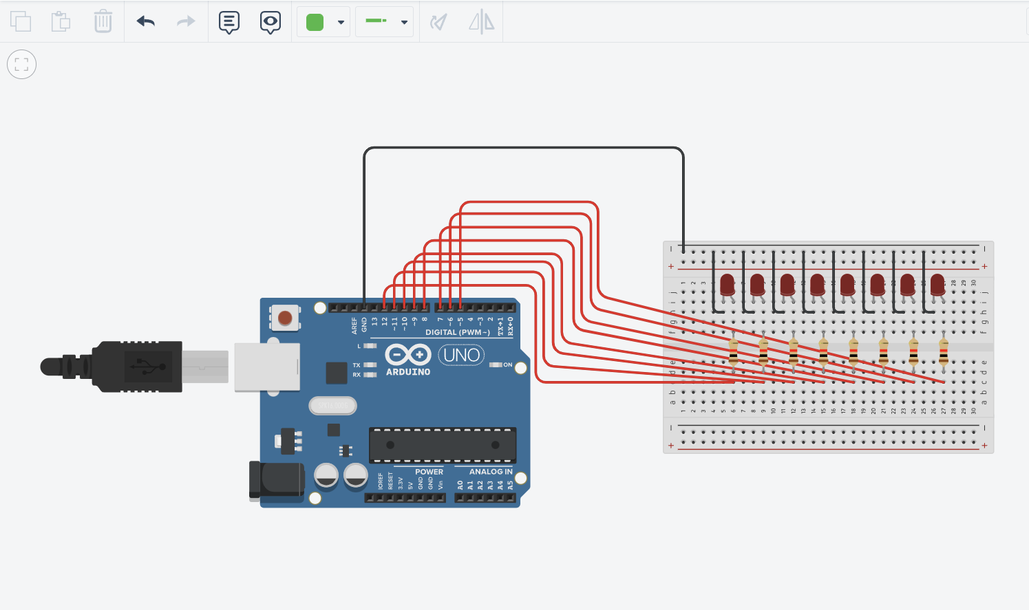

Figure No.1 Ring Counter Display Circuit Diagram

**Components Used**

1. 8 LEDs
2. Resistor
3. Breadboard

**CODE:**

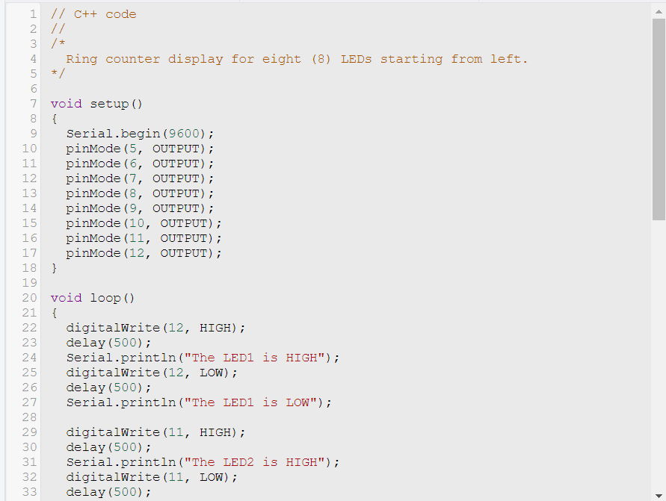

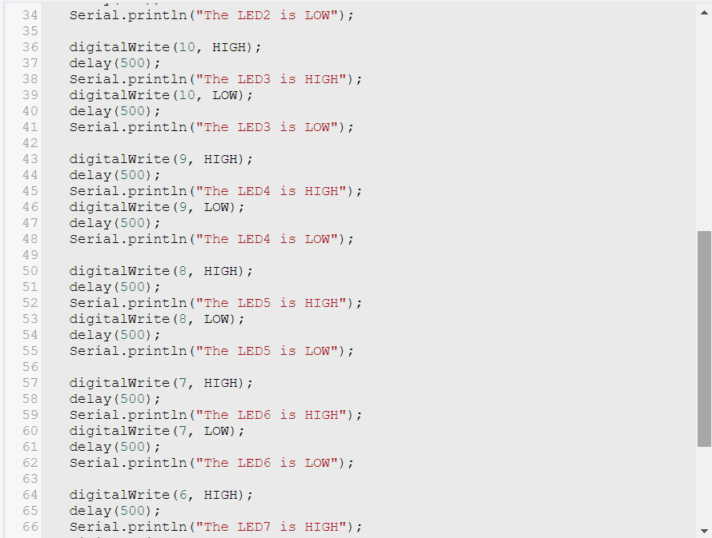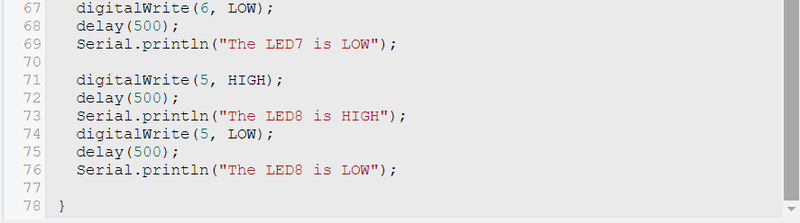

**Refer to this tinkercad link for my diagram:**

[**https://www.tinkercad.com/things/2dYEdtGLca5-incredible-fulffy/editelv**](https://www.tinkercad.com/things/2dYEdtGLca5-incredible-fulffy/editelv)

IV. Conclusion

*The given C++ code creates a visual effect using eight LEDs, illuminating them sequentially from left to right in a continuous loop and then turning them off in the same order. It utilizes two main functions, `setup()` and `loop()`. In the `setup()` function, it initializes serial communication and configures the LED pins as outputs.*

*The core functionality occurs in the `loop()` function, where LEDs are turned on one by one with a 500-millisecond delay between activations. The code communicates over a serial connection to indicate the active LED, aiding in real-time monitoring and debugging. After each LED is activated, it's promptly turned off, and a corresponding deactivation message is sent. This process repeats for all eight LEDs, creating a captivating ring counter LED display effect.*

*There's room for improvement by implementing loops and arrays for better code organization and flexibility, especially when adding or removing LEDs. Additionally, if serial communication isn't crucial, minimizing or removing excessive serial printing can enhance code execution speed. Overall, the code effectively manages LEDs, provides real-time feedback, and achieves the desired visual effect with opportunities for optimization.*

**References**

*For Loop Iteration (aka The Knight Rider) | Arduino Documentation*. (n.d.). Docs.arduino.cc. <https://docs.arduino.cc/built-in-examples/control-structures/ForLoopIteration>

*Led Four Bit Binary Counter Using Arduino | Tinkercad |*. (n.d.). Www.youtube.com. Retrieved September 30, 2023, from <https://www.youtube.com/watch?app=desktop&v=Ijczm6j2fDQ>

[1] D.J.D. Sayo. “University of the City of Manila Computer Engineering Department Honor Code,” PLM-CpE Departmental Policies, 2020.

*<This is in a separate page>*