**Microprocessor Lab**

Laboratory Activity No. 3

**Binary Representation of 8 LEDs in TinkerCad and Arduino Programming**

|  |
| --- |
|  |

Score

*Submitted by:*

**Antifona, Jedlyn D.**

**<Sat 1:00-7:00> / <CpE 0412-2>**

*Date Submitted*

**14-10-23**

*Submitted to:*

**Engr. Maria Rizette H. Sayo**

I. Objectives

This laboratory activity aims to implement the principles and techniques of hardware programming using Arduino through:

* To create Arduino circuit of Binary representation (decimal 0 – 256 using LEDs)

II. Method/s

* + Create own circuit diagram and provide code regarding Binary representation.

III. Results

**TinkerCad**

**Exercise 1: Write a code that does a binary representation display for eight (8) LEDs starting from left.**

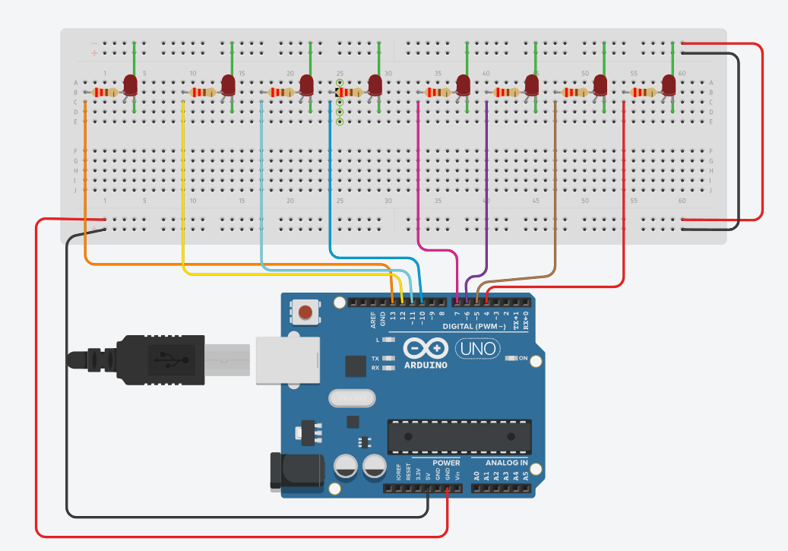

Figure No.1 Binary Representation Display Circuit Diagram

**Components Used**

1. 8 LEDs
2. Resistor
3. Breadboard

**CODE:**

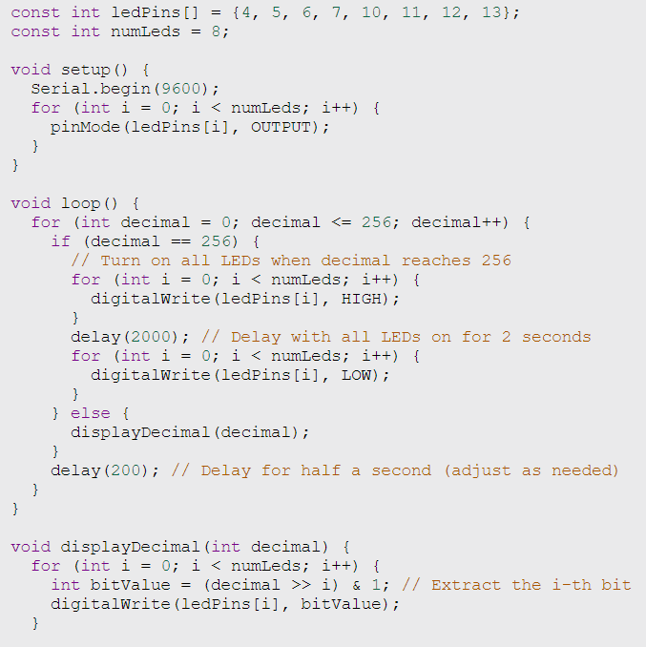

**Kindly refer with this link for my tinkercad diagram and code:**

<https://www.tinkercad.com/things/a7VJcdvgl6c-lab-3-microprocessor/editel?sharecode=Sjm_z8f5W__W5zVecOLep-YSajyxYYCCX2HDUX-ORnk>

**IV. Conclusion**

The provided code is the foundation of an Arduino project that manages an eight LED sequence, each attached to a different digital pins (4, 5, 6, 7, 10, 11, 12, and 13). The chosen pins are set up as outputs and serial connection is initialized in the setup() method. Using the displayDecimal() function, the code runs a loop from 0 to 256 times, sequentially turning on the LEDs to show the binary representation of the decimal number. All LEDs are momentarily lit for 2 seconds before being turned off when the decimal value reaches 256. Every 200 milliseconds, the display is refreshed. In order to dynamically light the LEDs in accordance with the binary value, the displayDecimal() function converts the decimal value into its binary equivalent. Additionally, it sends the decimal value to the Serial Monitor so that it can be monitored. For those who appreciate Arduino programming, this code structure is a priceless teaching resource because it makes binary counting and LED manipulation visually demonstrable.

**References**

*Led Four Bit Binary Counter Using Arduino | Tinkercad |*. (n.d.). Www.youtube.com. <https://www.youtube.com/watch?app=desktop&v=Ijczm6j2fDQ>

‌