Звіт до лабораторної роботи №2
Студента 307 групи
Добровольського Владислава
Код програми:
import math
import sys
import numpy as np
import matplotlib.pyplot as plt
import cmath

def f_rhs(t, x, y):
return (t / y, -t / x)

def exact_x(t): return math.exp(0.5*t*t)
def exact_y(t): return math.exp(-0.5*t*t)

def rk3_step(h, t, x, y):
k1x, k1y = f_rhs(t, x, y)
k2x, k2y = f_rhs(t + h/3.0, x + h/3.0*k1x, y + h/3.0*k1y)
k3x, k3y = f_rhs(t + 2.0*h/3.0, x + 2.0*h/3.0*k2x, y + 2.0*h/3.0*k2y)
x_out = x + h/4.0*(k1x + 3.0*k3x)
y_out = y + h/4.0*(k1y + 3.0*k3y)
return x_out, y_out

def am3_newton_step(h, tn, xn, yn, xn1, yn1, eps, maxit=30):

fxn, fyn = f_rhs(tn, xn, yn)
fx1, fy1 = f_rhs(tn+h, xn1, yn1)
tnp2 = tn + 2.0*h

x2, y2 = xn1, yn1

for _ in range(maxit):

fxp, fyp = tnp2 / y2, -tnp2 / x2

G1 = x2 - (xn1 + h/12.0*(5.0*fxp + 8.0*fx1 - fxn))
G2 = y2 - (yn1 + h/12.0*(5.0*fyp + 8.0*fy1 - fyn))

a11 = 1.0
a12 = (5.0*h/12.0) * (tnp2/(y2*y2))
a21 = -(5.0*h/12.0) * (tnp2/(x2*x2))
a22 = 1.0

det = a11*a22 - a12*a21
if abs(det) < 1e-15:
break

dx = (-G1*a22 + G2*a12) / det
dy = (-a11*G2 + a21*G1) / det

x2 += dx
y2 += dy
if abs(dx) < eps and abs(dy) < eps:
break

return x2, y2

def find_h_opt(eps, h0):
h = h0
while True:

x0, y0, t0 = 1.0, 1.0, 0.0
x1, y1 = rk3_step(h, t0, x0, y0)
x_big, y_big = am3_newton_step(h, t0, x0, y0, x1, y1, eps)

hh = h/2.0
xa, ya = rk3_step(hh, t0, x0, y0)
xb, yb = rk3_step(hh, t0+hh, xa, ya)
xc, yc = am3_newton_step(hh, t0, x0, y0, xa, ya, eps)
xd, yd = am3_newton_step(hh, t0+hh, xa, ya, xb, yb, eps)
x_half, y_half = am3_newton_step(hh, t0+h, xb, yb, xd, yd, eps)

err = max(abs(x_big - x_half), abs(y_big - y_half)) / 7.0
if err <= eps:
return h
h *= 0.5

def solve_task(eps=1e-5, h0=0.05, T=1.0):
h = find_h_opt(eps, h0)
print(f"h_opt = {h:.6g}\n")
header = "{:>8s} {:>12s} {:>12s} {:>12s} {:>12s} {:>12s} {:>12s}".format(
"t","x","y","exact_x","exact_y","err_x","err_y")
print(header)

t = 0.0
x = 1.0
y = 1.0
def row(tt, xx, yy):
print("{:8.4f} {:12.6f} {:12.6f} {:12.6f} {:12.6f} {:12.6f} {:12.6f}".format(
tt, xx, yy, exact_x(tt), exact_y(tt), abs(xx-exact_x(tt)), abs(yy-exact_y(tt))))
row(t, x, y)

x1, y1 = rk3_step(h, t, x, y); t += h
x2, y2 = rk3_step(h, t, x1, y1); t += h

if abs((t-h)*10 - round((t-h)*10)) < 1e-12: row(t-h, x1, y1)
if abs( t *10 - round( t *10)) < 1e-12: row(t, x2, y2)

tn = h
x_prev, y_prev = x1, y1
x_curr, y_curr = x2, y2
while t + 1e-12 < T:
x_next, y_next = am3_newton_step(h, tn, x_prev, y_prev, x_curr, y_curr, eps)
tn += h
t += h
x_prev, y_prev = x_curr, y_curr
x_curr, y_curr = x_next, y_next
if abs(t*10 - round(t*10)) < 1e-12:
row(t, x_curr, y_curr)

def am3_sigma(theta):

rho = cmath.exp(1j*theta)
alpha = rho*rho - rho
beta = (5.0/12.0)*rho*rho + (8.0/12.0)*rho - (1.0/12.0)
z = alpha / beta
return (z.real, z.imag)

def table_sigma(n=360):

th = np.linspace(0.0, 2.0*np.pi, n+1)
rows = []
for t in th:
u, v = am3_sigma(t)
rows.append((t, u, v))
return rows

def plot_boundary_and_region():

data = table_sigma(720)
uu = np.array([r[1] for r in data])
vv = np.array([r[2] for r in data])

def stable_mask(U, V):
Z = U + 1j*V
M = np.zeros_like(U, dtype=bool)
for i in range(U.shape[0]):
for j in range(U.shape[1]):
z = Z[i, j]
c2 = 1.0 - z*(5.0/12.0)
c1 = -1.0 - z*(8.0/12.0)
c0 = 0.0 - z*(-1.0/12.0)
roots = np.roots([c2, c1, c0])
if np.all(np.abs(roots) < 1.0 - 1e-12):
M[i, j] = True
return M

umin, umax = -10.0, 3.0
vmin, vmax = -10.0, 10.0
U, V = np.meshgrid(np.linspace(umin, umax, 240),
np.linspace(vmin, vmax, 240))
M = stable_mask(U, V)

plt.figure(figsize=(7,6))
plt.contourf(U, V, M, levels=[-0.5,0.5,1.5], alpha=0.75)
plt.plot(uu, vv, lw=1.3)
plt.axhline(0, lw=0.5); plt.axvline(0, lw=0.5)
plt.gca().set_aspect('equal', adjustable='box')
plt.xlabel("u = Re(σ)"); plt.ylabel("v = Im(σ)")
plt.title("AM3: Area of absolute stiykist")
plt.grid(True, ls='--', lw=0.3)

rho = 0.5
alpha = rho*rho - rho
beta = (5.0/12.0)*rho*rho + (8.0/12.0)*rho - (1.0/12.0)
z = alpha / beta
plt.scatter(z.real, z.imag, color='red', s=60, label='ρ = 0.5')
plt.legend()
plt.show()

if __name__ == "__main__":
try:
eps = float(input("eps: "))
h0 = float(input("h0 : "))
except Exception:
eps, h0 = 1e-5, 0.05
print(f"Using eps={eps}, h0={h0}.")
solve_task(eps, h0, T=1.0)

print("\nTable σ(θ)=u(θ)+iv(θ):")
tbl = table_sigma(36)
for i in range(min(10, len(tbl))):
th,u,v = tbl[i]
print(f"θ={th:8.5f} u={u:10.6f} v={v:10.6f}")

plot_boundary_and_region()

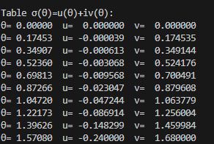
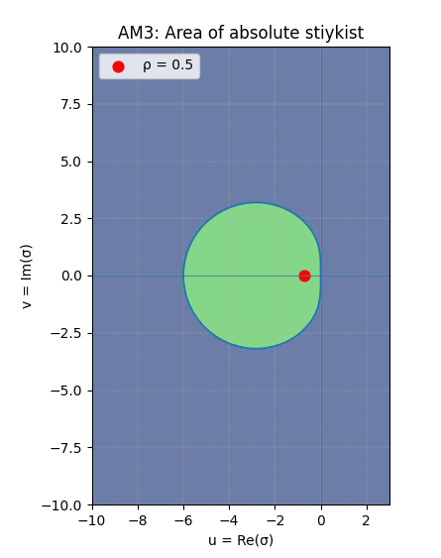
Також ми взяли точку для перевірки:
Підставили замість ро – 0.5.

