**Texas College of Management & IT**

**Lincoln University College**



**An Final Year Intern Report On**

**Content Management System (CMS)**

**At Texas Imaginology**

**Submitted by:**

**Roshika Dangal**

**LCID: LC00017000285**

**Texas College of management & IT**

***In partial fulfillment of the requirements for the Bachelor’s Degree in Information Technology***

**5th March, 2021**



**Recommendation Letter of Supervisor**

I hereby recommend that this internship report prepared under my supervision by

Roshika Dangal entitled “*Content Management System”* is accepted as fulfilling in partial requirements for the degree of Bachelor in Information Technology.

_____________________

Mr. Suraj Gautam

Project Manager

Texas Imaginology

(Internship Supervisor)



**LETTER OF APPROVAL**

This is to certify that this internship report prepared by Roshika Dangal entitled “Content Management System (CMS)” in partial fulfillment of the requirements for the degree of Bachelor in Information Technology has been well studied. In our opinion, it is satisfactory in the scope and quality as a project for the required degree.

|  |  |
| --- | --- |
| _____________________  **Internal Supervisor**  Lincoln University | _____________________  **Head of Department**  Mr. Suman Thapaliya  Department of BIT/BCS  Texas college of management & IT |

_____________________

**External Examiner**

Lincoln University

# ACKNOWLEDGEMENT

It is the matter of pleasure and gratitude to place you in this report which wouldn’t have been possible without the support and help of many individuals and organizations. I feel immensely happy to have this internship program in my course. I would like to take this opportunity to offer my earnest admiration to each and every one of them.

Firstly, I am really grateful to **Mr. Suman Thapaliya,** CEO of Texas ImaginologyandFormer IT Head of Texas College of Management and IT who really believed upon me and provided me with the great opportunity to work as an Intern at **Texas Imaginology**. I had a wonderful and a memorable experience being part of such a lovely and lively team.

I would like to express my sincere gratitude and indebtedness to my mentor **Mr. Suraj Gautam** for his relentless support, guidance and eminent mentorship. His valuable suggestion, guidance and kind supervision has encouraged me throughout the intern period and has enabled me to shape the present work.

I am highly indebted to **Texas College of Management and IT** for their guidance and constant supervision as well as for providing necessary information regarding the internship & also for their support in completing the internship report. Also, my special thanks go to **Mr. Chiran Rayamajhi** for his regular guidance and monitoring for preparing this report as it stands.

Finally, I am immensely obliged to the entire family of **Texas Imaginology** for their inspiration and encouraging guidance which really helped me towards achieving my goal. I am also thankful to my colleagues who irrespective of the situation, always encouraged and supported me to prepare this report.

Thanking You,

Roshika Dangal

# ABSTRACT

This internship report contains the details of the activities carried out during the internship conducted at Texas Imaginology, Kathmandu, Nepal. It was a real time work experience at Texas Imaginology. I had chance to learn about the system development aspect, agile workflow and the client support system. I was able to gather a lot of knowledge and experience from our mentor and other professionals. It also taught me on how to work in a group and be an efficient team member.

Mobile based applications are very popular in recent days. This type of application is popular. It is very easy to update and maintain mobile applications. In terms of accessibility, this type of application can be accessed from anywhere, anytime from any device supporting internet connection.

The “Content Management System” is web application. Main objective of content management system is to automate all functionalities of a college or university. Using this system you can manage all college management work like admission, fees submission, time table management and result declaration. Using this system you can view or update data and information about students and staff easily. This system helps in managing the activity like student admission, student registration, and fees submission. Admin can also retrieve information of employee student. Content Management System can store and manage all data of the various departments of a college like Administration, Attendance, Staff details etc. Using this system user can retrieve any information related to student, teacher and fees. Using this system teacher can check student attendance anytime. This system also help teacher to announce the result. College administration can also manage college work easily. Admin can check leave, salary and other details of teacher any time. They can also create time table of classes from this system. The Library module is used for the data process of library and book accessing for students and staffs.

I was assigned to develop and handle frontend platform for ‘Content Management System’ using Android.

**WEEKLY TIMETABLE**

|  |  |  |  |
| --- | --- | --- | --- |
| **Week** | **Working Department** | **Major Works** | **Approved by** |
| First (Aug1st- Aug5th) | Development | To know about project, features to be included and the general project flow diagram.   * The concept of Student Management System is studied along with its structure and flow of control. * Studied the SRS (System Requirement Specification) given | Suraj Gautam (Mentor, Project Manager) |
| Third (Aug 8th -Aug 12th) | Development | Know the new system of college admin.   * Studied the provided data and know basic information about the college and school administration. * Data collection that includes information regarding each faculties and different department of college and school. * We have the information about the sample system taken from different school and college so, it was very fruitful to start the project earlier. | Suraj Gautam (Mentor, Project Manager) |
| Third (Aug 15th -19th Aug) |  | To Startup the project   * The CIMS project is setup with the help of start.spring.io and Eclipse IDE. * The CIMS project is setup with the help of Android Studio and Java.   (Dashain Holiday during this week) | Suraj Gautam (Mentor, Project Manager) |
| Fourth (Aug 21st-Aug 26th) | Development | Learn about   * Application. Properties file, .xml file * Dependency Injection concept * Making banner for project. * MVVM pattern * Java Core Concept * Services in android | Suraj Gautam (Mentor, Project Manager) |
| Fifth (29th Aug -2nd Sept) | Development | Research and Implementation of   * Android Architecture * Spring inbuilt Security  Authentication and authorization. | Suraj Gautam (Mentor, Project Manager) |
| Sixth (Sept 5th -Sept 9th) | Development | Intergrations API for   * user registration, user edit, user delete, user retrieval by role, user retrieval by id. * user login, user logout, user password reset * Password Encryption using Gen Salt.   (Tihar Holiday) | Suraj Gautam (Mentor, Project Manager) |
| Seventh (Sept 12th- Sept 16th) | Development | Problem Resolution and improvement.   * Had problem in Rest API and solved it. * Encryption of username, user ID and role in token.   Integrations API for   * Account Section and Library Section | Suraj Gautam (Mentor, Project Manager) |
| Eighth (Sept 19th- Sept 23th | Development | * Explored GIT for version controlling * Making UI for Account. * Research on different android widgets and its implementation. | Suraj Gautam (Mentor, Project Manager) |
| Ninth (Sept 26th- Sept 30th) | Development | Making UI for   * Event Management in College and school. * Specifying User roles and permission for change. | Suraj Gautam (Mentor, Project Manager) |
| Tenth (3nd Oct– Oct 7th) | Development | Discussion on how to display account department content as per user need.  After discussion implementation of   * Different information or fees for library, admission, books, transportation, etc. * Projects API | Suraj Gautam (Mentor, Project Manager) |
| Eleventh (Oct 10th – Oct 14th) | Development | Learn about   * Expandable list view. * Dependencies used in android gradle file. | Suraj Gautam (Mentor, Project Manager) |
| Twelfth (Oct 17th- Oct 21st) | Development | Discussion on project accomplishment and to do list.  Learned about Rest API and its integration. | Suraj Gautam (Mentor, Project Manager) |
| Thirteenth (Oct 24rd - Oct 28th) | Development | Had to change the design pattern according to the new system of college and school. | Suraj Gautam (Mentor, Project Manager) |
| Fourteenth (31th Oct – 4th Nov) | Development | * Integrate API to list of students who paid the fees according to the section. | Suraj Gautam (Mentor, Project Manager) |
| Fifteenth (Nov 7th- Nov 11th) | Development | Made different Changes in again in UI of account. | Suraj Gautam (Mentor, Project Manager) |
| Sixteenth (Nov 14th- Nov 18th) | Development | * Made necessary changes in different part of the account section. * Made some corrections on API along with documentations. * Had a problem with the filter as it always shows a cross origin problem in the front end and fixed it. * Refined API for Event. | Suraj Gautam (Mentor, Project Manager) |
| Seventeenth (Nov 21th- Nov 25th) | Development | Working on bugs on   * Pagination * Account section not showing contact info. * Spring authentication revised and code optimized. | Suraj Gautam (Mentor, Project Manager) |
| Eighteenth (Nov 28th- Nov 31st) | Development | * Research on SQLite database and firebase database. * Tested the system and fixed bug. * Done research on Jenkins for War file deployment. * Optimization and refinement of code. * Deployment in Live Server | Suraj Gautam (Mentor, Project Manager) |

Fig. Weekly Timetable

**TABLE OF CONTENTS**

0

ACKNOWLEDGEMENT i

ABSTRACT ii

LIST OF TABLES x

LIST OF FIGURES xi

ABBREVIATIONS xii

CHAPTER 1: INTRODCTION 1

1.1 Introduction to Internship 1

1.2 Purpose of Internship 1

1.3 Objective of Internship 2

1.4 Motivation 3

1.4.1 Motivation for choosing Mobile development 3

CHAPTER 2: DESCRIPTION OF THE ORGANIZATION 4

2.1 Introduction to Organization 4

2.2 Contact Information 4

2.3 Major Function of Organization 5

*2.*3.1 Website Design and Development 5

*2*.3.2 Search Engine optimization 5

*2*.3.3 Graphic Design 5

*2*.3.4 Mobile Application Development 5

*2*.3.5 Web Analytics 6

2.4 Organization Selection 6

2.5 Organization Hierarchy 6

2.5.1 Management Team 6

2.5.2 Administrative Department 7

2.5.3 Software Development Team 7

2.5.4 Software Deployment Technical Team 7

2.6 Placement 8

2.7 Duration and Internship Plan 9

2.8 Responsibilities Assigned 9

CHAPTER 3: INTERN ACTIVITIES 11

3.1 Learning the process 11

3.1.1 Android 11

3.1.2 Android Studio 11

3.2 System Overview of College Management System 12

3.3 Understanding of Existing Projects 13

3.4 Setting Project Objectives 13

3.5 Requirement Analysis 13

3.5.1 Functional Requirement 13

3.5.2 Non Functional requirement 14

3.6 Defining the Context 14

3.7 System Design 15

3.7.1 ER-Diagram 15

3.8 Understanding of JSON 16

3.9 Development of API 16

3.10 JSON Parsing 16

3.11 User Interface Design 17

3.12 Group discussions and meetings 17

CHAPTER 4: IMPLEMENTATION AND TESTING 18

4.1 Implementation 18

4.1.1. Analysis and Design Tools 18

4.1.2. Implementation Tools 18

4.1.2 Tool Used 19

4.3 Usability Testing 19

4.3.1 Test for Navigation 19

4.3.2 Context Checking 19

4.4 Compatibility Testing 19

4.4.1 Browser Compatibility 20

4.4.2 Mobile Browsing 20

4.5 Performance Testing 20

• Web load testing 20

• Web stress testing 20

4.5.1 Web load testing 20

4.5.2 Web stress testing 20

CHAPTER 5: ASSESMENT OF INTERNSHIP 22

5.1 Learn from the internship 22

5.1.1 Work in Corporate Environment 22

5.1.2 Team Work and Collaboration 22

5.1.3 Working Mechanism of the Mobile Development 22

5.1.4 Implanting the Algorithm in Project 22

5.1.5 Use of different Tools 23

5.2 Challenges 23

5.2.1 Manage time 23

5.3 Influence to Future Career 23

5.3.1 Knowledge gain 23

5.3.2 Opportunity to learn from failure 24

5.3.3 Use of theoretical study 24

CHAPTER 6: CONCLUSION AND LIMITATION 25

6.1 Limitation 25

6.2 Recommendation to organization 25

6.3 Recommendation to Internship Program 26

6.4 Conclusion 26

REFERENCES 27

APPENDIX 28

# LIST OF TABLES

Table 1: Weekly Table ................................................................................................... iv

Table 2: Duration of internship ........................................................................................9

# LIST OF FIGURES

Figure 1: Organizational Hierarchy ..................................................................................8

# ABBREVIATIONS

CMIS : College Management Information System

UI : User Interface

API : Application Programming Interface

XP : Extreme Programming

OS : Operating System

DFD : Data Flow Diagram

JSON : Java Script Object Notation

# CHAPTER 1: INTRODCTION

## 1.1 Introduction to Internship

An internship is a pre-professional experience that provides an opportunity to gain relevant knowledge and skills prior to starting out in a particular career field. Internships are relatively short term in nature with the primary focus on getting some the job training and taking what’s learned in the classroom and applying it to the real world. Inters generally have a supervisor who assigns specific task and evaluates the interns overall work.

The internship program is designed to provide students engaged in a field experience with an opportunity to share their insights, to explore the links between students' academic preparation and their field work, and to assist participants in developing and carrying out the major research project which will serve to culminate their internship experience.

The Internship Program aims to provide students the opportunity to consolidate their theoretical foundation through practical experience. A major component of this experience is the formation of a professional attitude. The students are expected to develop their personality and capacity to adapt to, and handle, challenging situations in the real business world. Through the internship program, the students should be able to acquire transferable skills such as communications skills, interpersonal skills, technical skills, teamwork skills, management skills and problem-solving skills. Last but not least, the students can explore their interest in future career development.

## 1.2 Purpose of Internship

An internship is a work-related learning experience for individual who wish to develop hands on work experience in a certain occupational field. Internship program provides a new perspective to the students. It provides learning opportunities outside the boundaries of the course curriculum and classroom activities. During this period, interns have the opportunity to explore their field of interest, find out what future they are diving into and whether or not their skill sets match their path of career. An internship can be practically any experience that combines learning with hands-on activity. Generally, Internship have following purposes:

* To develop professional skills and experience the real work environment in the field of interest by involving in real field project.
* To increase confidence and real-world work experience in interested field.
* To develop the group work capability and get connected with practitioners in one’s area of interest

From the student perspective, internship involves working in your expected career development such as coding, programming, networking, marketing, etc by providing vital work experience that allows students to explore their area of interests and develop relevant skills and competencies.

From the organization perspective, internship provides a unique opportunity to train fresh talents, enhance their professional development as well as aid the professional growth of the intern mentor/supervisor. Organizations can also find potential employees within the interns.

## 1.3 Objective of Internship

An Internship program is an opportunity to integrate career related experience into an undergraduate education by participating in planned, supervised work. This can be practically any experience that combines learning with hands-on activity. The following are the internship objectives that are to be achieved:

1. Provide students the opportunity to relate theory to practice.
2. Give students in-service orientation to a career area they may wish to pursue.
3. Give students opportunity to work in their area of intended specialization.
4. Enhance students understanding of organizational and group processes.
5. Enhance student’s awareness of public service obligations.
6. Develop an ongoing relationship between the academic and practitioner community.

## 1.4 Motivation

An internship provides a motivation to come up the challenges, and create w working environment in the industrial production of the IT solution and services. It encourages team coordinate and discipline working in the real field for implementing the theoretical knowledge.

### 1.4.1 Motivation for choosing Mobile development

Mobile development has become a vital requirement and its scope is increasing every day. Mobile development is a field where you can have the opportunity to not just write codes but it also gives you the opportunity to use and enhance your creativity. This internship program as mobile development strongly motivated to gain experience and will be beneficial for my future career in the field of Information Technology.

# CHAPTER 2: DESCRIPTION OF THE ORGANIZATION

## 2.1 Introduction to Organization

Texas Imaginology is a software development company based in Nepali Actively working as a software development company. It has been serving clients with services like web designing, web development, search engine optimization, graphics designing and lot more.

Texas Imaginology is a company established with concrete aims to catapult the growing prospect of IT in Nepal to the un-scalable height by providing qualitative training, developing web based applications, desktop based application, Data Entry, webpage design and development & other computer related job independently. It finds technical solutions for the clients and students final year projects. Typically, this would mean it builds software products for the clients. It has a group of designers, Software engineers and content specialists. Together they form one of the leading custom software companies in Kathmandu for software development outsourcing. It offers software and content management services to international customers across multiple industries. It understands the challenges that its clients face within and across these industries. It provides practical, pragmatic and powerful solutions to address those challenges. Getting software out to 8 its users is the single goal that drives Step Up. It's mix of skills and talent means it has everything to meet that goal in one place. Design, development, content, testing, deployment and anything in between those clearly defined roles — Texas Imaginology cover it all.

## 2.2 Contact Information

The contact detail of Texas Imaginology is given in the following table.

|  |  |
| --- | --- |
| Type of firm | Lead form |
| Name of the form: | Texas Imaginology |
| Address | Mitrapark, sifal, Kathmandu |
| Telephone no: | +977-1-45345344 |
| Type of firm: | Private |
| Email: | info@texascollege.com |
| Contact Person Details: | Name: Bhes Raj Pokhrel  Designation: CEO  Mobile: +977- 9801644450 |

## 2.3 Major Function of Organization

### *2.*3.1 Website Design and Development

The organization provides professional website design, development and maintenance services. A skilled term of web designer and developers undertake various website projects on every platform of any complexity and provide the best website design and development in Nepal based on the latest technologies and industries trends.

### *2*.3.2 Search Engine optimization

Organization helps to increase the amount of visitor to a website by applying various strategies, technique and tactics and make a website obtain high-ranking placement in the search result page of a search engine (SERP)—including Google, Bing, Yahoo, and other search engines.

### *2*.3.3 Graphic Design

Graphic design is the process of visual communication and problem-solving through the correct use of typography, space and color. Texas Imaginology gives a services of Logo design, planning, analysis, logical design, physical design, implementation and maintenance.

### *2*.3.4 Mobile Application Development

They are expert in IOS and Android applications for transforming a complex business logic into a great mobile app experience.

### *2*.3.5 Web Analytics

They analyze and monitor whether or not sites pages are working properly. They give us an information about which areas of the site are popular and which area of the site do not get traffic.

## 2.4 Organization Selection

Among the criteria and sector based on the requirement of course, mobile development was chosen. Various organization is short listed and approached out. Selection of a proper organization is one of the important parts of internship program since it is a kind of industrial attachment project. A proper organization can give better exposure to the real work environment which is the essential objective of internship program. The priority was the selection of organization that has sufficient resource and better learning environment. I selected Texas Imaginology, an IT company that provides mobile-based services for national and international clients.

## 2.5 Organization Hierarchy

Texas Imaginology has a hierarchical organization structure. It has different department to facilitate the business process that have good coordination among each other which is show in figure below. The CEO of Texas Imaginology is responsible for directing over the operations and technology teams to make sound decisions and achieve better outcome for the business. CTO is responsible for the technology vision and the development effort for delivering high quality and cost effective services and solutions. Similarly, COO is responsible for operational management. Under the supervision of Project manager there are different teams as:

### 2.5.1 Management Team

Management team is responsible for overall management of the firm at Texas Imaginology. Chief Executive officer is responsible for execution of plan and policies of the firm. Managing director is responsible for implementing company policy, developing strategic plans and building an effective management team. CEO has responsibility for creating, planning, implementing and integrating the strategic direction of firm. Finance director prepare strategic plan and policies for finance and finance controller look for a best way to control financial condition of an organization. CTO task is to manage and control all technical aspects of firm.

### 2.5.2 Administrative Department

This department is responsible for carrying out day to day administration of the firm. Admin officer looks after all the administrative work to be performed, Accountant looks after day to day financial transaction, sales manager looks after the sale of an organization, front desk receptionist look after all visitors of the organization and deal with them whereas marketing officer perform the task of marketing the software product and system developed by the firm.

### 2.5.3 Software Development Team

This department is responsible for carrying out the entire development related task under the supervision of CTO, product manager and project manager or supervisor. Coding, Designing, Database Design are some of the task done by software development team.

### 2.5.4 Software Deployment Technical Team

Software Deployment Technical team is responsible for testing, deployment and analysis of software in between the development process or after complete development of the software. This team is comprises of software tester, quality controller, quality assurance, technical engineer and technical support personnel. Deployment and publishing of software is one of the major task of this team. Support after the deployment of software in client side is provided under the supervision of this team.

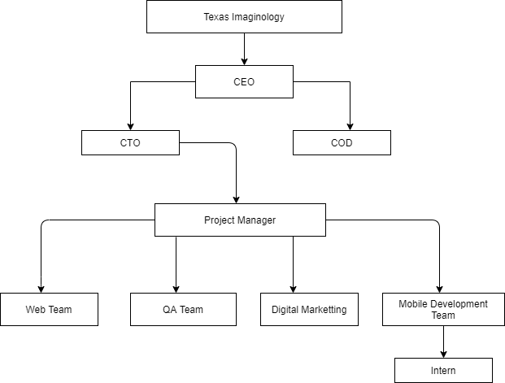

*Figure 1: Organizational Hierarchy*

## 2.6 Placement

To get the organization for the internship, the authorities of the organization carried out an interview. Upon being selected for the internship, the organization was joined on. During the internship period, the organization provided me with the work space. The working environment was good. Regular visit of the project supervisor was done to deliver the updates about the project progress

## 2.7 Duration and Internship Plan

As per the requirement of the Lincoln University I had done our internship for 12 weeks dated from October 12, 2020 to January 6, 2021, where different tasks related with the project were assigned and completed within given time limit.

|  |  |
| --- | --- |
| **Particular** | **Time** |
| **Start Date of the Internship** | July 26th 2020 |
| **End Date of the Internship** | October 18th 2021 |
| **Total Duration** | 12 Weeks |
| **Position** | Android Developer |
| **Mentor** | Mr. sudin gautam |
| **Supervisor** | Mr. suman thapaliya |
| **Office Hour** | 5 pm – 7pm |
| **Working Hour** | 2 hour per day |
| **Working Days** | 2 days per week |

*Table 2: Duration of internship*

## 2.8 Responsibilities Assigned

During internship at Texas Imaginology, the target was to meet the necessity of the developing applications that would meet the digital world slowly turning its pace into the mobile application. During development period various activities and task as per the requirement of the both the organization and the project were involved. We were assigned to study and conduct research on application development. After knowing the fundamental of mobile application the development of application took its way much easier along with the help of internet information and idea. I worked as an Android Application developer.

A verity of task performed are described below:

* Implement android for designing front end of Admin panel.
* Handling the JSON value
* Fetching Rest API

# CHAPTER 3: INTERN ACTIVITIES

## 3.1 Learning the process

The first activity as an intern for me was to learn the process of the company that assisted in being familiar to the tools used and the process that was followed in the organization for accomplishing a project. In this process, the guidance of the mentor and the seniors helped me a lot. Also in the course, I learned even more about the tools that I was to use to complete the assigned project through different tutorials and mentor’s assistance.

I learned the following tools were used in the organization for developing a system.

### 3.1.1 Android

Android is an open source and Linux-based Operating System for mobile devices such as smartphones and tablet computers. Android was developed by the Open Handset Alliance, led by Google, and other companies.

Android offers a unified approach to application development for mobile devices which means developers need only develop for Android, and their applications should be able to run on different devices powered by Android.

### 3.1.2 Android Studio

Android Studio is the official Integrated Development Environment (IDE) for Android app development, based on IntelliJ IDEA. On top of IntelliJ's powerful code editor and developer tools, Android Studio offers even more features that enhance your productivity when building Android apps, such as:

* A flexible Gradle-based build system
* A fast and feature-rich emulator
* A unified environment where you can develop for all Android devices
* Apply Changes to push code and resource changes to your running app without restarting your app
* Code templates and GitHub integration to help you build common app features and import sample code
* Extensive testing tools and frameworks
* Lint tools to catch performance, usability, version compatibility, and other problems
* C++ and NDK support
* Built-in support for Google Cloud Platform, making it easy to integrate Google Cloud Messaging and App Engine

**3.1.3 Version Control System**

Version control systems are a category of software tools that helps in recording changes made to files by keeping a track of modifications done to the code.

As we know that a software product is developed in collaboration by a group of developers they might be located at different locations and each one of them contributes in some specific kind of functionality/features. So in order to contribute to the product, they made modifications in the source code (either by adding or removing). A version control system is a kind of software that helps the developer team to efficiently communicate and manage (track) all the changes that have been made to the source code along with the information like who made and what change has been made. A separate branch is created for every contributor who made the changes and the changes aren’t merged into the original source code unless all are analyzed as soon as the changes are green signaled they merged to the main source code. It not only keeps source code organized but also improves productivity by making the development process smooth.

## 3.2 System Overview of College Management System

College Management Information System is Mobile Based application whose aim is to automate all functionalities of a college or university. Using this system you can manage all college management work like admission, fees submission, time table management and result declaration. Using this college management system you can view or update data and information about students and staff easily. This system helps in managing the activity like student admission, student registration, and fees submission. Admin can also retrieve information of employee student. This system can be used to store student information like attendance, fees, and student result etc. admin can create report regarding any student any time using this system. Using this system you can register new student and their course details. You can submit student’s fees and can check fees details anytime. You can create exam result and submit in this system. Student can check their result online by logging to the system. You can also add new employee in the system and can check details of the employee easily. Student can also check course detail online from this system

Using this system you can manage all information of all aspects of a college, its students, faculties, Departments, marks and other curricular activities. College management system provides the easiest way to manage all functionalities of a college. This system facilitates colleges to maintain the functionality related to college employees and their students.

College Management System can store and manage all data of the various departments of a college like Administration, Attendance, Staff details etc. using this system user can retrieve any information related to student, teacher and fees. Using this system teacher can check student attendance anytime. This system also help teacher to announce the result.

College administration can also manage college work easily. Admin can check leave, salary and other details of teacher any time. They can also create time table of classes from this system. The Library module is used for the data process of library and book accessing for students and staffs.

## 3.3 Understanding of Existing Projects

## 3.4 Setting Project Objectives

After studying the existing systems, we found out what our project was supposed to do and set the following objectives.

* The main objective of developing the current project entitled “COLLEGE MANAGEMENT SYSTEM” is to build effective system which is fast, accurate, consistency, reliable and flexible enough so that it can incorporate any future enhancements.
* By automating the system using computers, sophisticated technology can be used for making the information more flexible, accurate, and secure and user friendly.
* Time and man power can be more effectively utilized and online information can be easily available to the user and at the same time we can maintain higher level of security.
* Every user such as student, staff and administration can able to see the information of each student through online from anywhere and anytime.
* To manage the information of student and track all the information of student, salary and employee.

## 3.5 Requirement Analysis

Requirement Analysis is a first step in project development process. We performed the task for determining the needs and condition of the mobile development taking possibility of possible conflicting requirements of all the stakeholders, such as beneficiaries or users.

### 3.5.1 Functional Requirement

A functional requirement defines a function of a system or its component. Functions are the set of input, the behaviors and outputs. Functional Requirements may be calculations technical details, data manipulation and processing and other specific functionality that define what system is supposed to accomplish.

Some functional requirement of system is given below:

1. Assign Students to their respective courses along with their respective sections

2. Assign Teachers to their individual and specific time and subject criteria.

3. Assign librarian to keep records of students’ involvement in library.

### 3.5.2 Non Functional requirement

Non-functional requirement deals with the quality and performance of the system. It focuses on security, advancements and performance mechanism of the system. The nonfunctional requirement of our system is as follows:

1. Keep the Students and teachers updated about different events.

## 3.6 Defining the Context

A context diagram in [engineering is](https://en.wikipedia.org/wiki/Engineering) a [diagram th](https://en.wikipedia.org/wiki/Diagram)at defines the boundary between the [system,](https://en.wikipedia.org/wiki/System) or part of a system, and its environment, showing the entities that interact with it. This diagram is a high level view of a [system. I](https://en.wikipedia.org/wiki/System)t is similar to a [block diagram. T](https://en.wikipedia.org/wiki/Block_diagram)he context diagram for the assigned project is shown below in the figure:

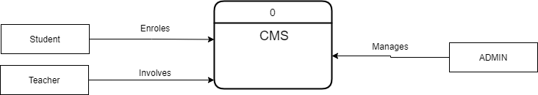

Figure: Context Diagram

## 3.7 System Design

### 3.7.1 ER-Diagram

An entity relationship diagram (ERD), also known as an entity relationship model, is a graphical representation of an information system that represents the relationships among entities, objects or events within that system.

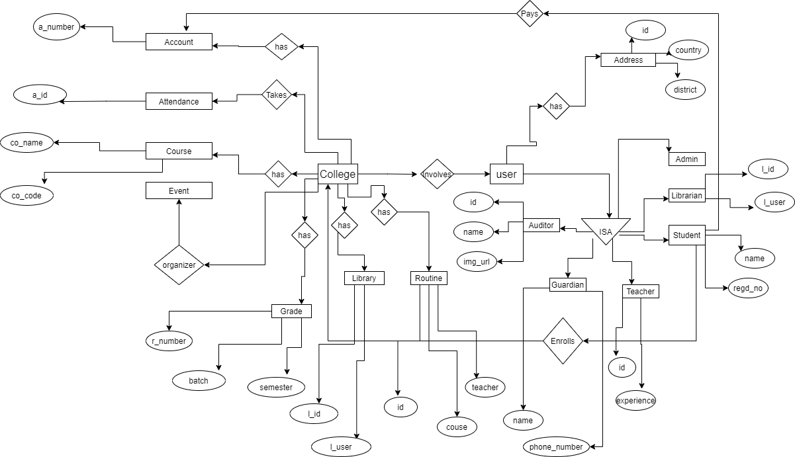

Figure: E-R Diagram

## 3.8 Understanding of JSON

JSON stands for JavaScript Object Notation. JSON is a lightweight format for storing and transporting data. JSON is often used when data is sent from a server to a web page. JSON is "self-describing" and easy to understand. In the system that I involved in the internship have built the rest API which is in the JSON form.

Type of JSON

* Simple JSON
* Hierarchal JSON

## 3.9 Development of API

The College Management System will be available to both web and mobile. We have built the API for this project for building an API we have used Spring Boot and JPA.As we have to work on the cross platform (Java, React, Android) the filter is used to work on cross platform.

## 3.10 JSON Parsing

A JSON parsing is needed to send data form the web pages to the server or getting the data to web pages from the server. As we have used the rest API and the JSON parsing is needed in the system. The process of JSON parsing is given below in figure:

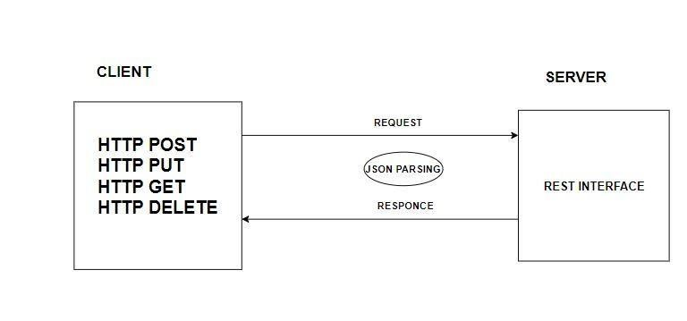

*Figure 2:System Architecture*

## 3.11 User Interface Design

In my internship period, I have done following tasks assigned by the android department.

Routine Section Design: In the First week of my internship, I was assigned with a Simple Task "Routine Section Design" of student management system. I use android studio as IDE and java as programming language. In this period, I learned much about android app development. How to link front end design to java code as backend. Project structure of android studio. How the xml file interacts with java code. And learned about android app life cycle.

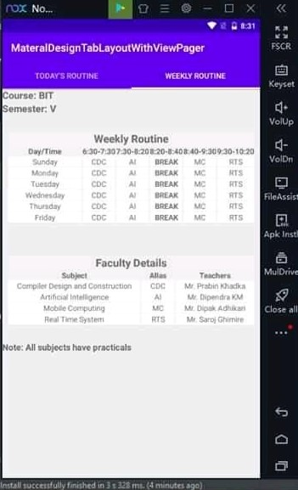

## 3.12 Group discussions and meetings

Apart from all the project related activities, one of the most important task was also carried out throughout the internship period that was discussions and meetings.

* Team members were supposed to attend a daily discussion about the progress of project.
* Meeting with the mentor was conducted weekly to discuss the progress and to get the feed backs from him to improvise the project.

# CHAPTER 4: IMPLEMENTATION AND TESTING

## 4.1 Implementation

The main purpose of implementation of this system is to manage Students’, Teacher’s, Courses’, academic and economic data as well data of extracurricular activities in computerized manner.

### 4.1.1. Analysis and Design Tools

* There is various presence of designing tools to create figures and diagrams like entity relationship diagram, flow chart, use case diagram and other desired diagram. In this project draw.io was used for diagrammatic design of the proposed system.

* Use case diagram and activity diagram of the system is used to analyze system design. The figures and diagrams help to analyze the system and release the information required to maintain the interaction with the system. It also makes the development process easier and faster.

### 4.1.2. Implementation Tools

* The tool implemented for the programming logic of the system is Java and JavaScript language.
* Front end of the system is developed by using Android

### 4.1.2 Tool Used

**Draw.io**

In the system structuring part of the report organization, ER Diagrams, DFDs and Use case diagrams were drawn with the help of the case tool called Draw Io. It is an easy tool for constructing different types of diagrams providing necessary images, shapes etc. It also provides some standards that are available in designing.

## 4.3 Usability Testing

### 4.3.1 Test for Navigation

Navigation means how a user surfs the web pages, different controls like buttons, boxes or how the user uses the links on the page to surf different page.

Usability Testing includes the following:

* Web application should be easy to use.
* Instructions provided should be clear.
* Main menu should be provide in each page.
* It should be consistent enough.

### 4.3.2 Context Checking

The context checking, I have done is given below:

* Check for spelling errors
* Use of annoying color in system
* To follow standards for web page and context building
* To check color fonts and frames

## 4.4 Compatibility Testing

Compatibility of your website is very important testing aspect. See which compatibility test can be executed:

* Browser Compatibility Testing
* Mobile Browsing

### 4.4.1 Browser Compatibility

In my web testing career I have experienced this as most influencing part on the website testing.

Some application is very dependent on browser. Different browser has different configuration and setting that your web page should be compatible with. Web application should be cross browser platform. I have tested in Google chrome, Mozilla, torch Internet Explorer.

### 4.4.2 Mobile Browsing

A web application should run in mobile also so we have to check weather a application is compatible with the mobile or not. The mobile browsing helps to check weather a application is responsive or not.

## 4.5 Performance Testing

Web application should sustain heavy load. Web performance testing should include:

## Web load testing

## Web stress testing

The application performance on different internet connection speed.

### 4.5.1 Web load testing

We need to test if many users are accessing or requesting the same page. System sustain in peak load times. To handle the many request at a time I have used number of PC to request the same page so that the load is maintain in the system.

|  |  |  |  |
| --- | --- | --- | --- |
| Test cases | Steps to be executed | Expected results | Pass/Fail |
| New admin creation from 10 different device | a.Go to admin panel page of system  b.Enter credential for admin creation | Web load testing is pass if admin is created from all device | Pass |

Table: Web load testing

### 4.5.2 Web stress testing

Generally, stress means stretching the system beyond its specified limits. Web stress testing is performed to break the site by gibing stress and its checked as how the system reacts to stress and how it recovers from crashes. Stress is generally given on input fields, login and sign up areas. In my internship, I was able to test the login system by given number of username and password.

|  |  |  |
| --- | --- | --- |
| Test cases | Results | Pass/Fail |
| Multiple wrong username and password is sent | Alert is shown for every username and password | Pass |

Table: Web stress testing

# CHAPTER 5: ASSESMENT OF INTERNSHIP

## 5.1 Learn from the internship

The time I have spent at Texas Imaginology as an intern, was a great experience. I got opportunity to learn in a professional environment. This helped me to improve my skills, knowledge, abilities and to work in a group. Apart from this,

* I have learned that problem solving skill is very important.
* It helped me develop a strong work ethic.
* It helped me realize that in professional world deadline is a very serious subject and hence proper planning and work discipline must be maintained throughout the office period.

### 5.1.1 Work in Corporate Environment

The internship program presented me with the opportunity to work in real world working scenario and experience the workplace culture and tradition.

### 5.1.2 Team Work and Collaboration

Team work and collaboration is vital in context of an organization. I experienced how the project is completed with the combined efforts of all group members. Additionally, I came to know several tools that is used to develop the web application in organization.

### 5.1.3 Working Mechanism of the Mobile Development

Good understanding of how Mobile development is processed in real world helps to develop the system. The internship program helps me to well verse in working mechanism of the mobile development using android along with other tools.

### 5.1.4 Implanting the Algorithm in Project

In studies we study many algorithms but, implementing the algorithm in the real field is little different and we have to select the best algorithm that is feasible for the project.

### 5.1.5 Use of different Tools

During the course of the internship I came to know about different tools that is used in the mobile development. While every tool is not easy to begin with, but strong desire and sheer will power has made me to understand many tools that is used.

#### 5.1.6 Monitor Analyze the Test Result

During the course of the testing the analysis of the test result is very important we should analyze the result and make sure that the correct result should be accepted.

## 5.2 Challenges

### 5.2.1 Manage time

Challenging part I face is to manage time, no matter how I try hard I will always feel pressure of deadline at last moments.

# 5.3 Influence to Future Career

Internship is the basic step for a professional career. Internship is a different world from college. It is a platform to learn practically. During the internship period I following points help me in career.

### 5.3.1 Knowledge gain

It is not possible to estimate the practical situations while studying in a classroom, an internship is a platform where one can get huge stuff to learn and the best chance to handle the situation. You can even see how an ideal company follows standards and principles. How an Organization structure works, its limitations, learn skills from each and every member that you come across through the training, inspire from the leadership how they handle the team and how they direct you to work. You will undergo how to handle pressure and satisfy the customers with your service.

### 5.3.2 Opportunity to learn from failure

During the internship you will be allocated with a trainer or a guide, they teach you and train you. They allow you to practice and your work will be cross-checked by them so that you can try and even if you fail at something, you get the opportunity to learn from it and can improve yourself to give best. You can ask as many queries as possible while learning. Do not let yourself down and realize your capability. By taking feedback from employees one can understand where the intern is lagging behind in the field and plan to meet the requirements.

### 5.3.3 Use of theoretical study

Many of us would have studied a lot during their academic period, we will have an idea of how the industry works, but practically it is a bit different. We may face certain issues while implementing them into action, the intern will have a chance to come across through that phase. We can experience the real competitive world during training, they also get to experience with new equipment, updated standards in their field. Also, internship can impress the interviewer to land a job.

# CHAPTER 6: CONCLUSION AND LIMITATION

## 6.1 Limitation

The limitation of this system are as follows:

* These types of CMS are already available in our markets, but it does not have the feature that we are providing to our college.
* The main functionality such as ENTERING AND RETRIVING of the attendance in the CMS will not be provided by the companies who had developed this project earlier.
* We are going to introduce our project on a special platform JAVA, Android, & React which is very user friendly.
* Here we will provide the high permissions to the Admin so he can handle the complete college for better security and maintenance.
* There will be different permissions to the admin and faculty and also to the student.

## 6.2 Recommendation to organization

Texas Imaginology might be a perfect organization to apply for an intern in development of mobile and web application since the working environment of the organization is very much good. Also proper guidance is given by the experienced employee. The organization could be better if size of the human resource is increased and different methodology is followed for rapid development.

## 6.3 Recommendation to Internship Program

The university has put great effort to include various courses that would help in the real world working environment. The university must execute some research and studies to select the course that fulfill the current market requirements that would help the students to qualify themselves in the practical implications as well. However, still lots of efforts are to be made because the current courses and knowledge gained in college is still not sufficient enough to work in practical environment. Internship must be thought as a learning process which guides individual work in the practical environment, and then only true benefits of internship can be obtained.

## 6.4 Conclusion

Along with the completion of my three months’ internship program, I have acquired the most essentials experiences of team work and many more. I am thankful to all of colleague in Texas Imaginology for their tremendous help that they provided me during the internship.

# REFERENCES

* [ONLINE] Available at: [https://1000projects.org/college-management-systemcms.html.](https://1000projects.org/college-management-system-cms.html) [Accessed 19 December 2020].

* [ONLINE] Available at: [https://www.slideshare.net/mohit0749/collegemanagement-system-project-48367405.](https://www.slideshare.net/mohit0749/college-management-system-project-48367405) [Accessed 19 December 2020].

* [ONLINE] Available at: https://developer.android.com/studio/intro. [Accessed 20 December 2020].

* [ONLINE] Available at: http://texascollege.edu.np/. [Accessed 20 December 2020].

* [ONLINE] Available at: https://www.academia.edu/37015964/Android_Application_for_College_Managem ent_System. [Accessed 20 December 2020].

# APPENDIX

