
- Write and submit deliverable2 report based on report template guidelines and your mentors, instructor’s guidance
- The report should include all sections mentioned in syllabus for deliverable2
Department of Electrical Engineering & Computing Sciences
Academic Year | 2025-2026
Semester |  | Fall Spring | Summer
Course Code - Name | ISTE-500.600 Senior Development Project I
Instructor | Huda Saadeh
Exam | - Quiz/Test | Assignment Mid  Deliverable2 Report | Final | - Other
Start Date | Mon., Sep. 29, 2025
Duration | 6 Weeks / Due Sun. Nov 9, 2025

Student ID | Student Name
396001477 | Jeeda Kotob
396004854 | Ryma Ait Tayeb
771008583 | Ibraheem Mustafa

CLOs:
  - Apply requirements elicitation methods in an extra-classroom environment.
  - Architect an effective, user-centric solution.
  - Apply contemporary software development practices.
  - Create and document a proper project plan.

If the assessment maps to a single CLO, state the CLO below:

CLO | Section | Max Score | Students Average Score
CLO2 | System Architecture, Requirements Analysis and Modeling | 5+20=25
CLO4 | WBS, Gantt Chart, RACI Matrix, Risk, Budget & Test Plan | 20+15+10+10=55

CourseGenie+: Centralized Academic Workflow Automation

by

Jeeda Kotob, 396001477 , CIT
Ryma Ait Tayeb, 396004854, CIT
Ibraheem Mustafa, 771008583, CIT

A Capstone Project Submitted to RIT-Dubai

Fall 2025

Mentors

Dr. Ali Assi
Mr. Qusai Hasan

ABSTRACT
Learning management systems are an essential component of higher education institutions. Existing platforms often prioritize student services and tend to underrepresent requirements from instructors and administrators. We present CourseGenie+, a web-based application with customized dashboards that streamlines faculty workflows by automating manual and time-consuming tasks. The system integrates syllabus and assessment management, grading statistics, course peer-reviewing, exam scheduling, room distributions, and reporting tools for course and program evaluation. CourseGenie+ also allows administrators to track syllabus submissions, collect Course Assessment Reports, configure course sections and manage faculty workflow. Integration of CourseGenie+ establishes it as a centralized academic workflow automation tool that bridges the gap between teaching, administration, and accreditation, enabling faculty to focus more on teaching while ensuring administrators meet compliance and quality standards.
Keywords
Learning Management Systems, Workflow Automation, Academic Administration, Dashboards, Course Assessment Reports, Course Learning Outcomes, Program Learning Outcomes.

TABLE OF CONTENTS
List of Figures v
List of Tables vi
I. Introduction 1
II. Problem Statement 2
III. Norms and Values 3
A. Work and Quality 3
B. Collaboration and Participation 3
C. Accountability 3
IV. Literature Review 4
A. Introduction 4
B. Features and Comparisons 4
C. Gaps and Limitations in LMSs 5
D. Visualization and Analytics in LMSs 6
E. Assessment and Accreditation Needs 8
F. Peer Review in Academic Systems 9
G. Conclusion 11
V. Benchmarking 12
VI. Requirements Elicitation Methods 13
A. Brainstorming 13
B. Observations 13
C. Interviews 13
1) Interviews with Professors 13
2) Interview with Institutional Effectiveness Manager 14
VII. Initial Project Scope 14
A. Project Scope 14
1. Included Scope 14
2. Excluded Scope 15
VIII. Development Methodology and Process 15
A. Flexibility 15
B. Iterative Improvement with Focus on Value 15
C. Stakeholder Engagement 16
IX. Stakeholders 16
A. Primary 16
1) Professors 16
2) Administrators 16
B. External 16
1) Accreditation Bodies 16
X. System Requirements and Documentation 17
A. Functional and Non-Functional Requirements 17
1. Functional Requirements: 17
2. Non-Functional Requirements: 18
B. User Stories 19
C. Use Cases 43
1. User Login & Dashboard Access 43
2. System-Generated CAR Preview & Submission 45
D. System Use Case Diagram 47
XI. Project Planning 48
A. Work Breakdown Structure 48
B. Gantt Chart 49
C. RACI Matrix 50
XII. Risk Assessment 50
XIII. Resources and Budget Planning 55
A. Resources 55
1. Human Resources 55
2. Technical Resources 56
3. Logistical Resources 56
B. Cost Estimate and Budgeting 57
1. Software and Tools 57
C. Initial Bill of Materials (BoM) 58
1. BoM Summary: 58
3. Budget Overview 59
XIV. Test Plan (First Cut) 60
References 63

LIST OF FIGURES

Figure 1: System Use Case Diagram 47
Figure 2: Work Breakdown Structure 48
Figure 3: Gantt Chart 49
Figure 4: RACI Matrix 50

LIST OF TABLES
Table 1: Project Benchmark 12
Table 2: Project User Stories 42
Table 3: UC01 - User Login & Dashboard Selection 44
Table 4: UC02 - System-Generated CAR Review & Submission 47
Table 5: 5x5 Risk Assessment Matrix 51
Table 6: Risk Level Interpretation Legend 51
Table 7: Project Risk Register & Mitigation Strategies 54
Table 8: BoM Summary 59
Table 9: System Test Plan 62

I. Introduction
Learning Management Systems (LMSs) have become essential tools in higher education systems, providing digital support for teaching, learning, and administration. At RIT, the LMS used is MyCourses by Brightspace. MyCourses supports students through their learning journey, by providing features such as assignment submission, content delivery, grade viewing and attendance tracking. These features are also provided for instructors, however, they are considered limited compared to the required teaching workflows.
To fill in these gaps, faculty often tend to rely on external solutions such as spreadsheets, email, online review forms and text reports. These methods not only require extra manual work, but are time consuming and prone to errors, inconsistencies and difficulties in meeting accreditation and academic requirements.
CourseGenie, a previous capstone project, demonstrated the potential of extending the LMS functionality with a narrowed focus on professor-centered tools as assessment management, syllabus generation and grading statistics. However, the system still lacks many advanced features and several unresolved issues.
CourseGenie+ introduces dedicated dashboards for both instructors and administrators. These dashboards will centralize the academic workflow and automate key academic tasks including, but not limited to, Course Assessment Report (CAR) file generation, course calendar generation, exam management, etc. By creating role-specific dashboards, CourseGenie+ aims to increase efficiency, reduce manual work, prevent errors and provide an enhanced visibility to course and program level performance.

II. Problem Statement
Within higher education institutions, there is growing pressure on faculty members and educational administrators to carry out an ever-expanding number of repetitive, time-consuming academic management activities. These include drafting and collecting syllabi, compiling CAR files, mapping Course Learning Outcomes (CLOs) to Program Learning Outcomes (PLOs), and managing examination logistics such as scheduling and room allocation. Additional requirements, such as peer-review documentation, further add to the administrative responsibilities.
Currently, most of these activities are completed manually through emails, spreadsheets, and limited LMS tools. This fragmented approach results in inefficiencies, delays, and a lack of centralized oversight. For administrators, the absence of automated systems to track progress or alert relevant personnel often leads to missed deadlines, delayed course reviews, and difficulties in ensuring compliance with accreditation standards.
The core problem lies in the lack of centralized, automated tools to support professor and administrator workflows in existing LMS platforms, particularly MyCourses. Without such tools, inefficiencies persist, compliance becomes difficult, and academic staff are unable to fully focus on teaching and institutional quality improvement.

III. Norms and Values
The team has established clear norms and values to be adapted by the team to ensure consistent quality, accountability, and collaboration throughout the project.

A. Work and Quality
All deliverables are expected to be completed, clean, and professional, reflecting both qualitative and quantitative effort. The team places emphasis on meaningful progress and constructive feedback, ensuring that all work contributes to the overall success of the project.

B. Collaboration and Participation
Tasks are assigned by skills, but all members are responsible for understanding all aspects of the project. This guarantees that during assessments and presentations, every member can answer questions and contribute fully. Open discussions in weekly meetings and ongoing communication through group chats provide space for all members to share ideas, raise issues, and propose solutions.

C. Accountability
Punctual attendance at team meetings is required, with any exceptions communicated in advance. Each member is responsible for meeting deadlines and delivering high-quality work. Team members are expected to take ownership of tasks, demonstrate initiative, and commit fully to the project, going beyond minimum requirements where necessary.

IV. Literature Review

A. Introduction
Learning Management Systems play a critical role in the higher education learning systems affecting all aspects of teaching, learning and administration. Several systems have been implemented and have reached a universal level. However, the literature shows that these systems vary significantly in terms of usability, reporting capabilities and support for different stakeholders. This review explores five major themes that have been identified across recent studies: core features and comparisons, common gaps and limitations in current LMSs, system visualization and analytics, assessment and accreditation requirements, and peer review in academic systems. These themes highlight the strengths and limitations of existing learning management systems which will aid in the process of delivering CourseGenie+.

B. Features and Comparisons
One of the most recurrent conclusions in the literature is that learning management systems offer a “core toolkit” of features. Sánchez et al. [1] conducted a comparative study of 45 LMSs based on six categories: interoperability, accessibility, productivity tools, communication tools, learning tools, and security. They found that almost all systems included common functions such as assignment submissions, content repositories, announcements, and gradebooks. These are considered essential for course delivery and serve as the foundation of current LMSs. However, the authors also showed that systems differed significantly in adaptability and usability. For example, Moodle and Paradiso were rated as the strongest overall, as they offered greater adaptability and smoother integration of tools across categories. Brightspace, on the other hand, scored only average, providing the core toolkit but with less flexibility and limited support for broader institutional workflows. The authors concluded that effectiveness depends not only on features themselves, but also on how well tools align with institutional needs and instructor workflows.
Another common theme is the trade-off between administrative strength and usability. Yamani, Alharthi, and Smirani [2] compared Brightspace and Blackboard with surveys of over 500 students. They found that Brightspace was preferred for its clean, user-friendly interface, while Blackboard was rated higher for its reporting and administrative capabilities. This variation reflected differences in design priorities: Blackboard emphasized administration and refined reporting, while Brightspace prioritized student accessibility and ease of use. At RIT Dubai, where MyCourses is based on Brightspace, this trade-off means students benefit from simplicity, but instructors and administrators face limitations in reporting and course management. CourseGenie+ aims to fill this gap by maintaining usability while introducing professor- and administrator-oriented tools such as CAR file generation, and exam scheduling.
These studies collectively show that while contemporary LMSs meet a baseline of shared features, they tend to prioritize students over faculty. This leaves instructors without sufficient tools for accreditation-related tasks or advanced analytics. For CourseGenie+, this evidence highlights the value of extending MyCourses by building on the core toolkit with enhanced visualization, reporting, and accreditation tools.

C. Gaps and Limitations in LMSs
While LMSs are effective at delivering core teaching tools, multiple studies highlight persistent gaps in how they serve instructors and administrators. These gaps arise not only from missing features but also from the limited adoption and usability of tools that already exist.
Simon et al. [3], in a mixed-methods study with 41 instructors and 41 students, found that Moodle was primarily used as a repository for slides and announcements. Instructors avoided its collaboration features, preferring email or WhatsApp, while students reported built-in tools were confusing and time-consuming. The authors concluded that tool utilization depends more on alignment with teaching practices than on availability.
Li, Jung, and Wise [4] studied instructor engagement with learning analytics dashboards and found two patterns: some teachers attempted to adapt their teaching, while others only monitored performance. Yet, in both cases, dashboards were difficult to interpret, and instructors lacked institutional support to use the data effectively. The authors argued that dashboards often fail when they present complex data without actionable context.
Together, these studies show that LMSs often provide advanced features that are underutilized or ineffective in practice. Instructors rely on external tools for communication and spend extra time manually interpreting abstract data. For CourseGenie+, these insights reinforce the need to avoid duplicating replaceable features (e.g., chat forums) and instead focus on automating essential workflows such as CLO–PLO mapping, syllabus tracking, and CAR reporting. Its contextualized grade visualization and statistics aim to reduce manual effort while directly supporting instructor decision-making.

D. Visualization and Analytics in LMSs
The use of visualization and analytics in Learning Management Systems has grown to be essential for improving efficiency and vital decision-making. Hernández-de-Menéndez et al. [5] explained that learning analytics allows educators to gather, process, and interpret large amounts of data to better evaluate performance, boost student engagement, and refine teaching strategies. Their research highlights that well-designed visualization dashboards can turn complex datasets into clear, actionable insights. These tools help instructors and administrators recognize trends, monitor progress, and make more informed decisions. This idea directly connects to the goals of CourseGenie+, which plans to include interactive dashboards that display grading trends, assessment completion, and course review updates for both professors and administrators.
Ngulube and Ncube [6] further emphasize that analytics should not only measure academic performance but also enhance the overall user experience (UX) of LMS platforms. Their review found that features such as progress charts, heatmaps, and interactive dashboards greatly improve engagement and usability, especially for instructors. When analytics are integrated in intuitive and concise ways, they argue that they help reduce mental effort and ease users in finding helpful insights quickly. In the same way, CourseGenie+ uses visual analytics within its professor and admin dashboards to simplify everyday tasks, such as monitoring syllabus submissions, tracking CAR file progress, and analyzing assessments.
Kui et al. [7] conducted a comprehensive survey of visual analytics techniques that are used in online education. They concluded that visual analytics bridge untapped educational data with actionable decision-making. The authors describe different visualization models, like temporal, comparative, and hierarchical, that enable educators to monitor student progress, recognize struggling learners, and analyze learning outcomes. They state that visual analytics encapsulates the intersection of untapped educational data and actionable data-driven decisions. Following the same logic, CourseGenie+ incorporates similar analytics to not only generate student performance visualization but also attend to institutional needs such as CLO–PLO mapping and monitoring course performance trends. These are the studies reinforcing the value that analytics and visualization bring toward enhancing the quality of teaching and streamlining the administrative functions of an institution. Still, the majority of legacy LMS systems continue to prioritize the student-facing analytics while the faculty workflow components, like assessment documentation and peer-review tracking, remain underappreciated. Learning analytics in CourseGenie+ expands on this paradigm by offering comprehensive tools to document transparent, goal-directed, and collaborative efforts to bridge faculty and administrators.

E. Assessment and Accreditation Needs
Assessment and accreditation are central to quality assurance in higher education, ensuring that academic programs meet established educational standards. Vlachopoulos et al. [8] conducted a systematic review on “genuine assessment” and emphasized the importance of evaluation methods that reflect real-world outcomes and generate evidence-based data for accreditation. Their evaluation covers over a decade of research and shows the need and value of digital assessment systems in providing accurate, evidence-based data to accrediting authorities. This is consistent with CourseGenie+, which aims to improve consistency and transparency in the reports by automating CAR files and linking CLOs with PLOs. The same review pointed out that traditional assessment and reporting methods are often slow, inconsistent, and error-prone, creating major challenges during accreditation audits. They call for integrated digital systems that can centralize evidence, automate report generation, and simplify faculty participation within outcome-based education (OBE) frameworks. CourseGenie+ answers this need by offering a unified platform that streamlines CAR & Syllabus files management and submissions, CLO–PLO mappings, grade statistics and more. Automating these processes reduces administrative effort while maintaining the precision and accountability necessary for accreditation. The review further emphasizes that authentic assessment should go beyond checking boxes for compliance, and it should encourage continuous improvement and reflective teaching. This necessitates systems that capture data over extended periods and associate assessment data with changes in the curriculum [8].
To summarize, while the literature demonstrates how technology has transformed assessment and accreditation, it also points to the absence of integrated solutions that consolidate all these disparate elements. CourseGenie+ addresses these issues by having a comprehensive and data-empowered solution that leverages valuable assessment, continuous improvement, and accreditation readiness to ensure the establishment is always prepared.

F. Peer Review in Academic Systems
A study done by Jenkins et al. [9] identified how a structured faculty peer-review process can enhance teaching quality and institutional culture. The study was conducted at Johns Hopkins School of Nursing, where they used the Design for Six Sigma (DMADV) framework: Define, Measure, Analyze, Design, Verify. The paper focused on the first three stages by conducting methods like surveys (Define), literature benchmarking (Measure), and taskforce discussions (Analyze), which helped to identify best practices in peer review of teaching [9] . These principles can guide the implementation of a digital peer review feature, where structured workflows, automated report generation, and survey integration ensure the process is systematic and transparent.
In the define phase, the Faculty Peer Review of Teaching Taskforce was created, composed of 11 members across different academic ranks and disciplines. Through earlier literature research, the group identified four key themes: (1) peer observation is useful but needs a supportive environment, (2) success requires clear goals, consistent tools, and trained reviewers, (3) post-observation discussions are essential, and (4) faculty ownership increases adoption. Benchmarking across eight peer institutions revealed substantial variations, with some having formal models and others using peer review informally. This highlights the lack of a standardized model across higher education. CourseGenie+ could use these findings by embedding standardized peer review templates and structured discussion fields into its professor dashboard, improving consistency and collaboration.
To understand faculty opinions, the researchers conducted a Qualtrics survey on “qualities of good teaching” and “peer review procedures.” Out of 68 full-time faculty, 27 responded (≈40%), strongly supporting ideas like active learning, student–faculty interaction, prompt feedback, and inclusiveness in teaching. These findings aligned with Chickering and Gamson’s (1987) seven principles of good practice. While most faculty agreed with the teaching-quality indicators, weaker areas were related to online teaching and time management, showing that digital or hybrid instruction needs more institutional support. In CourseGenie+, similar surveys can be built directly into the system to collect feedback, with results visualized and linked to peer review reports to create a continuous improvement loop.
Most faculty also supported a formative and recurring peer review approach rather than a one-time evaluation. About 81% saw reviews as developmental, 93% preferred reviewers with several years of teaching experience, and all agreed that new faculty should receive a review within two years. Many suggested repeating reviews every 3–5 years and coordinating them through the Office of Teaching and Learning. This shows that faculty prefer a system focused on mentorship, reflection, and collaboration instead of ranking. The CourseGenie+ platform can apply this by automatically scheduling review cycles, sending alerts, and keeping data confidential, ensuring the process is efficient and consistent.
The main limitation of the study is that it was conducted at one institution with only full-time faculty, excluding adjunct and part-time instructors whose roles often differ. Despite this, the research provides a strong foundation for building peer review systems in higher education. For CourseGenie+, this means developing flexible tools that support all types of faculties and can be scaled across diverse academic contexts.

G. Conclusion
In conclusion, from the literature work, we noticed a recurring pattern that most LMS platforms provide a common set of features, such as gradebooks, submissions, and content repositories. However, they tend to fail to meet instructor and administrative needs. Comparative studies emphasized usability trade-offs, with systems like Brightspace favoring student experience but limiting advanced reporting and administrative workflows. Other studies showed that even when analytics and collaboration tools are present, they are often underutilized due to complexity or lack of alignment with educational needs. Together, these results highlight major weaknesses in the current LMS architecture and highlight the need for solutions that go beyond features that directly affect students to facilitate faculty collaboration, accreditation, and administrative management.

V. Benchmarking
This section compares existing LMS platforms to identify gaps in faculty-centered workflows. Table 1 highlights the key features and limitations relevant to the design of CourseGenie+.
Platform / System | Core Features | Limitations Identified | Relevance to CourseGenie+
Brightspace (MyCourses) | Official LMS used at RIT; supports assignment submission, grading, announcements, and attendance tracking | Lacks comprehensive faculty tools such as CAR file generation, syllabus tracking, and peer-review management | Serves as integration reference; highlights the need for professor- and admin-centered automation
Blackboard | Provides advanced administrative and reporting tools | Complex interface and less user-friendly for instructors | Demonstrates the trade-off between functionality and usability
Moodle | Open-source LMS with customizable modules and plugin support | Limited data visualization and less intuitive analytics dashboards | Serves as a model for extensibility but indicates need for improved reporting and visualization
CourseGenie (Phase 1) | Previous capstone project with core syllabus and assessment management | Missing automation features for CAR files, peer-review workflows, and exam management | Establishes the baseline system; informs the iterative enhancements in CourseGenie+
Table 1: Project Benchmark

As shown in Table 1, existing LMSs’ shortcomings are that they are either heavily student-oriented, like Brightspace, or emphasize administrative depth (e.g., Blackboard), often at the expense of usability and workflow automation. CourseGenie+ differentiates itself by specifically targeting faculty and administrative efficiency through the automated generation of CAR files with integrated CLO-PLO mapping, streamlined syllabus submission with progress tracking for administrators, a structured peer-review workflow for evaluation, and an enhanced dashboard with analytics and visualization features. These benchmarking insights directly shaped the system architecture and feature priorities of CourseGenie+, ensuring that it aligns with institutional requirements while addressing limitations found in existing LMSs.

VI. Requirements Elicitation Methods

A. Brainstorming
The team conducted brainstorming sessions in the initial weekly meetings alongside the project mentors. These discussions helped gather project requirements from the mentors. In addition, the brainstorming sessions also allowed the team members to collaborate with mentors in the process of identifying new features for the project.

B. Observations
The team closely inspected the existing CourseGenie Phase 1 system to identify implemented features, gaps, and usability issues. Observing how some features were implemented revealed some bugs and limitations based on the requirements. In addition, the team reviewed the university's current LMS platform, MyCourses, from a faculty perspective to better understand the limitations and benchmark potential features for the project.

C. Interviews
1) Interviews with Professors: Weekly meetings with project mentors Dr. Ali Assi and Mr. Qusai Hassan served as informal interviews for the requirement gathering stage. In these sessions, the mentors introduced the limitations of the current system being used, MyCourses, and the academic processes outside the lecture halls. They also provided suggestions on what enhancements and functionalities they expect in their roles as Professors at RIT Dubai.
2) Interview with Institutional Effectiveness Manager: To capture the administrative perspective, the team interviewed Ms. Dezzil Castelino, Institutional Effectiveness Manager at RIT Dubai. As a potential administrative user role in the proposed system, she highlighted the need for features such as an admin dashboard, syllabus submission tracking, CAR files collection and initiation of peer-review processes. This ensured that the system requirements addressed not only professor needs but also administrative oversight.

VII. Initial Project Scope

A. Project Scope
1. Included Scope: The initial scope of CourseGenie+ focuses on extending existing LMS functionalities with features specifically targeted toward professors and administrators. For professors, the scope includes tools such as assessment management, syllabus generation, grade visualization and statistics, CLO management, CAR file generation, CLO–PLO mapping, course review reports, and exam-related management (room allocation, schedules, notifications). Additionally, CourseGenie+ will provide a customizable course calendar with drag-and-drop functionality and professor profile management.
For administrators, the scope includes a dedicated dashboard to configure courses and sections, monitor syllabus submission, collect CAR files, and initiate peer-review processes. These features will ensure that CourseGenie+ serves as a centralized and streamlined platform for academic management while complementing existing student-oriented systems like MyCourses.
2. Excluded Scope: To avoid duplication of functionality already well-served by MyCourses, CourseGenie+ will not include student dashboard features such as assignment submissions, gradebooks, attendance and course content view.

VIII. Development Methodology and Process
This project is managed using the Agile Scrum methodology, which provides a flexible and collaborative framework to ensure the timely delivery of a useful product. Agile is particularly effective in team projects where requirements evolve and continuous contributions are needed from members with diverse skills.
A. Flexibility
Agile offers the flexibility needed for a team working together for the first time. As members become familiar with one another’s strengths, roles can be adjusted dynamically. This adaptability ensures that efforts are focused on producing high-quality results rather than on rigid reporting structures.
B. Iterative Improvement with Focus on Value
The system includes a wide range of features such as CAR file generation, CLO–PLO mapping, syllabus tracking, exam management, and collaboration tools. Agile Scrum supports development by delivering these features in increments, with each sprint focusing on the most important functionality. This approach prevents stagnation, allows for continuous refinement, and ensures steady progress toward a high-quality final product.

C. Stakeholder Engagement
A central strength of Scrum is its emphasis on stakeholder feedback. The team holds regular meetings with the mentor, co-mentor, and institutional effectiveness representative to validate progress and gather input. This ensures that the evolving system remains relevant to professors and administrators and supports their actual workflows.

IX. Stakeholders
Our project involves multiple stakeholders with different priorities and interests. These stakeholders can be classified into primary, secondary and external groups based on their level of involvement and interaction with the system.

A. Primary
1) Professors: They are the main users of the system. Professors use the dashboards to create and manage assessments, generate syllabi, visualize grades, and produce CAR files.
2) Administrators: Represented by the Institutional Effectiveness Manager and related staff, administrators use the system to configure courses, track syllabus submission, collect CAR files, and manage the peer-review process.

B. External
1) Accreditation Bodies: Organizations such as the KHDA, set the standards for curriculum alignment and reporting. While they do not interact with the system directly, their requirements influence features such as CLO–PLO mapping, CAR reports, and syllabus submission tracking.

X. System Requirements and Documentation
This section outlines the functional & non-functional requirements, user stories, and use cases that define how CourseGenie+ operates and benefits system users.

A. Functional and Non-Functional Requirements
The following system requirements define the core features CourseGenie+ must provide and the performance and security constraints it must satisfy.

1. Functional Requirements:
- The system must allow professors to generate and manage assessments with weights and descriptions.
- The system must allow professors to edit syllabi content and regenerate the file.
- The system must display student grades with visualization and summary statistics.
- The system must generate CAR files including CLO–PLO mapping and performance metrics.
- The system must provide professor profiles that can be edited (office hours, office location, email).
- The system must support cross-course collaboration by displaying professors teaching the same course and enabling communication.
- The system must support exam management by distributing students into rooms, generating reports, and sending notifications with exam date, time, and room details.
- The system must generate a course calendar automatically from assessments and allow drag-and-drop updates.
- The system must allow professors to create course review reports for remarks, suggestions, and peer review
- The system must allow admins to configure which courses professors can view.
- The system must track syllabus submission progress and display completion status.
- The system must provide a centralized collection of CAR files.
- The system must allow admins to initiate the peer-review process, assign reviewers, and set deadlines.

2. Non-Functional Requirements:

- Given that multiple professors access the system simultaneously, the system must handle the load without crashing or significant performance degradation.
- Given that a professor or admin performs an action, when the action is being executed, then the system must respond within 2 seconds.
- Given that professors and admins may access the system across different devices, when the system is used on desktops, tablets, or mobiles, it must remain accessible and usable.
- Given that academic data is sensitive, when users log in or perform actions, the system must ensure session management and security to protect confidentiality.

B. User Stories
The user stories capture the system from each user’s perspective. Table 2 summarizes the prioritized user stories and the acceptance criteria.
Title | User Story | Acceptance Criteria | Priority | Estimate
- User Login & Dashboard Selection | As a user who may have one or multiple roles (Admin and/or Professor), I want to log in and when applicable, choose my role so that I am taken directly to the corresponding dashboard. | Given the user has Professor role only, when the user logs in successfully, then the user is navigated directly to the Professor Dashboard.  Given the user has Admin role only, when the user logs in successfully, then the user is navigated directly to the Admin Dashboard.  Given the user has both Admin and Professor roles, when the user logs in successfully, then the system displays a role-selection popup with options “Continue as Admin” and “Continue as Professor”  Given the role-selection popup is displayed, when the user selects “Continue as Professor”, then the user is navigated directly to the Professor Dashboard.  Given the role-selection popup is displayed, when the user selects “Continue as Admin”, then the user is navigated directly to the Admin Dashboard. | High | 5
- Admin Dashboard | As an admin, I want to have an administrative dashboard, so that I can manage courses and sections efficiently. | Given the admin is on the admin dashboard page, when the page loads, then the dashboard should display courses as clickable cards.  Given the dashboard displays course cards, when the admin clicks on a course card, then the admin should be navigated to the course page showing its section cards. | High | 5
- Syllabus Submission Tracking | As an admin, I want to view syllabi submission progress bars for professors, so that I can easily track uncompleted syllabus submissions. | Given an admin on the admin dashboard, when the admin selects the syllabus tab, then the system should redirect the admin to the Syllabus Page.  Given an admin is on the Syllabus Page, when the page loads, then the admin should see progress bars displaying professors’ syllabus submission progress, organized by department. | High | 5
- Viewing Syllabus Submissions | As an admin, I want to view syllabus submissions in a designated tab so that I don’t have to manually collect submissions. | Given the admin is on the syllabus page, when the admin clicks on a professor’s name, then the system should display all syllabi submitted by that professor.  Given the admin is viewing a professor’s syllabus submissions, when the admin selects a syllabus, then the system should open a preview of the selected syllabus for review.  Given the admin is viewing a professor’s syllabus submissions, when the admin clicks the download button, then the system should download the file in PDF format.  Given a professor has no syllabus submissions, when the admin views that professor’s record then the system should indicate that no submissions are available.  Given the admin is viewing the list of syllabus submissions for a professor,  when a submission’s timestamp is later than the designated deadline,  then the system should display an ‘Overdue’ indicator next to that syllabus entry. | High | 8
- Sending Syllabus Submission Reminders | As an admin, I want the system to automatically send reminders to professors who have not submitted their syllabi so that I don’t have to manually follow up. | Given a professor has not submitted the syllabus file, when the due date is 2 days away, then the system should automatically send an email reminder that includes the course section and due date. | Medium | 3
- Course Section Creation | As an admin, I want to configure new course sections from the system so that I can manage semester schedules efficiently. | Given an admin is viewing a course page, when the page loads, then an “Add Section” button is displayed.  Given an admin is on the course page, when the admin clicks “Add Section”, then a create section form popup is opened. | Medium | 3
- CAR File Submission Tracking | As an admin, I want to view progress bars for professors, so that I can easily track uncompleted CAR file submissions. | Given an admin on the admin dashboard, when the admin selects the CAR Files tab, then the system should redirect the admin to the CAR files page.  Given an admin is on the CAR files page, when the page loads, then the admin should see progress bars displaying professors’ CAR files submission progress, organized by department. | High | 5
- Viewing CAR File Submissions | As an admin, I want to view CAR file submissions in a designated tab so that I don’t have to manually collect submissions. | Given the admin is on the CAR File page, when the admin clicks on a professor’s name, then the system should display all CAR files submitted by that professor.  Given the admin is viewing a professor’s CAR file submissions, when the admin selects a file, then the system should open a preview of the selected CAR for review.  Given the admin is viewing a professor’s CAR submissions, when the admin clicks the download button, then the system should download the file in PDF format.  Given a professor has no CAR file submissions, when the admin views that professor’s record then the system should indicate that no submissions are available.  Given the admin is viewing the list of CAR File submissions for a professor,  when a submission’s timestamp is later than the designated deadline,  then the system should display an ‘Overdue’ indicator next to that CAR entry. | High | 8
- Sending CAR Submission Reminders | As an admin, I want the system to automatically send reminders to professors with uncompleted CAR submissions, so that I don’t have to manually follow up with them. | Given a professor has not submitted the CAR file, when the due date is 2 days away, then the system should automatically send an email reminder that includes the course section and due date. | Medium | 3
- Peer Review Reports Submission Tracking | As an admin, I want to view progress bars for professors, so that I can easily track uncompleted peer review report submissions. | Given an admin on the admin dashboard, when the admin selects the Peer Review tab, then the system should redirect the admin to the peer review page.  Given an admin is on the peer review page, when the page loads, then the admin should see progress bars displaying professors’ peer review submission progress, organized by department. | Medium | 5
- Exam Room Allocation | As an admin, I want to assign available rooms to each course’s exam in the system, so that I can eliminate the manual process of sending room lists, collecting responses and resolving conflicts. | Given the admin is on the Exam Room page, when the admin selects one or more rooms for a course and clicks Save, then the selected rooms are assigned to that course in the system.  Given the room allocations have been saved, when professors view the exam room assignment page, then they only see the rooms allocated to their course. | High | 5
- System-Generated CAR Preview & Submission | As a professor, I want the system to automatically generate the CAR file for my course section so that I can reduce manual effort, minimize errors and streamline the reporting process. | Given the professor is on a course section page, when they open the CAR Report tab, then the system generates and displays a CAR preview with available course data.  Given the CAR preview is displayed and required data is missing, when the professor views the preview, then the system indicates missing information and disables the Submit button.  Given the CAR preview is displayed, when the professor selects Download, then the system generates and downloads the CAR as PDF.  Given the CAR preview is displayed and required data is complete, when the professor selects Submit, then the system records the CAR submission and displays a confirmation message. | High | 8
- Peer Review Evaluation (Reviewer) | As a reviewer, I want to complete my peer-review evaluation within the system through a guided workflow so that I can provide structured and unbiased feedback without coordination delays. | Given the reviewer is logged in, when they open the peer review page, then the system displays a “Pending Reviews” section listing professors they must review.  Given a pending review is listed, when the reviewer selects “Start Review”, then the system displays the evaluation form with required rating and comment fields.  Given the reviewer completes all required fields, when the reviewer submits the evaluation, then the system saves the evaluation and displays a confirmation message.  Given required fields are missing, when the reviewer attempts to submit, then the system prevents submission and shows a warning. | Medium | 5
- Peer Review Evaluation (Reviewee) | As a reviewee, I want to access the peer-review feedback I received and submit my reflection separately so that I can provide unbiased responses without time constraints. | Given the reviewer has submitted feedback, when the reviewee navigates to their peer review page, then the system displays a “Received Feedback” section containing the submitted evaluation.  Given the feedback is visible, when the reviewee selects “Add Reflection” the system displays a text field for entering reflection.  Given the reviewee enters a reflection, when they submit the reflection, then the system saves the reflection and displays a confirmation message. | Medium | 5
- User Profile | As a user, I want to view and update my personal information such as office hours and contact details on my dashboard so that I can keep my profile accurate and up to date. | Given a user is on any page, when the user clicks the avatar in the top-right, then a menu options with ‘Edit Profile’ option.  Given the menu is open, when the user clicks Edit Profile, then the profile page opens displaying current user info.  Given the profile page is open, when the user edits the fields and clicks Save, then the changes are saved and shown on the profile. | Low | 3
- Course Calendar Generation | As a professor, I want all course assessments to be automatically added to my course calendar and be able to modify them when needed so that I can maintain an organized and up to date schedule. | Given a professor is on a course overview page, when they toggle the sidebar menu, they should see a “Course Calendar” option listed.  Given a professor is on a course overview page, when they click on the “Course Calendar” option from the sidebar, then they should be redirected to the calendar page for that specific course section.  Given a professor is on the calendar page, when the page loads, then a weekly course calendar is displayed with labeled week cards containing assessment cards assigned to that week.  Given the course calendar page is displayed, when there are unassigned assessments, then they appear in an Unscheduled Assessments section.  Given the calendar and assessment cards are displayed, when the professor drags and drops an assessment to any week, then the card appears under that week.  Given the professor has moved assessment cards, when they click Save, then the updated placements are saved. | High | 8
- Exam Room Assignment | As a professor, I want to assign my section’s students to the available exam rooms in the system so that the allocation is completed correctly without needing manual student distribution or coordination with other instructors. | Given the rooms are assigned to the course, when the professor opens Exam Room Assignment, then the available rooms and their capacities are displayed.  Given the professor selects one or more rooms, when they confirm the selection then the system automatically distributes the enrolled students across the selected rooms based on capacity.  Given the professor has confirmed the selection, when they click save, then the room assignment is saved and visible to other instructors. | High | 8
- Exam Notifications | As a professor, I want students to automatically receive email notifications with the assigned exam room, date, and time so that I can ensure timely and accurate communication of exam details. | Given the professor has completed the exam room assignment for their section, when the professor clicks save, then the system automatically generates and sends an email notification to all enrolled students containing exam date, time and their assigned exam room. | Low | 3
- Exam Room Allocations Report | As a professor, I want to access and print a report showing students assigned exam rooms so that I can easily verify allocations and assist with on-site coordination during exams. | Given the exam room assignment has been completed, when the professor clicks view report, then a report should be displayed showing each student and their assigned room.  Given the report is displayed, when the professor clicks download, then the report should be exported in a printable format. | Medium | 5
- Cross-Course Collaboration | As a professor, I want to view professors teaching the same courses and have direct links for individual and group emails so that we can collaborate more efficiently and maintain alignment in course delivery. | Given a professor is on a course overview page, when the page loads, then a card is displayed listing other professors teaching the same course.  Given the collaboration card is displayed, when a professor clicks an individual name or the group email option, then an email window opens addressed to that professor or group. | Low | 3
- Grade Coloring | As a professor, I want grades in the gradebook to be automatically color-coded highlighting top, average and bottom performers per assessment so that I can quickly identify performance trends without manual review. | Given a professor is on a course overview page, when they toggle the sidebar menu, they should see a “Grading” option listed.  Given a professor is on a course overview page, when they click on the “Grading” option from the sidebar, then they should be redirected to the grade book page for that specific course section.  Given a professor is on the grading page, when the page loads, then a gradebook table is displayed showing students as rows and assessments as columns.  Given the gradebook is displayed, when assessment scores appear, then the two highest scores in that column are highlighted in green, the two scores closest to average are highlighted in yellow, and the two lowest scores in that column are highlighted in red. | High | 5
- Grade Statistics | As a professor, I want to view grade statistics such as class averages, grade distributions, and pass rates so that I can analyze overall class performance and identify areas for improvement. | Given a professor is on a course overview page, when they toggle the sidebar menu, they should see a “Grade Statistics” option listed.  Given a professor is on a course overview page, when they click on the “Statistics” option from the sidebar, then the dashboard should display overall class performance statistics such as average score, highest score, lowest score, pass/fail rate, grade distribution, etc. | Medium | 5
Table 2: Project User Stories

C. Use Cases
The use cases specify the flow of interactions between users and the system for two of the system’s key workflows.

1. User Login & Dashboard Access

Name | User Login & Dashboard Access
Identifier | UC01
Description | The system authenticates a user and navigates them to the appropriate dashboard based on their assigned role(s). If the user has both Admin and Professor roles, the system prompts the user to select which dashboard to access.
Goal | Ensure authenticated users are directed to the correct dashboard based on their role(s).
Actors | User (Admin, Professor or both), Authentication System
Preconditions | - The user account exists  - The user’s role assignments are defined in the system
Assumptions | The login page shows username, password, a log in button and a reset password link.
Frequency | Multiple times per day during active semesters.
Main Flow | - User enters login credentials and submits login request.  - The system authenticates the credentials.  - The system retrieves the role(s) assigned to the user.  - The system navigates the user to the appropriate role-specific dashboard.  - The use case ends when the appropriate dashboard is displayed.
Alternate Flows | AF 2.1: Invalid Credentials  - At step 2: If the credentials are invalid:  - 2a. The system displays an error message (“Invalid username or password”).  - 2b. The user may try again or click Reset Password.  AF 3.1: User Has Multiple Roles (Admin + Professor)  - At step 3: If more than one role is assigned:  - 3a. The system displays a role-selection popup with options (“Continue as Admin” / “Continue as Professor”).  - 3b. The user selects the desired role for the current session.  - 3c. The system proceeds to step 4, redirecting to the chosen role’s dashboard.
Post Conditions | - Success: The user is authenticated and redirected to the role-specific dashboard.  - Failure: The user remains on Login page with an error message shown.
Table 3: UC01 - User Login & Dashboard Selection

2. System-Generated CAR Preview & Submission

Name | System-Generated CAR Preview & Submission
Identifier | UC02
Description | When a professor selects one of their course sections and opens the CAR tab, the system automatically generates and displays a preview of the CAR. The professor may download the CAR or submit it if all required data is complete.
Goal | Provide professors with a generated CAR that reduces manual reporting effort and supports review, download, and submission.
Actors | Professor (Primary) , Database (Supporting System)
Preconditions | - The professor is logged in.  - The professor has at least one assigned course section.  - CAR generation data sources (grades, CLO mapping, assessment records, etc.) exist in the database.
Frequency | Preview can be accessed multiple times during semester. Submission is only done once per semester.
Main Flow | - The professor logs in and is navigated to the Professor Dashboard.  - The professor selects one of the course sections displayed on the dashboard.  - The professor opens the CAR tab.  - The system generates and displays the CAR preview for the selected section.  - The use case ends when the CAR preview is visible.
Alternate Flows | AF 4.1: Incomplete Required Data  - At step 4:  - 4a. The system detects that required CAR data is missing.  - 4b. The system displays a notice indicating missing information.  - 4c. The Submit action is disabled until the missing information is completed.  - 4d. The flow returns the professor reviewing the preview.  AF 4.2: Download CAR  - At step 4:  - 4a. The professor selects Download  - 4b. The system generates the CAR as a PDF.  - 4c. The system initiates the download.  - 4d. The flow ends, the professor remains on the CAR preview.  AF 4.3: Submit CAR  - At step 4:  - 4a. The professor selects Submit  - 4b. The system records the CAR submission.  - 4c. The system displays a confirmation message.  - 4d. The flow ends, the professor remains on the CAR preview.
Post Conditions | - Preview only (no action taken): The CAR preview is displayed.  - Preview with successful download: The CAR preview is displayed, and a CAR PDF successfully downloaded.  - Submission Recorded: The CAR was submitted with confirmation.  - Preview with submission unavailable and warning message.
Table 4: UC02 - System-Generated CAR Review & Submission

D. System Use Case Diagram
The system use case diagram provides a high-level overview of the CourseGenie+ system. It identifies the primary system actors and their interactions with the key use cases of the system highlighting use case dependencies and role-based access workflows within a shared system.

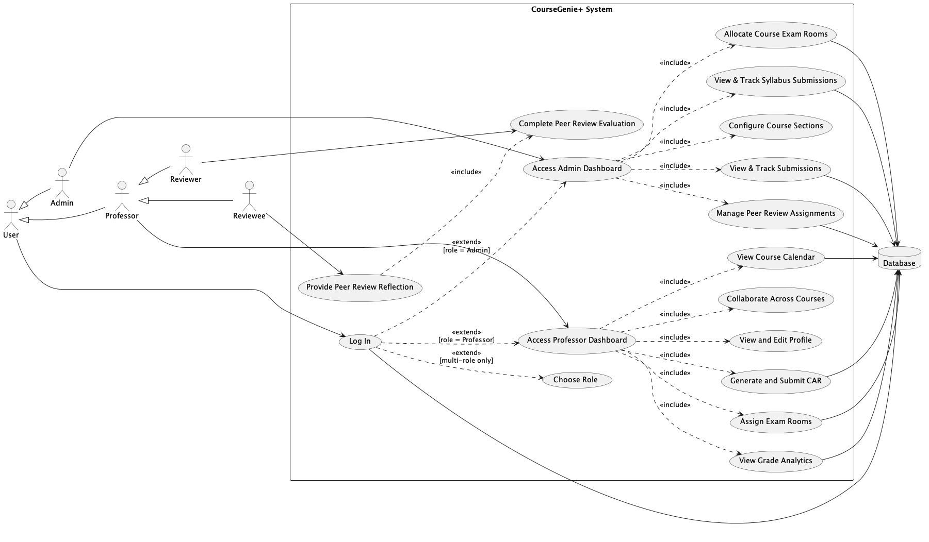
Figure 1: System Use Case Diagram

XI. Project Planning
This section outlines the project planning artifacts used to organize, schedule and assign responsibilities throughout the development of CourseGenie+. This includes a Work Breakdown Structure to define the major system components, a Gantt chart to visualize task scheduling and a RACI matrix to clarify task assignments among team members.

Work Breakdown Structure

The Work Breakdown Structure organizes the project into phases of a hierarchical structure showing the sub-systems on different levels.

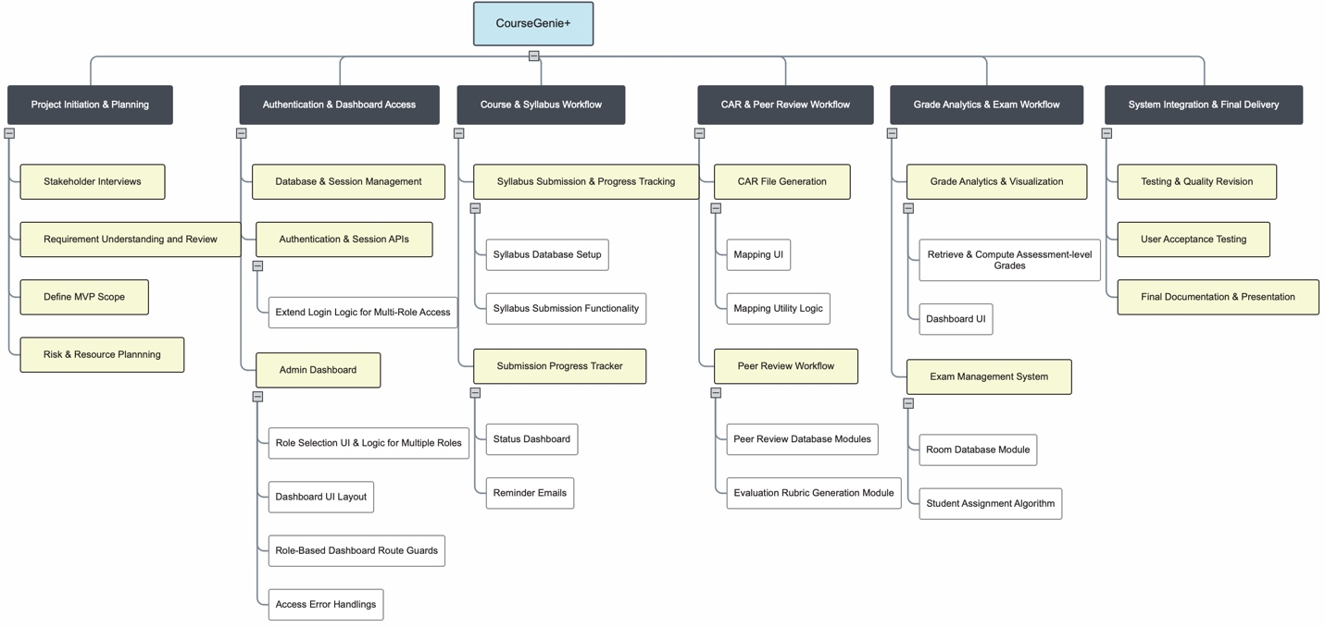
Figure 2: Work Breakdown Structure

Gantt Chart
The Gantt Chart visualizes the task durations and sequencing during the planned timeline of the project completion.
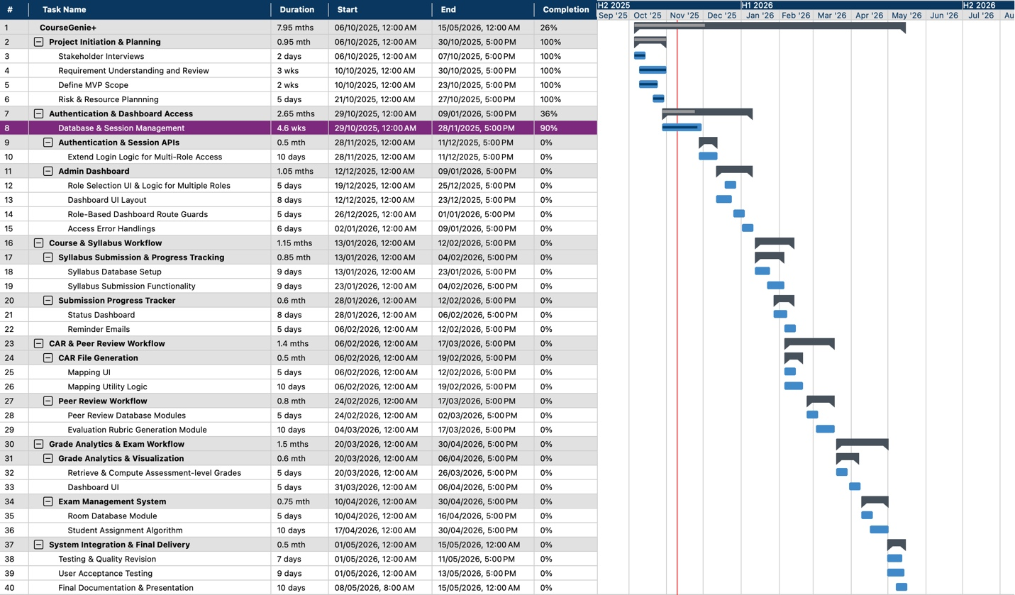
Figure 3: Gantt Chart

RACI Matrix
The RACI matrix clarifies who is responsible, accountable, consulted and/or informed of the main identified project tasks.

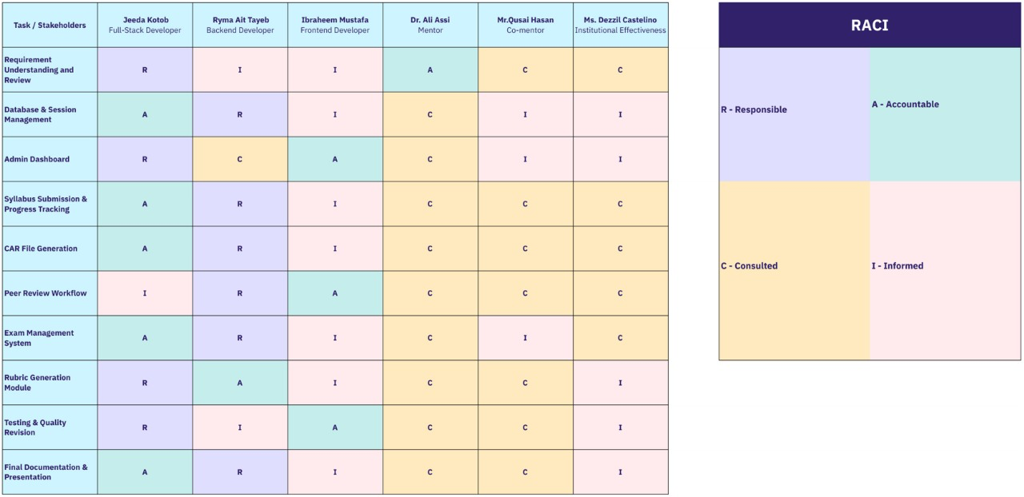
Figure 4: RACI Matrix

XII. Risk Assessment
This section evaluates potential technical, operational and project-related risks that could affect the development and deployment of CourseGenie+. A risk matrix, interpretation legend and a risk register are used to identify, classify and plan to mitigate these risks.

- Risk Matrix

The 5x5 risk matrix below categorizes risks based on their impact on the project’s outcomes in addition to their likelihood of occurring.

Impact
Likelihood |  | 1 (Insignificant) | 2  (Minor) | 3  (Noticeable) | 4  (Major) | 5  (Critical)
Likelihood | 5  (Very High) | Medium | High | High | Critical | Critical
Likelihood | 4  (High) | Medium | Medium | High | High | Critical
Likelihood | 3 (Moderate) | Low | Medium | Medium | High | High
Likelihood | 2  (Low) | Low | Low | Medium | Medium | High
Likelihood | 1  (Very Low) | Negligible | Low | Low | Medium | Medium
Table 5: 5x5 Risk Assessment Matrix

- Legend

The legend defines how combined likelihood and impact scores translate into risk severity levels and the appropriate team response strategy.

Risk Level | Score Range | Meaning / Required Action
Low | 1-7 | Acceptable risk, no special intervention needed.
Medium | 8-14 | Needs monitoring during development.
High | 15-19 | Required planned mitigation and follow up in sprints to prevent delays and quality issues.
Critical | >=20 | Must be addressed immediately, risks timeline or project success
Table 6: Risk Level Interpretation Legend
- Project Risk Register & Mitigation

The following risk register lists the risks identified to possibly occur during the development of CourseGenie+, along with their severity levels and individual mitigation strategies.

Risk | Type | Likelihood (1–5) | Impact (1–5) | Risk Score | Risk Level | Mitigation Strategy
Learning Curve in Spring Boot (Backend) and Angular (Frontend) Development | Technical | 4 | 4 | 16 | High | Allocate dedicated learning sprints, follow Spring Boot documentation, pair-program with mentor feedback, prototype incrementally.
UI Complexity or User Confusion | Technical | 3 | 4 | 12 | Medium | Apply consistent labeling, minimize clicks, include tooltips, conduct usability testing with 2–3 professors before release.
Database Relationship Misconfiguration Leading to Data Integrity Issues | Technical | 3 | 5 | 15 | High | Use ERD modeling, enforce referential integrity, conduct database testing early before implementing dependent modules.
Time Constraints Due to Academic Workload | Project Management | 5 | 4 | 20 | Critical | Adopt strict weekly sprint plans, set non-negotiable task deadlines, shift secondary features to later milestones.
Inability to Integrate with MyCourses Database (Permission Restrictions) | Technical/External | 5 | 3 | 15 | High | Build CourseGenie+ as a standalone workflow system and allow professors/admins to import/export required data manually (e.g., CSV uploads), avoiding the need for direct MyCourses API integration.
Scope Creep Due to Continuous Feature Ideas | Project Management | 4 | 4 | 16 | High | Establish a fixed MVP scope; implement a change request list; new features are only added after milestone validations.
Unclear or Evolving Requirements | Requirements / Stakeholder | 3 | 4 | 12 | Medium | Conduct requirement clarification meetings per milestone; finalize workflows before development; maintain change log.
Low Adoption by Professors | User Adoption / Behavioral | 3 | 5 | 15 | High | Ensure UI simplicity, provide quick video tutorials, run short demo workshops, and collect feedback early.
Incorrect Room Capacity Handling | Operational | 2 | 5 | 10 | Medium | Automatically validate student count against room capacity; display warning messages and prevent confirmation if capacity exceeded.
Data Entry or Selection Errors | Human Error / Functional | 4 | 3 | 12 | Medium | Use dropdown validations, confirmation dialogs, auto-default safe values, and highlight required fields to prevent mistakes.
Table 7: Project Risk Register & Mitigation Strategies

XIII. Resources and Budget Planning
Effective resource planning is essential to ensure that CourseGenie+ progresses smoothly across all development phases. Since the project is conducted within an academic context, resource allocation focuses on optimizing team expertise, available technology, and institutional support rather than financial assets. This section outlines the human, technical, and logistical resources required to successfully complete the project.

A. Resources
1. Human Resources: The CourseGenie+ team consists of three senior students in the Computing and Information Technologies program, each contributing specialized skills while collaborating on all parts of the project.
- Jeeda Kotob - Full Stack Developer: Integrating the backend and frontend, managing the database, and maintaining the flow of information between the various components of the system.
- Ryma Ait Tayeb - Back End Developer: Building and maintaining the server-side logic, implementing the APIs through Spring Boot, and managing the security and integrity of the data.
- Ibraheem Mustafa - Front End Developer: Using Angular, Ibraheem designs the interfaces, builds responsive dashboards, and creates a seamless experience for the users, including professors and administrators.
As project mentors, Dr. Ali Assi and Mr. Qusai Hasan provide technical and architectural supervision. As an external stakeholder, Ms. Dezzil Castelino, the Institutional Effectiveness Manager, offers insights into administrative workflows and accreditation-related requirements. To foster coordination, accountability, and quality assurance in the project, all stakeholders participate in compliance with scheduled activities, including weekly mentor meetings and sprint reviews.
2. Technical Resources: CourseGenie+ is built using a combination of open-source and educationally licensed technologies that support scalability and maintainability. The following tools and platforms form the core of the project’s technical infrastructure:
- Backend Framework: Spring Boot for secure and modular application logic.
- Frontend Framework: Angular for dynamic user interfaces and dashboard development.
- Database System: MySQL for structured data management and reliable storage.
- Version Control: GitHub for collaborative coding, version tracking, and repository management.
- Development Tools: Visual Studio Code and IntelliJ IDEA for coding, debugging, and testing.
- Diagramming and Documentation: PlantUML & MindView for system design and project planning diagrams.
These tools collectively support an agile development cycle, enabling rapid prototyping, continuous integration, and iterative testing without financial overhead.
3. Logistical Resources: Since CourseGenie+ is developed within RIT Dubai, the team benefits from institutional facilities and services essential to project execution.
- Development Hardware: Each member uses a personal laptop, meeting project specifications.
- Campus Resources: Access to RIT labs, meeting rooms, and classrooms for collaborative work and presentations.
- Communication and File Sharing: Google Drive and GitHub for real-time file exchange, progress updates, and document synchronization.
- Mentorship and Feedback Sessions: Weekly review meetings to ensure progress tracking and provide opportunities for technical and strategic feedback from mentors.

B. Cost Estimate and Budgeting
CourseGenie+ is a university-supported academic project that operates with no direct financial expenditures. All required development and testing resources are provided through institutional access or open-source platforms, ensuring a cost-effective and sustainable workflow.

1. Software and Tools: Every framework and tool used in this project is open-source or accessible under free academic plans. Hence, there is no need for external subscriptions or paid proprietary tools. These include Spring Boot, Angular, MySQL, Postman, IntelliJ IDEA, and GitHub. All project components are therefore free.
RIT Dubai provides the computing resources and project development, storage, version control, and testing facilities. Hence, the entire implementation is cost-free.

2. Infrastructure and Hosting: The development and testing environments are your personal laptops or those provided by RIT. For demonstration purposes, the temporary deployment will use internal virtual machines or RIT institutional servers. There is no cost for external commercial hosting. Educational or free-tier services like GitHub or MySQL will provide data storage and repositories.

C. Initial Bill of Materials (BoM)
The Bill of Materials would identify all the necessary components, technologies, and resources that are required for the successful making and development of CourseGenie+. Since the project is software-based, the BoM emphasizes hardware development and testing, as well as the major software frameworks and services that we are using.

1. BoM Summary:
Category | Component | Source | Purpose of Need | Estimated Cost
Hardware | Developer Laptops | Personal / RIT Dubai | Used for software development, testing, and demonstrations | Provided / Available
Software | Spring Boot Framework | Open Source | Backend development and API integration | Use Existing / Free
Software | Angular Framework | Open Source | Frontend user interface development | Use Existing / Free
Database | MySQL Server | Oracle Community | Data storage and management | Use Existing / Free
Version Control | GitHub | GitHub Education | Repository management and collaborative development | Use Existing / Free
Design Tools | PlantUML & MindView | Open Source | Project planning and system design diagrams | Use Existing / Free Trial
Table 8: BoM Summary

- Budget Overview: The mentioned components are either open-source or already provided
at no cost. Therefore, the BoM fully complies with the zero-cost project budget as outlined in Section XII. No additional funding is required as of what is foreseeable from now, and the identified resources are efficient enough for completing all project deliverables within the planned timeline.

XIV. Test Plan (First Cut)
The test plan outlines the initial set of functional test cases designed to validate the core features for both professors and administrators. The purpose of this first-cut test plan is to verify that essential workflows are performed as expected. The cases below specify test conditions, inputs, execution steps, and expected outcomes to ensure consistency during testing.

ID | Title | Trace | Preconditions | Input | Steps | Expected Output | Actual Output | Pass/Fail
1 | Login -> Professor Dashboard | US1, UC01 | User exists with Professor role only | Username: axacad5  Password: ali123 | Open Login -> Enter credentials -> Login | Redirects to Professor Dashboard
2 | Login -> Admin Dashboard | US1, UC01 | User exists with Admin role only | Username: dmccad  Password: dezzil123 | Open Login -> Enter credentials -> Login | Redirects to Admin Dashboard
3 | Login -> Role Selection Popup | US1, UC01 | User has Admin + Professor roles | Username: kxkcad  Password: khalid123 | Login | Role selection popup displayed
4 | Select Professor from Popup | US1, UC01 | Role popup visible | Click Continue as Professor | Click Continue | Redirects to Professor Dashboard
5 | Select Admin from Popup | US1, UC01 | Role popup visible | Click Continue as Admin | Click Continue | Redirects to Admin Dashboard
6 | Invalid Login Shows Error | UC01 AF2.1 | Any user | Username: axacad5  Password:  wrongPass | Attempt login | "Invalid username or password." displayed
7 | Admin Dashboard Displays Course Cards | US2 | Logged in as Admin | --- | Load dashboard | Course cards visible
8 | Open Course Section List | US2 | Course cards visible | Click course card | Click card | Section cards displayed
9 | Navigate to Syllabus Page | US3 | Logged in as Admin | Click Syllabus tab | Click tab | Redirect to Syllabus Page
10 | Syllabus Progress Bars Display | US3 | On Syllabus Page | --- | Load Page | Progress bars grouped by department
11 | View Professor Syllabus Submissions | US4 | On Syllabus Page | Click professor name | Click name | Submission list displayed
12 | Preview Syllabus | US4 | Submission list visible | Click syllabus entry | Click entry | Preview opens
13 | Download Syllabus PDF | US4 | Preview visible | Click Download | Click Download | PDF downloaded
14 | Show No Submissions Case | US4 | Professor has no submissions | Open professor record | Open record | "No submissions available" displayed
15 | Overdue Indicator Appears | US4 | Submission past deadline | --- | Open list | "Overdue" displayed
16 | Auto Reminder for Syllabus Due | US5 | Due in 2 days | --- | Wait for scheduler | System sends reminder email
17 | Add Section Button Visible | US6 | On course page | --- | Load page | "Add Section" visible
18 | Open Add Section Form | US6 | Add Section visible | Click Add Section | Click button | Form opens
19 | Navigate to CAR Files Page | US7 | Logged in as Admin | Click CAR Files tab | Click tab | Redirects to CAR Files Page
20 | CAR Progress Bars Display | US7 | On CAR Files Page | --- | Load page | Progress bars grouped by department
21 | View Professor CAR Submissions | US8 | On CAR Files Page | Click professor name | Click name | Submission list displayed
22 | Preview CAR File | US8 | CAR list visible | Click CAR entry | Click entry | CAR preview opens
23 | Download CAR PDF | US8 | Preview visible | Click Download | Click Download | PDF downloaded
24 | Show No CAR Submissions | US8 | Professor has none | Open record | Open record | "No submissions available" displayed
25 | Overdue CAR Marked | US8 | Late CAR exists | --- | Open list | "Overdue" displayed
26 | Auto Reminder for CAR Due | US9 | Due in 2 days | --- | Wait for scheduler | System sends reminder email
27 | Navigate to Peer Review Page | US10 | Logged in as Admin | Click Peer Review tab | Click tab | Redirects to Peer Review Page
28 | Peer Review Progress Bars Display | US10 | On Peer Review Page | --- | Load page | Progress bars grouped by department
29 | Generate CAR Preview | US12, UC02 | Professor on section page | Open CAR tab | Open tab | CAR preview generated
30 | Submit CAR (Complete Data) | US12, UC02 AF4.3 | All required data present | Click Submit | Click Submit | Submission recorded + confirmation
Table 9: System Test Plan

REFERENCES

[1] | J. Sánchez, M. Serrano, A. Duarte and F. García, "Learning Management Systems for Higher Education: A Comparative Study," Journal of Educational Technology, vol. 21, no. 2, pp. 145-162, 2024.
[2] | A. Yamani, S. Alharthi and H. Smirani, "Blackboard vs. Brightspace: A Comparative Study," International Journal of Emerging Technologies in Learning (iJET), vol. 17, no. 9, pp. 45-58, 2022.
[3] | B. Simon, K. Müller and R. Patel, "Adoption of Moodle Tools: Instructor and Student Perspectives," Education and Information Technologies, vol. 29, no. 4, pp. 2105-2122, 2024.
[4] | Q. Li, Y. Jung and A. F. Wise, "How instructors use learning analytics: The pivotal role of pedagogy," Journal of Computing in Higher Education, vol. 37, pp. 55-75, 2025.
[5] | M. Hernández-de-Menéndez, R. Morales-Menendez, C. A. Escobar and R. A. Ramírez Mendoza, "Learning analytics: state of the art," International Journal on Interactive Design and Manufacturing (IJIDeM), vol. 16, no. 3, pp. 1209-1230, 2022.
[6] | P. Ngulube and M. M. Ncube, "Leveraging Learning Analytics to Improve the User Experience of Learning Management Systems in Higher Education Institutions," Information, vol. 16, no. 5, pp. 419-419, 2025.
[7] | X. Kui, N. Liu, Q. Liu, J. Liu, X. Zeng and C. Zhang, "A survey of visual analytics techniques for online education," Visual Informatics, vol. 6, no. 7, 2022.
[8] | D. Vlachopoulos and A. Makri, "A systematic literature review on authentic assessment in higher education: Best practices for the development of 21st century skills, and policy considerations," Studies in Educational Evaluation, vol. 83, p. 101425–101425, 2024.
[9] | E. Jenkins, R. D’Aoust, S. de Souza Elias, H.-R. Han, P. Sharps and C. Alvarez, "Faculty peer review of teaching taskforce: A quantitative descriptive research study for the peer review process," Nurse Education Today, vol. 106, p. 105055, 2021.

