Fundamental of Data Management

Task 4.1.1

1NF (First Normalization Form)

Given Table

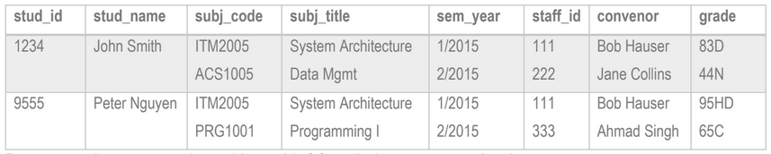

Table Converted to 1st Normal Form

|  |  |  |  |  |  |  |  |  |  |
| --- | --- | --- | --- | --- | --- | --- | --- | --- | --- |
| Stud_id | Stud_name | Subj_code | Subj_title | Sem | Year | Staff_id | convenor | Marks | Grade |
| 1234 | John Smith | ITM2005 | System Architecture | 1 | 2015 | 111 | Bob Hauser | 83 | D |
| 1234 | John Smith | ACS1005 | Data Management | 2 | 2015 | 222 | Jane Collins | 44 | N |
| 9555 | Peter Nguyen | ITM2005 | System Architecture | 1 | 2015 | 111 | Bob Hauser | 95 | HD |
| 9555 | Peter Nguyen | PROG1001 | Programming I | 2 | 2015 | 333 | Ahmad Singh | 65 | C |

Rules to Achieve 1NF form:

1. Each column should contain atomic value i.e. Single Value in each column
2. A column should contain values that are of same type
3. Each column should have unique name
4. Order in which data is stored doesn’t matter