Task 8.1.2

Query: SELECT * FROM Purchase;

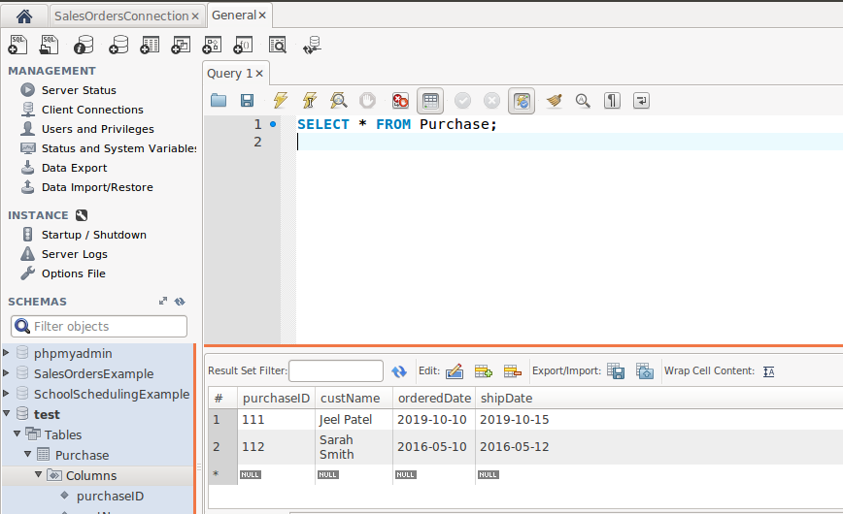

* The question mark represents a parameter / argument that will later be replaced by

the database, example we know the purchasedID is a foreign key non nullable value,

sql is smart enough to fill this value for us. In MySQL this value is replaced with

LAST_INSERT_ID()

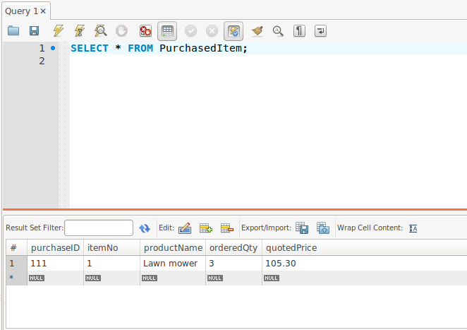

Query: SELECT * FROM PurchasedItem;