Task C2.2.2 JSONiq

Raw JSON Data

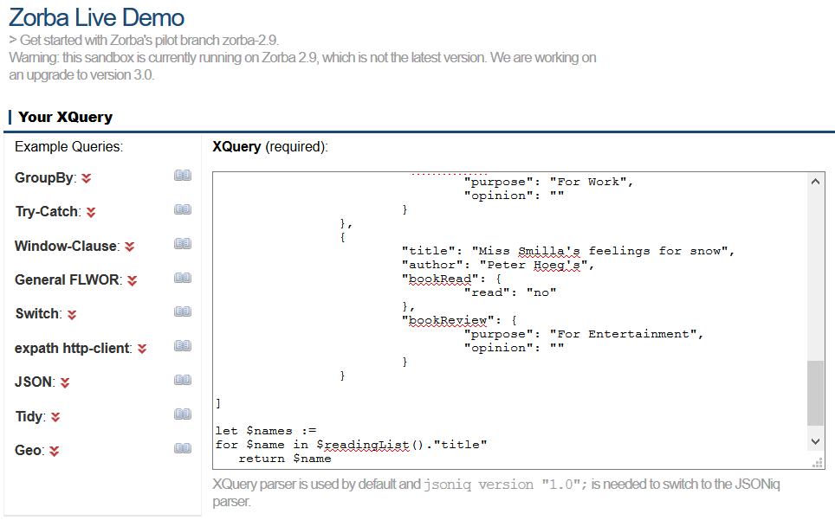

Output



JSONiq Query

let $names :=

for $name in $readingList().”title”

return $name

return [$names]