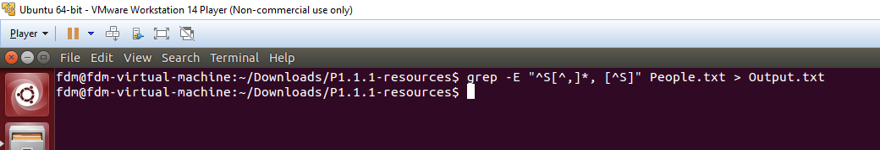

Command: grep -E "^S[^,]\*, [^S]" People.txt > Output.txt

Output File:

