**Adding line number to the output**

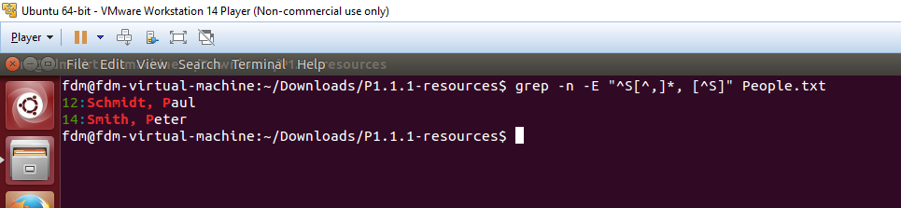

-n is use to print line number to the output window

Command: grep -n -E "^S[^,]*, [^S]" People.txt

**Printing Number of Matches rather than Matches**

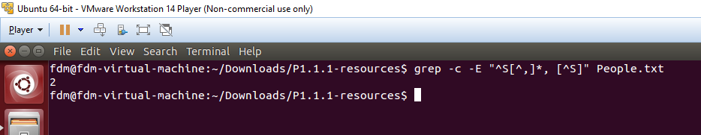

-c is use to print number of matches to the output window

Command: grep -c -E "^S[^,]*, [^S]" People.txt