DAYANANDA SAGAR COLLEGE OF ENGINEERING
(An Autonomous Institute affiliated to VTU, Belagavi, Approved by AICTE & ISO 9001:2008 Certified)
Accredited by National Assessment & Accreditation Council (NAAC) with ‘A’ grade,
Shavige Malleshwara Hills, Kumaraswamy Layout, Bengaluru-111


Report
On
“ SMART CAMPUS INFORMATION SYSTEM APPLICATION”
Submitted by
Jeel S Vaghasiya (1DS25CG021) & Jigyasu Tanwar (1DS25CG022)

Second Semester B.E (CG)
2025-2026

Under the guidance of
Prof. Alka Rani
Assistant Professor
Dept. of CSE
DSCE, Bangalore

Department of Computer Science and Engineering
Bangalore-780111

VISVESVARAYA TECHNOLOGICAL UNIVERSITY
DAYANANDA SAGAR COLLEGE OF ENGINEERING
Shavige Malleshwara Hills, Kumaraswamy Layout, Bangalore - 560111
Department of Computer Science & Engineering


CERTIFICATE

This is to certify that the application entitled “SMART CAMPUS INFORMATION SYSTEM APPLICATION” is a bonafide work carried out by Jeel S Vaghasiya (1DS25CG021) and Jigyasu Tanwar (1DS25CG022) during the Second Semester Python Programming Laboratory Sessions, Bachelor of Engineering in Computer Science and Engineering under Visvesvaraya Technological University, Belgaum in the academic year 2025–26.

Prof. Alka Rani Dr.Ramesh Babu
(Faculty In-charge) Vice principal & Head
Assistant Professor, Department of CSE,
Department of CSE, DSCE
DSCE
Signature.................... Signature....................

Name of the Examiners: Signature with date:
- .................................... ………………………………

- .................................... ……………………………….

Application – Smart Campus Information System
Dayananda Sagar College of Engineering plans to develop a simple Python-based Smart Campus Information System to manage student information, academic records, and performance analysis. At present, several administrative tasks such as student registration, course enrollment, record maintenance, searching student data, fee calculation, and performance analysis are often handled manually. These manual processes can be time-consuming, inefficient, and prone to errors.
To improve efficiency and accuracy, the institution intends to implement a basic software system that enables administrative staff to perform various academic management tasks digitally. The system will allow administrators to register students, manage course enrollments, maintain academic records, search and sort student data, calculate fees, store and retrieve records from files, scan directories for project files, and analyze student performance using data analytics tools.
The Smart Campus Information System will be developed gradually through Python laboratory experiments. Each experiment focuses on implementing a specific functional module, and together these modules form a complete integrated application. The final system will consist of several modules such as Student Registration, Course Enrollment Management, Student Records Management, Search and Sorting, Fee Calculation, File Management, Directory Scanning, and Performance Analytics, all integrated through a Main System Application Dashboard.
Students will develop these modules week by week, and in the final weeks they will integrate all modules to demonstrate the complete working of the Smart Campus Information System.

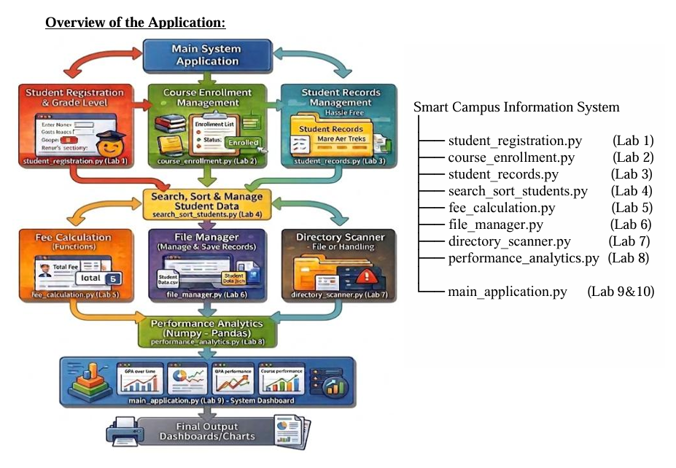

Smart Campus Information System (Mini Project Integration) : Demonstrate a complete Python application for the Smart Campus Information System by integrating all the modules developed from Lab 1 to Lab 8.
The final program should demonstrate the working of all components including:
- Student registration and grade evaluation
- Course enrollment management
- Student record storage and management
- Searching and sorting student data
- Fee calculation using functions
- File-based academic record management
- Directory scanning with exception handling
- Student performance analytics using NumPy, Pandas, and Matplotlib

Implementation of the Application
The Smart Campus Information System is a single, menu-driven Python application (main_application.py) that integrates all the modules developed during the Lab 1 to Lab 8 sessions into one System Dashboard, exactly as shown in the overview diagram above. When the program starts, it loads all saved records from a CSV file and then repeatedly displays a main menu, calling the appropriate module based on the user's choice until the user chooses to exit. Each student record is stored as a dictionary and carries the USN, name, three subject marks, computed average, grade, enrolled course and total fee.
The functionality of each integrated module is described below:
• Student Registration & Grade Evaluation (Lab 1): accepts a student's details and marks in three subjects, computes the average, and assigns a grade (A+, A, B, C or FAIL) using a dedicated grade-evaluation function.
• Course Enrollment Management (Lab 2): lets the administrator enroll a registered student into one of the available courses and updates that student's total fee.
• Student Records Management (Lab 3): displays all stored records in a neat tabular form and allows a record to be deleted by USN.
• Searching and Sorting (Lab 4): searches for a student by USN or name, and sorts the records either alphabetically by name or in descending order of average marks.
• Fee Calculation using Functions (Lab 5): a function computes the total fee as the common base fee plus the course-specific fee.
• File-based Record Management (Lab 6): all records are saved to and loaded from the file student_records.csv, so the data is preserved between runs.
• Directory Scanning with Exception Handling (Lab 7): scans a chosen directory for project files (.py and .csv), using try-except blocks to handle missing folders and permission errors safely.
• Performance Analytics (Lab 8): uses Pandas to build a DataFrame of the records, NumPy to compute the class mean, highest, lowest and standard deviation of the averages, and Matplotlib to generate a bar chart of every student's average marks.
This integration of all eight modules under a single dashboard (Lab 9 & 10) forms the complete working Smart Campus Information System.

Program Code
File: main_application.py
"""
================================================================================
SMART CAMPUS INFORMATION SYSTEM - main_application.py
(Lab 9 & 10 : Mini Project Integration)
================================================================================
A single menu-driven Python application that integrates all the modules built
from Lab 1 to Lab 8 into one Smart Campus Information System dashboard:

Lab 1 Student Registration & Grade Evaluation
Lab 2 Course Enrollment Management
Lab 3 Student Records Management
Lab 4 Searching and Sorting Student Data
Lab 5 Fee Calculation using Functions
Lab 6 File-based Academic Record Management (CSV)
Lab 7 Directory Scanning with Exception Handling
Lab 8 Student Performance Analytics (NumPy, Pandas, Matplotlib)

Authors : Jeel S Vaghasiya (1DS25CG021)
Jigyasu Tanwar (1DS25CG022)
================================================================================
"""

import os
import csv
import numpy as np
import pandas as pd
import matplotlib
matplotlib.use("Agg") # headless backend so charts save without a GUI
import matplotlib.pyplot as plt

RECORD_FILE = "student_records.csv"

# Master list of student records held in memory while the program runs.
# Each record is a dictionary with these keys:
# usn, name, sub1, sub2, sub3, average, grade, course, fee
students = []

# Courses offered on campus and their additional fee (Lab 2 / Lab 5)
COURSES = {
"1": ("Python Programming", 5000),
"2": ("Data Structures", 6000),
"3": ("Web Development", 5500),
"4": ("Machine Learning", 8000),
}
BASE_FEE = 40000 # common college base fee

# ============================================================================ #
# LAB 6 : FILE-BASED ACADEMIC RECORD MANAGEMENT
# ============================================================================ #
def save_records():
"""Write every student record to a CSV file."""
fields = ["usn", "name", "sub1", "sub2", "sub3",
"average", "grade", "course", "fee"]
with open(RECORD_FILE, "w", newline="") as f:
writer = csv.DictWriter(f, fieldnames=fields)
writer.writeheader()
writer.writerows(students)

def load_records():
"""Load student records from the CSV file if it exists, else seed demo data."""
global students
if os.path.exists(RECORD_FILE):
with open(RECORD_FILE, "r", newline="") as f:
reader = csv.DictReader(f)
students = []
for row in reader:
for k in ("sub1", "sub2", "sub3", "fee"):
row[k] = int(row[k])
row["average"] = float(row["average"])
students.append(row)
else:
seed_demo_data()
save_records()

def seed_demo_data():
"""Create a few sample records so the system is usable on first run."""
samples = [
("1DS25CG021", "Jeel S Vaghasiya", 88, 92, 85, "Python Programming"),
("1DS25CG022", "Jigyasu Tanwar", 79, 81, 76, "Data Structures"),
("1DS25CG023", "Aarav Mehta", 65, 58, 70, "Web Development"),
("1DS25CG024", "Diya Nair", 91, 95, 89, "Machine Learning"),
]
for usn, name, s1, s2, s3, course in samples:
avg = (s1 + s2 + s3) / 3
students.append({
"usn": usn, "name": name, "sub1": s1, "sub2": s2, "sub3": s3,
"average": round(avg, 2), "grade": evaluate_grade(avg),
"course": course, "fee": calculate_fee(course),
})

# ============================================================================ #
# LAB 5 : FEE CALCULATION USING FUNCTIONS
# ============================================================================ #
def calculate_fee(course_name):
"""Return total fee = base fee + the course-specific fee."""
course_fee = 0
for _, (name, fee) in COURSES.items():
if name == course_name:
course_fee = fee
break
return BASE_FEE + course_fee

# ============================================================================ #
# LAB 1 : STUDENT REGISTRATION & GRADE EVALUATION
# ============================================================================ #
def evaluate_grade(average):
"""Map an average mark to a letter grade."""
if average >= 90:
return "A+"
elif average >= 75:
return "A"
elif average >= 60:
return "B"
elif average >= 40:
return "C"
return "FAIL"

def register_student():
print("\n--- Student Registration & Grade Evaluation ---")
usn = input(" Enter USN : ").strip().upper()
if any(s["usn"] == usn for s in students):
print(" ! A student with this USN already exists.")
return
name = input(" Enter Name : ").strip()
try:
s1 = int(input(" Marks in Subject 1 : "))
s2 = int(input(" Marks in Subject 2 : "))
s3 = int(input(" Marks in Subject 3 : "))
except ValueError:
print(" ! Marks must be whole numbers. Registration cancelled.")
return
average = round((s1 + s2 + s3) / 3, 2)
grade = evaluate_grade(average)
students.append({
"usn": usn, "name": name, "sub1": s1, "sub2": s2, "sub3": s3,
"average": average, "grade": grade, "course": "Not enrolled", "fee": 0,
})
save_records()
print(f" > Registered. Average = {average}, Grade = {grade}")

# ============================================================================ #
# LAB 2 : COURSE ENROLLMENT MANAGEMENT
# ============================================================================ #
def enroll_course():
print("\n--- Course Enrollment Management ---")
usn = input(" Enter student USN : ").strip().upper()
student = next((s for s in students if s["usn"] == usn), None)
if not student:
print(" ! No student found with that USN.")
return
print(" Available Courses:")
for key, (name, fee) in COURSES.items():
print(f" {key}. {name} (Course Fee: Rs.{fee})")
choice = input(" Choose course number : ").strip()
if choice not in COURSES:
print(" ! Invalid course choice.")
return
course_name = COURSES[choice][0]
student["course"] = course_name
student["fee"] = calculate_fee(course_name)
save_records()
print(f" > {student['name']} enrolled in {course_name}. "
f"Total fee: Rs.{student['fee']}")

# ============================================================================ #
# LAB 3 : STUDENT RECORDS MANAGEMENT
# ============================================================================ #
def display_record(s):
print(f" {s['usn']:12} | {s['name']:18} | Avg: {s['average']:6} | "
f"Grade: {s['grade']:4} | {s['course']:18} | Fee: Rs.{s['fee']}")

def view_records():
print("\n--- Student Records ---")
if not students:
print(" No records available.")
return
print(" " + "-" * 92)
for s in students:
display_record(s)
print(" " + "-" * 92)

def delete_record():
print("\n--- Delete Student Record ---")
usn = input(" Enter USN to delete : ").strip().upper()
global students
before = len(students)
students = [s for s in students if s["usn"] != usn]
if len(students) < before:
save_records()
print(" > Record deleted.")
else:
print(" ! USN not found.")

# ============================================================================ #
# LAB 4 : SEARCHING AND SORTING STUDENT DATA
# ============================================================================ #
def search_student():
print("\n--- Search Student ---")
key = input(" Enter USN or Name : ").strip().lower()
found = [s for s in students
if key in s["usn"].lower() or key in s["name"].lower()]
if not found:
print(" ! No matching student found.")
return
for s in found:
display_record(s)

def sort_students():
print("\n--- Sort Students ---")
print(" 1. By Name (A-Z) 2. By Average (high to low)")
ch = input(" Choice : ").strip()
if ch == "1":
ordered = sorted(students, key=lambda s: s["name"])
elif ch == "2":
ordered = sorted(students, key=lambda s: s["average"], reverse=True)
else:
print(" ! Invalid choice.")
return
for s in ordered:
display_record(s)

# ============================================================================ #
# LAB 7 : DIRECTORY SCANNING WITH EXCEPTION HANDLING
# ============================================================================ #
def scan_directory():
print("\n--- Directory Scanner ---")
path = input(" Enter directory path (blank = current) : ").strip() or "."
try:
items = os.listdir(path)
py_files = [f for f in items if f.endswith(".py")]
csv_files = [f for f in items if f.endswith(".csv")]
print(f" Scanned: {os.path.abspath(path)}")
print(f" Total items : {len(items)}")
print(f" Python files: {py_files if py_files else 'None'}")
print(f" CSV files : {csv_files if csv_files else 'None'}")
except FileNotFoundError:
print(" ! Error: that directory does not exist.")
except PermissionError:
print(" ! Error: permission denied for that directory.")
except Exception as e:
print(f" ! Unexpected error: {e}")

# ============================================================================ #
# LAB 8 : STUDENT PERFORMANCE ANALYTICS (NumPy, Pandas, Matplotlib)
# ============================================================================ #
def performance_analytics():
print("\n--- Student Performance Analytics ---")
if not students:
print(" No records to analyse.")
return

# Pandas: build a DataFrame from the records
df = pd.DataFrame(students)
averages = np.array(df["average"], dtype=float) # NumPy array

# NumPy: summary statistics
print(f" Number of students : {len(df)}")
print(f" Class mean average : {np.mean(averages):.2f}")
print(f" Highest average : {np.max(averages):.2f}")
print(f" Lowest average : {np.min(averages):.2f}")
print(f" Standard deviation : {np.std(averages):.2f}")

topper = df.loc[df["average"].idxmax()]
print(f" Class topper : {topper['name']} ({topper['average']})")

# Matplotlib: bar chart of each student's average, saved to a PNG file
plt.figure(figsize=(8, 4.5))
plt.bar(df["name"], df["average"], color="#2E75B6")
plt.axhline(np.mean(averages), color="red", linestyle="--",
label=f"Class mean ({np.mean(averages):.1f})")
plt.title("Student Performance - Average Marks")
plt.xlabel("Student")
plt.ylabel("Average Marks")
plt.xticks(rotation=20, ha="right")
plt.legend()
plt.tight_layout()
plt.savefig("performance_chart.png", dpi=120)
plt.close()
print(" > Performance chart saved as 'performance_chart.png'.")

# ============================================================================ #
# MAIN SYSTEM APPLICATION DASHBOARD (Lab 9 & 10)
# ============================================================================ #
def main():
load_records()
print("=" * 70)
print(" SMART CAMPUS INFORMATION SYSTEM - DASHBOARD")
print("=" * 70)

menu = """
----------------------------------------------------------------------
MAIN MENU
----------------------------------------------------------------------
1. Student Registration & Grade Evaluation (Lab 1)
2. Course Enrollment Management (Lab 2)
3. View Student Records (Lab 3)
4. Delete Student Record (Lab 3)
5. Search Student (Lab 4)
6. Sort Students (Lab 4)
7. Fee Details (per student) (Lab 5)
8. Scan Directory for Project Files (Lab 7)
9. Performance Analytics (Lab 8)
10. Exit
----------------------------------------------------------------------"""

while True:
print(menu)
choice = input(" Enter your choice : ").strip()
if choice == "1":
register_student()
elif choice == "2":
enroll_course()
elif choice == "3":
view_records()
elif choice == "4":
delete_record()
elif choice == "5":
search_student()
elif choice == "6":
sort_students()
elif choice == "7":
show_fee_details()
elif choice == "8":
scan_directory()
elif choice == "9":
performance_analytics()
elif choice == "10":
print("\n Records saved to file. Thank you! Goodbye.")
break
else:
print(" ! Invalid choice. Please try again.")

def show_fee_details():
print("\n--- Fee Details ---")
usn = input(" Enter USN : ").strip().upper()
student = next((s for s in students if s["usn"] == usn), None)
if not student:
print(" ! USN not found.")
return
print(f" Student : {student['name']}")
print(f" Course : {student['course']}")
print(f" Base Fee : Rs.{BASE_FEE}")
print(f" Total Fee : Rs.{student['fee']}")

if __name__ == "__main__":
main()

Output
A sample run of the integrated application is shown below. It demonstrates viewing records, registering and enrolling a new student, searching and sorting, fee details, directory scanning, and the performance analytics module.
======================================================================
SMART CAMPUS INFORMATION SYSTEM - DASHBOARD
======================================================================

----------------------------------------------------------------------
MAIN MENU
----------------------------------------------------------------------
1. Student Registration & Grade Evaluation (Lab 1)
2. Course Enrollment Management (Lab 2)
3. View Student Records (Lab 3)
4. Delete Student Record (Lab 3)
5. Search Student (Lab 4)
6. Sort Students (Lab 4)
7. Fee Details (per student) (Lab 5)
8. Scan Directory for Project Files (Lab 7)
9. Performance Analytics (Lab 8)
10. Exit
----------------------------------------------------------------------
Enter your choice : 3

--- Student Records ---
--------------------------------------------------------------------------------------------
1DS25CG021 | Jeel S Vaghasiya | Avg: 88.33 | Grade: A | Python Programming | Fee: Rs.45000
1DS25CG022 | Jigyasu Tanwar | Avg: 78.67 | Grade: A | Data Structures | Fee: Rs.46000
1DS25CG023 | Aarav Mehta | Avg: 64.33 | Grade: B | Web Development | Fee: Rs.45500
1DS25CG024 | Diya Nair | Avg: 91.67 | Grade: A+ | Machine Learning | Fee: Rs.48000
--------------------------------------------------------------------------------------------

Enter your choice : 1

--- Student Registration & Grade Evaluation ---
Enter USN : 1DS25CG025
Enter Name : Riya Shah
Marks in Subject 1 : 84
Marks in Subject 2 : 77
Marks in Subject 3 : 90
> Registered. Average = 83.67, Grade = A

Enter your choice : 2

--- Course Enrollment Management ---
Enter student USN : 1DS25CG025
Available Courses:
1. Python Programming (Course Fee: Rs.5000)
2. Data Structures (Course Fee: Rs.6000)
3. Web Development (Course Fee: Rs.5500)
4. Machine Learning (Course Fee: Rs.8000)
Choose course number : 1
> Riya Shah enrolled in Python Programming. Total fee: Rs.45000

Enter your choice : 5

--- Search Student ---
Enter USN or Name : jeel
1DS25CG021 | Jeel S Vaghasiya | Avg: 88.33 | Grade: A | Python Programming | Fee: Rs.45000

Enter your choice : 6

--- Sort Students ---
1. By Name (A-Z) 2. By Average (high to low)
Choice : 2
1DS25CG024 | Diya Nair | Avg: 91.67 | Grade: A+ | Machine Learning | Fee: Rs.48000
1DS25CG021 | Jeel S Vaghasiya | Avg: 88.33 | Grade: A | Python Programming | Fee: Rs.45000
1DS25CG025 | Riya Shah | Avg: 83.67 | Grade: A | Python Programming | Fee: Rs.45000
1DS25CG022 | Jigyasu Tanwar | Avg: 78.67 | Grade: A | Data Structures | Fee: Rs.46000
1DS25CG023 | Aarav Mehta | Avg: 64.33 | Grade: B | Web Development | Fee: Rs.45500

Enter your choice : 7

--- Fee Details ---
Enter USN : 1DS25CG021
Student : Jeel S Vaghasiya
Course : Python Programming
Base Fee : Rs.40000
Total Fee : Rs.45000

Enter your choice : 8

--- Directory Scanner ---
Enter directory path (blank = current) :
Scanned: /home/student/smart_campus
Total items : 4
Python files: ['main_application.py']
CSV files : ['student_records.csv']

Enter your choice : 9

--- Student Performance Analytics ---
Number of students : 5
Class mean average : 81.33
Highest average : 91.67
Lowest average : 64.33
Standard deviation : 9.57
Class topper : Diya Nair (91.67)
> Performance chart saved as 'performance_chart.png'.

Enter your choice : 10

Records saved to file. Thank you! Goodbye.

Performance Analytics Output (Chart)
The chart below is produced by the Performance Analytics module (Lab 8) using Matplotlib. It plots each student's average marks, with the dashed line marking the class mean.
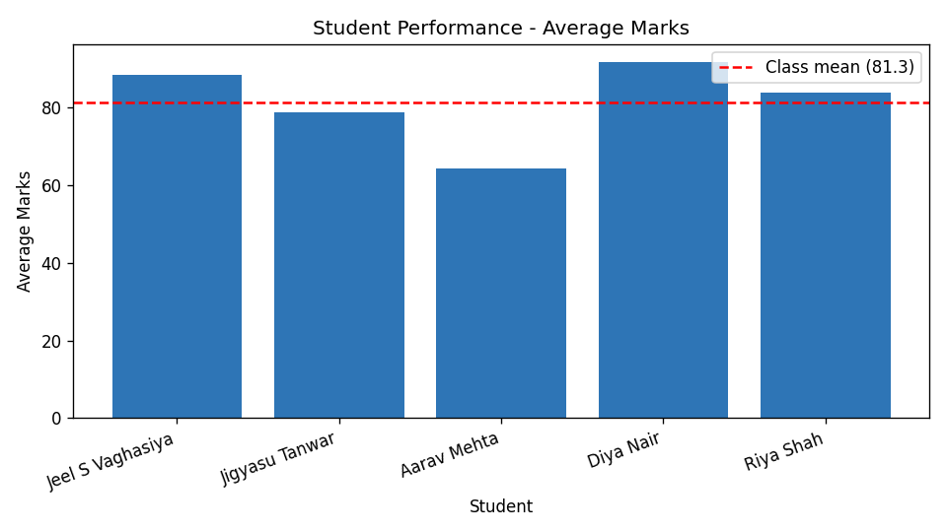
Fig. 2 - Student performance analytics (generated by the application)

GitHub Repository
The complete source code of the Smart Campus Information System application has been uploaded to the following public GitHub repository:
https://github.com/JeelVaghasiya/Q9.git

Conclusion
The Smart Campus Information System successfully integrates the eight modules built across the laboratory sessions into one easy-to-use Python application. Through this mini project we applied object handling with dictionaries, functions, file handling with CSV, exception handling, and data analytics using NumPy, Pandas and Matplotlib. The result is a working dashboard that can register students, evaluate grades, manage courses and fees, search and sort records, store data persistently, scan directories safely and analyse student performance visually. The system can be extended further with attendance management, a database back-end and a graphical user interface.

