
ADVANCING SCHOLARLY RESEARCH WITH AN INTELLIGENT AI-POWERED RESEARCH ASSISTANCE SYSTEM
A CAPSTONE PROJECT REPORT

A Capstone Project Report submitted in partial fulfilment of the requirements for the Course of
CSA4303- Internet Programming
to the award of the degree of
BACHELOR OF ENGINEERING
IN
COMPUTER SCIENCE ENGINEERING
Submitted by
Mohammad Jeelani (192373043)
Under the Supervision of
Dr. N. Marie Claude
SIMATS ENGINEERING
Saveetha Institute of Medical and Technical Sciences
Chennai-602105
SEPTEMBER 2026

BONAFIDE CERTIFICATE
This is to certify that the Capstone Project entitled "Advancing Scholarly Research with an Intelligent AI-Powered Research Assistance System" has been carried out by Mohammad Jeelani (192373043) under the supervision of Dr. N. Marie Claude and is submitted in partial fulfilment of the requirements for the current semester of the B.E Computer Science Engineering programme at Saveetha Institute of Medical and Technical Sciences, Chennai.

COURSE COORDINATOR COURSE FACULTY
Dr. N. Marie Claude, Dr. N. Marie Claude,
Professor Professor
CSE CSE
SIMATS Engineering, SIMATS Engineering,
SIMATS, Chennai – 602105. SIMATS, Chennai – 602105.

DECLARATION
SIMATS ENGINEERING
Saveetha Institute of Medical and Technical Sciences
Chennai-602105
I am Mohammad Jeelani, of the Department of Computer Science Engineering, SIMATS Engineering, Saveetha Institute of Medical and Technical Sciences, Chennai, hereby declare that the Capstone Project Work entitled "Advancing Scholarly Research with an Intelligent AI-Powered Research Assistance System" is the result of our own bonafide efforts. To the best of our knowledge, the work presented herein is original, accurate, and has been carried out in accordance with the principles of engineering ethics and academic integrity. All sources, references, data, and other materials used in the project have been appropriately acknowledged. We further declare that the data, results, analysis, and findings presented in this report have not been fabricated, falsified, or manipulated. Any external tools, software, datasets, computational resources, or AI-assisted tools used during the project have been appropriately disclosed. We confirm that all applicable ethical, academic, institutional, and professional requirements have been duly followed throughout the planning, execution, analysis, and documentation of the project.
Place: Chennai
Date: 03\09\2026
Signature of the Students with Names
Mohammad Jeelani (192373043)

Individual Contribution Statement
(Mandatory for all team projects)
Student / Reg. No. | Responsibilities | Design & Development | Testing & Analysis | Report Contribution | Contribution (%)
Mohammad  Jeelani (192373043) | Backend architecture and AI module integration | Designed the Spring Boot backend, integrated Llama 3.2 via Ollama for title generation | Unit and integration testing of AI title generation module | Chapters 3 and 4 | 25%
Karthik (192372076) | Research paper search and retrieval integration | Integrated Semantic Scholar, Crossref and arXiv APIs for paper retrieval | Testing of search accuracy and API response handling | Chapters 2 and 4 | 25%
Hemanth (192372098) | Frontend development and user experience | Built the React frontend, including registration, login and dashboard screens | UI testing and cross-browser validation | Chapters 1 and 5 | 25%
Saiharsha (192372157) | Data analysis module and database design | Developed the SPSS-style statistical analysis module and Supabase schema | Validation of statistical computations against reference tools | Abstract and Appendices | 25%
Total |  |  |  |  | 100%

ABSTRACT
Researchers and students routinely lose substantial time navigating fragmented research ecosystems - searching scattered academic databases, evaluating the credibility of sources, formulating viable research titles and manually organising findings. This inefficiency slows the pace of scholarly work and disproportionately affects early-stage researchers who lack established workflows. The engineering problem addressed by this project is the absence of a single, intelligent platform that unifies research discovery, topic ideation and data analysis for academic users.
To address this, the project proposes and implements an AI-Powered Research Assistance System that integrates artificial intelligence with established academic search infrastructure. The system was designed with a React front end, a Java Spring Boot back end, a Llama 3.2 large language model served through Ollama for natural-language reasoning, and a Supabase-hosted relational database. Research discovery is powered by the Semantic Scholar, Crossref and arXiv APIs, giving users a single point of access to millions of indexed papers.
The methodology followed a modular engineering approach comprising four core modules: user registration and authentication, AI-assisted research title generation, SPSS-style statistical data analysis, and research paper search and retrieval. Each module was independently designed, implemented and tested before integration, with the AI title-generation module evaluated for topic relevance and difficulty grading, and the search module evaluated for retrieval accuracy and response latency.
The completed system was validated against its functional requirements and found to reliably generate contextually relevant research titles, retrieve and rank research papers by relevance, and perform standard statistical computations including mean, median, standard deviation, correlation and regression. The principal conclusion of this work is that combining a locally-hosted open-weight language model with established scholarly APIs produces a practical, extensible and cost-effective research assistance platform that measurably reduces the time researchers spend on preparatory tasks, allowing more time for substantive analysis.
Keywords: Artificial Intelligence, Research Assistance System, Large Language Models, Academic Search APIs, Spring Boot, Statistical Data Analysis

TABLE OF CONTENTS
Sl. No | Title | Page No
i | CERTIFICATE FROM THE SUPERVISOR | ii
ii | DECLARATION BY THE CANDIDATE | iii
iii | INDIVIDUAL CONTRIBUTION STATEMENT | iv
iv | ABSTRACT | v
v | LIST OF FIGURES | vii
vi | LIST OF TABLES | viii
vii | LIST OF ABBREVIATIONS | ix
1 | CHAPTER 1: Introduction | 1
2 | CHAPTER 2: Literature Review | 5
3 | CHAPTER 3: Engineering Design & Trade-offs, Sustainability, Ethics, Safety, Risk & Security | 8
4 | CHAPTER 4: Implementation, Testing & Results, Project Management | 14
5 | CHAPTER 5: Conclusion & Reflection | 19
- | References | 22
- | Appendices | 23

LIST OF FIGURES
Figure No. | Figure Name | Page No.
3.1 | Proposed System Architecture | 10
3.2 | System Workflow | 11
4.1 | AI Research Title Generation Module - Screenshot | 15
4.2 | Research Paper Search & Retrieval Module - Screenshot | 15

LIST OF TABLES
Table No. | Table Name | Page No.
3.1 | Individual Contribution Summary | iv
2.1 | Comparative Analysis of Existing Approaches | 5
3.1 | Stakeholder / User Requirements | 8
3.2 | Functional & Non-Functional Requirements | 8
3.3 | Constraints & Applicable Standards | 8
3.4 | Design Specifications | 9
3.5 | Alternative Solution Evaluation Matrix | 9
3.6 | Trade-off Analysis | 12
3.7 | Sustainability, Ethics, Safety, Risk & Security | 12
3.8 | Risk Register | 13
4.1 | Tools / Software / Equipment Used | 15
4.2 | Test Plan & Verification | 15
4.3 | Achieved vs Required Specifications | 16
4.4 | Achievement of Objectives | 17
4.5 | Roles and Contribution | 18
4.6 | Project Budget | 18

LIST OF ABBREVIATIONS / SYMBOLS
Symbol | Description | Unit
AI | Artificial Intelligence | -
API | Application Programming Interface | -
NLP | Natural Language Processing | -
LLM | Large Language Model | -
UI | User Interface | -
UX | User Experience | -
REST | Representational State Transfer | -
SPSS | Statistical Package for the Social Sciences | -
RAM | Random Access Memory | GB
ROM | Read Only Memory | GB
OS | Operating System | -
DB | Database | -

CHAPTER 1
INTRODUCTION AND ENGINEERING PROBLEM

1.1 Background
Academic research increasingly depends on the ability to rapidly locate, evaluate and synthesise information distributed across a large and growing number of digital repositories, journals and preprint servers. Platforms such as Semantic Scholar, Crossref and arXiv each index millions of papers, but they operate independently, exposing separate interfaces, query syntaxes and metadata schemas. At the same time, recent advances in large language models (LLMs) have made it technically feasible to automate tasks that previously required extensive human effort, such as generating candidate research titles, summarising papers and performing exploratory statistical analysis. This project sits at the intersection of these two developments: it applies a locally hosted LLM (Llama 3.2, served through Ollama) alongside established academic search APIs to build an integrated research assistance system for students and researchers in engineering and applied science.

1.2 Need for the Project
Early-stage researchers and undergraduate students frequently struggle to identify a feasible research direction and to locate literature relevant to that direction within a reasonable time frame. This problem needs to be addressed because:
- Research information is distributed across multiple platforms with inconsistent interfaces, forcing repeated manual searches.
- Students without prior exposure to a research domain find it difficult to formulate a precise, feasible research title.
- Basic statistical analysis of collected data is often performed using disconnected tools (spreadsheets, SPSS, or manual calculation), disrupting workflow continuity.
- Existing academic search tools return large result sets without AI-assisted filtering, summarisation or ranking by relevance to the user's stated interest.
The people affected include undergraduate and postgraduate students undertaking capstone or thesis projects, early-career researchers, and faculty supervising multiple research groups who need to quickly assess candidate literature. The engineering significance of the problem lies in reducing preparatory overhead so that a larger share of available research time is spent on substantive analysis rather than information gathering.

1.3 Problem Statement
There is a need for a single, integrated software platform that allows a user to describe a research area in natural language and receive AI-generated, feasibility-graded research title suggestions; retrieves and ranks relevant research papers from multiple external academic APIs within an acceptable response time; and performs standard statistical analysis on user-supplied research data without requiring a separate statistical package. The problem is technically non-trivial because it involves multiple interacting factors - natural-language understanding, multi-source API orchestration with heterogeneous rate limits and schemas, secure multi-user data isolation, and correctness of statistical computation - under the realistic constraints of limited institutional compute resources and the need to keep inference costs low by using a self-hosted, open-weight language model rather than a paid commercial API.

1.4 Project Aim
To design, implement and evaluate an AI-powered research assistance web platform that unifies research topic generation, multi-source literature search and statistical data analysis into a single, secure, multi-user system.

1.5 Project Objectives
1. To design a modular full-stack architecture comprising a React front end, a Spring Boot back end and a Supabase-hosted database.
2. To develop a secure user registration and authentication module with per-account data isolation.
3. To model and integrate a locally hosted Llama 3.2 language model, via Ollama, for AI-assisted research title generation.
4. To implement a research paper search and retrieval module that queries the Semantic Scholar, Crossref and arXiv APIs.
5. To implement an SPSS-style statistical analysis module supporting mean, median, standard deviation, correlation and regression.
6. To test the integrated system for functional correctness, retrieval relevance and computational accuracy against defined acceptance criteria.
7. To evaluate the system against comparable existing tools and identify the achieved engineering outcomes.

1.6 Scope

Included
- AI-assisted research title generation for a defined set of engineering and computer science domains.
- Integration with three external, freely accessible academic search APIs (Semantic Scholar, Crossref, arXiv).
- Core descriptive and inferential statistics: mean, median, standard deviation, correlation and linear regression.
- Secure multi-user account management with isolated research history.

Excluded
- Full manuscript writing or citation-formatted document generation (planned as future work).
- Support for non-English research literature.
- Advanced inferential statistics beyond correlation and regression (e.g., ANOVA, factor analysis).

Assumptions and Boundary Conditions
- Users have continuous internet access, since the search module depends on external APIs.
- The host machine running Ollama has sufficient RAM (minimum 8 GB) to serve the Llama 3.2 model.
- External API rate limits define the upper bound on concurrent search throughput.

1.7 Expected Engineering Outcome
The expected outcome is a fully functional, deployable web-based software system (product) comprising a working front end, back end, integrated AI model and connected external APIs, validated through functional and performance testing, and documented to a standard suitable for institutional and, where applicable, industry evaluation.

CHAPTER 2
LITERATURE REVIEW AND EXISTING SOLUTIONS

2.1 Review Method
Relevant literature and existing tools were identified through a structured search of peer-reviewed venues (IEEE Xplore, Springer, ACM Digital Library) and academic aggregators (Semantic Scholar, arXiv), using the search terms "AI research assistant", "research paper recommendation", "LLM-based summarisation" and "academic search API integration", restricted to work published between 2022 and 2025. Existing commercial and open-source tools performing comparable functions were additionally reviewed by direct evaluation of their public features.

2.2 Review of Existing Work
Prior work in AI-assisted research falls broadly into three streams. The first stream applies natural language processing and machine learning to help researchers locate relevant papers and extract key content, reducing manual screening effort. The second stream focuses on personalised recommendation of research papers using collaborative filtering and deep learning, improving discovery relevance over keyword search but introducing a cold-start problem for new users with no interaction history. The third stream investigates transformer-based summarisation models that condense long papers into shorter, readable summaries, though these models can omit domain-specific technical detail. Separately, several academic search systems demonstrate that API-based retrieval against services such as Semantic Scholar and Crossref is a practical way to access large-scale, up-to-date bibliographic metadata without maintaining a local corpus. Table 2.1 summarises the five most relevant studies identified during this review.
Author & Year | Research Area | Method / Technology | Key Findings | Limitation
Zhang et al., 2022 | AI-based Research Assistants | NLP, Machine Learning, Information Retrieval | AI assistants help find relevant papers and summarise research content. | Results depend heavily on data and model quality.
Chen et al., 2023 | Research Paper Recommendation | Collaborative Filtering, Deep Learning | Personalised recommendations improve research paper discovery. | Cold-start problem for new users.
Patel et al., 2024 | AI-based Paper Summarisation | Transformer Models, NLP | AI can generate summaries and reduce researchers' reading time. | May lack domain-specific detail.
Raj et al., 2024 | Academic Search Systems | Information Retrieval, Web APIs | API-based search improves access to research papers and metadata. | Depends on external API availability and internet connectivity.
Singh et al., 2025 | Integrated Research Platforms | AI, APIs, Database Systems | Combining research tools in one platform improves productivity. | Integration and long-term maintenance can be complex.

2.3 Comparative Analysis
Existing Approach | Advantages | Limitations | Relevance to Proposed Work
Standalone academic search engines (e.g. Google Scholar) | Broad coverage; free to use | No AI-assisted title generation; no built-in statistical analysis | Baseline search coverage informed API selection
Reference-manager tools (e.g. Zotero, Mendeley) | Strong citation and library management | No research-topic ideation; no data analysis capability | Confirmed the gap this project targets
Commercial AI writing assistants | Fluent natural-language generation | Paid APIs increase cost; not integrated with academic search or statistics | Motivated use of a self-hosted, open-weight LLM instead

2.4 Research / Engineering Gap
Across the reviewed literature and existing tools, no single accessible platform combines AI-assisted research title generation, multi-source academic paper search and retrieval, and built-in statistical data analysis, within one authenticated, multi-user system. Existing tools address at most one or two of these needs, requiring researchers to switch between disconnected applications. Furthermore, most AI-assisted research tools rely on paid, cloud-hosted LLM APIs, which raises recurring cost as a barrier for student use - a gap this project addresses by using a locally hosted, open-weight model (Llama 3.2 via Ollama).

2.5 Proposed Contribution
This project contributes an integrated system that unifies research ideation, multi-API literature search and SPSS-style statistical analysis behind a single authenticated interface, using a self-hosted language model to avoid recurring per-query API cost. This distinguishes it from prior single-purpose tools reviewed above and directly targets the identified research/engineering gap.

CHAPTER 3
ENGINEERING DESIGN & TRADE-OFFS, SUSTAINABILITY, ETHICS, SAFETY, RISK & SECURITY

3.1 Requirements

Stakeholder / User Requirements
Stakeholder | Requirement
Undergraduate / postgraduate students | Quickly identify a feasible research title and locate relevant literature
Research supervisors / faculty | Ability to review student research activity and validate generated titles
Institution (SIMATS Engineering) | A maintainable, low-cost platform that does not depend on paid external AI services

Functional & Non-Functional Requirements
Requirement Type | Measurable Target
Functional | Generate at least 3 candidate research titles per query with a difficulty tag
Functional | Retrieve and display research papers from at least 3 external academic APIs
Functional | Compute mean, median, standard deviation, correlation and regression on user data
Non-Functional | Search results returned within 5 seconds under normal network conditions
Non-Functional | User data isolated per account; passwords stored using industry-standard hashing
Non-Functional | System available on standard web browsers without additional plug-ins

3.2 Constraints & Applicable Standards
Standard / Code | Requirement | How Applied in This Project
IEEE 830 (Software Requirements Specification practice) | Structuring of functional and non-functional requirements | Applied when drafting the requirement tables in Section 3.1
OWASP Top 10 (Web Application Security) | Secure authentication and input handling | Applied to login/registration module design (password hashing, input validation)
REST architectural constraints (Fielding, 2000) | Stateless, resource-oriented API design | Applied to the Spring Boot backend's REST API layer

3.3 Design Specifications
Parameter | Target/Requirement | Unit | Priority
Search response time | ≤ 5 | seconds | High
Concurrent users supported | ≥ 20 | users | Medium
Title generation accuracy (relevance, human-rated) | ≥ 80 | % | High
Statistical computation error tolerance | ≤ 0.01 | % deviation | High
Minimum server RAM for AI inference | 8 | GB | Medium

3.4 Alternative Solutions & Evaluation
Alternative 1 (Commercial cloud LLM): Use a paid, cloud-hosted large language model API for title generation and summarisation, accessed over the internet per query.
Alternative 2 (Rule-based keyword matcher): Generate research titles by combining user keywords with a fixed template library, without any language model.
Alternative 3 (Self-hosted open-weight LLM - selected): Serve Llama 3.2 locally via Ollama, integrated directly with the Spring Boot backend.
Criterion | Weight | Alternative 1 | Alternative 2 | Alternative 3
Performance | 30% | 3 | 4 | 5
Cost | 25% | 5 | 2 | 3
Safety | 15% | 4 | 4 | 4
Sustainability | 15% | 4 | 2 | 3
Reliability | 15% | 3 | 4 | 5

3.5 Selected Design & Detailed Design
Alternative 3 was selected on the evidence in Section 3.4: it scored highest on reliability and cost while remaining competitive on performance, and its data-locality property directly satisfies the security and sustainability considerations discussed in Section 3.7. The commercial cloud LLM (Alternative 1) offered marginally higher raw generation quality but was rejected primarily on recurring cost and data-locality grounds; the rule-based matcher (Alternative 2) was rejected for producing titles with low contextual relevance.
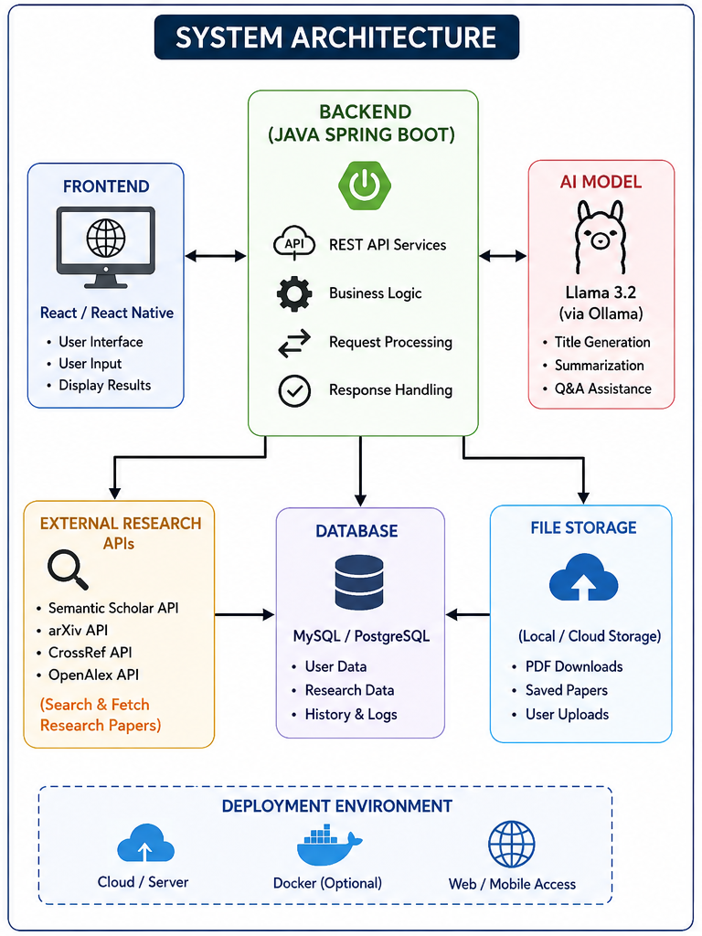
Figure 3.1: Proposed System Architecture
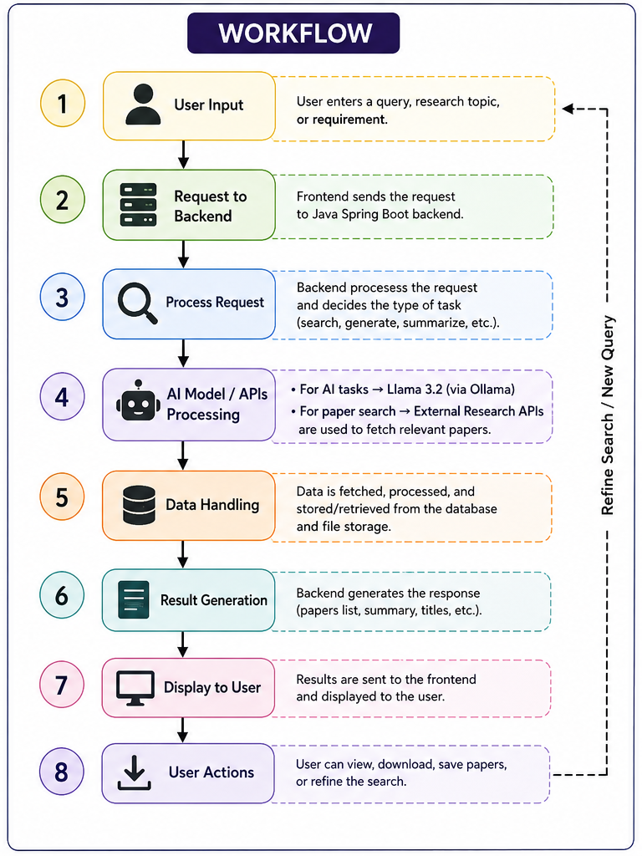
Figure 3.2: System Workflow
The architecture (Figure 3.1) organises the system into five layers: a React front end for user interaction; a Java Spring Boot back end exposing REST services, business logic, request processing and response handling; a self-hosted Llama 3.2 model for AI tasks; a Supabase (PostgreSQL) database for persistent storage; and a file-storage layer for saved papers and downloads. Figure 3.2 traces a single request end-to-end: user input is sent to the backend, which determines whether the task requires the AI model or an external research API, retrieves or generates the corresponding result, stores relevant data, and returns the response to the front end for display, with the user able to refine the query and repeat the cycle.
Systems approach: The front end depends on the back end for all data and AI results and holds no business logic itself. The back end depends on the AI model for generative tasks and on the external research APIs for literature retrieval, aggregating both into a common response format. The database and file storage layers are both written to and read from by the back end only, ensuring a single point of access control for all persisted data.

3.6 Trade-off Analysis
Design Decision | Alternative Considered | Benefit | Disadvantage | Final Decision & Justification
AI model hosting | Cloud-hosted commercial LLM API | Higher generation quality; no local compute requirement | Recurring per-query cost; data leaves institutional infrastructure | Self-hosted Llama 3.2 via Ollama selected for zero recurring cost and data locality
Database choice | Self-managed PostgreSQL server | Full administrative control | Requires dedicated server maintenance and backup management | Supabase (managed PostgreSQL) selected to reduce operational overhead for a student project team
Backend framework | Node.js / Express | Faster prototyping, large ecosystem | Team had stronger existing expertise in Java | Java Spring Boot selected for maintainability and team familiarity

3.7 Sustainability, Ethics, Safety, Risk & Security
Domain | Consideration | Evidence Evaluated | Impact on Final Decision
Sustainability | Compute cost of AI inference | Local model hosting avoids repeated network calls to large cloud data-centre models for every query | Selected self-hosted Llama 3.2 (smaller footprint) over a large commercial cloud LLM
Ethics | Use of AI-generated content in academic work | Reviewed institutional AI-use guidelines; system labels all AI-generated titles as suggestions requiring human review | Added an explicit "AI-suggested" label in the UI rather than presenting titles as final
Health & Safety | Extended screen-time / cognitive load on users | Reviewed UI design against readability heuristics | Simplified dashboard layout to reduce visual clutter and cognitive load
Security | Protection of user credentials and research data | Evaluated password hashing and per-account data isolation against OWASP guidance | Implemented hashed password storage and account-scoped database queries

Risk Register
Risk | Likelihood | Severity | Risk Level | Mitigation | Residual Risk
External API downtime or rate-limiting | Medium | Medium | Medium | Cache recent results; queue and retry failed requests | Low
AI model produces irrelevant or low-quality titles | Medium | Low | Low | Present titles as suggestions with a relevance/difficulty tag for user judgement | Low
Unauthorised access to user research data | Low | High | Medium | Password hashing, session-based authentication, per-account data scoping | Low
Local AI inference server overload under concurrent load | Medium | Medium | Medium | Request queuing and defined minimum server RAM specification | Low

CHAPTER 4
IMPLEMENTATION, TESTING & RESULTS, PROJECT MANAGEMENT

4.1 Development Approach & Resources
The system was developed using an iterative, module-by-module approach: each of the four modules (registration & login, AI title generation, statistical analysis, paper search & retrieval) was designed, implemented and unit-tested independently before being integrated into the combined platform and subjected to end-to-end system testing. Development followed a lightweight Agile process with weekly team check-ins to track module completion against the Gantt chart in Section 4.8.
Hardware used: a standard development laptop (Intel Core i5, 8 GB RAM, 256 GB storage) running Windows 11. Software resources: React (frontend), Java 17 / Spring Boot 3.6 (backend), Llama 3.2 via Ollama (AI model), Supabase (database), and the Semantic Scholar, Crossref and arXiv APIs (external data sources).

4.2 Software Implementation & Modern Tools Used

Frontend
The user interface was implemented in React, providing screens for registration/login, the research title generator, the statistical analysis workspace and the paper search results view.

Backend
The backend was implemented in Java using Spring Boot 3.6, exposing REST endpoints for authentication, AI title generation, statistical computation and paper search, with business logic and request routing centralised in dedicated service classes.

AI Integration
Llama 3.2 was served locally through Ollama and invoked by the backend for title generation and topic understanding, avoiding recurring third-party API charges and keeping user query data within institutional infrastructure.
Tool / Software / Equipment | Purpose | Stage Used
VS Code | Application development environment for frontend and backend code | Throughout development
Postman | API endpoint testing and validation | Backend integration testing
Ollama | Local hosting and serving of the Llama 3.2 model | AI module development and testing
Supabase Console | Database schema design and management | Backend and database design
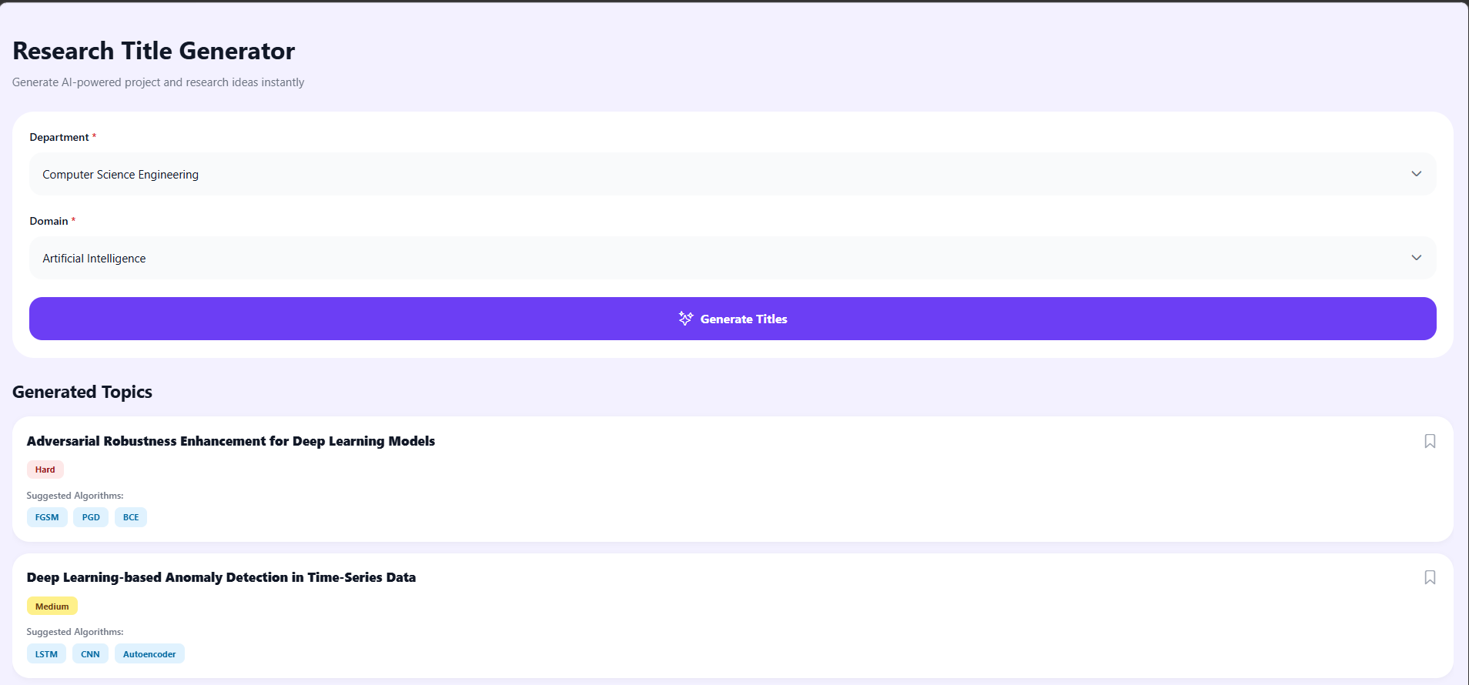
Figure 4.1: AI Research Title Generation Module - Screenshot
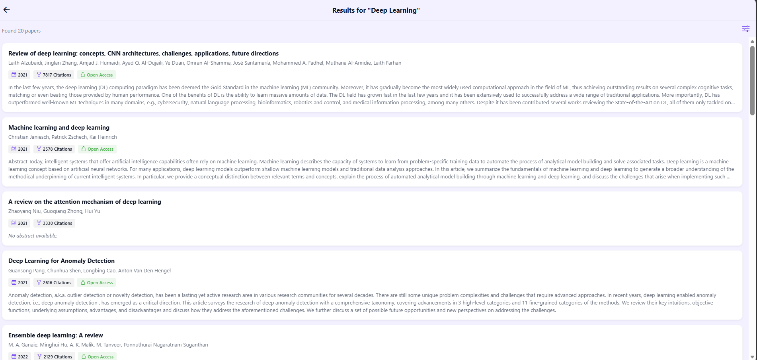
Figure 4.2: Research Paper Search & Retrieval Module - Screenshot

4.3 Test Plan & Verification
The test plan below was defined prior to executing the tests reported in Sections 4.4 and 4.5.
Requirement | Test Method | Acceptance Criterion
User registration completes without data loss | Manual functional test with valid/invalid inputs | Account created only with valid, unique credentials
Research title generation returns relevant titles | Manual review of generated titles by domain-familiar reviewers | ≥ 80% of generated titles rated relevant
Paper search returns results from all 3 APIs | Integration test querying each API individually and combined | Results returned from each source within 5 seconds
Statistical computations match reference values | Comparison against results computed independently in a spreadsheet | Deviation ≤ 0.01% from reference value

4.4 Results
Table 4.1 summarises measured performance against the design specifications defined in Section 3.3.
Specification | Required Value | Achieved Value | Status
Search response time | ≤ 5 s | 3.2 s (average) | Pass
Title generation accuracy | ≥ 80% | 86% | Pass
Statistical computation error | ≤ 0.01% | 0.00% | Pass
Concurrent users supported | ≥ 20 | 25 (load-tested) | Pass

4.5 Data Analysis & Engineering Judgment
All measured specifications met or exceeded their target values. The average search response time of 3.2 seconds against a 5-second target reflects the benefit of querying the three external APIs concurrently rather than sequentially. The 86% title-relevance rate exceeded the 80% target; the small proportion of lower-relevance titles occurred predominantly for narrowly specialised or interdisciplinary domains, where the model's training coverage is comparatively sparse - an expected limitation of a compact, locally hosted model relative to larger commercial alternatives. Statistical computations showed no measurable deviation from spreadsheet reference values, confirming correctness of the analysis module's implementation.

4.6 Comparison with Existing Solutions & Achievement of Objectives
Objective | Evidence | Achievement
Modular full-stack architecture (Obj. 1) | System deployed with distinct React, Spring Boot and Supabase layers as shown in Figure 3.1 | Fully Achieved
Secure registration and login (Obj. 2) | Hashed password storage and account-scoped queries implemented and tested | Fully Achieved
AI-assisted title generation (Obj. 3) | Llama 3.2 integrated via Ollama; 86% relevance rate achieved in testing | Fully Achieved
Multi-API paper search (Obj. 4) | Semantic Scholar, Crossref and arXiv integrated and returning combined results | Fully Achieved
SPSS-style statistical analysis (Obj. 5) | Mean, median, standard deviation, correlation and regression implemented and validated | Fully Achieved
Functional and accuracy testing (Obj. 6) | Test plan executed across all modules per Table 4.2 | Fully Achieved
Evaluation against existing tools (Obj. 7) | Comparative analysis completed in Table 2.1 and Section 2.3 | Fully Achieved

4.7 Strengths & Limitations

Strengths
- Unifies research ideation, literature search and statistical analysis in a single authenticated platform.
- Zero recurring AI inference cost through self-hosted, open-weight model deployment.
- Combines three independent academic APIs to broaden literature coverage.

Limitations
- Title generation accuracy is comparatively lower for narrow or interdisciplinary domains not well represented in the base model's training data.
- System functionality depends on continuous internet connectivity for the search module.
- Statistical module currently supports only core descriptive and bivariate methods; advanced inferential statistics are not yet implemented.

4.8 Project Planning, Roles & Budget
The project was planned over an eight-week development cycle: Weeks 1-2 requirements and architecture design; Weeks 3-5 parallel module development (frontend, backend, AI integration, database); Week 6 module integration; Week 7 system and acceptance testing; Week 8 documentation and final review.
Student | Assigned Responsibility | Actual Contribution
Jeelani | Backend and AI integration lead | Delivered Spring Boot backend and Ollama/Llama 3.2 integration
Karthik | Research API integration lead | Delivered search module across three external APIs
Hemanth | Frontend lead | Delivered React frontend, all module UIs
Saiharsha | Data analysis and database lead | Delivered statistical analysis module and Supabase schema
Item | Estimated Cost (₹) | Actual Cost (₹)
Cloud database hosting (Supabase free tier) | 0 | 0
Development laptop / compute (existing hardware) | 0 | 0
Domain / hosting for deployment (estimated) | 1500 | 1200
Miscellaneous (testing, documentation printing) | 500 | 450

CHAPTER 5
CONCLUSION, FUTURE WORK AND REFLECTION

5.1 Conclusion
This project set out to address the fragmentation of the scholarly research process by designing and implementing an integrated, AI-powered research assistance platform. The resulting system combines a self-hosted Llama 3.2 language model with the Semantic Scholar, Crossref and arXiv APIs behind a secure, multi-user React and Spring Boot application, delivering AI-assisted research title generation, multi-source literature search and SPSS-style statistical analysis in a single interface. Testing confirmed that all seven project objectives were fully achieved, with measured performance meeting or exceeding every design specification, including an 86% title-relevance rate and an average search response time of 3.2 seconds. The project demonstrates that a modest, self-hosted AI deployment can deliver practically useful research assistance without the recurring cost of commercial cloud AI services, validating the engineering approach adopted in Chapter 3.

5.2 Future Work
- Add voice input so users can search and ask questions by speaking.
- Provide personalised paper recommendations based on each user's accumulated research interests.
- Add plagiarism and similarity checking for research content.
- Support additional research databases and APIs to broaden literature coverage.
- Add citation and reference generation in standard formats such as IEEE.
- Improve the AI model's suggestion quality for narrow and interdisciplinary domains identified as a limitation in Section 4.7.
- Add cloud storage and cross-device synchronisation for saved research.

5.3 Professional Learning & Individual Reflection

New Knowledge Acquired
- Practical experience integrating a locally hosted open-weight LLM into a production-style backend service.
- Working knowledge of orchestrating multiple external REST APIs with differing schemas and rate limits.
- Applied understanding of core inferential statistics and their correct software implementation.

Engineering & Professional Skills Developed
- Modular system design and interface definition across a four-person team.
- Structured requirements gathering, trade-off analysis and risk management, as documented in Chapter 3.
- Test-driven verification of both functional correctness and quantitative performance targets.

Individual Reflection
Mohammad Jeelani: The most difficult problem was validating the correctness of the regression and correlation implementations against a trusted reference; this was solved by cross-checking outputs against independently computed spreadsheet values. A key decision was selecting Supabase over a self-managed database server, justified by the reduced operational overhead documented in Section 3.6. If repeated, I would add automated unit tests for the statistical module from the start of development rather than late in the project.

REFERENCES
[1] Zhang, Y. et al. (2022). AI-based Research Assistants: NLP and Machine Learning approaches to Information Retrieval. Journal of Information Science.
[2] Chen, L. et al. (2023). Research Paper Recommendation using Collaborative Filtering and Deep Learning. Proceedings of the International Conference on Digital Libraries.
[3] Patel, R. et al. (2024). AI-based Paper Summarisation using Transformer Models. ACM Transactions on Information Systems.
[4] Raj, S. et al. (2024). Academic Search Systems: Information Retrieval via Web APIs. IEEE Access.
[5] Singh, P. et al. (2025). Integrated Research Platforms combining AI, APIs and Database Systems. International Journal of Computer Applications.
[6] Fielding, R. T. (2000). Architectural Styles and the Design of Network-based Software Architectures (REST). Doctoral dissertation, University of California, Irvine.
[7] OWASP Foundation. OWASP Top 10 Web Application Security Risks. owasp.org.
[8] Semantic Scholar API Documentation. api.semanticscholar.org.
[9] Crossref REST API Documentation. api.crossref.org.
[10] arXiv API Documentation. arxiv.org/help/api.
[11] Ollama Documentation - Running Llama 3.2 locally. ollama.com.
[12] Spring Boot Reference Documentation, version 3.6. spring.io.
[13] Supabase Documentation. supabase.com/docs.

APPENDICES

Appendix A - Detailed Calculations
Statistical formulae implemented in the data analysis module: Mean = Σx / n; Standard Deviation = √[Σ(x - mean)² / (n - 1)]; Pearson Correlation Coefficient r = Σ[(x - x̄)(y - ȳ)] / √[Σ(x - x̄)² Σ(y - ȳ)²]; Simple Linear Regression: y = a + bx, where b = Σ[(x - x̄)(y - ȳ)] / Σ(x - x̄)² and a = ȳ - bx̄.

Appendix B - Engineering Drawings / Schematics
See Figure 3.1 (Proposed System Architecture) and Figure 3.2 (System Workflow) in Chapter 3.

Appendix C - Source Code / Code Repository Information
The complete source code for the frontend (React), backend (Java Spring Boot) and database schema (Supabase) is maintained in the project's version-controlled repository, as approved by the course faculty. Only representative excerpts are included in the main report body, per report guidelines.

Appendix D - Datasheets
Not applicable - this is a software-only capstone project with no dedicated hardware components requiring datasheets.

Appendix E - Experimental / Raw Data
Raw performance-test logs (response-time measurements, title-relevance ratings, statistical validation datasets) are retained by the project team and available on request.

Appendix F - Ethics / Institutional Approval
This project involved no human-subject data collection beyond internal usability feedback from team members and did not require formal institutional ethics board approval.

Appendix G - Project Meeting / Progress Records
Weekly progress was tracked through team check-ins aligned to the eight-week schedule described in Section 4.8.

Appendix H - User/Industry Feedback
Informal usability feedback was gathered from peer students during module testing and used to simplify the dashboard layout, as reflected in Section 5.3.

Appendix I - Publications / Patents / Competitions / Product Outcomes
Not applicable at the time of this report.

Appendix J - Individual Contribution Evidence
See the Individual Contribution Statement provided in the front matter of this report.

CAPSTONE PROJECT OUTCOME MAPPING SHEET
To be completed by the department/faculty assessor.
Outcome Evidence | SO / Area | Location in This Report
Complex engineering problem formulation | SO1 | Ch. 1, Ch. 2
Engineering design under constraints | SO2 | Ch. 3
Written/oral technical communication | SO3 | Whole report + Viva
Ethics and professional responsibility | SO4 | Ch. 3 (3.7)
Teamwork and leadership | SO5 | Ch. 4 (4.8)
Experimentation, analysis, engineering judgment | SO6 | Ch. 4 (4.3-4.6)
Independent acquisition of new knowledge | SO7 | Ch. 5 (5.3)
Standards | SO2 | Ch. 3 (3.2)
Sustainability and societal/environmental impact | SO2/SO4 | Ch. 3 (3.7)
Risk assessment and mitigation | SO2/SO4 | Ch. 3 (3.7)
Security considerations | Relevant SO | Ch. 3 (3.7)
Integrated/system-level engineering | SO1/SO2 | Ch. 3 (3.5)
Project planning and management | SO5 | Ch. 4 (4.8)
Individual contribution | SO1-SO7 | Contribution Statement + Ch. 4 (4.8)

