SIMATS ENGINEERING ASSESSMENT TOOL 1

NAME: Mohammad Jeelani REG NO: 192373043
COURSE NAME: INTERNET PROGRAMMING COURSE CODE: CSA4303

CO3-AT1

Question 1
Suppose that a college wants to develop an online student registration system where students submit their details through a web form, and the data is processed using a Java Servlet.
Explain the architecture of a servlet-based application. Design and implement a servlet to handle form data using both GET and POST methods. Describe the servlet life cycle (init, service, destroy) and justify which method is more appropriate for handling sensitive data.

Answer:

Servlet Architecture, GET/POST and Servlet Life Cycle

Servlet Architecture

A Servlet is a Java program that runs on a web server and handles requests from clients such as web browsers.

The basic architecture is:

Student
↓
Web Browser
↓ HTTP Request
Web Server / Servlet Container
↓ StudentRegistrationServlet
↓ Processing / Validation
↓
HTTP Response
↓
Web Browser

- HTML Registration Form
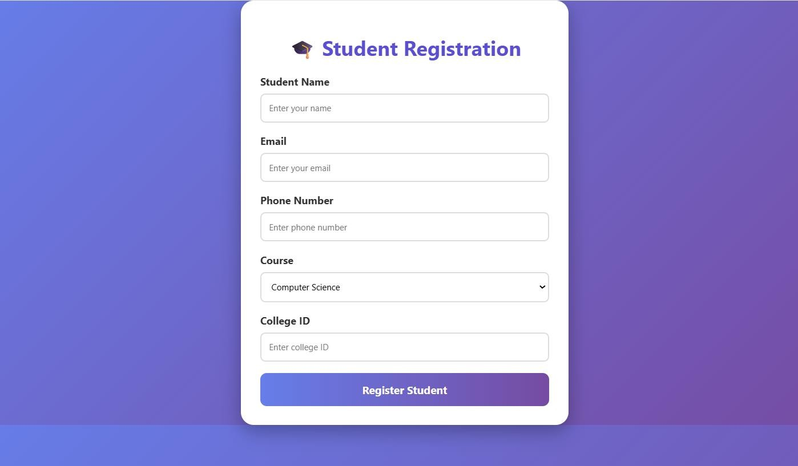

Servlet Using GET and POST
import java.io.*;
import jakarta.servlet.*; import jakarta.servlet.http.*;
public class StudentRegistrationServlet extends HttpServlet { protected void doGet(HttpServletRequest request,
HttpServletResponse response)
throws ServletException, IOException { response.setContentType("text/html");
PrintWriter out = response.getWriter();

String name = request.getParameter("name"); String course = request.getParameter("course");

out.println("<h2>GET Request</h2>"); out.println("<p>Name: " + name + "</p>"); out.println("<p>Course: " + course + "</p>");
}

protected void doPost(HttpServletRequest request, HttpServletResponse response)
throws ServletException, IOException { response.setContentType("text/html");
PrintWriter out = response.getWriter();

String name = request.getParameter("name"); String email = request.getParameter("email"); String course = request.getParameter("course");

out.println("<h2>Registration Successful</h2>"); out.println("<p>Name: " + name + "</p>"); out.println("<p>Email: " + email + "</p>"); out.println("<p>Course: " + course + "</p>");
}
}

Servlet Life Cycle

The servlet life cycle consists of three main methods:

init()
Called only once when the servlet is created. public void init() {
System.out.println("Servlet initialized");
}

Used for initialization tasks such as loading configuration.

service()
Called whenever the servlet receives a request. Client Request
↓
service()
↓
doGet() / doPost()

The service() method determines whether the request is GET, POST, etc., and calls the appropriate method.

destroy()
Called once before the servlet is removed from memory. public void destroy() {
System.out.println("Servlet destroyed");
}

Used for cleanup operations.

Life Cycle Diagram
Servlet Loaded
↓ init()
↓ service()
↙ ↘
doGet() doPost()
↘ ↙
Response
↓ destroy()

5. GET vs POST

GET | POST
Data is sent in URL | Data is sent in request body
Less suitable for sensitive data | More appropriate for sensitive data
Data can appear in browser history | Data is not normally displayed in URL
Suitable for retrieving data | Suitable for submitting data
Limited URL length | Can handle larger request data

Question 2
Suppose that a website requires users to log in and maintain their session across multiple pages after authentication.
Design a session management system using HttpSession and Cookies in Servlets. Explain how session tracking works in web applications and compare session-based tracking with cookies.

Answer:

Session Management Using HttpSession and Cookies

Session Management

Session management allows a web application to remember a user across multiple HTTP requests.

For example:

Login
↓ Home Page
↓ Profile
↓ Products

The server needs to know that all these requests belong to the same user.

Login Servlet Using Http Session
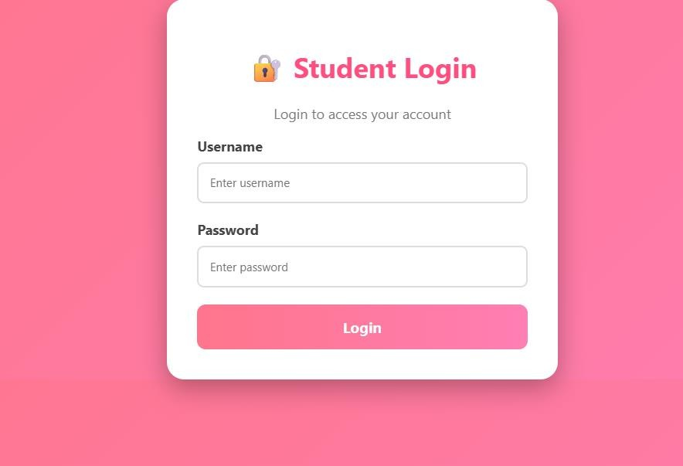

Login Servlet Using HttpSession
import java.io.*;
import jakarta.servlet.*; import jakarta.servlet.http.*;
public class LoginServlet extends HttpServlet { protected void doPost(HttpServletRequest request,
HttpServletResponse response)
throws ServletException, IOException {

String username = request.getParameter("username"); String password = request.getParameter("password");

if (username.equals("admin") && password.equals("1234")) {

HttpSession session = request.getSession(); session.setAttribute("username", username);
response.sendRedirect("home");
}
else {
response.setContentType("text/html"); PrintWriter out = response.getWriter();
out.println("<h2 style='color:red'>"); out.println("❌ Invalid Username or Password"); out.println("</h2>");
}
}
}

Home Servlet
import java.io.*;
import jakarta.servlet.*; import jakarta.servlet.http.*;

public class HomeServlet extends HttpServlet { protected void doGet(HttpServletRequest request,

HttpServletResponse response)
throws ServletException, IOException { response.setContentType("text/html");
PrintWriter out = response.getWriter();

HttpSession session = request.getSession(false);
if (session != null) { String username =
(String) session.getAttribute("username");

out.println("<html>");
out.println("<body style='font-family:Arial;text-align:center;background:#e0f7fa;padding:50px'>");

out.println("<div style='background:white;padding:40px;border-radius:20px;width:450px;margin:auto'>");

out.println("<h1 style='color:#0097a7'>"); out.println("🎉 Welcome " + username); out.println("</h1>");

out.println("<p>You are successfully logged in.</p>"); out.println("<a href='logout'>Logout</a>");
out.println("</div>"); out.println("</body>"); out.println("</html>");

} else {

out.println("<h2>Please Login First</h2>");
}
}
}

Logout Servlet
import java.io.*;

import jakarta.servlet.*; import jakarta.servlet.http.*;
public class LogoutServlet extends HttpServlet { protected void doGet(HttpServletRequest request,
HttpServletResponse response)
throws IOException {

HttpSession session = request.getSession(false);

if (session != null) { session.invalidate();
}

response.sendRedirect("login.html");
}
}

Cookies
A cookie is a small piece of data stored by the browser. Create Cookie
Cookie cookie =
new Cookie("username", "Sravanthi"); cookie.setMaxAge(60 * 60); response.addCookie(cookie);
Read Cookie
Cookie[] cookies = request.getCookies(); if (cookies != null) {
for (Cookie cookie : cookies) {
if (cookie.getName().equals("username")) { String username =
cookie.getValue();

System.out.println(username);
}
}
}

How Session Tracking Works

User Login
↓

Server creates HttpSession
↓
Session ID generated
↓
Session ID sent to Browser
↓
Browser sends Session ID with every request
↓
Server identifies the session
↓
User remains logged in

The session ID is commonly maintained through a cookie called JSESSIONID.

Http Session vs Cookies

HttpSession | Cookies
Data is mainly stored on server | Data is stored on client/browser
Uses a session ID | Stores cookie values
Suitable for login sessions | Suitable for preferences/small data
More suitable for sensitive session state | Client can modify cookie data
Session expires after timeout/invalidation | Cookie has its own expiration
Can store multiple attributes | Limited storage size

Conclusion

For an authentication system, HttpSession is preferred for maintaining server-side login state. Cookies are commonly used to carry the session identifier between the browser and server.

Question 3
Suppose that an e-commerce platform needs to store and retrieve product details from a database using a Java-based web application.
Design a JDBC-based application to connect to a database, insert product data, and retrieve it using SQL queries. Explain the JDBC architecture and describe the steps involved in database connectivity along with proper exception handling.

Answer:

JDBC E-Commerce Application

JDBC Architecture

JDBC stands for Java Database Connectivity.

It allows Java applications to communicate with databases.

Java Web Application
↓ JDBC API
↓
Driver Manager
↓ JDBC Driver
↓ MySQL Database

Database Creation
CREATE DATABASE ecommerce; USE ecommerce;
CREATE TABLE product (
id INT PRIMARY KEY AUTO_INCREMENT, name VARCHAR(100),
price DOUBLE, quantity INT
);

Colorful Product HTML Form

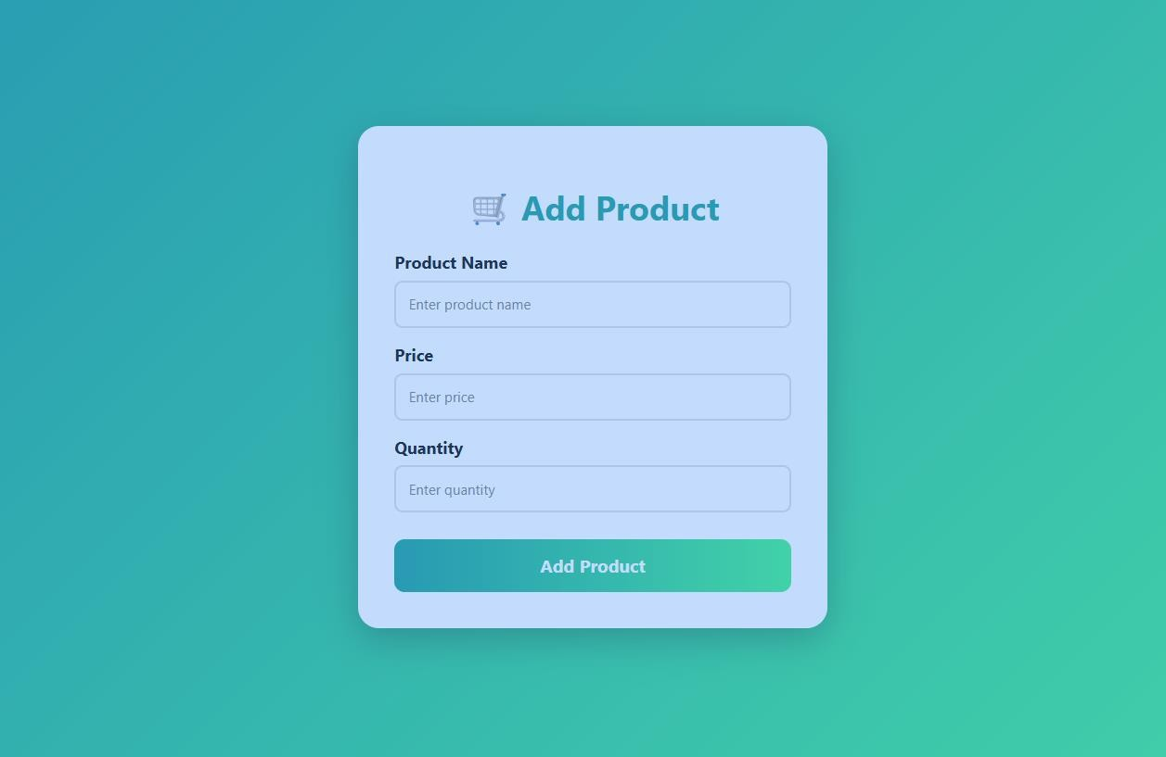

JDBC Database Connection
import java.sql.*;

public class DBConnection {

public static Connection getConnection() throws SQLException {

String url = "jdbc:mysql://localhost:3306/ecommerce";

String username = "root"; String password = "root";

return DriverManager.getConnection( url,
username, password
);
}
}

Change "root" password according to your MySQL installation.

Insert Product Using Servlet
import java.io.*; import java.sql.*;
import jakarta.servlet.*; import jakarta.servlet.http.*;
public class ProductServlet extends HttpServlet { protected void doPost(HttpServletRequest request,
HttpServletResponse response)
throws ServletException, IOException { response.setContentType("text/html");
PrintWriter out = response.getWriter();

String name = request.getParameter("name");

double price = Double.parseDouble(
request.getParameter("price"));

int quantity = Integer.parseInt(
request.getParameter("quantity"));

String sql =
"INSERT INTO product(name, price, quantity) " + "VALUES (?, ?, ?)";

try (
Connection con = DBConnection.getConnection();

PreparedStatement ps = con.prepareStatement(sql)
) {

ps.setString(1, name); ps.setDouble(2, price); ps.setInt(3, quantity);

ps.executeUpdate();

out.println("<html>");
out.println("<body style='font-family:Arial;background:#38ef7d;text-align:center;padding:50px'>");

out.println("<div style='background:white;padding:40px;border-radius:20px;width:450px;margin:auto'>");

out.println("<h1 style='color:#11998e'>"); out.println("✅ Product Added Successfully!"); out.println("</h1>");

out.println("<p>Product: " + name + "</p>"); out.println("<p>Price: ₹" + price + "</p>"); out.println("<p>Quantity: " + quantity + "</p>");

out.println("</div>"); out.println("</body>"); out.println("</html>");

} catch (SQLException e) {

out.println("<h2 style='color:red'>"); out.println("Database Error: "
+ e.getMessage()); out.println("</h2>");
}
}
}

Retrieve Products
import java.io.*;
public class ProductListServlet extends HttpServlet { protected void doGet(HttpServletRequest request,
HttpServletResponse response)
throws ServletException, IOException { response.setContentType("text/html");
PrintWriter out = response.getWriter();

String sql =
"SELECT * FROM product";

out.println("<html>"); out.println("<head>"); out.println("<style>");
out.println("body{font-family:Arial;background:linear-gradient(135deg,#667eea,#764ba2);padding:40px;}");
out.println("table{width:80%;margin:auto;background:white;border-collapse:collapse;}");
out.println("th{background:#5a4fcf;color:white;padding:15px;}"); out.println("td{padding:12px;text-align:center;border-bottom:1px solid #ddd;}"); out.println("h1{text-align:center;color:white;}");
out.println("</style>"); out.println("</head>");

out.println("<body>"); out.println("<h1>🛒 Product List</h1>"); out.println("<table>");
out.println("<tr>"); out.println("<th>ID</th>"); out.println("<th>Product Name</th>"); out.println("<th>Price</th>"); out.println("<th>Quantity</th>"); out.println("</tr>");

try (
Connection con = DBConnection.getConnection();

Statement st = con.createStatement();

ResultSet rs = st.executeQuery(sql)
) {

while (rs.next()) {

out.println("<tr>");

out.println("<td>"
+ rs.getInt("id")
+ "</td>");

out.println("<td>"
+ rs.getString("name")
+ "</td>");

out.println("<td>₹"
+ rs.getDouble("price")
+ "</td>");

out.println("<td>"
+ rs.getInt("quantity")
+ "</td>");

out.println("</tr>");
}

} catch (SQLException e) {

out.println("<tr><td colspan='4'>"); out.println("Database Error: "
+ e.getMessage()); out.println("</td></tr>");
}

out.println("</table>"); out.println("</body>"); out.println("</html>");
}
}

JDBC Steps

Remember these 5 important steps for the exam:

Step 1 — Load JDBC Driver Class.forName("com.mysql.cj.jdbc.Driver");

Modern JDBC drivers can register automatically, but this is commonly shown in JDBC fundamentals.
Step 2 — Establish Connection Connection con =
DriverManager.getConnection( url, username, password);
Step 3 — Create Statement PreparedStatement ps =
con.prepareStatement(sql); Step 4 — Execute SQL
For INSERT/UPDATE/DELETE:

ps.executeUpdate(); For SELECT:
ResultSet rs = ps.executeQuery();
Step 5 — Close Resources rs.close();
ps.close();
con.close();

Using try-with-resources, as in the example above, automatically closes resources.

Exception Handling

JDBC operations can produce SQLException. try {
Connection con = DBConnection.getConnection();

// Database operations

}
catch (SQLException e) {

System.out.println(
"Database Error: " + e.getMessage());

}

Code of Conduct:

I (Mohammad Jeelani / 192373043) certify that this submission is my original work and that I have adhered to the guidelines specified for this assessment.
I understand that any violation of academic integrity rules will result in disciplinary action.

Signature of the student: P. Sravanthi

RUBRICS FOR CALCULATION:

Criteria | Weightag  e (%) | Level 4  (Exemplary) | Level 3  (Proficient) | Level 2  (Developing) | Level 1  (Beginning)
Understandin g of Scenario | 20% | Demonstrates clear and complete understanding of the scenario and  context | Shows good understanding with minor gaps | Partial understanding; misses key aspects | Misinterprets or fails to understand the scenario
Identification of Key Issues | 20% | Accurately identifies all relevant issues and factors involved | Identifies most key issues with minor omissions | Identifies limited issues; some irrelevant  points | Unable to identify key issues
Application of Concepts | 25% | Applies appropriate concepts effectively to  address the  scenario | Applies concepts with minor errors | Limited or partially correct application | Unable to apply relevant concepts
Decision Making | 20% | Makes well-reasoned, logical decisions with strong rationale | Makes reasonable decisions with some  justification | Makes weak decisions with limited justification | No clear decisions made or rationale  provided

Clarity of Response | 15% | Response is clear, structured, and logically presented | Generally clear with minor issues | Somewhat unclear or poorly  structured | Disorganized and difficult to understand

