SIMATS ENGINEERING ASSESSMENT TOOL 2

NAME: Mohammad Jeelani

REG NO: 192311272
COURSE NAME: INTERNET PROGRAMMING COURSE CODE: CSA4303

C03-AT2

Servlet Architecture & Workflow Question:
Present the architecture of Java Servlets and explain the complete request–response cycle with a neat diagram.

Focus Areas:
  - Client–Server interaction
  - Role of Web Container
  - Request and Response objects

Answer:

Java Servlets – Complete Solutions

Servlet Architecture & Workflow Definition
A Java Servlet is a server-side Java program used to handle client requests and generate
dynamic responses.

Servlet Architecture
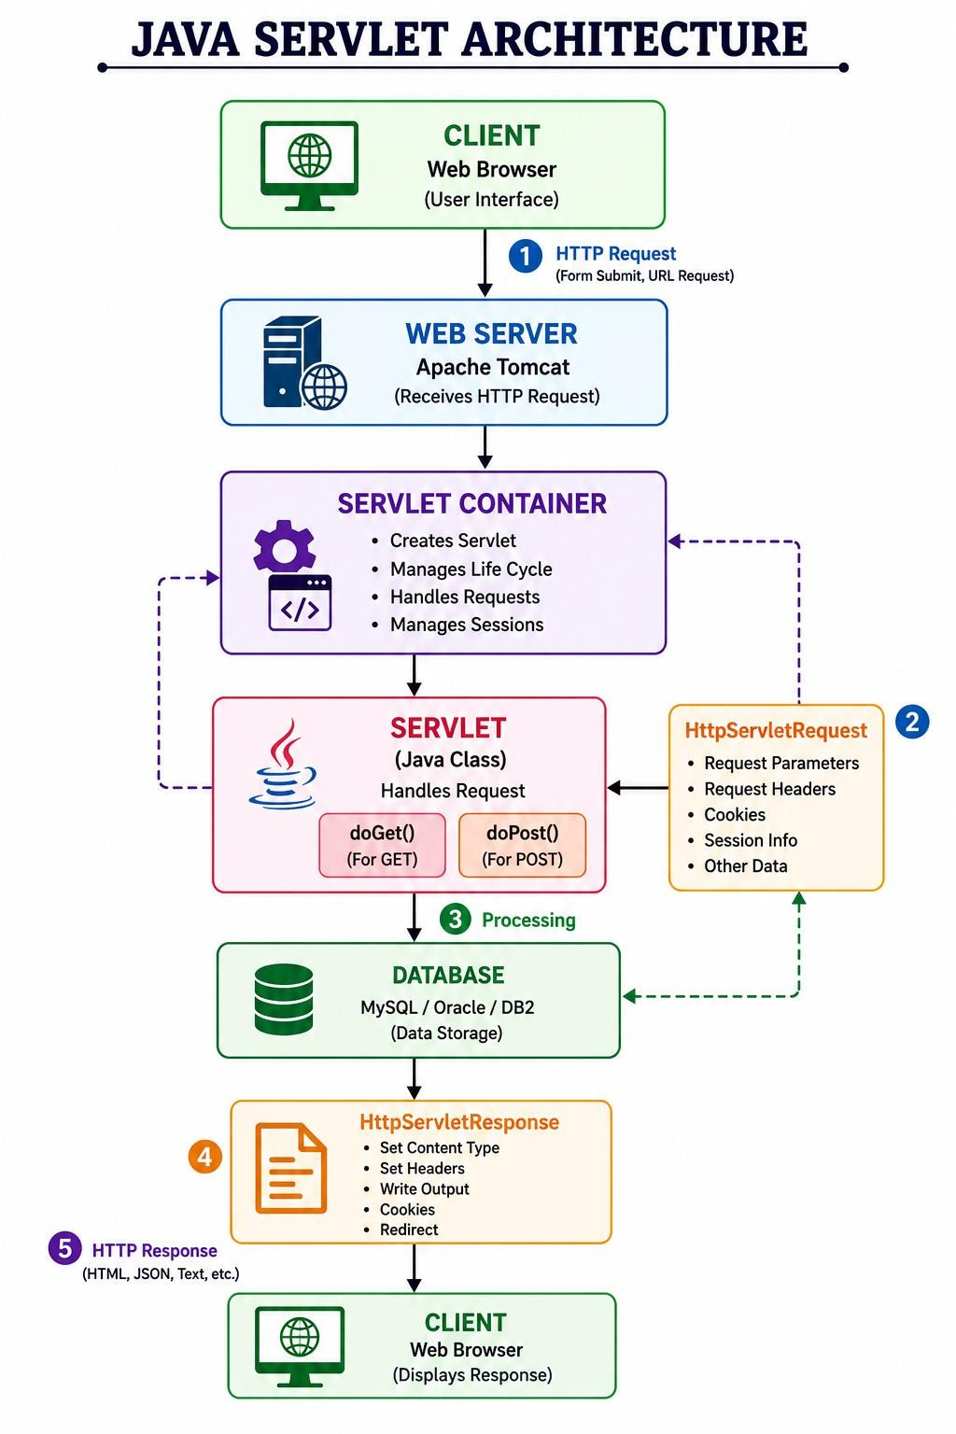

Request–Response Cycle

- User enters information in a web browser.
- Browser sends an HTTP request to the web server.
- The web server passes the request to the Servlet Container.
- The container identifies the required servlet.
- It creates HttpServletRequest and HttpServletResponse objects.
- The servlet processes the request.
- The servlet may communicate with a database or other services.
- The servlet generates a response.
- The container sends the HTTP response back to the browser.
- Browser displays the result.

Request Object

HttpServletRequest contains information sent by the client.

Example:

String name = request.getParameter("name"); It can obtain:
  - Form parameters
  - Request method
  - Headers
  - Cookies
  - Session information

Response Object

HttpServletResponse is used to send data back to the client.

Example: response.setContentType("text/html"); PrintWriter out = response.getWriter(); out.println("<h1>Welcome!</h1>");
Simple Workflow
Client
↓ HTTP Request
↓
Web Container
↓ Servlet
↓ Business Logic
↓ Database
↓ Servlet
↓
HTTP Response

↓ Client

Servlet Life Cycle Analysis Question:
Explain the Servlet Life Cycle with a sequence diagram and analyze the role of init(), service(), and destroy() methods.

Focus Areas:
  - Life cycle phases
  - Execution flow
  - Performance implications

Answer:

Servlet Life Cycle Analysis

The Servlet Life Cycle describes how a servlet is created, used, and destroyed by the servlet container.

Life Cycle Diagram
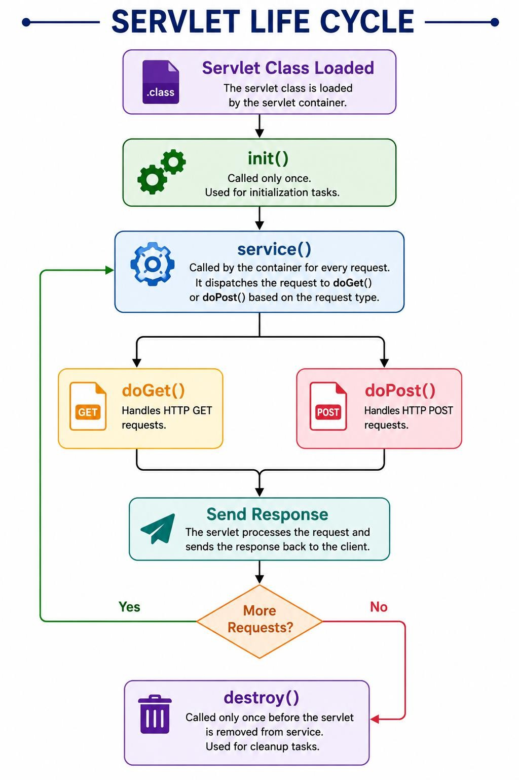

init()
The init() method is called once when the servlet is initialized. public void init() {
System.out.println("Servlet initialized");

}

Uses

- Initialize resources
- Read configuration
- Establish required initial resources

service()

The service() method is called whenever the servlet receives a request. For HttpServlet, it dispatches the request to methods such as:
GET → doGet() POST → doPost()

Example:

protected void doGet(HttpServletRequest request, HttpServletResponse response) {
// Process GET request
}
protected void doPost(HttpServletRequest request, HttpServletResponse response) {
// Process POST request
}

destroy()
The destroy() method is called once before the servlet is removed from service. public void destroy() {
System.out.println("Servlet destroyed");
}

Uses

- Release resources
- Close connections
- Perform cleanup

Performance Implications

Method | Frequency | Performance
init() | Once | Expensive initialization can be done here
service() | Every request | Should be efficient
destroy() | Once | Used for cleanup

Important: A servlet instance can handle multiple requests, potentially concurrently. Therefore, shared mutable instance variables should be handled carefully.

GET vs POST Method Evaluation Question:
Compare GET and POST methods used in form submission. Present scenarios where each method is appropriate.

Focus Areas:
  - Data transmission
  - Security aspects
  - URL limitations

Answer:

GET vs POST Method Evaluation

Both GET and POST are HTTP methods commonly handled by servlets.

GET

GET sends parameters as part of the URL.

Example:



Servlet:

protected void doGet(HttpServletRequest request, HttpServletResponse response)
throws ServletException, IOException {
String name = request.getParameter("name"); response.getWriter().println(
"Welcome " + name
);
}

Suitable Uses

- Searching
- Filtering
- Retrieving information
- Pages that can be bookmarked
- Read-only operations

Example:

/products?category=mobile

POST

POST sends data in the HTTP request body.
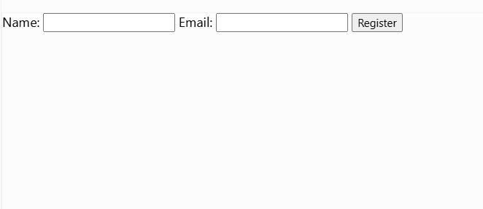

Servlet:

protected void doPost(HttpServletRequest request, HttpServletResponse response)
throws ServletException, IOException {

String name = request.getParameter("name"); String email = request.getParameter("email");

response.getWriter().println( "Registration successful"
);
}

Suitable Uses

- Registration
- Login
- Payment/order submission
- Updating information
- Uploading data

GET vs POST Table

Feature | GET | POST
Data location | URL/query string | Request body
Visibility | Visible in URL | Not normally visible in URL
Bookmarking | Possible | Generally not used for bookmarking
Caching | Can be cached | Generally not treated as a simple cacheable retrieval
Data size | Limited by URL/request-line limits | Supports larger request bodies
Idempotency | Intended for safe retrieval | Often used for state-changing operations
Sensitive data | Not appropriate | More appropriate, but HTTPS is still required
Typical use | Search/retrieve | Submit/create/update

Security Point

POST is preferable to GET for passwords and other sensitive form data because the data is not placed in the URL. However, POST does not encrypt the data. HTTPS/TLS is required for confidentiality.

Session Tracking Techniques Question:
Present different session tracking mechanisms (HttpSession, Cookies, URL rewriting). Evaluate their advantages and limitations.

Focus Areas:
  - Session persistence
  - Security concerns
  - Use-case comparison

Answer:

Session Tracking Techniques

HTTP is stateless, so a web application needs session tracking to recognize the same user across multiple requests.

The major techniques are:

- HttpSession
- Cookies
- URL Rewriting

HttpSession

HttpSession stores session-related information on the server.

Example
HttpSession session = request.getSession(); session.setAttribute("username", "Sravanthi"); Retrieve it:
HttpSession session =
request.getSession(false);

String username =
(String) session.getAttribute("username"); Logout:
session.invalidate();

Advantages

- Convenient API
- Session data is maintained server-side
- Good for login/authentication state
- Can store multiple attributes

Limitations

- Uses server memory/storage
- Requires session management infrastructure
- Session IDs must be protected

Cookies
Cookies are small pieces of data stored by the browser. Create Cookie
Cookie cookie =
new Cookie("username", "Sravanthi");

cookie.setMaxAge(3600); response.addCookie(cookie);
Read Cookie
Cookie[] cookies = request.getCookies();

if (cookies != null) {

for (Cookie c : cookies) {

if (c.getName().equals("username")) {

System.out.println(c.getValue());
}
}
}

Advantages

- Simple
- Can persist beyond a single session
- Useful for preferences and small client-side values

Limitations

- Stored on the client
- Users can delete or modify them
- Limited storage
- Should not contain sensitive information directly

URL Rewriting

URL rewriting adds the session identifier to the URL when cookies cannot be used.

Example: https://example.com/profile;jsessionid=ABC123 Servlet example:
String url = response.encodeURL("profile");

out.println("<a href='" + url + "'>Profile</a>");

Advantages

  - Works when cookies are disabled
  - Useful as a fallback session-tracking mechanism

Limitations

  - Session ID can appear in URLs
  - URLs may be logged or shared
  - Less convenient
  - Requires links to be encoded properly

Session Tracking Comparison

Technique | Storage | Advantage | Limitation
HttpSession | Server | Good for login/session data | Uses server resources
Cookies | Client | Simple and persistent | Can be modified/deleted
URL  Rewriting | URL + server session | Works without cookies | Session ID may leak through URLs

Best Choice
For a login system: HttpSession
+
Secure session cookie
+ HTTPS

is generally the preferred approach

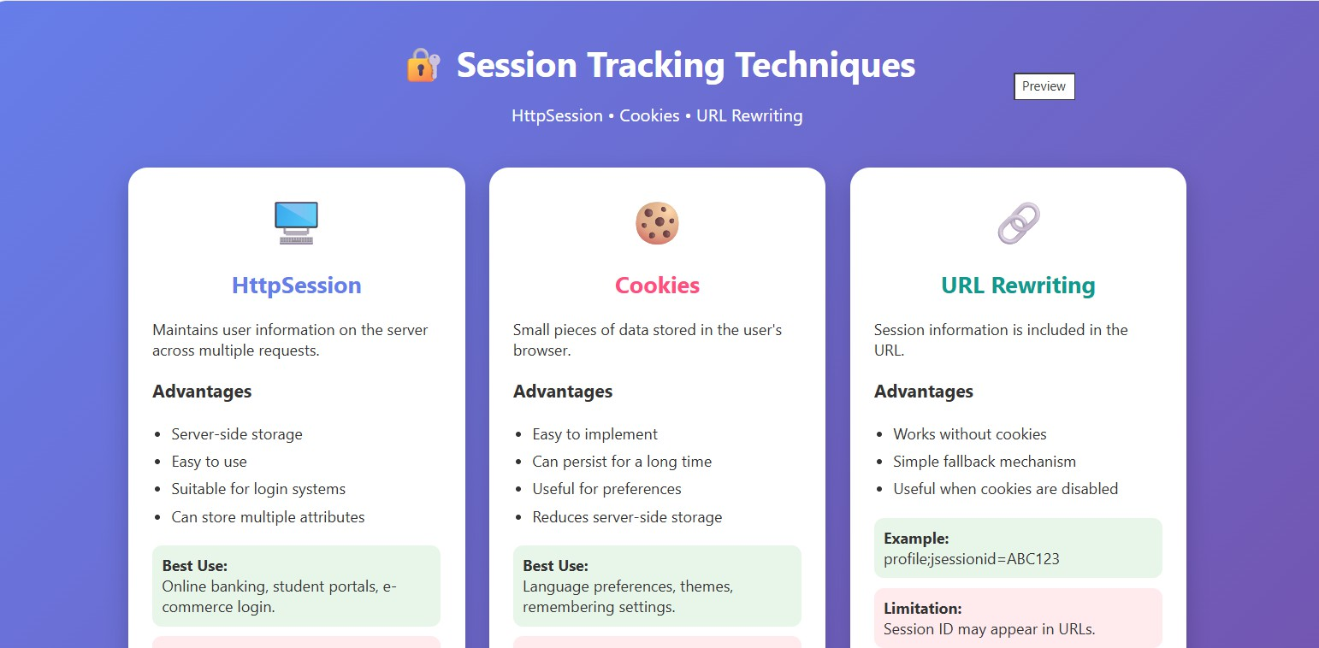
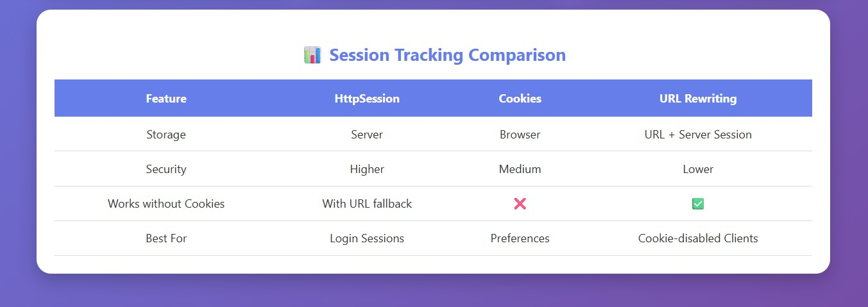

Cookies vs Sessions – Critical Analysis Question:
Analyze and compare Cookies and Sessions in web applications. Present real-time use cases.

Focus Areas:
  - Storage location
  - Security risks
  - Performance considerations

Answer:

Cookies vs Sessions – Critical Analysis Cookies

A cookie is stored in the user's browser.

Browser
│
│
▼ Cookie
Web Server

Example:

Cookie cookie =
new Cookie("theme", "dark"); response.addCookie(cookie); Sessions
A session stores the user's application state primarily on the server.

Browser
│
│ Session ID
▼ Server
│
▼ Session Data

Example:

HttpSession session = request.getSession();

session.setAttribute( "username", "Sravanthi"
);

Cookies vs Sessions

Feature | Cookies | Sessions
Storage | Client/browser | Mainly server
Identification | Cookie value | Session ID
Size | Small | Depends on server resources
Persistence | Can persist for a specified time | Usually expires after timeout/invalidation

Feature | Cookies | Sessions
Security | Client can inspect/modify values | Data is server-side
Server memory | Low | Uses server resources
Performance | Avoids server-side storage for simple values | Requires server-side session lookup
Best use | Preferences, non-sensitive identifiers | Login/authentication and user state

Real-Time Use Cases

- Online Shopping

Cookies can remember:

Language = English Theme = Dark

A session can maintain:

Logged-in user Shopping cart Checkout state

- Banking Website

Session management can maintain:

Authenticated user Current login session Authorization state

Sensitive information should not simply be stored in client-side cookies.

- Social Media

A session can maintain the user's authenticated state across:

Home
↓ Profile
↓ Messages

↓ Settings

- E-Commerce Preferences

Cookies can remember:

Preferred language
Recently selected preferences Security Considerations

For authentication sessions, applications should use secure cookie attributes such as:

Secure HttpOnly SameSite

Secure

Cookie is sent only over HTTPS.

HttpOnly

Helps prevent JavaScript from directly reading the cookie.

SameSite

Helps reduce certain cross-site request risks. Also:
- Use HTTPS.
- Do not store passwords in cookies.
- Use sufficiently strong, unpredictable session IDs.
- Invalidate sessions during logout.
- Regenerate the session ID after authentication where appropriate.

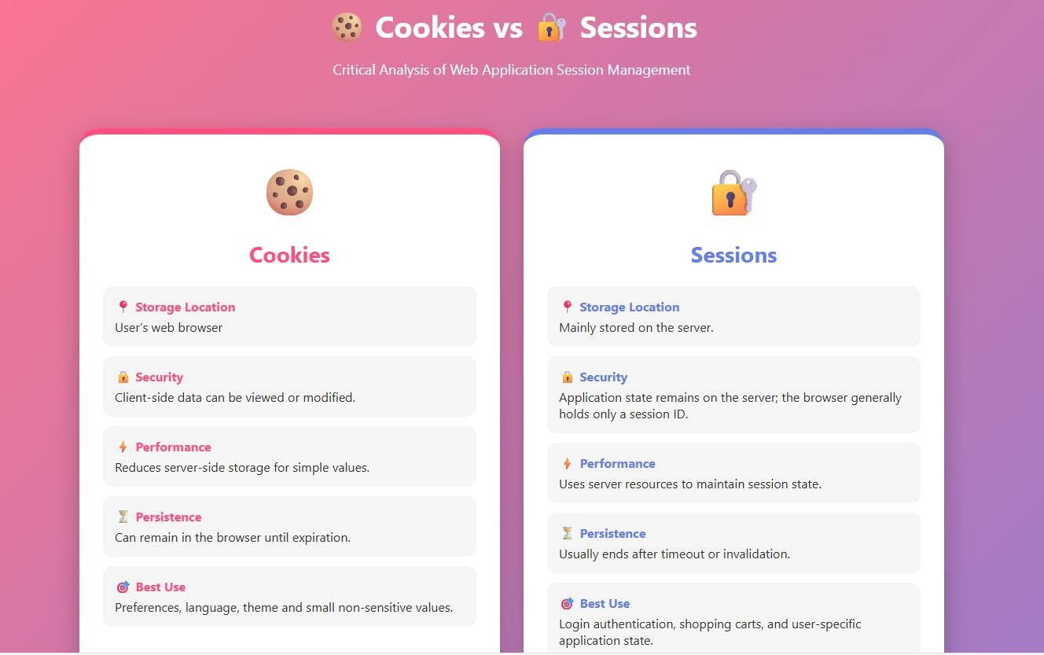
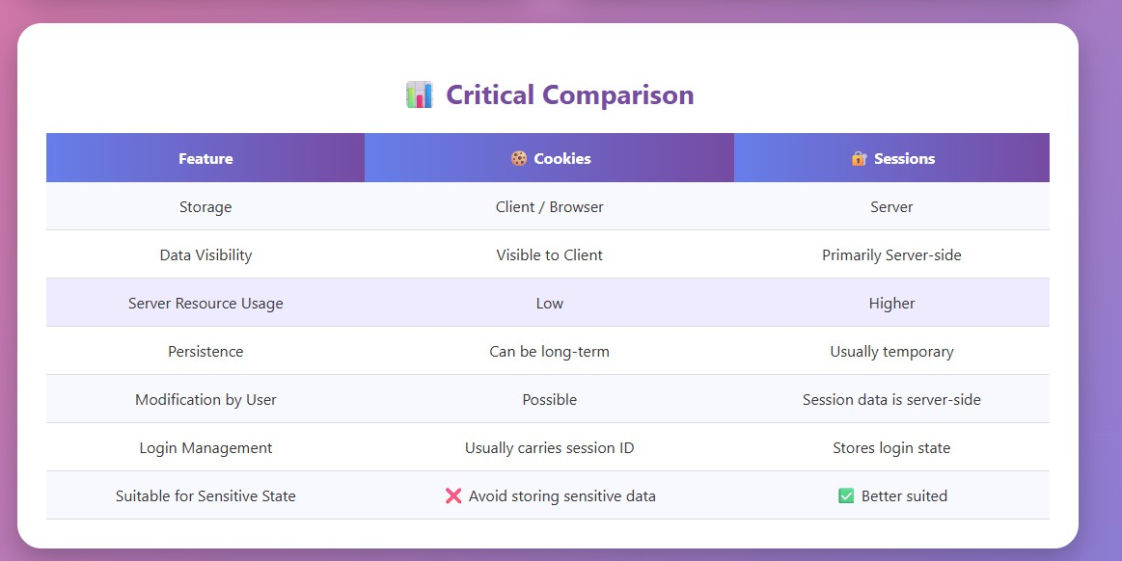

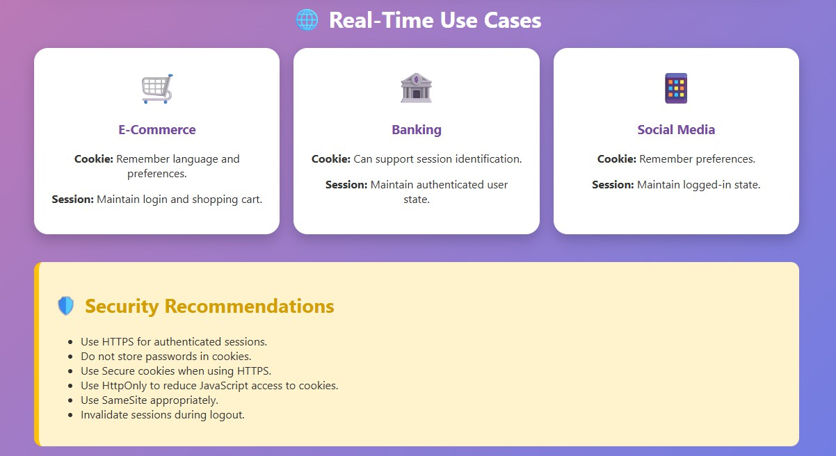

Code of Conduct:

I (Mohammad Jeelani / 192373043) certify that this submission is my original work and that I have adhered to the guidelines specified for this assessment.
I understand that any violation of academic integrity rules will result in disciplinary action.

Signature of the student: Mohammad Jeelani

RUBRICS FOR CALCULATION:

Technical Presentation
Criteria | Weight  age | Level 4 –  Exemplary | Level 3 –  Proficient | Level 2 –  Developing | Level 1 –  Beginning

Technical Content Accuracy | 30 | Highly accurate, in-  depth, and insightful technical explanation | Technically correct content with adequate depth and clarity | Basic concepts presented with limited accuracy and depth | Content contains major technical errors; concepts poorly  understood
Problem Identification | 25 | Problem rigorously analyzed using appropriate and advanced  methods | Problem clearly defined with a logical engineering  approach | Problem identified but analysis or methodology is weak | Problem statement unclear or incorrect; no logical  approach
Use of Tools | 20 | Advanced tools, well-analyzed data, and highly effective  visuals | Appropriate tools and data used effectively with clear  visuals | Limited use of tools and basic data interpretation | Minimal or incorrect use of tools and data; poor visuals
Communicati on | 15 | Highly engaging, confident, and audience-focused  delivery | Clear, organized, and professional communicati  on | Understandabl e but lacks clarity, structure, or confidence | Poor organization, unclear speech, ineffective  slides
Professionalis m | 10 | Exemplary professionalis m, leadership, and ethical awareness | Professional conduct with effective team collaboration | Basic professionalis m; uneven team participation | Lacks professionalis m; minimal contribution or ethical  awareness

