SIMATS ENGINEERING

ASSESSMENT TOOL 1

NAME: Mohammad Jeelani

REG NO: 192373043
COURSE NAME: INTERNET PROGRAMMING COURSE CODE: CSA4303

C04-AT1

XSLT-Based Transformation vs. JSP-Based Dynamic Rendering
XSLT (Extensible Stylesheet Language Transformations) and JSP (JavaServer Pages) can both be used to present XML-derived information as web reports, but they follow different processing models. XSLT is primarily a transformation technology, whereas JSP is a server-side presentation technology that can combine data access, application logic, and HTML generation.

Processing Model and Execution Flow:
In an XSLT-based system, an XML document is supplied to an XSLT processor together with an XSLT stylesheet. The processor parses the XML source and applies template rules, XPath expressions, conditions, sorting, and other transformation instructions. The result may be HTML, XML, or text. The basic flow is XML data → XSLT stylesheet → transformation processor → output document → browser.
In a JSP-based system, a browser sends a request to a web server. A Servlet container processes the request and executes the JSP page. The JSP is translated into a Servlet and compiled when necessary. Server-side code retrieves or processes data, and the JSP generates an HTML response. The flow is browser request → JSP/Servlet → business/data layer → dynamic HTML → browser.

Transformation Mechanisms:
XSLT is declarative. Developers describe how XML nodes should be selected and transformed rather than writing a conventional sequence of programming statements. XPath provides powerful navigation and selection of XML nodes. XSLT is therefore particularly strong when the source is XML and the output is another structured document.

JSP is procedural and presentation-oriented. Java code, expression language, JSTL, and custom tags can be used to control output. JSP can also access application services and databases through the surrounding Java architecture. This makes JSP more general-purpose than XSLT, but it can also result in more application code.

Performance and Resource Utilization:
XSLT can be efficient for repeated transformations when stylesheets are compiled or cached and when the XML document is moderate in size. However, the XML must generally be parsed before transformation, which consumes memory and CPU. Very large XML documents can therefore become resource-intensive.
JSP has additional server-side processing overhead because requests may involve controllers, business services, database operations, session management, and HTML generation. Once a JSP is compiled, its execution can be efficient, but high concurrency can increase CPU, memory, connection-pool, and server-resource usage.

Flexibility and Complex Transformations:
XSLT is highly flexible for XML-centric transformations. It supports filtering, sorting, grouping, conditional processing, template matching, and hierarchical transformations. It is especially suitable when XML is the main data representation.
JSP is more flexible for application-oriented logic because Java libraries, APIs, services, authentication mechanisms, and database access can be integrated directly into the application architecture. Complex business rules are generally easier to implement in Java than in XSLT.

Real-World Suitability:
XSLT is effective for XML reporting systems, document conversion, legacy XML-based systems, configuration-driven reports, and situations where the same XML data must be presented in multiple formats.
JSP is more appropriate for interactive enterprise applications, portals, dashboards, e-commerce applications, and systems where report generation depends on databases, user sessions, authorization, and complex business logic.

Conclusion:
XSLT is the better choice when the primary requirement is transforming structured XML into another structured representation. JSP is preferable when XML data is only one part of a larger dynamic web application. For a reporting system centered on XML, XSLT can provide a clean separation between data and presentation; for interactive applications with significant server-side business logic, JSP offers greater overall flexibility.

MVC Using JSP/Servlets vs. Modern PHP Frameworks such as Laravel or Symfony
Both JSP/Servlet-based MVC applications and modern PHP frameworks such as Laravel and Symfony implement the MVC principle, but their ecosystems, development models, and deployment characteristics differ.

Architectural Design:
A JSP/Servlet MVC application commonly uses Servlets as controllers, Java classes or services as the model/business layer, and JSP pages as views. The controller receives requests, invokes business services, retrieves or modifies data, and forwards the result to a JSP view.
Laravel and Symfony also separate routing, controllers, business services, models, templates, and persistence. Laravel commonly uses Blade templates and Eloquent ORM, while Symfony provides a modular architecture with components, dependency injection, routing, controllers, Doctrine integration, and Twig templates.

Separation of Concerns:
Both approaches support strong separation of concerns when correctly designed. JSP/Servlet applications can use filters, controllers, service classes, repositories, JavaBeans, and dependency injection to keep responsibilities separate. Modern PHP frameworks provide many conventions and reusable components that encourage developers to keep controllers thin and move business logic into services or domain classes.

Scalability:
JSP/Servlet applications run in mature Java application servers and can scale horizontally using load balancers and multiple application instances. Java's strong multithreading model, connection pools, caching systems, and extensive enterprise ecosystem make it suitable for high-traffic systems.
Laravel and Symfony applications can also scale horizontally by adding application instances behind a load balancer. PHP's traditional request lifecycle is stateless at the application level, which can simplify horizontal scaling. Modern PHP runtimes and deployment architectures support caching, queues, asynchronous workers, and optimized database access.

Maintainability:
JSP/Servlet applications can be highly maintainable, particularly in large organizations with established Java standards, but poorly structured applications may become verbose because developers must configure and connect many components manually.

Laravel emphasizes developer productivity and convention, providing routing, authentication support, migrations, ORM functionality, queues, caching, validation, and testing facilities.
Symfony is highly modular and emphasizes reusable components, dependency injection, configuration, and enterprise-grade architecture. Both can reduce repetitive code when compared with a raw Servlet/JSP implementation.

Data Handling and Backend Integration:
Java provides mature JDBC, JPA, Hibernate, messaging, transaction-management, and enterprise integration capabilities. This makes JSP/Servlet-based systems strong candidates for applications with complex enterprise backends.
Laravel provides Eloquent ORM, query builders, database migrations, queues, caching, events, and API integration. Symfony can integrate with Doctrine and many other components. Both frameworks can efficiently interact with relational databases, APIs, message brokers, and external services when properly configured.

Performance:
Raw JSP/Servlet applications can provide strong performance because the Java runtime is optimized for long-running server processes and high concurrency. However, performance depends heavily on architecture, database access, caching, and deployment configuration. Laravel and Symfony provide good performance for typical web workloads, but framework overhead can become significant if applications are poorly optimized. PHP applications can achieve high throughput using modern PHP runtimes, opcode caching, reverse proxies, caching layers, queues, and horizontal scaling.

Conclusion:
For large enterprise systems with complex integrations, long-running services, sophisticated transaction requirements, and an existing Java ecosystem, JSP/Servlet MVC remains a strong option. For rapid development, modern web APIs, maintainable convention-based applications, and teams experienced with PHP, Laravel or Symfony can be highly effective. The best choice depends on organizational expertise, existing infrastructure, application complexity, and expected workload rather than on the framework alone.

XML Schema Validation vs. Database-Level Validation
When structured data must be validated before storage, XML Schema validation and
database-level validation address different layers of data integrity. XML Schema validates the

structure and data types of XML documents before application processing, while database validation protects the integrity of data at the persistence layer.

XML Schema-Based Validation:
An XML Schema defines permitted elements, attributes, data types, occurrence constraints, patterns, ranges, and relationships. An XML document can be checked against the schema before it reaches the database. This is useful for detecting malformed or structurally invalid input early.

Database-Level Validation:
A database can enforce constraints such as NOT NULL, UNIQUE, PRIMARY KEY, FOREIGN KEY, CHECK constraints, and appropriate data types. Application code using JDBC, JSP, PHP PDO, or another database API sends data to the database, which enforces the constraints regardless of which application component generated the request.

Data Integrity:
XML Schema provides strong structural validation at the document level. It is especially effective when XML documents are exchanged between independent systems.
Database constraints provide a stronger final integrity boundary for persistent data because the rules are enforced where the data is stored. They protect against invalid data entering the database from different applications, scripts, services, or administrative tools.

Validation Complexity:
XML Schema is well suited to hierarchical XML structures, data types, optional and repeated elements, and document-oriented validation. Complex business rules, however, may require additional application logic.
Database constraints are excellent for relational integrity, uniqueness, references, and simple value restrictions. More complex business rules may require triggers or application-level validation, but excessive trigger logic can make systems harder to maintain.

Performance:
XML validation requires parsing and schema checking, which consumes CPU and memory. For small or moderate XML documents, the overhead is generally manageable. For large documents or high-frequency requests, repeated validation can increase resource consumption.
Database constraints add some processing during insert and update operations. However, these checks are usually optimized by the database engine and are essential for protecting persistent data. Poorly designed queries, excessive network round trips, and missing indexes often have a greater performance impact than simple constraints.

Real-Time Environments:
For immediate feedback, application-level XML validation can reject malformed input before a database operation occurs. This reduces unnecessary database requests and can provide clear validation messages.
Database validation is essential as the final protection layer. In real-time systems, the strongest approach is usually layered validation: perform early input/schema validation for fast feedback and enforce critical integrity constraints at the database level.

Conclusion:
XML Schema and database validation should not normally be treated as competing alternatives. XML Schema is best for validating the structure and content of incoming XML documents, while database constraints are best for protecting persistent relational data.
Combining both provides stronger data integrity and reliable real-time validation.

DOM Parsing vs. SAX Parsing vs. XSLT Transformation
DOM, SAX, and XSLT are different XML-processing techniques and should be selected according to document size, transformation requirements, memory limits, and application complexity.

DOM Parsing:
DOM (Document Object Model) parses the complete XML document and constructs an in-memory tree. Applications can navigate to any node, modify the document, search it repeatedly, and access parent or child relationships easily.

Memory Consumption:
DOM has high memory consumption because the complete document and its tree representation must remain in memory. For large XML documents, memory requirements can become a major limitation.

Processing Speed:
DOM can be convenient and fast for repeated random access after the document has been parsed, but initial parsing and tree construction can be expensive for very large documents. Implementation Complexity:
DOM is comparatively easy to understand because developers work with a tree structure. It is suitable when random access or modification is required.

SAX Parsing:
SAX (Simple API for XML) is event-driven. Instead of building a complete tree, it reads the

document sequentially and generates events such as the start of an element, character data, and the end of an element.

Memory Consumption:
SAX has very low memory requirements because it does not normally store the complete XML document in memory. This makes it particularly suitable for very large XML files. Processing Speed:
SAX can process large streams efficiently because it reads data sequentially and avoids constructing a complete document tree. However, the application must process events as they arrive.

Implementation Complexity:
SAX is more complex than DOM when applications need relationships between distant nodes or random access. Developers must maintain application state while handling events.

XSLT Transformation:
XSLT is a rule-based transformation technology. It reads XML and applies a stylesheet containing templates, XPath expressions, conditions, sorting, and other transformation instructions to produce HTML, XML, or text.

Memory and Performance:
XSLT processing normally requires parsing the source XML, and the exact memory and performance characteristics depend on the processor and implementation. It is highly convenient for structured XML-to-XML or XML-to-HTML transformations, but very large documents can still impose significant resource requirements.

Comparison:
DOM is best when an application needs random access, navigation, or modification of an XML tree. SAX is best when documents are extremely large and the application needs sequential processing with low memory usage. XSLT is best when the primary goal is transforming XML into another structured output.

Trade-Offs:
DOM offers simplicity and flexibility at the cost of memory. SAX offers scalability and low memory usage at the cost of more complicated event-driven programming. XSLT offers powerful declarative transformations at the cost of requiring knowledge of XPath and XSLT and potentially significant processing for large documents.

Conclusion:
There is no universally best XML technique. DOM should be selected for flexible in-memory manipulation, SAX for streaming and very large documents, and XSLT for declarative XML

transformation and report generation. In some systems, these technologies can also be combined.

JSP/PHP Server-Side Rendering vs. XML/XSLT Transformation
Traditional server-side rendering with JSP or PHP and XML-based transformation with XSLT are two approaches for delivering dynamic content. They differ significantly in where application processing occurs, how data is transformed, and how the application scales.

Performance:
JSP/PHP rendering generates the final HTML on the server for each request or through reusable server-side components and caching. Performance depends on application logic, database queries, server configuration, and caching.
XSLT transforms XML data into HTML or another output. The transformation can be performed on the server or, in some environments, by a client-side XML processor. The overall cost includes XML parsing and transformation. For XML-centric reporting, XSLT can be efficient and clean, but it is not automatically faster than server-side rendering.

Scalability Under Concurrent Loads:
JSP/PHP applications can scale horizontally using multiple application instances, load balancers, caching, database replication, queues, and other infrastructure. However, every dynamic request may consume server CPU, memory, database connections, and other resources.
XSLT can reduce presentation-layer coupling because the transformation rules are separate from the XML data. Reusable stylesheets and caching can reduce repeated work.
Nevertheless, parsing and transforming large XML documents for many concurrent users can become expensive. The scalability advantage therefore depends on document size, transformation complexity, caching, and where the transformation occurs.

Impact on User Experience:
Server-side JSP/PHP rendering can return complete HTML directly to the browser, which is useful for fast initial page rendering and broad browser compatibility. It also integrates naturally with authentication, sessions, forms, and interactive application logic.
XSLT can produce structured HTML from XML, making it useful for report-style interfaces. However, XML processing can increase response-generation time if documents are large.

Modern web applications generally favor HTML-based rendering and API-driven architectures for highly interactive user experiences.

Development Complexity:
JSP/PHP frameworks provide routing, validation, authentication, database integration, templating, testing, and reusable application components. This makes them appropriate for complete web applications.
XSLT provides a strong separation between XML data and presentation rules. It is relatively elegant for transformations but can become difficult to maintain when the transformation logic becomes very complex or when extensive business logic is introduced.

Recommendation:
For modern interactive web applications, server-side rendering using a well-designed JSP/Servlet architecture or a modern PHP framework is generally more appropriate than relying primarily on XSLT. These approaches integrate better with databases, authentication, APIs, business logic, caching, and modern deployment architectures.
XSLT remains highly valuable for XML-centric systems such as document conversion, structured reports, legacy enterprise integrations, and situations where the same XML source must be transformed into multiple output formats.

Final Conclusion:
For a general-purpose modern web application, JSP/PHP-based server-side rendering should usually be preferred because it provides stronger integration with application services and backend systems. XSLT should be selected when XML transformation itself is the central requirement. The final decision should consider workload, XML document size, concurrency, development expertise, existing infrastructure, and long-term maintenance requirements.

OVERALL OUTPUT:
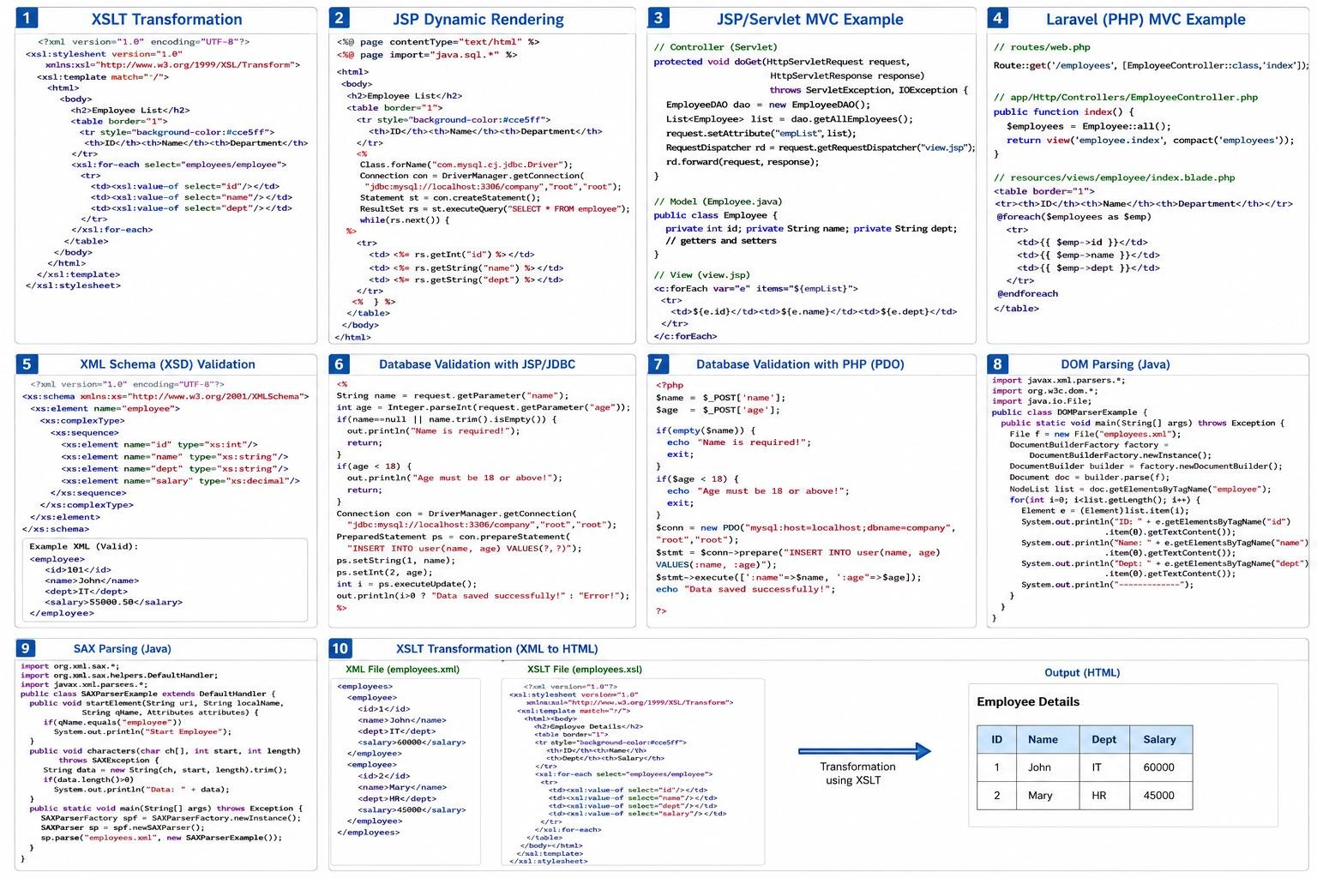

Code of Conduct:

I ____________________ (Mohammad Jeelani / 192373043) certify that this submission is my original work and that I have adhered to the guidelines specified for this assessment. I understand that any violation of academic integrity rules will result in disciplinary action.

Signature of the student: Mohammad Jeelani

RUBRICS FOR CALCULATION:

 |  | Comparative analysis
Criteria | Weightage (%) | Level 4 (Exemplary) | Level 3 (Proficient) | Level 2 (Developing) | Level 1 (Beginning)

Scope of Items | 20% | Selects highly relevant items with clear scope and  justification | Selects appropriate items with minor gaps | Selection is limited or partially relevant | Items are unclear or not relevant
Comparison Depth | 25% | Provides detailed and comprehensiv e comparison across multiple  aspects | Provides adequate comparison with some depth | Limited comparison with few aspects | Very minimal or no comparison
Use of  Evidence | 20% | Supports comparison with accurate data, examples, or  references | Uses some supporting evidence with minor gaps | Limited or weak supporting evidence | No supporting evidence provided
Critical Thinking | 20% | Demonstrates strong critical thinking with clear interpretation  and reasoning | Shows reasonable interpretation with minor gaps | Basic interpretation; lacks depth | No meaningful interpretation
Clarity of Presentation | 15% | Well-organized, clear, and logically structured  presentation | Generally clear with minor issues | Somewhat unclear or poorly structured | Disorganized and difficult to understand

