

PROJECT REPORT

Cash-Book: Smart Finance & Digital Ledger

SUBMITTED BY:

Bhuva Jeel M. (Roll No: 520)
Savsaviya Kushal B. (Roll No: 526)
Narola Jash M. (Roll No: 558)

GUIDED BY:
Sanskruti Ramani

Acknowledgement
- We take great pleasure in presenting this project, Cash-Book: Smart Finance & Digital Ledger, developed during our academic semester. We would like to mention here that this project would not have been possible without the invaluable support and guidance of our professors.

- As the final frontier toward achieving our degree, the activity of developing an IT project has helped us bridge the gap between academic knowledge and practical real-life applications. It has prepared us to apply our learning effectively and motivated us to grow into capable IT professionals.

- On the occasion of completing our project on Cash-Book, we would like to express our heartfelt gratitude to all those who directly or indirectly supported us. We are extremely grateful to everyone who has helped us in this journey. We would especially like to extend our sincere thanks to our Guide for their valuable suggestions, encouragement, and stimulating discussions that guided us throughout the project. We would also like to express our gratitude to our Principal for their constant support and guidance.

- It has been a rich and rewarding experience, and this project stands as a testament to the knowledge and skills we have gained during our academic journey.

Declaration
- We hereby declare that the project "Cash-Book: Smart Finance & Digital Ledger" is our original work completed as part of our academic requirements. The project provides an online platform for personal and small business finance management, featuring tracking of daily transactions, party ledgers, EMI/subscriptions, receipt management, and deep analytics.

- Cash-Book is developed using React, Node.js, and MongoDB, representing a complete, full-stack, scalable digital ledger solution.

- We sincerely thank our guide and our parents and family members for their continuous support, guidance, and encouragement throughout this project.

- We further declare that this work has not been submitted to any other institution for any degree, diploma, or certificate.

3
Cash-Book: Sma
NO. | Title | Page NO.
1 | Introduction to project | 5
2 | project profile | 6
3 | technology study | 7
4 | objectives | 9
5 | system flow diagram | 11
6 | Data Flow Diagram (DFD) / Unified Modeling Language (uml) | 12
7 | ER diagram | 13
8 | database design | 14
9 | system diagram (screenshots) | 20
10 | references | 3s
1. Introduction of Project
- It aims to simplify personal and small business finance management by offering a fast, convenient, and accessible way to track income, expenses, and debts.
- The platform eliminates the limitations of traditional paper ledgers, such as data loss, manual calculation errors, and restricted physical access.
- It offers essential financial management features including:
  - User registration & secure authentication
  - Daily transaction tracking (Income/Expense) categorized dynamically
  - Party Ledger (Udhaar Book) for tracking debts and credits
  - EMI & Subscription tracking with calendar views
  - Receipts Vault for securely storing bill images
  - Advanced analytics and summary reports
  - Shared cashbooks through user invitations
- For admins, the system includes:
  - System analytics and user metrics
  - Transaction and cashbook oversight
  - Platform setting configurations
- Cash-Book acts as a digital companion, allowing users to make informed financial decisions through clear insights and organized records.
- The project uses modern web technologies:
  - Frontend: React (Vite)
  - Backend: Node.js (Express)
  - Database: MongoDB (Mongoose)
- It serves as a real-world implementation of an end-to-end financial SaaS solution.

2. Project Profile
cash-book : smart finance & digital ledger
project Title : | CASH-BOOK SMART FINANCE & DIGITAL LEDGER
operating system : | WINDOWS 10 /11/LIUX/MACOS
front end  tschnologies : | REACT(VITE), TAILWIND CSS, FRAMER MOTION
Back end  technologies : | NODE JS,EXPRESS JS, MONGO DB(MONGOSE)
platform : | VISUAL STUDIO CODE
documentation tool : | MICROSOFT WORD /HTML /CSS PDF GRNRRATION
project guide : | SANSKRUTI RAMANI
project duration : | ALMOST 3 MONTHS
prepared by : | bhuva jeel m.  narola jash m.  savsaviya kushal b.

3. Technology Study
❖ React :
- React was first developed by Jordan Walke at Facebook in 2011.
- React is a JavaScript library used for building user interfaces (UI), especially single-page applications (SPA).
- React uses a component-based architecture, where the UI is divided into reusable pieces called components.
- React uses a Virtual DOM to efficiently update only the parts of the page that change, improving performance.
- Vite is used as the build tool, providing a faster and leaner development experience for modern web projects.
❖ HTML & Tailwind CSS :
- First developed by Tim Berners-Lee in 1990, HTML is short for Hypertext Markup Language.
- HTML is used to create electronic documents (called pages) that are displayed on the World Wide Web.
- Tailwind CSS is a utility-first CSS framework used in this project to rapidly build custom user interfaces without leaving the HTML/JSX.
❖ JavaScript :
- JavaScript is a dynamic computer programming language.
- It is lightweight and most commonly used as a part of web pages.
- JavaScript allows client-side scripts to interact with the user and fetch dynamic data asynchronously.
❖ Node.js & Express.js :
- Node.js was developed by Ryan Dahl in 2009.
- It allows running JavaScript outside the browser (on the server side), using the V8 JavaScript engine.
- Express.js is a minimal and flexible Node.js web application framework that provides a robust set of features for web and mobile applications.
- It is used in this project to create RESTful APIs to handle frontend requests securely.
❖ MongoDB :
- MongoDB was first released in 2009 by MongoDB Inc.
- MongoDB is an open-source NoSQL database.
- It stores data in flexible, JSON-like documents instead of tables, making it perfect for dynamic data models.
- MongoDB is schema-less by nature, though Mongoose is used in this project to enforce structured schemas.
- It is designed for high performance, scalability, and flexibility.
❖ Development Tools:
- VS Code (Visual Studio Code): A free, open-source code editor developed by Microsoft. It is widely used for coding, debugging, and software development.
- Postman: Used for API testing and endpoint verification.
- Git & GitHub: Used for version control and source code management.
4. Objectives
- The objective of the project Cash-Book is to design and develop a professional, responsive, and user-friendly web application for personal and small-business finance tracking.
- The platform offers essential features such as transaction logging, categorization, receipt attachments, party ledger for debts/credits, and subscription tracking.
- The aim is to deliver a scalable system that helps users gain complete control and visibility over their financial flow.

Start To End Process
1. Project Planning & Requirement Analysis
- Define the purpose of the website: digital ledger and financial management.
- Identify key features for users: transaction management, dynamic categories, invitations (shared cashbooks), and analytics.
- Finalize the technology stack: React, Tailwind CSS (frontend), Node.js, Express, and MongoDB (backend).
2. UI/UX Design
- Design a modern, clean, and responsive dashboard interface.
- Use intuitive color schemes (green for income, red for expense) and high-quality icons.
- Incorporate animations (Framer Motion) to enhance user experience.
3. Frontend Development
- Use React for building the frontend user interface.
- Build pages such as: Dashboard Home, Transactions, Party Ledger, Receipts Vault, EMI Tracker, and Settings.
4. Backend Development
- Use Node.js with Express.js to handle user authentication, transaction logic, and data aggregation.
- Connect to MongoDB via Mongoose for managing backend data like:
  - Users
  - Transactions and Cashbooks
  - Categories and Payment Modes
  - Invitations and Receipts
- Implement secure authentication (JWT) for API protection.
5. Functionality Implementation
- User Side: Registration/Login, add/edit/delete transactions, filter by date/category, manage debts, view graphical reports.
- Admin Side: System analytics, manage all users, oversee total transactions across the platform.
6. Testing & Optimization
- Perform end-to-end testing of form validations, API response times, and state management.
- Optimize UI rendering using React hooks and lazy loading components.
5. System Flow Diagram
❖ Process Flow Diagram:
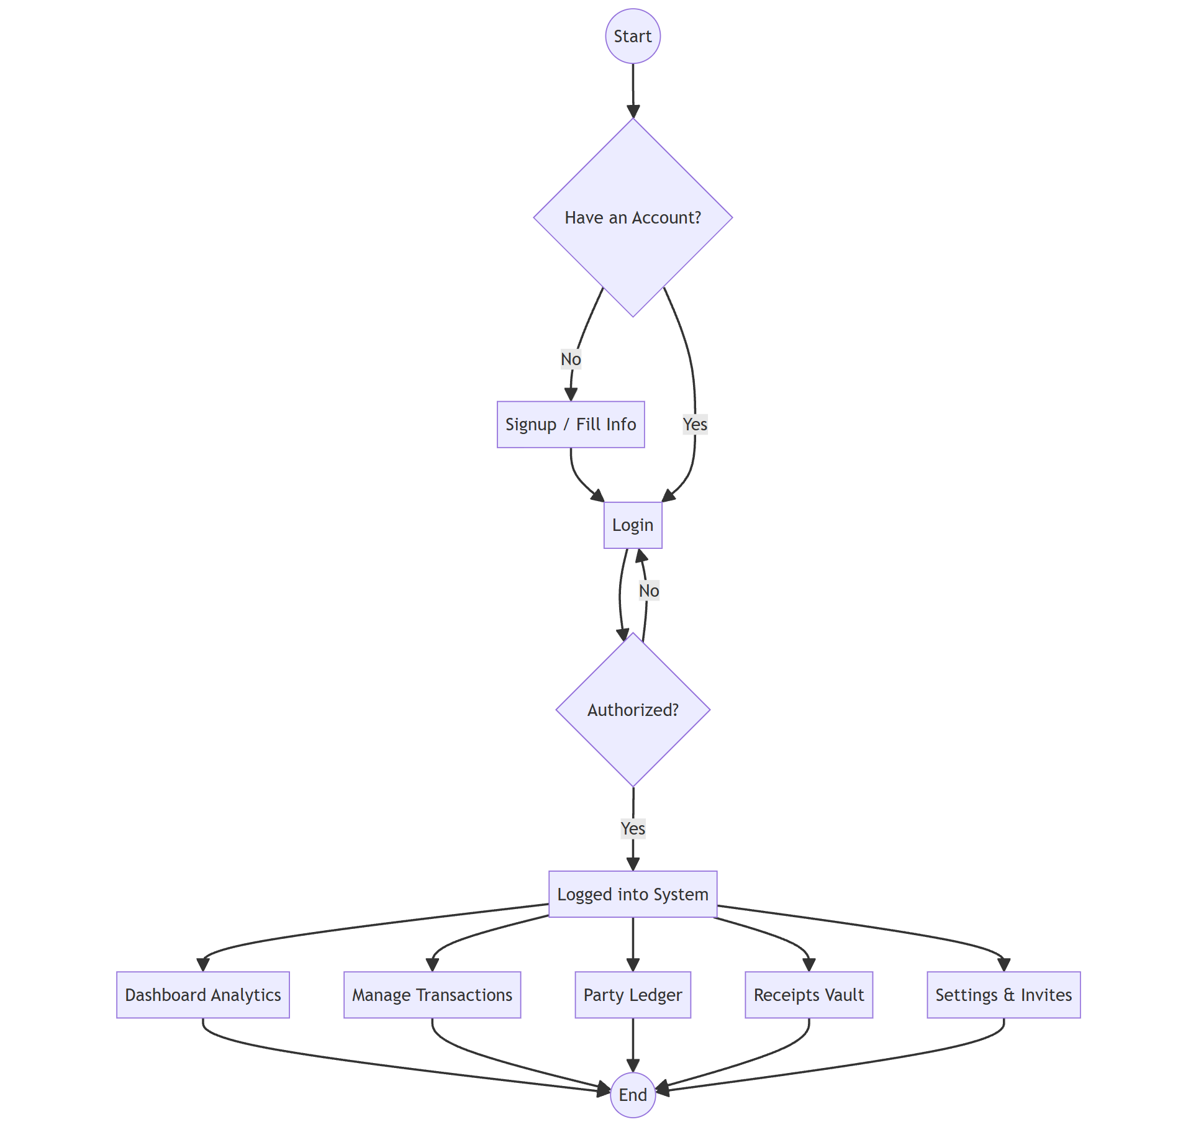
6. Data Flow Diagram(DFD) / Undefined Modeling Language(UML)
❖ Context Diagram (0 Level DFD):
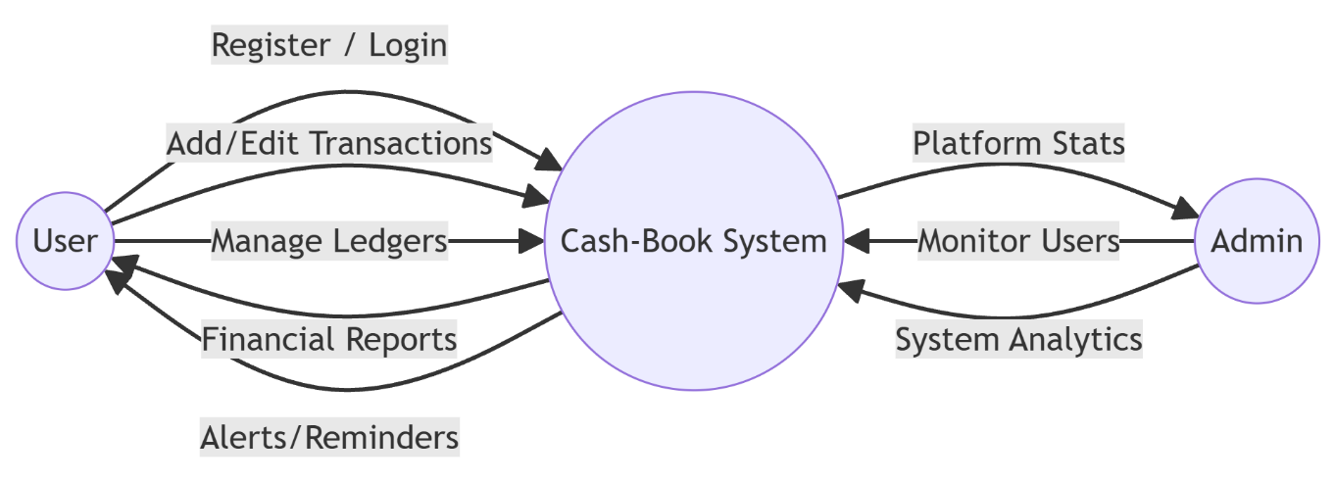
7. ER Diagram
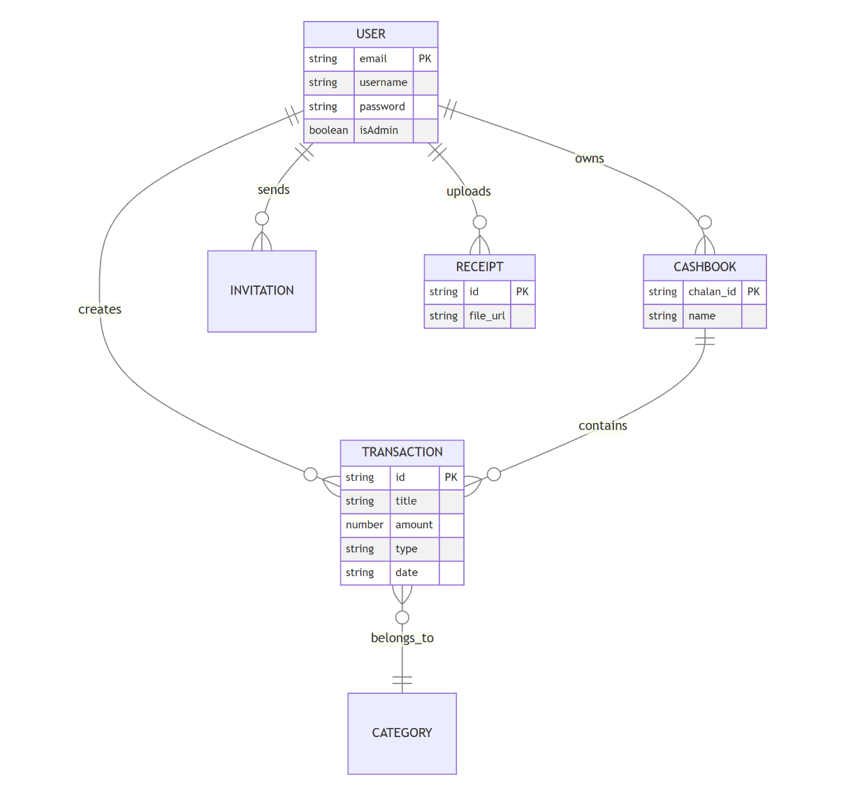
8. Database Design
❖ Collection Name: User
Field Name | Data Type | Constraints | Description
username | String | Required, Trimmed | User's display name
email_id | String | Required, Unique | User's email (Primary key identifier)
password | String | Required | Hashed password
mobile | String | Required | Contact number
role | String | Enum: [0, 1] | 0 = Admin, 1 = User

❖ Collection Name: Transaction
Field Name | Data Type | Constraints | Description
title | String | Required | Title of transaction
type | String | Required (income/expense) | Transaction type
amount | Number | Required | Transaction value
date | String | Required | Date (YYYY-MM-DD)
chalan_id | String | Required | Links to a Cashbook
category | String | Default: '' | Transaction category
user_email | String | Required | Email of the user who made it
party_type | String | Enum: [creditor, debtor] | For party ledger entries

❖ Collection Name: Cashbook
Field Name | Data Type | Constraints | Description
chalan_id | String | Required, Unique | Unique ID of the cashbook
chalan_name | String | Required | Display name of cashbook
user_email | String | Required | Owner's email

❖ Collection Name: Invitation
Field Name | Data Type | Constraints | Description
invite_name | String | Required | Name of the invitee
invite_email | String | Required | Email of the invited user
inviter_email | String | Required | Email of the user sending invite
cashbook_id | String | Required | The cashbook being shared
status | String | Enum: [pending, accepted, rejected] | Current status of invite

❖ Collection Name: Receipt
Field Name | Data Type | Constraints | Description
title | String | Required | Description of the receipt
file_url | String | Required | URL/Base64 of the receipt image
user_email | String | Required | Owner's email
date | String | Required | Date of upload

9. System Diagram
❖ Admin side:

Admin Login
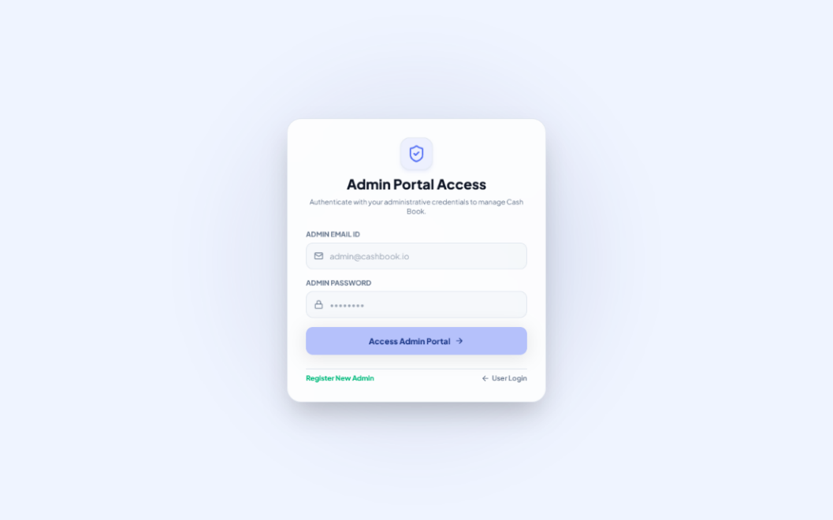

Admin Register
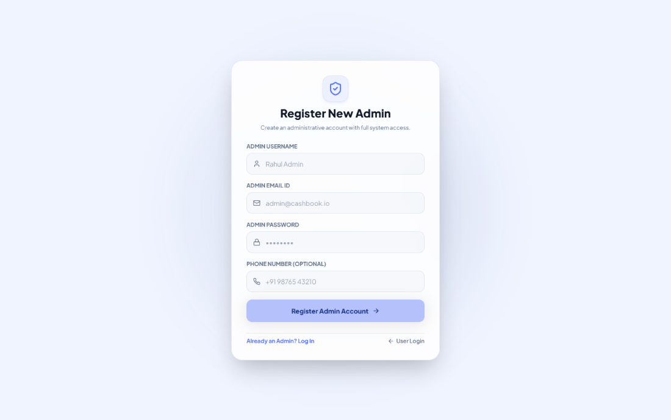

Admin Dashboard
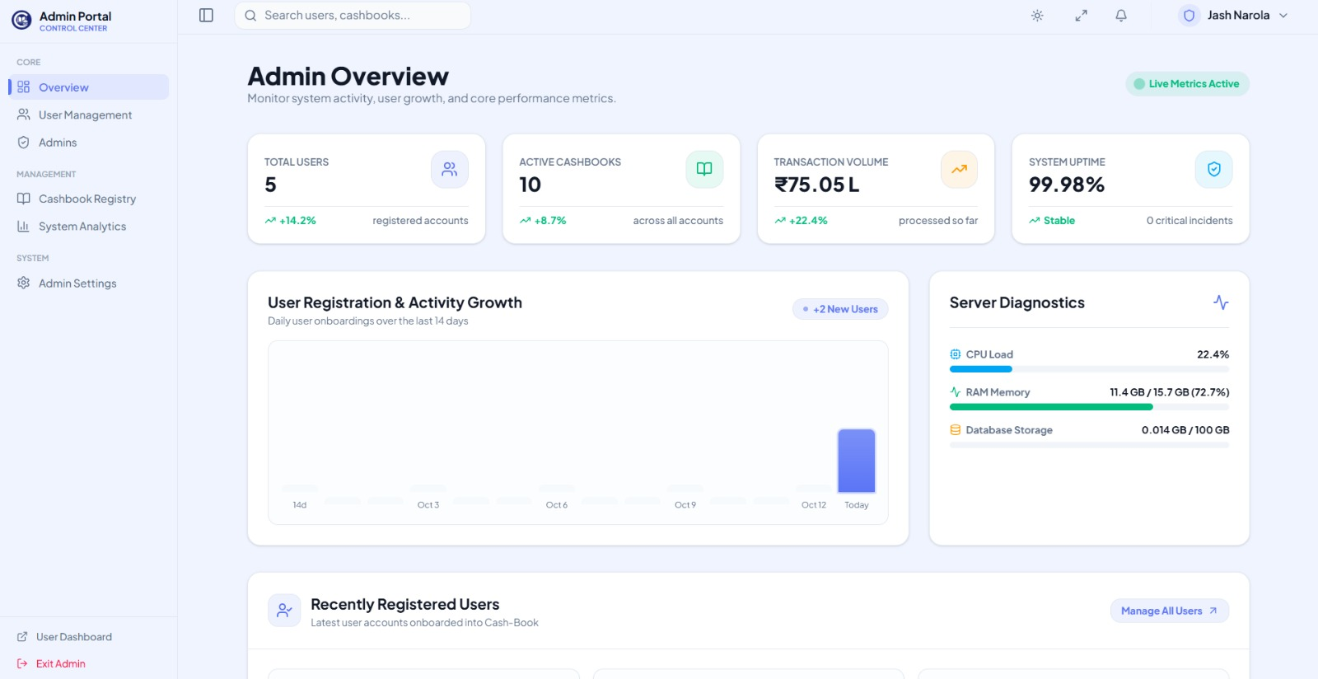

User Management
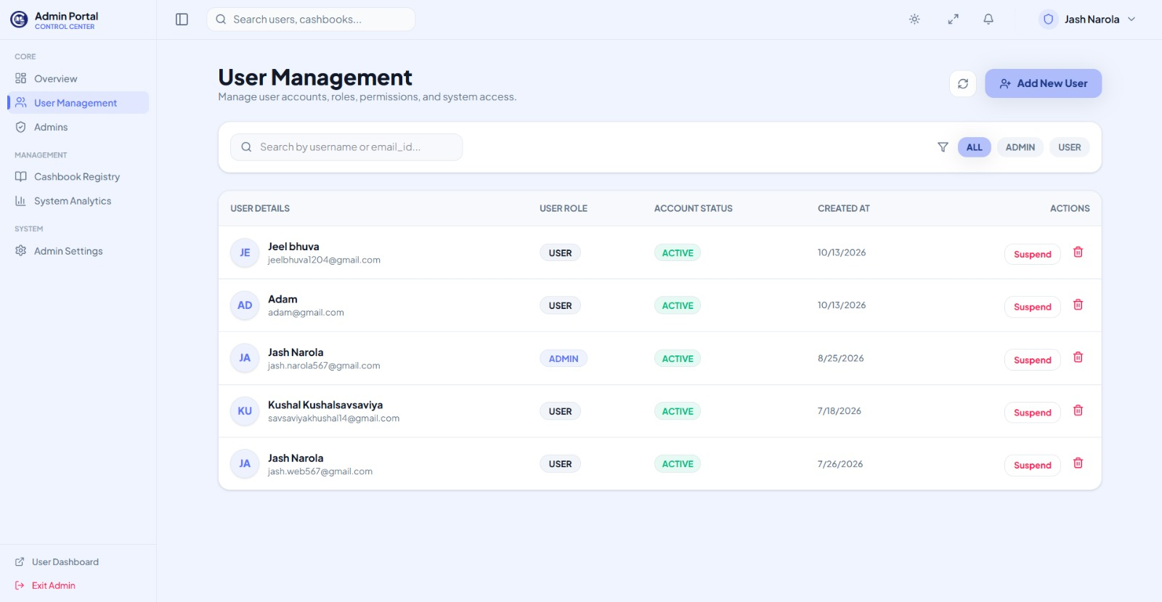

Cashbook Management
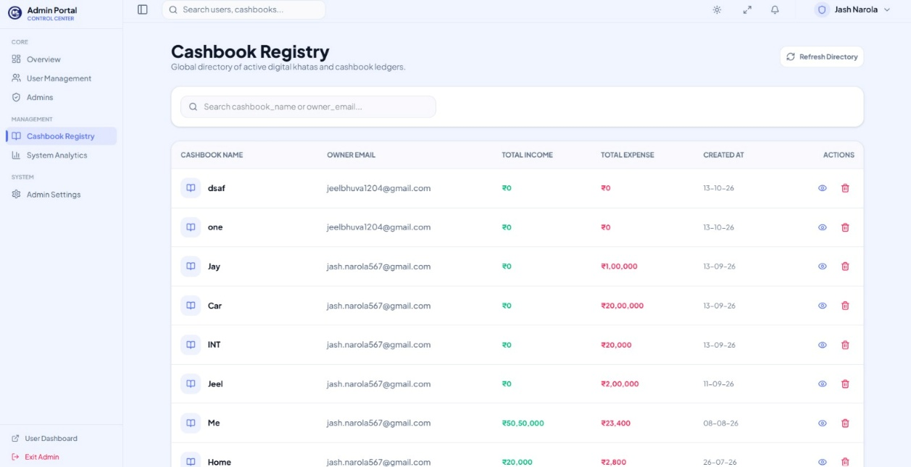

System Analytics
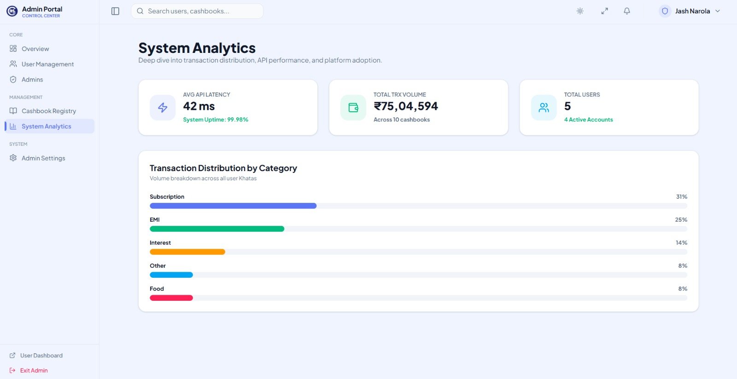

❖ User side:

Landing Page (Index)
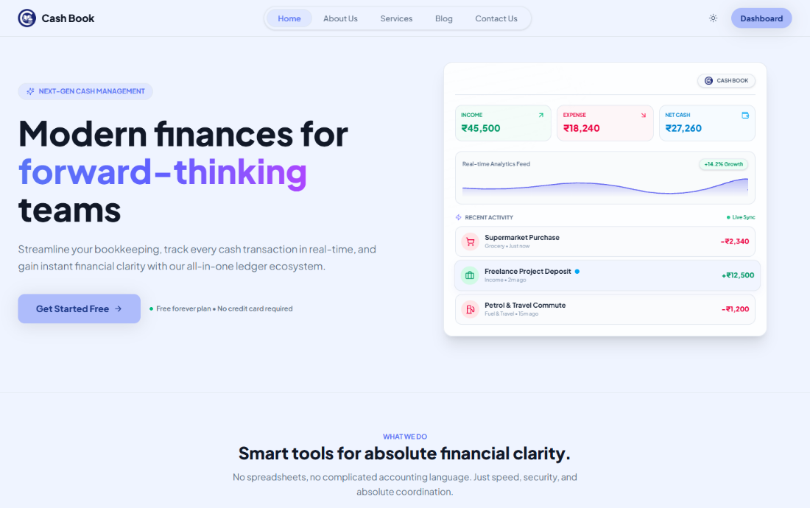

User Login

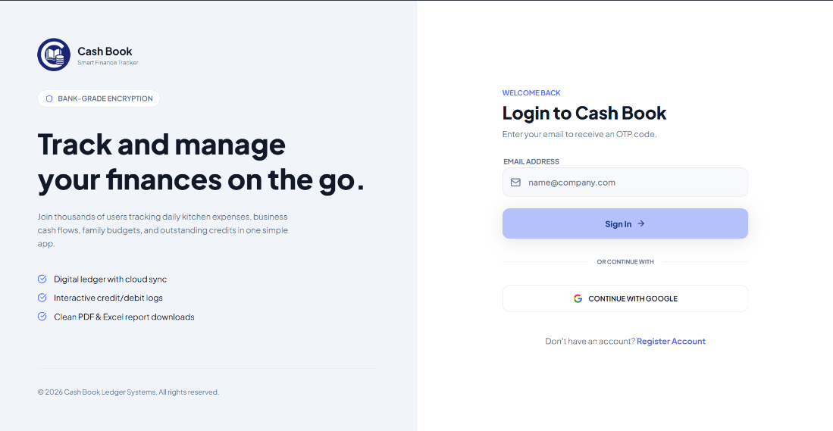

User Register

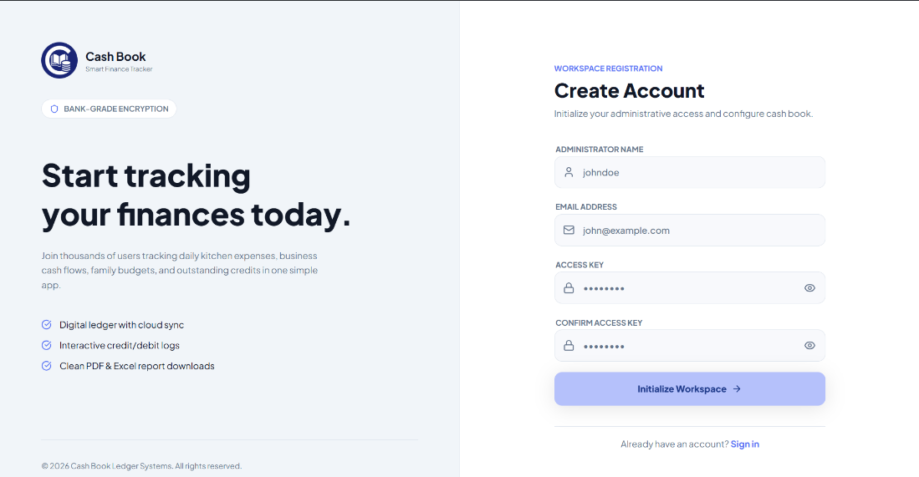

Dashboard (Home)
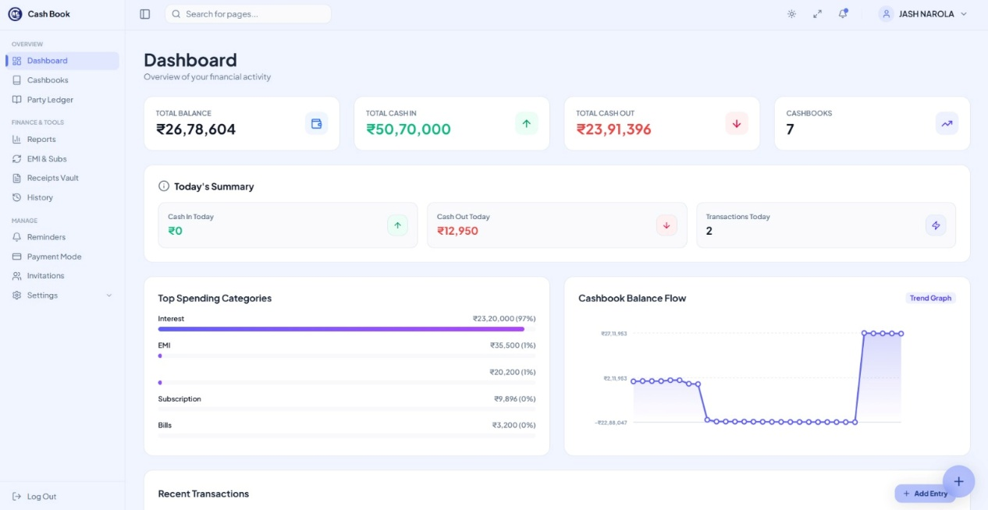

User Cashbooks
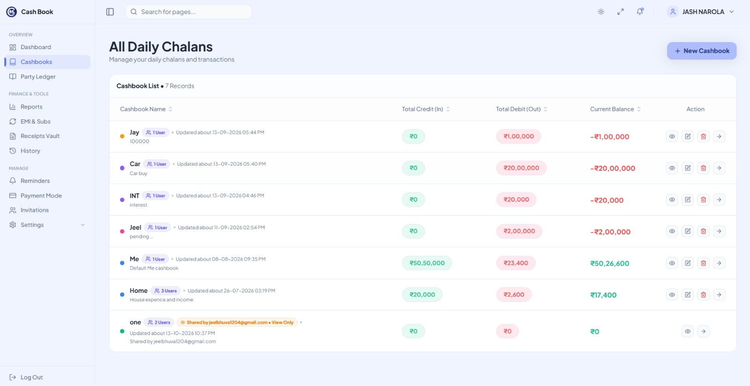

Transactions Page
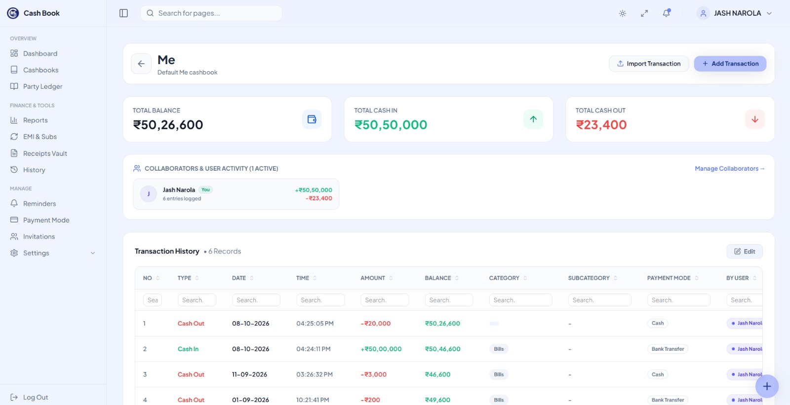

Add Transaction Popup
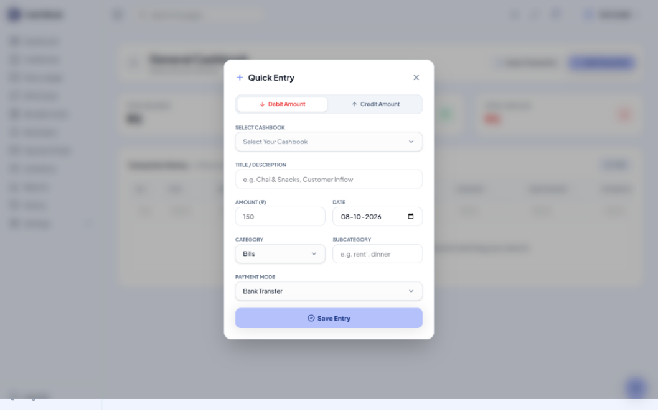

Party Ledger (Udhaar Book)
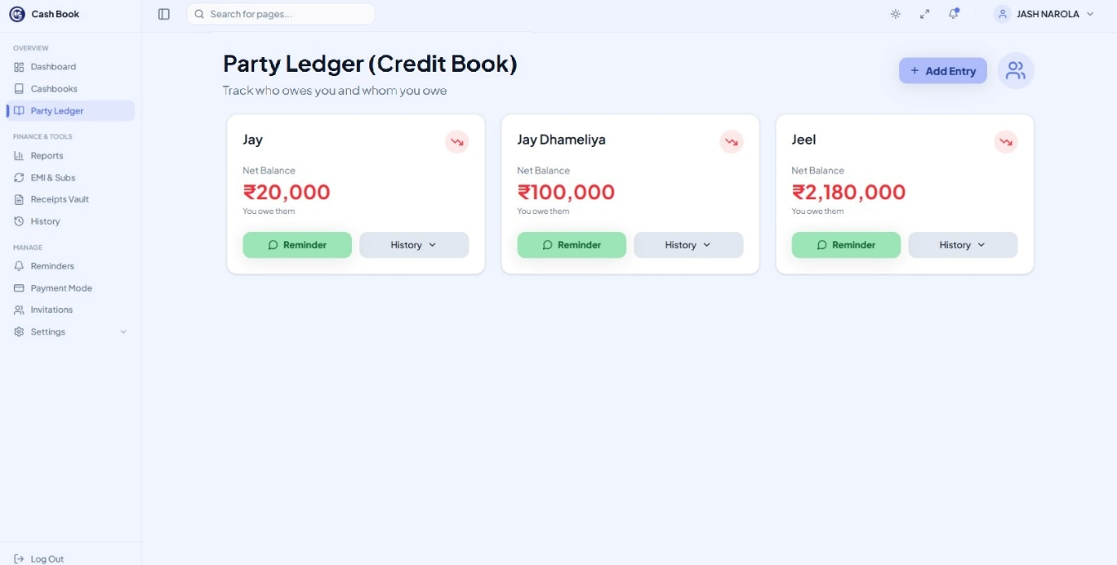

EMI & Subs
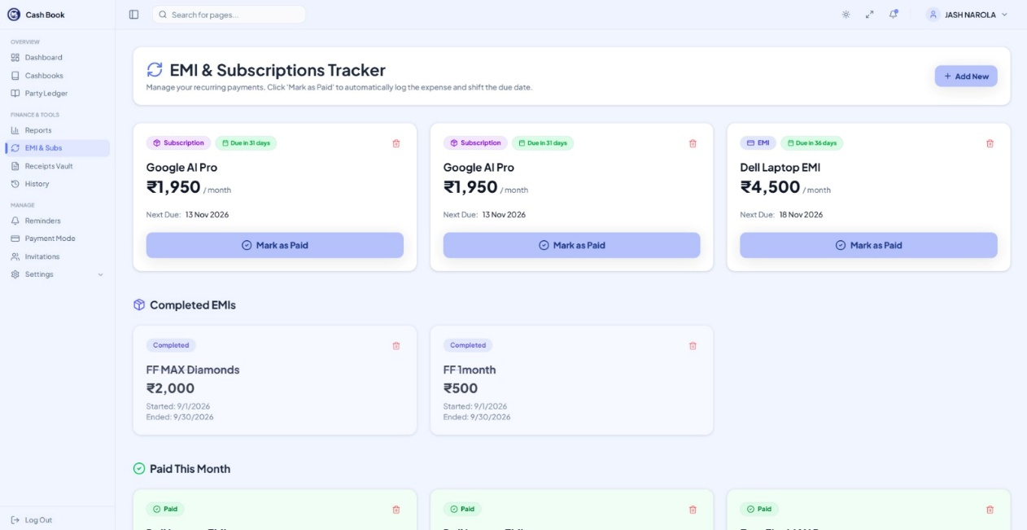

Receipts Vault
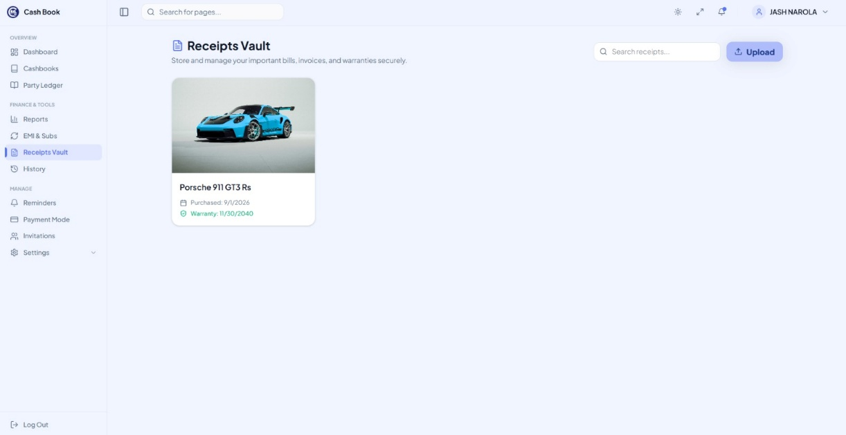

Reminders
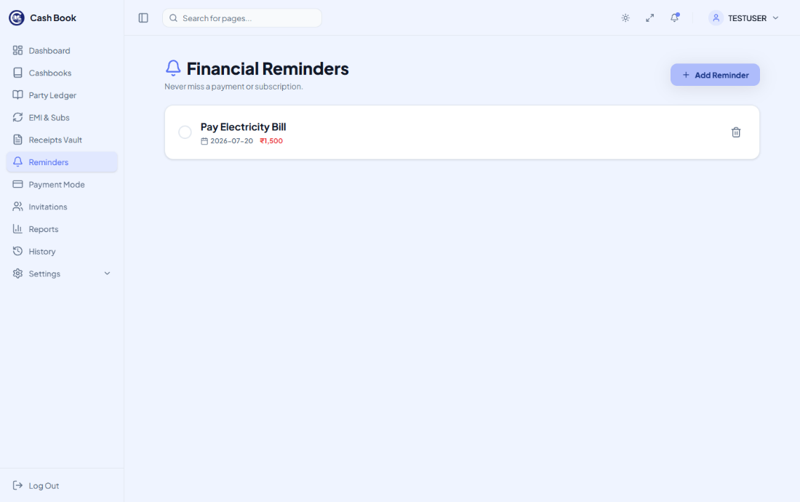

Payment Mode
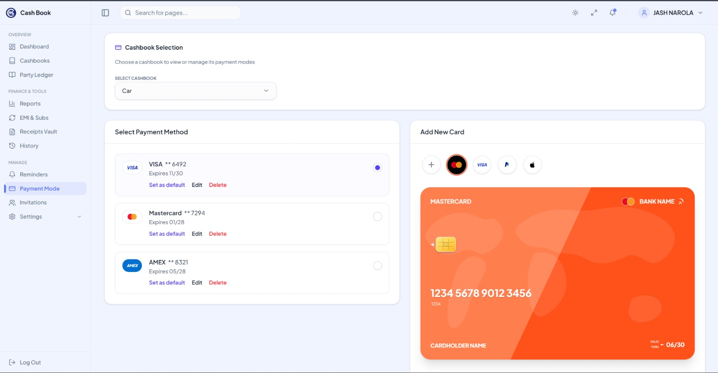

Invitations
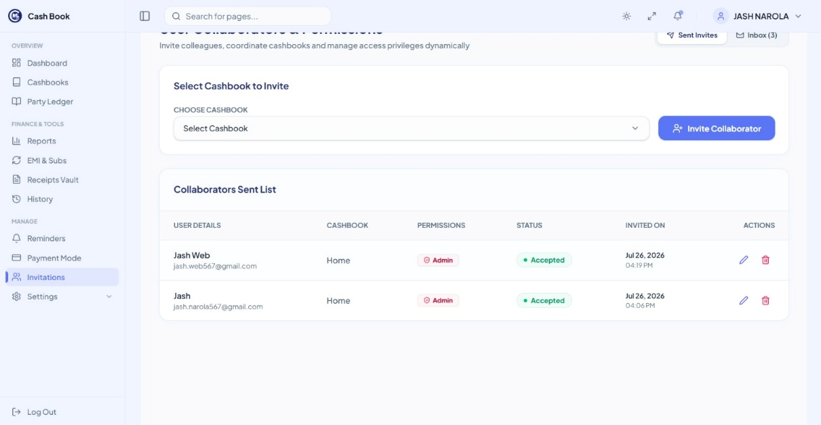

Reports
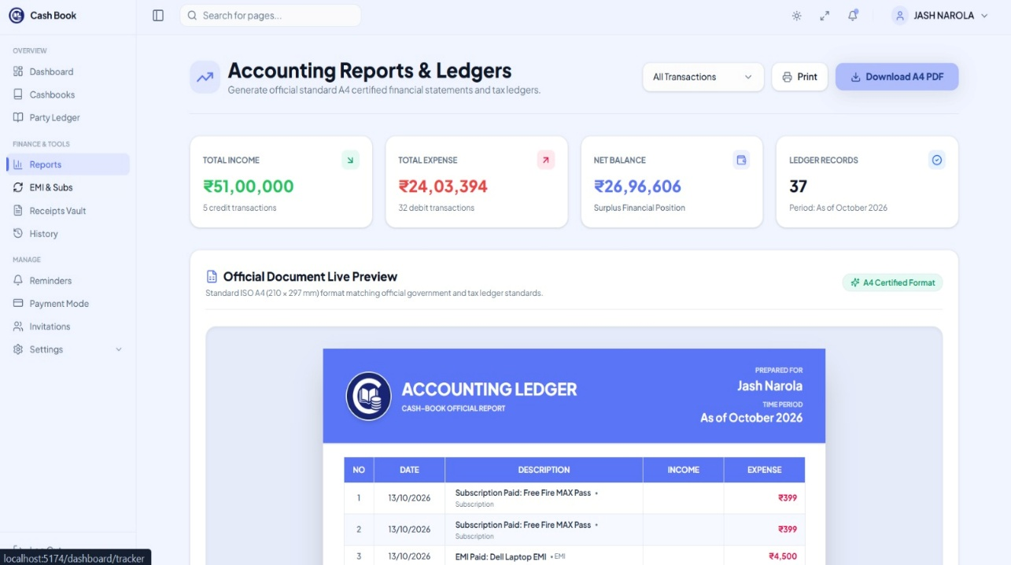

History
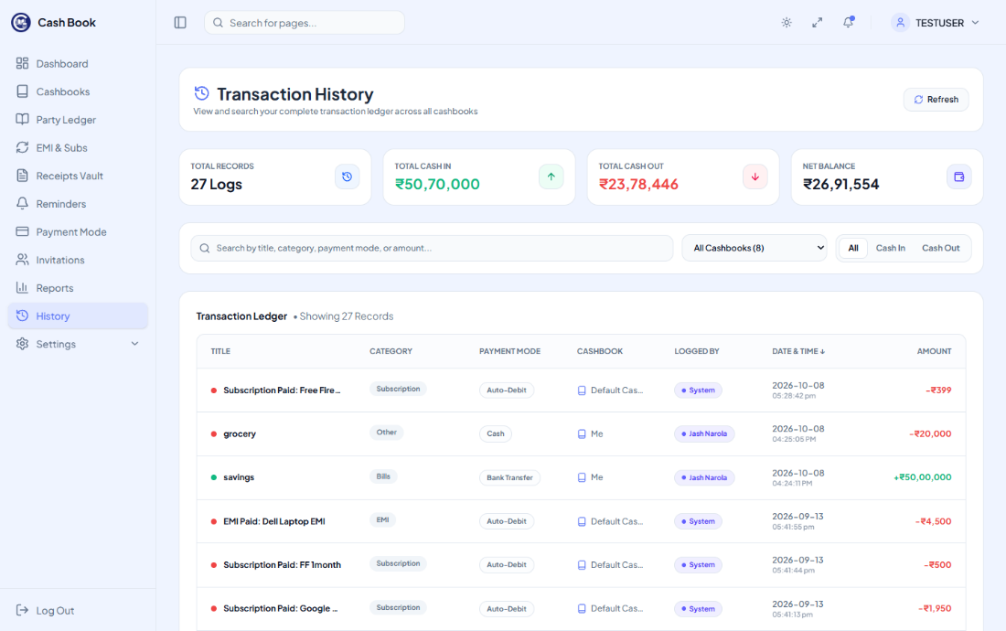

Profile
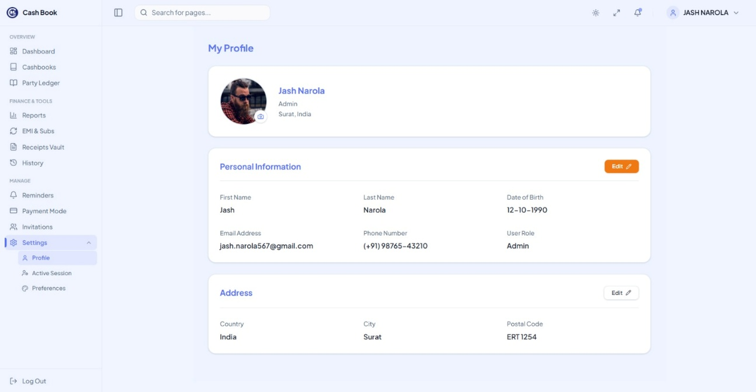

Active Sessions
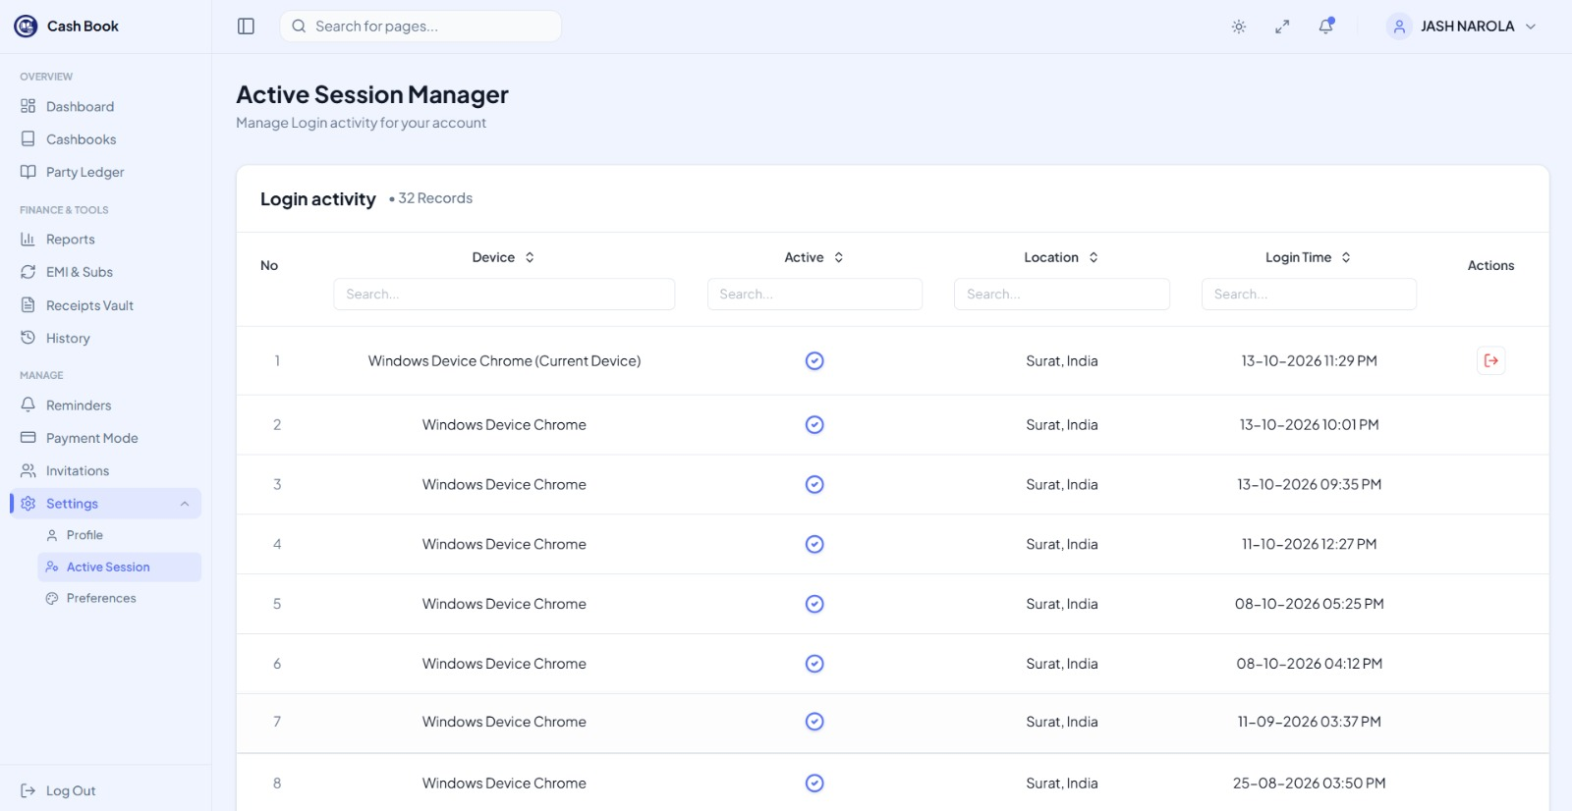
Preferences
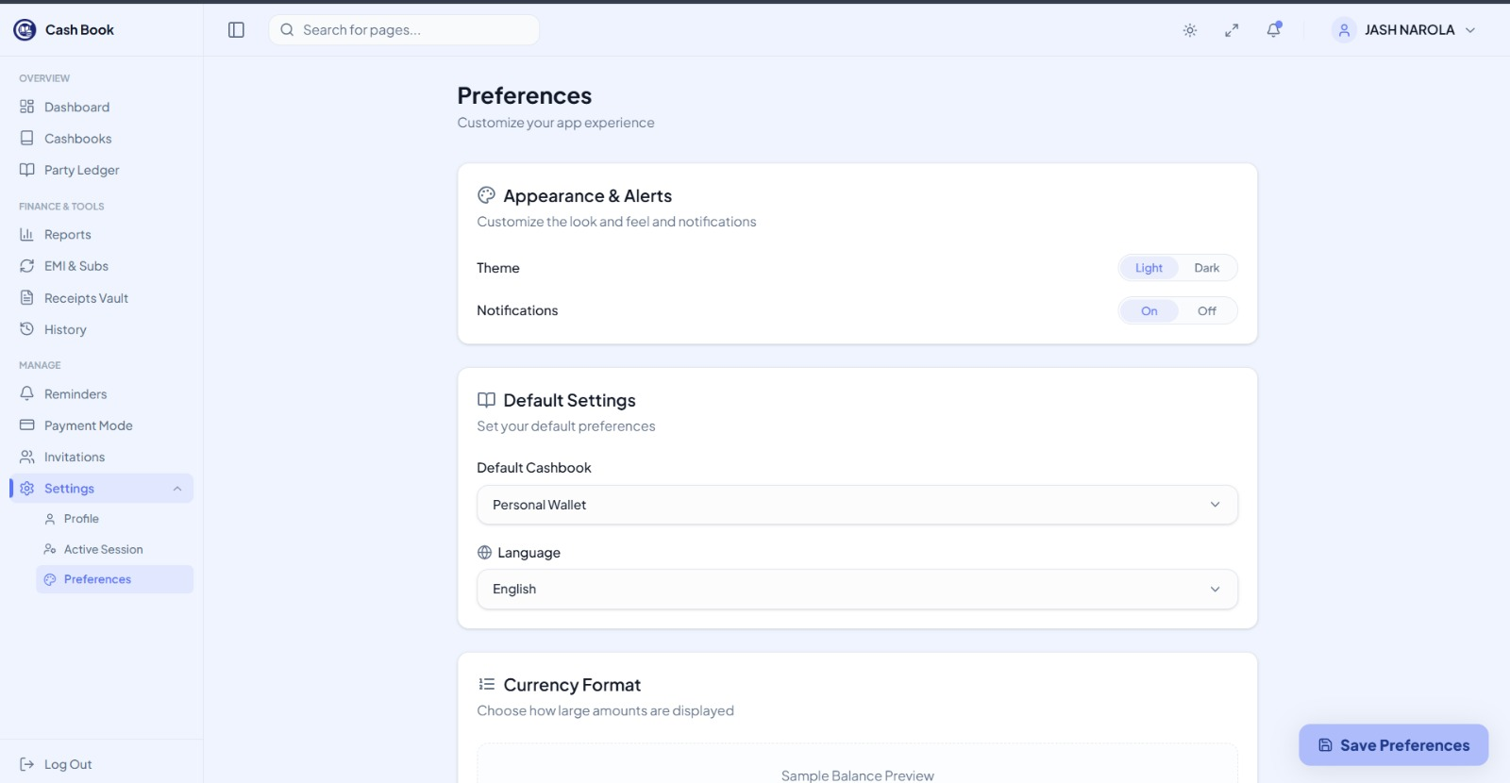

References
- Documentation & Technical Resources:
• React Official Documentation: https://reactjs.org/docs/getting-started.html
• Node.js & Express API Reference: https://nodejs.org/en/docs/ | https://expressjs.com
• MongoDB & Mongoose Manuals: https://docs.mongodb.com/manual/| https://expressjs.com/en/4x/api.html
• Tailwind CSS Design https://tailwindcss.com/docs
• Gemini for Diagrams : https://gemini.google.com
Institutional Guidance & Support:
Prof. V. B. Shah Institute of Management & Sutex Bank College of Computer Applications & Science, Amroli
Guidance and Mentorship by (Assistant Professor)
Veer Narmad South Gujarat University (VNSGU), Surat

