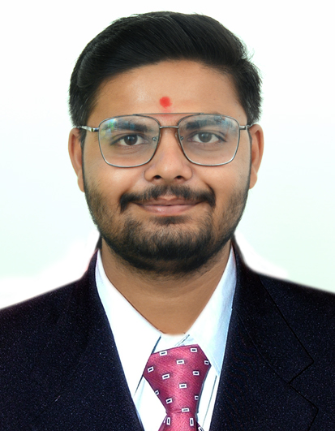
Y
Piyava (gir),near Visavadar,Junagadh, 362130
Mo: +91 7573861879, E-mail: amansavaliya2000@gmail.com
DOB: July 06th, 2002

Career Objective: Build a career with an organization of repute,
contribute significantly to the organization and fully utilize
my training, skills and positive attitude.

Highlights
- First class student since standard 10 (Mention Achievements here)
- Miracle software
- Tally Prime 9
- MS office
- Language Proficiency:
Gujarati, Hindi, English

Soft Skills
- Communication skills
- Convincing Skills
- Time management skills

Hobbies
- Running
- Reading
- Listening to story
Profile Snapshots
- An honest, hardworking, energetic, and sincere management student (Write some of your qualities)
- Work Experience
- Worked with PQR Ltd. as an Accounts Executive from June 2020 to August 2022. (Write work experience details – remove this section if you do not have any experience)
- Qualifications
- Pursuing MBA from Darshan University with 7 CGP (Batch 2025-2027)
- B.COM from harivandana collage, Gujarat with 65.00%. (Batch 2021-2024)
- SSC from Shree XYZ School, Gujarat State Education Board with 00.00%. (Batch 2021-2022)

- Project
- Summer internship project at Home First Finance Limited (5th June, 2023 to 5th August,2023)
- Courses
- Tally Prime 9 (basic)
- Miracle (basic)

- Workshop, Seminars and Webinars (mention all relevant exposure at School and at DIM)
- 23rd to 28th January 2023 of GST simplified MDP government seminars
- Expert session on “overview of banking industry” conducted by officials of bank of Baroda.
- Participated in Abhivyakti 2022 and 2023 organized by department of management at Darshan University.
- Organized Prize and certificate event of Frolic 2022 at Darshan University.

I declare that above mentioned information is correct to best of my knowledge and belief.

Date:
Place: Rajkot Yash Joshi

