**LAB EXERCISE 1**

**Write a simple "Hello World" program in two different programming languages of your choice. Compare the structure and syntax**.

C Python

#include <stdio.h> print(" Hello World ")

main() {

printf("Hello World");

}

**LAB EXERCISE 2**

**Research and create a diagram of how data is transmitted from a client to a server over the internet.**

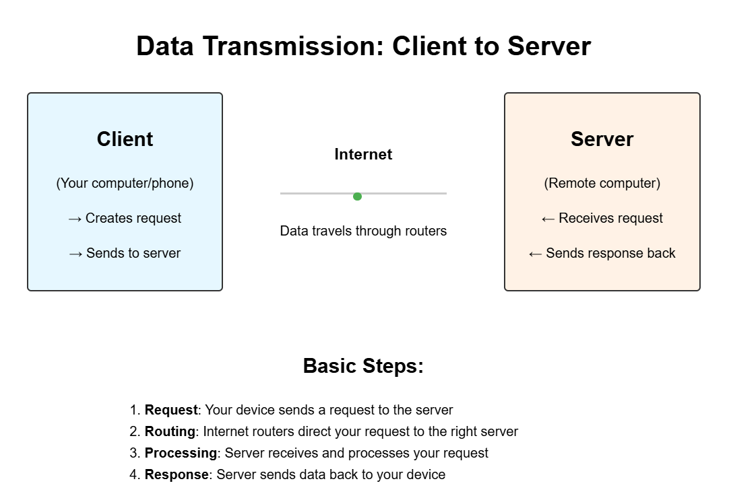

**LAB EXERCISE: 3**

|  |  |  |
| --- | --- | --- |
| HTTP is primarily used for web communication, and tools | |  |
| like curl and wget allow you to simulate requests to interact with web | | |
| servers. |  | |

**Simulate HTTP and FTP requests using command line tools (e.g., curl).**

FTP is used for file transfers, and command line tools

**LAB EXERCISE: 4**

**Identify and explain three common application security vulnerabilities. Suggest possible solutions.**

1. SQL Injection

* Explanation: Attackers insert malicious SQL code to manipulate databases.
* Solution: Use prepared statements and parameterized queries.

2. Cross-Site Scripting (XSS)

* Explanation: Attackers inject scripts into web pages to steal data.
* Solution: Validate input and encode output to prevent script execution.

3. Cross-Site Request Forgery (CSRF)

* Explanation: Attackers trick users into performing unwanted actions on authenticated sites.
* Solution: Use anti-CSRF tokens in forms to validate requests.

**LAB EXERCISE: 5**

**Design a basic three-tier software architecture diagram for a web application.**

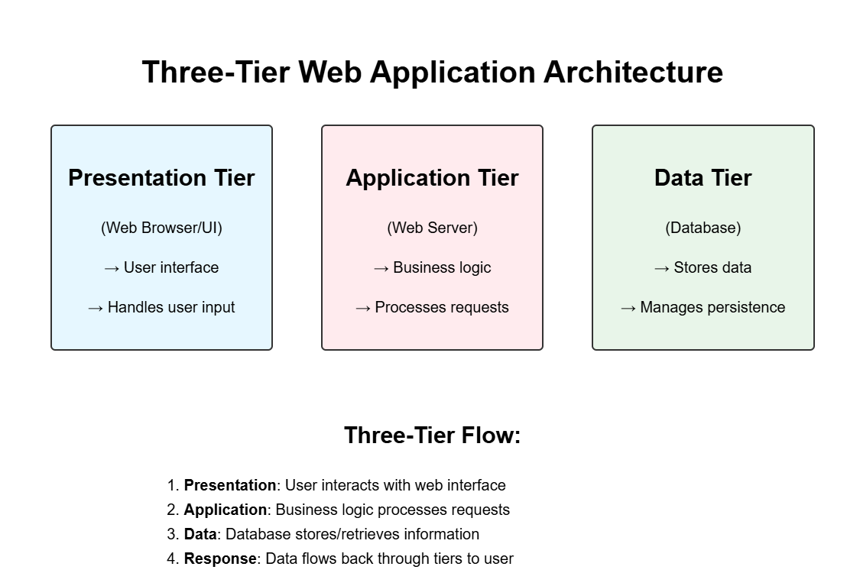

**LAB EXERCISE: 6**

***Write and upload your first source code file to GitHub.***

Step 1: Create a GitHub Account

* Go to <https://github.com>
* Sign up or log in.

Step 2: Create a New Repository

1. Click the + icon (top right) → New repository
2. Enter:
   * Repository name: (e.g., book4u)
   * Description (optional)
   * Choose Public or Private
   * Check *"Initialize this repository with a README"*
3. Click Create repository

Step 3: Add Your First Source Code File

Create a file using a text editor or terminal:

Or manually add file with your code in VS Code

**LAB EXERCISE: 7**

**Create a GitHub repository and document how to commit and push code changes**

# **Creating a GitHub Repository**

1. Log In: Access your GitHub account.
2. New Repository: Click the "+" icon and select "New repository."
3. Repository Details: Enter a name, description, and choose visibility.
4. Create Repository: Click "Create repository" to finalize.

# **Committing and Pushing Code Changes**

1. Clone Repository: Use git clone to copy the repository locally.
2. Make Changes: Edit or create files in your local repository.
3. Stage Changes: Use git add filename to stage files.

**LAB EXERCISE: 8**

**Create a student account on Github and collaborate on a small project with a classmate.**

1.Create a New Repository

2. Create a New Repository

* 1. Click + → New repository
  2. Name it (e.g., student-project)
  3. Initialize with README
  4. Click Create repository
  5. Click Create repository

3. Invite Your Classmate to Collaborate

1.Go to your repo → Click on Settings → Collaborators

2.Add your classmate’s GitHub username

3. Click Invite

**LAB EXERCISE: 9**

**Follow a GIT tutorial to practice cloning, branching, and merging repositories.**

* Install Git from [git-scm.com](https://git-scm.com/) and set up your username and email using git config.
* Clone a repository using git clone <repository_URL>.
* Navigate into the project folder with cd <repo_name>.
* Create a new branch using git checkout -b <branch_name>.
* Make changes to files and stage them using git add ...
* Commit the changes using git commit -m "Your message".
* Switch back to the main branch using git checkout main.
* Merge your branch into main using git merge <branch_name>.
* Push changes to GitHub with git push origin main.
* Delete the feature branch if needed using git branch -d <branch_name>.

**LAB EXERCISE: 10**

**Create a flowchart representing the Software Development Life Cycle (SDLC).**

**LAB EXERCISE: 11**

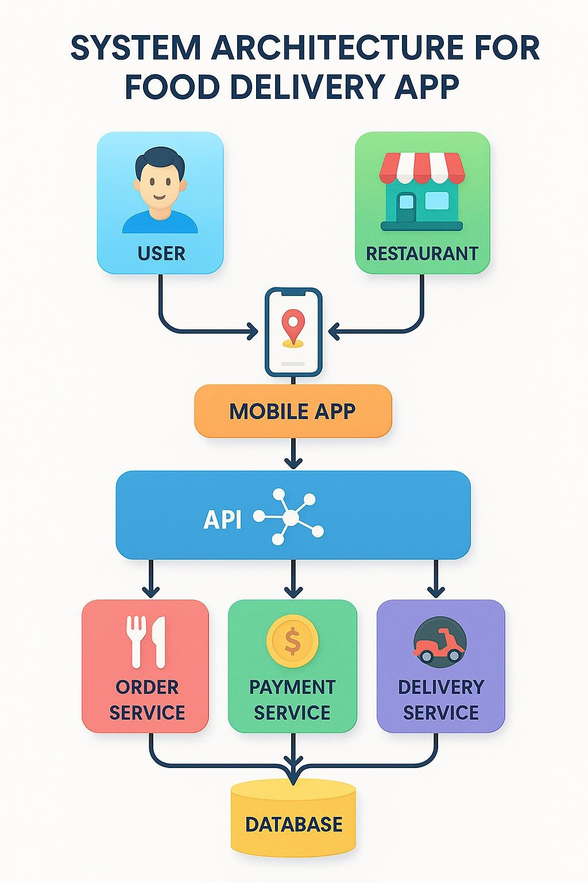**Design a basic system architecture for a food delivery app**

**LAB EXERCISE: 12**

**Develop test cases for a simple calculator program.**

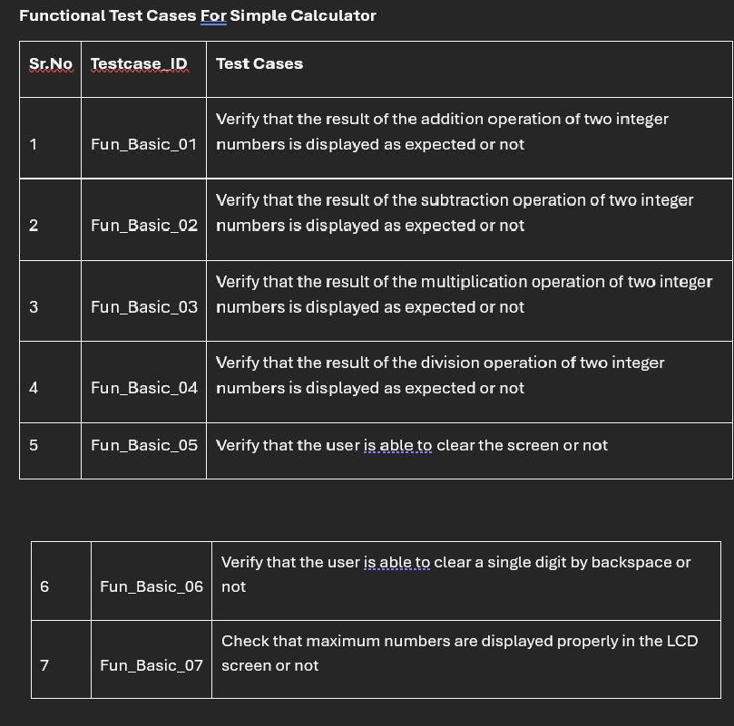

**LAB EXERCISE: 13**

**Create a DFD for a hospital management system.**

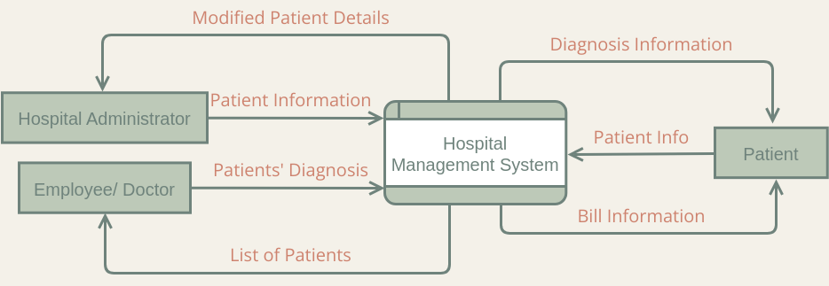

**LAB EXERCISE: 14**

**Draw a flowchart representing the logic of a basic online registration system.**

