BASELIOS MATHEWS II COLLEGE OF ENGINEERING
Lake view, Muthupilakadu, Sasthamotta – 690520,Kollam,Kerala
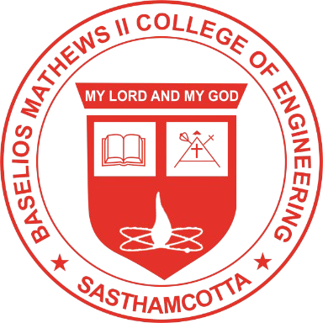
CERTIFICATE
This is to certify that the report entitled “HOSTEL OS: An Intelligent Hostel Operations,Safety and Resource Optimization Platform”submitted by ALBI THOMAS (LBMC23CS105), GOKUL S R (BMC23CS056), JEEN GEORGE MATHUNNY (BMC23CS057), S ADITHYAN (BMC23CS094) to the APJ Abdul Kalam Technological University in partial fulfillment of the requirements of the BTech Degree in Computer Science Engineering is a bonafide record of the project phase-1 work carried out by them under my guidance and super vision. This report in any form has not been submitted to any other University or Institute for any purpose.
Prof. Dr JAYAKRISHNAN R
Associate Professor
(Project Coordinator)
Department of Computer Science & Engineering
Baselios Mathews II College Of Engineering

Prof. MANOLEKSHMI I
Assistant professor
(Project Guide)
Department of Computer Science & Engineering
Baselios Mathews II College Of Engineering

Prof. GIMY JOY
HEAD OF THE DEPARTMENT
Department of Computer Science & Engineering, Baselios Mathews II College of Engineering

Internal Examiner External Examiner

