HOSTEL OS: An Intelligent Hostel Operations,Safety and Resource Optimization Platform

B.TECH PHASE-I PROJECT REPORT

Submitted by
GOKUL SR (BMC23CS056)
JEEN GEORGE MATHUNNY (BMC23CS057)
S ADITHYAN (BMC23CS094)
ALBI THOMAS (LBMC23CS105)
Under the guidance of
Prof. MANOLEKSHMI I
(Assistant Professor, Department of Computer Science)
To
the APJ Abdul Kalam Technological University in partial fulfillment of the requirements for the award of the Degree
of
BACHELOR OF TECHNOLOGY IN
COMPUTER SCIENCE AND ENGINEERING
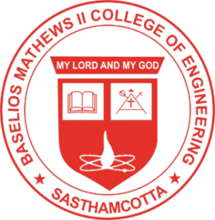
Department of Computer Science and Engineering
BASELIOS MATHEWS II COLLEGE OF ENGINEERING
(Approved by AICTE & Affiliated to A.P.J ABDUL KALAM TECHNOLOGICAL UNIVERSITY)
Lake View, Muthupilakkadu, Sasthamcotta - 690 520, Kollam, Kerala
OCTOBER 2026

