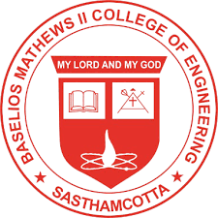

BASELIOS MATHEWS II COLLEGE OF ENGINEERING
Department of Computer Science and Engineering

An Intelligent Hostel Operations,Safety and Resource Optimization Platform
HOSTEL OS

A Project Report submitted to
APJ Abdul Kalam Technological University
In partial fulfillment of the requirements for the award of the degree of
Bachelor of technology in Computer Science and Engineering
Project Guide : | Asst. Prof. Manolekshmi I
Project Coordinator : | Dr. Jayakrishnan R

Gokul S R | BMC23CS056
Jeen George Mathunny | BMC23CS057
S Adithyan | BMC23CS094
Albi Thomas | LBMC23CS105

October 2026

