26/4/2021//--adbms_lab

3. List all data from customer

create table CUSTOMER (cname varchar(15),city varchar(20)NOT NULL,PRIMARY KEY(cname));

insert into CUSTOMER (cname, city) values ('ANIL', 'CALCUTTA');

insert into CUSTOMER (cname, city) values ('SUNIL', 'DELHI');

insert into CUSTOMER (cname, city) values ('MEHUL', 'BARODA');

insert into CUSTOMER (cname, city) values ('MANDAR', 'PATNA');

insert into CUSTOMER (cname, city) values ('MADHURI', 'NAGPUR');

insert into CUSTOMER (cname, city) values ('PRAMOD', 'NAGPUR');

insert into CUSTOMER (cname, city) values ('SANDIP', 'SURAT');

insert into CUSTOMER (cname, city) values ('SHIVANI', 'BOMBAY');

insert into CUSTOMER (cname, city) values ('KRANTI', 'BOMBAY');

insert into CUSTOMER (cname, city) values ('NAREN', 'BOMBAY');

select * from CUSTOMER;

output

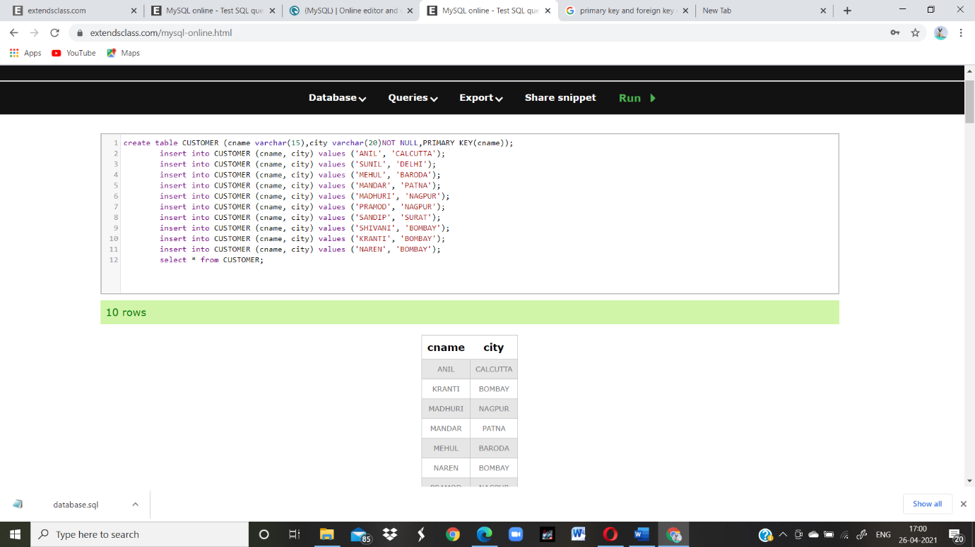

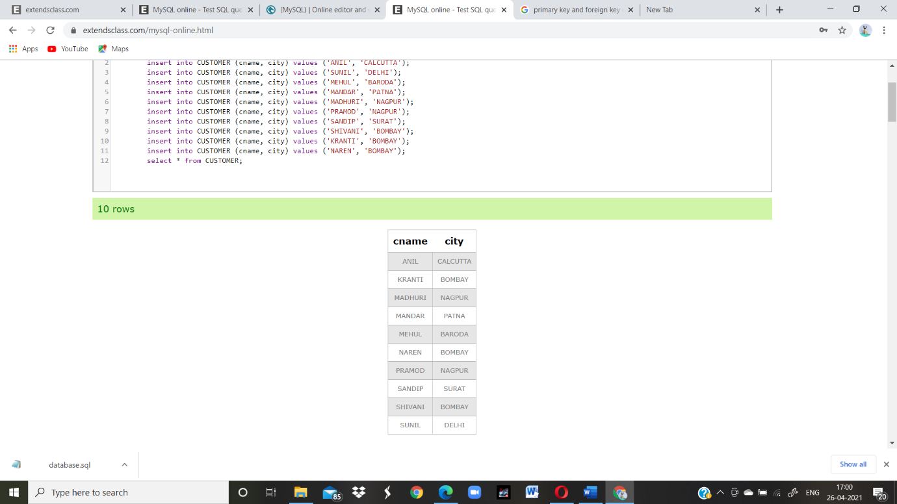

1. List all data from branch

CREATE TABLE BRANCH12s (BNAME VARCHAR(20) PRIMARY KEY,CITY VARCHAR(30) CHECK (CITY IN ('NAGPUR','DELHI','BANGALORE','BOMBAY')) NOT NULL);

INSERT INTO BRANCH12s VALUES ('VRCE','NAGPUR');

INSERT INTO BRANCH12s VALUES ('AJNI','NAGPUR');

INSERT INTO BRANCH12s VALUES ('KAROLBAGH','DELHI');

INSERT INTO BRANCH12s VALUES ('CHANDNI','DELHI');

INSERT INTO BRANCH12s VALUES ('DHARAMPETH','NAGPUR');

INSERT INTO BRANCH12s VALUES ('MG-ROAD','BANGALORE');

INSERT INTO BRANCH12s VALUES ('ANDHERI','BOMBAY');

INSERT INTO BRANCH12s VALUES ('NEHRU-PALACE','DELHI');

INSERT INTO BRANCH12s VALUES ('POWAI','BOMBAY');

SELECT * FROM BRANCH12s;

output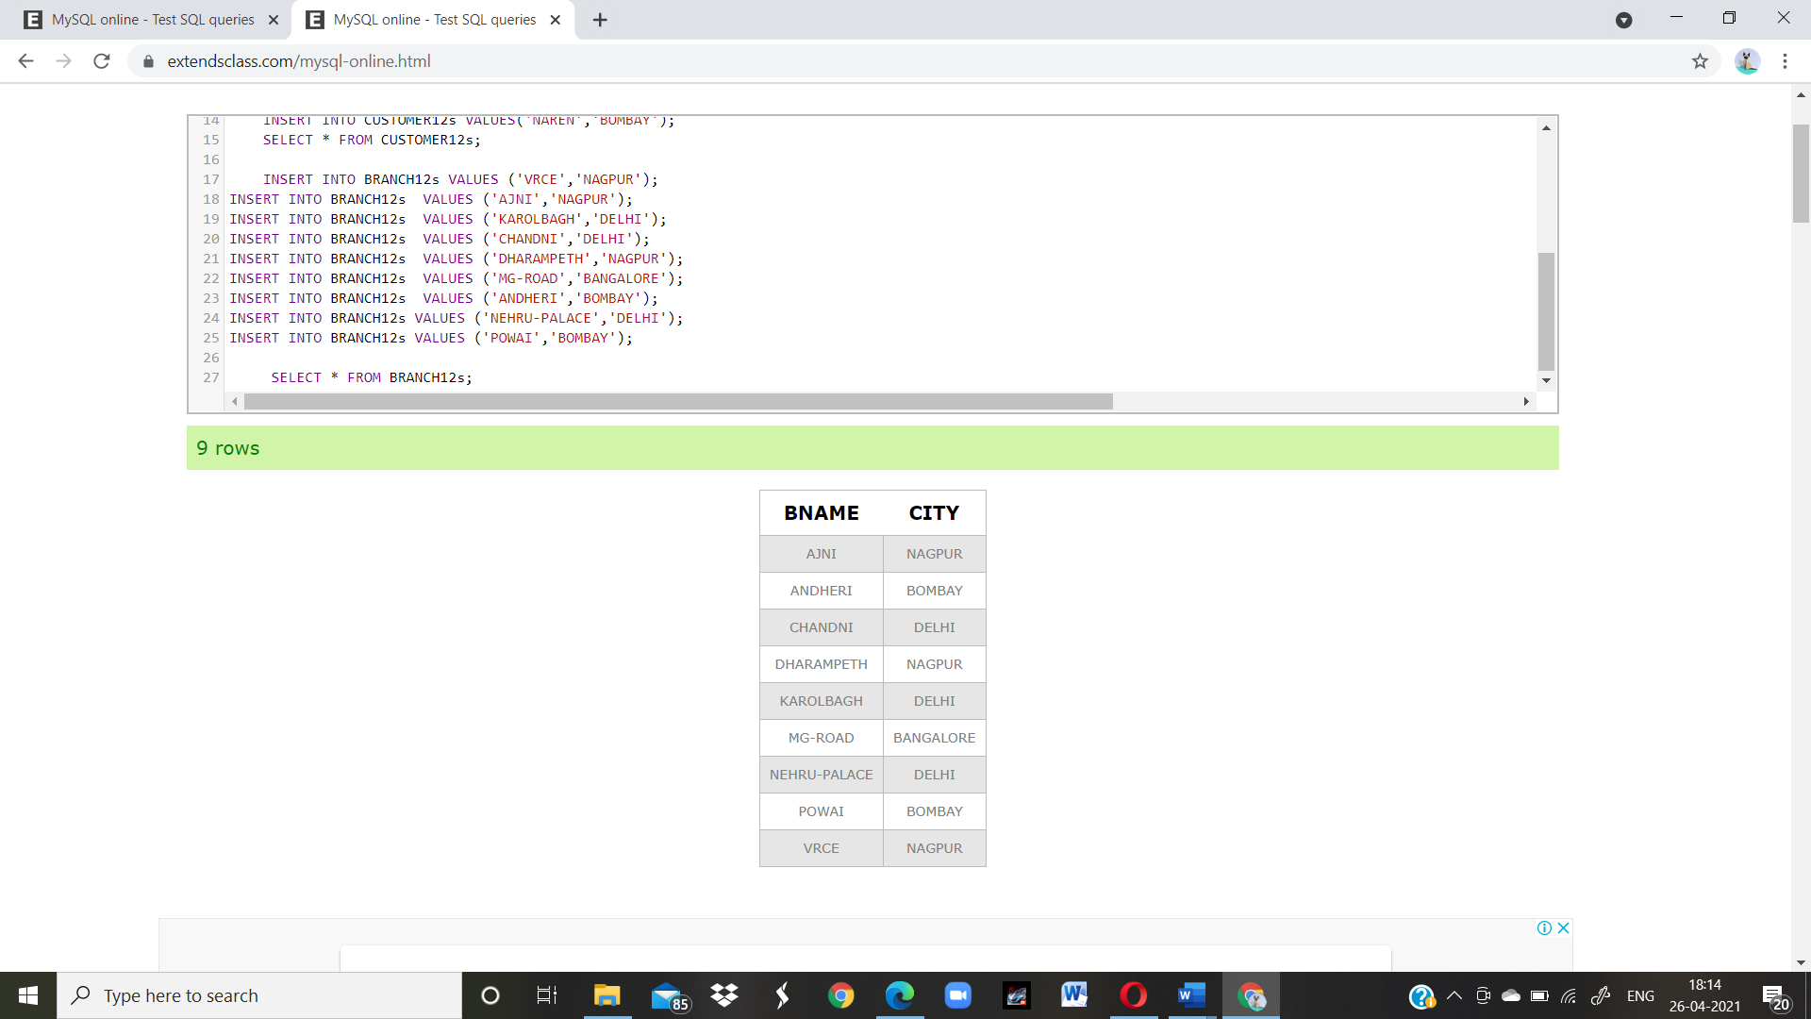

7. Give name of customers

CREATE TABLE CUSTOMERs (CNAME VARCHAR(15) PRIMARY KEY ,CITY VARCHAR(20) NOT NULL);CREATE TABLE DEPOSITs (ACTNO VARCHAR(5) CHECK (ACTNO LIKE 'D%') PRIMARY KEY ,CNAME VARCHAR(15) REFERENCES CUSTOMER(CNAME) ,BNAME VARCHAR(20) REFERENCES BRANCH(BNAME),AMOUNT FLOAT(8,2) CHECK (AMOUNT>0) NOT NULL, ADATE DATE);

INSERT INTO CUSTOMERs VALUES('ANIL','CALCUTTA');

INSERT INTO CUSTOMERs VALUES('SUNIL','DELHI');

INSERT INTO CUSTOMERs VALUES('MEHUL','BARODA');

INSERT INTO CUSTOMERs VALUES('MANDAR','PATNA');

INSERT INTO CUSTOMERs VALUES('MADHURI','NAGPUR');

INSERT INTO CUSTOMERs VALUES('PRAMOD','NAGPUR');

INSERT INTO CUSTOMERs VALUES('SANDIP','SURAT');

INSERT INTO CUSTOMERs VALUES('SHIVANI','BOMBAY');

INSERT INTO CUSTOMERs VALUES('KRANTI','BOMBAY');

INSERT INTO CUSTOMERs VALUES('NAREN','BOMBAY');

SELECT * FROM CUSTOMERs;

Output

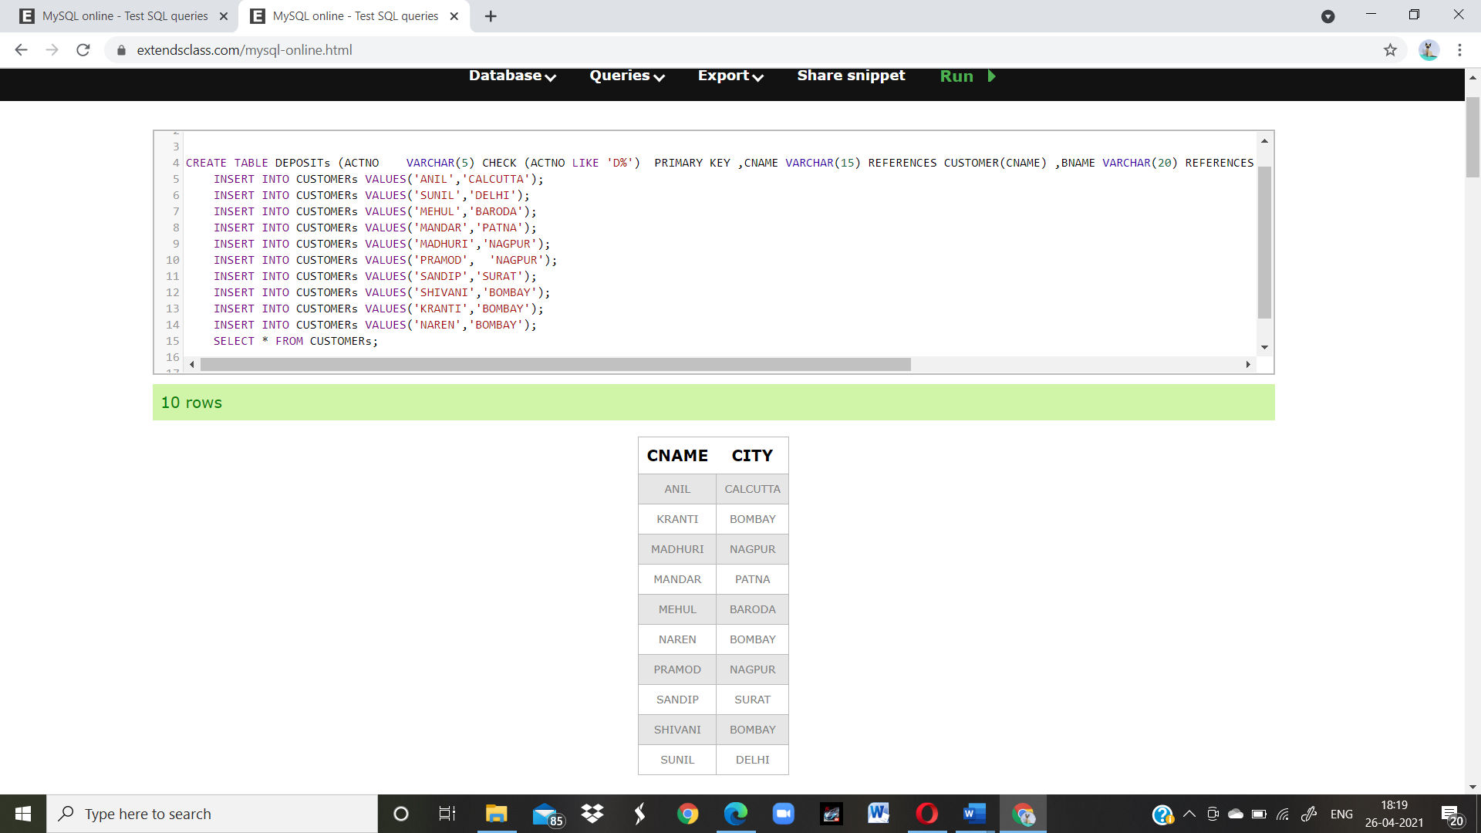

9. Give name of borrows

CREATE TABLE BORROW (LOANNO VARCHAR (8) CHECK (LOANNO LIKE 'L%') PRIMARY KEY,CNAME VARCHAR(15) REFERENCES CUSTOMER(CNAME) ,BNAME VARCHAR(20) REFERENCES BRANCH(BNAME),AMOUNT FLOAT(8,2) CHECK (AMOUNT>0) NOT NULL);

INSERT INTO BORROW VALUES ('L201','ANIL','VRCE','1000.00');

INSERT INTO BORROW VALUES ('L206','MEHUL','AJNI','5000.00');

INSERT INTO BORROW VALUES ('L311','SUNIL','DHARAMPETH','3000.00');

INSERT INTO BORROW VALUES ('L321','MADHURI','ANDHERI','2000.00');

INSERT INTO BORROW VALUES ('L371','PRAMOD','VIRAR','8000.00');

INSERT INTO BORROW VALUES ('L481','KRANTI','NEHRU PLACE','3000.00');

SELECT * FROM BORROW;

Outrput

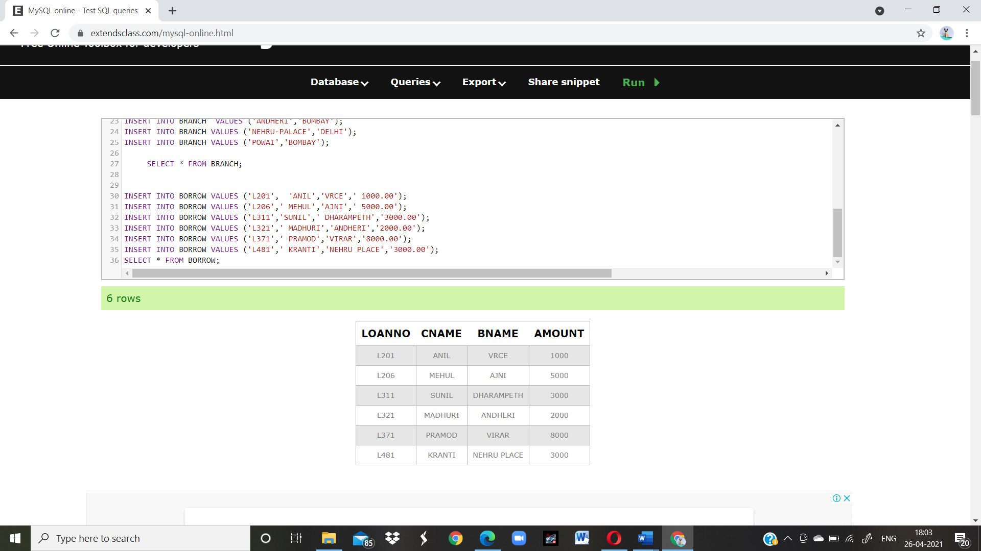

10. Give names of customer living in city Nagpur