24/5/2021 EXP:8 Jeena Mathew

RMCA-A-S2:42

EXPERIMENT NO.7 : 24/05/2021 GROUP BY AND HAVING

1.List the branches having sum of deposit more than 5000.

SELECT D.BNAME FROM DEPOSIT1 D, BRANCH B WHERE D.BNAME=B.BNAME GROUP BY D.BNAME HAVING SUM(D.AMOUNT)>5000;

**OUTPUT**

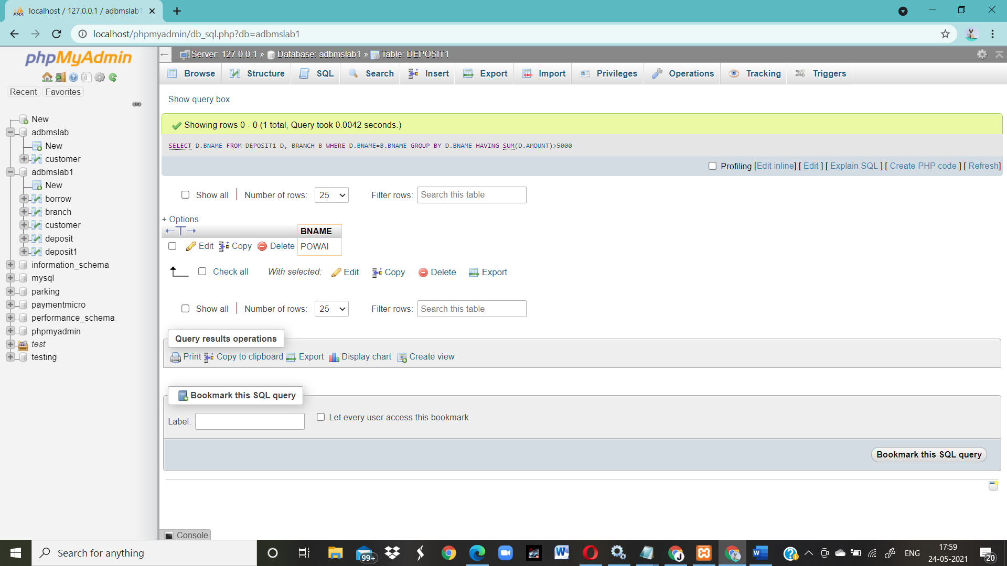

2.List the branches having sum of deposit more than 500 and located in city BOMBAY

SELECT D.BNAME FROM DEPOSIT1 D, BRANCH B WHERE D.BNAME=B.BNAME AND B.CITY='BOMBAY' GROUP BY D.BNAME HAVING SUM(D.AMOUNT)>5000;

**OUTPUT**

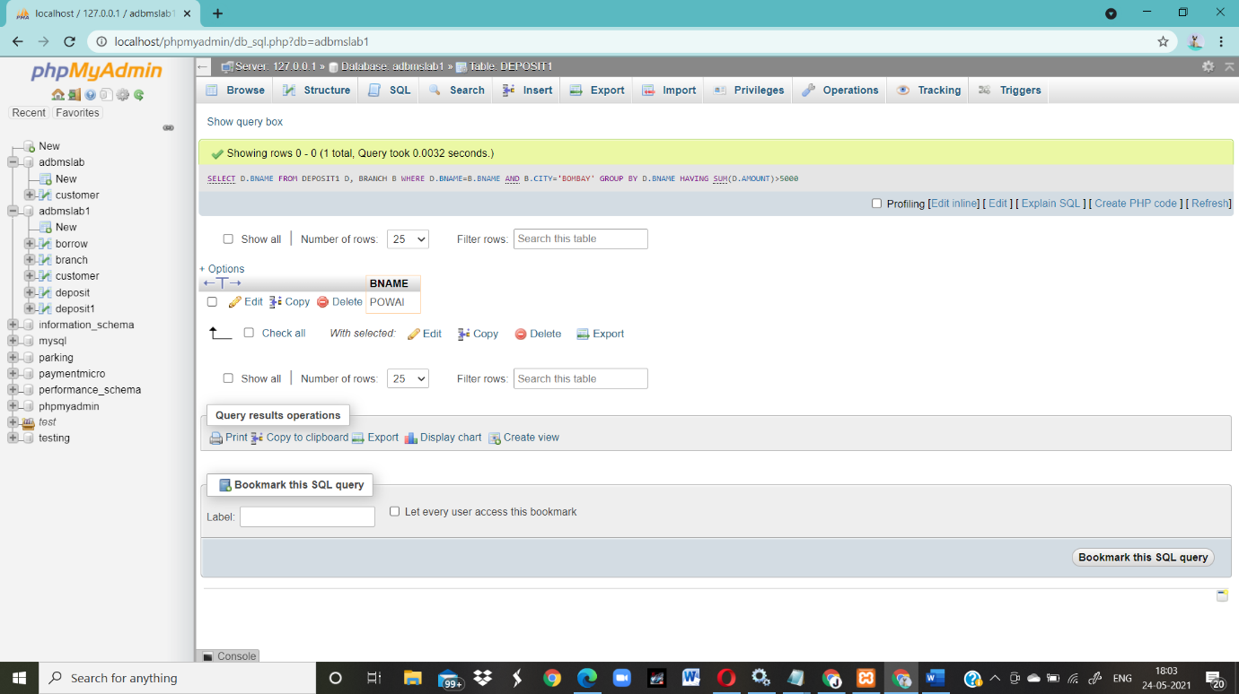

3.List the names of customers having deposited in the branches where the average deposit is more than 5000.

select CNAME from deposit1 where AMOUNT=(select AVG(Amount) from DEPOSIT1 GROUP BY BNAME having AVG(Amount)>5000);

**OUTPUT**

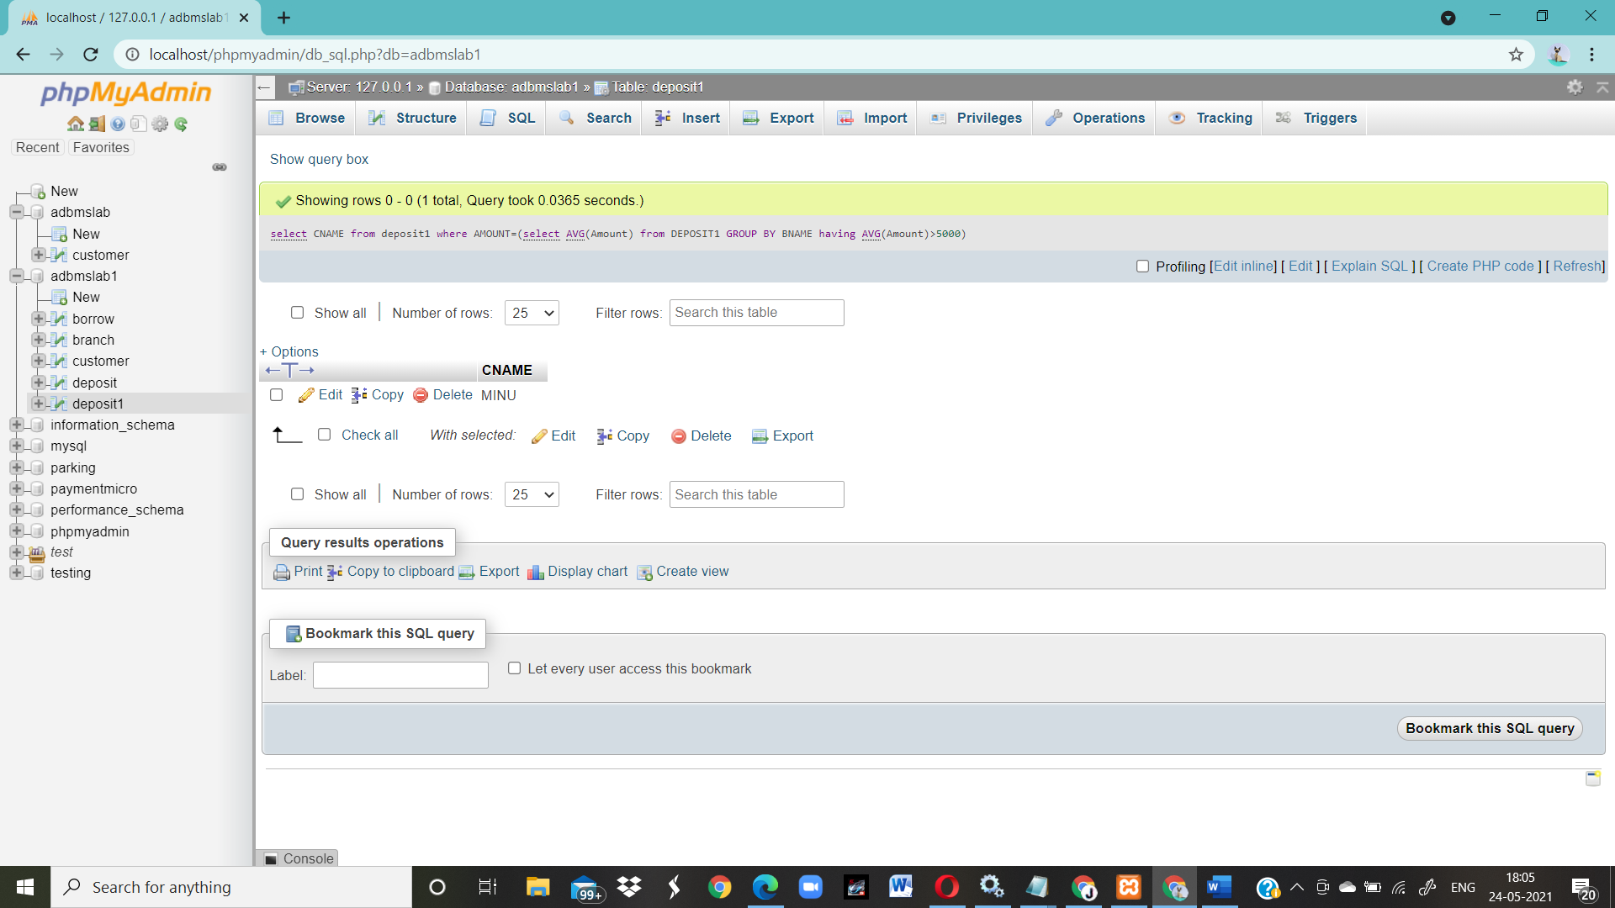

4.List the names of customers having maximum deposit

SELECT CNAME,MAX(AMOUNT)"AMOUNT" FROM deposit;

**OUTPUT**

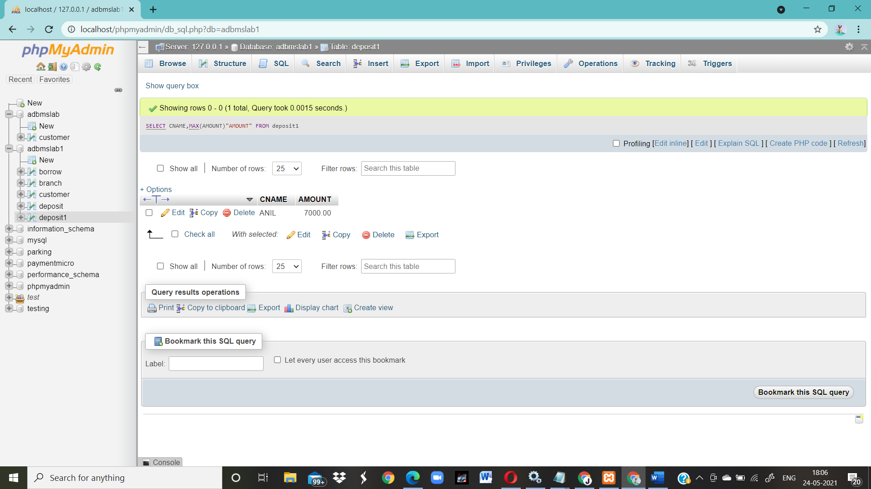

5.List the name of branch having highest number of depositors?

SELECT D1.BNAME FROM DEPOSIT1 D1 GROUP BY D1.BNAME HAVING COUNT(D1.CNAME) > = ALL (SELECT COUNT (D2.CNAME) FROM DEPOSIT1 D2 GROUP BY D2.BNAME);

6.Count the number of depositors living in NAGPUR.

select count(deposit1.cname)from deposit1,CUSTOMER where CUSTOMER.CITY='nagpur';

**OUTPUT**

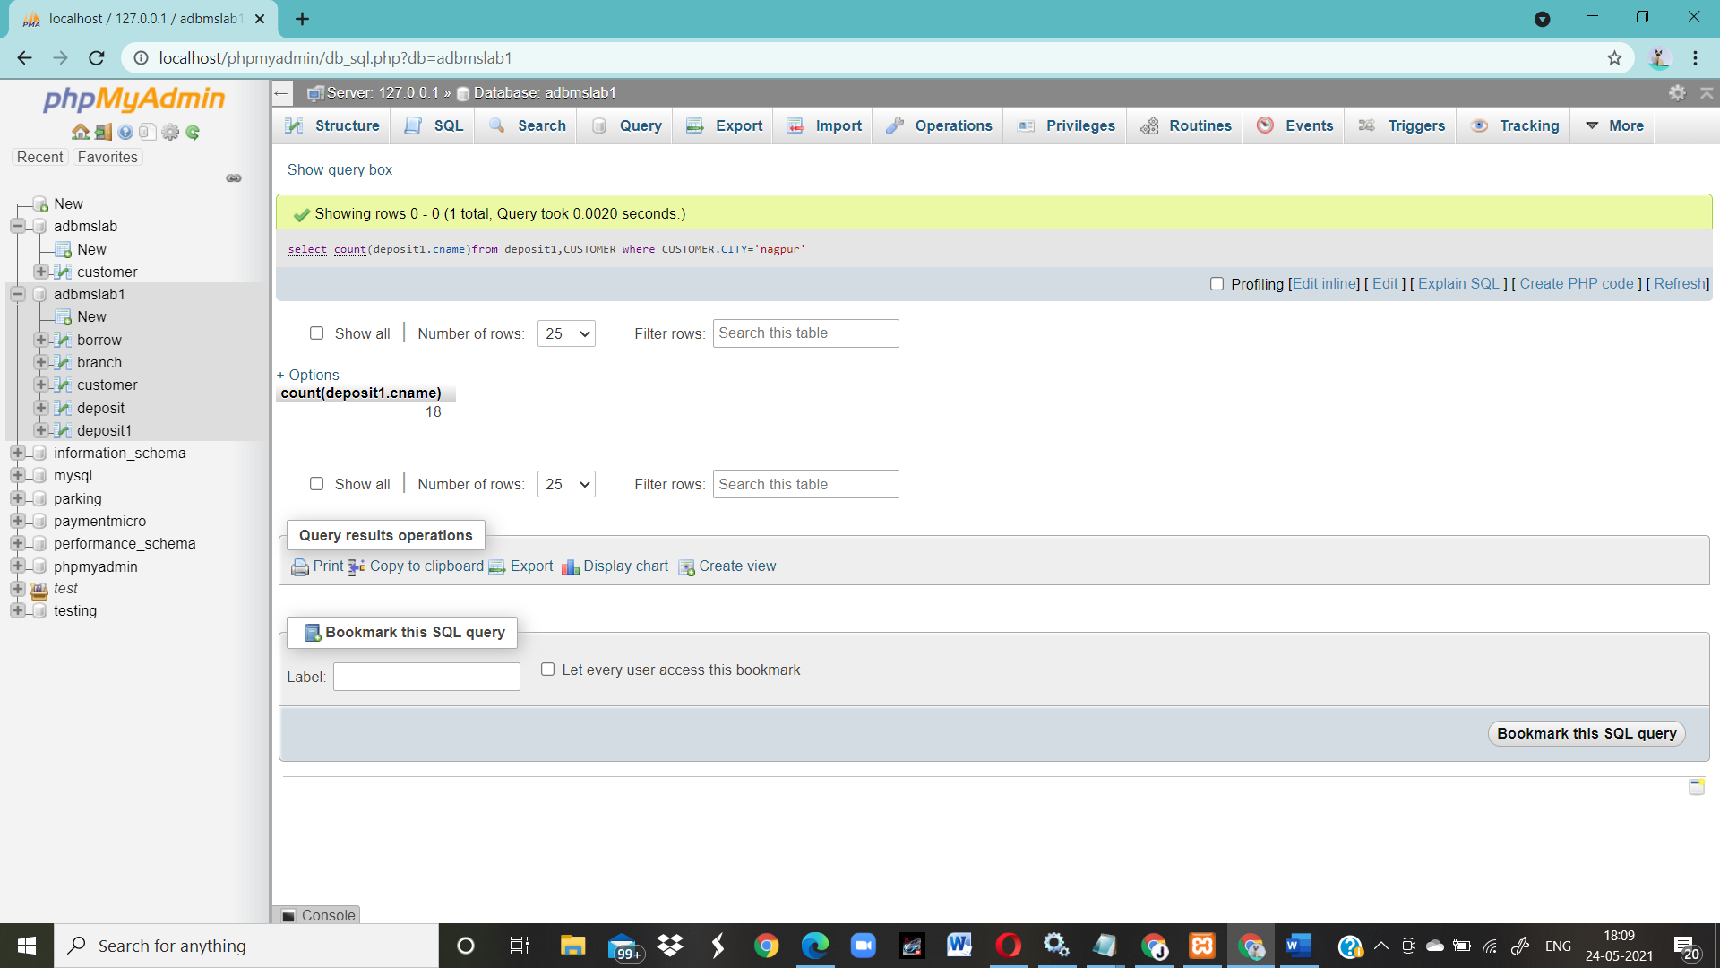

7.Give names of customers in VRCE branch having more deposite than any other customer in same branch

Select CNAME from deposit1 where BNAME='VRCE' and amount=(select max(AMOUNT) from deposit1 where BNAME='VRCE');

**OUTPUT**

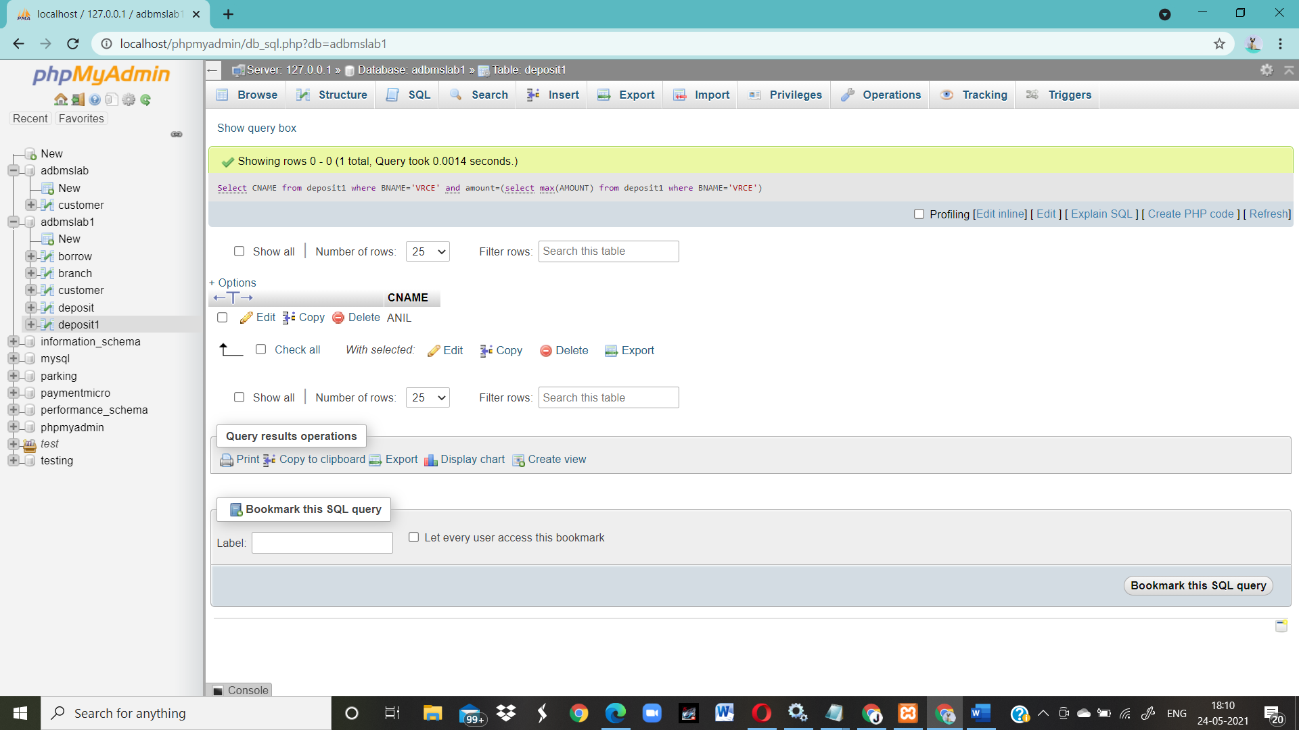

8.Give the names of branch where number of depositors is more than 5

SELECT BNAME from deposit1 GROUP BY BNAME HAVING COUNT(BNAME)>5;

**OUTPUT**

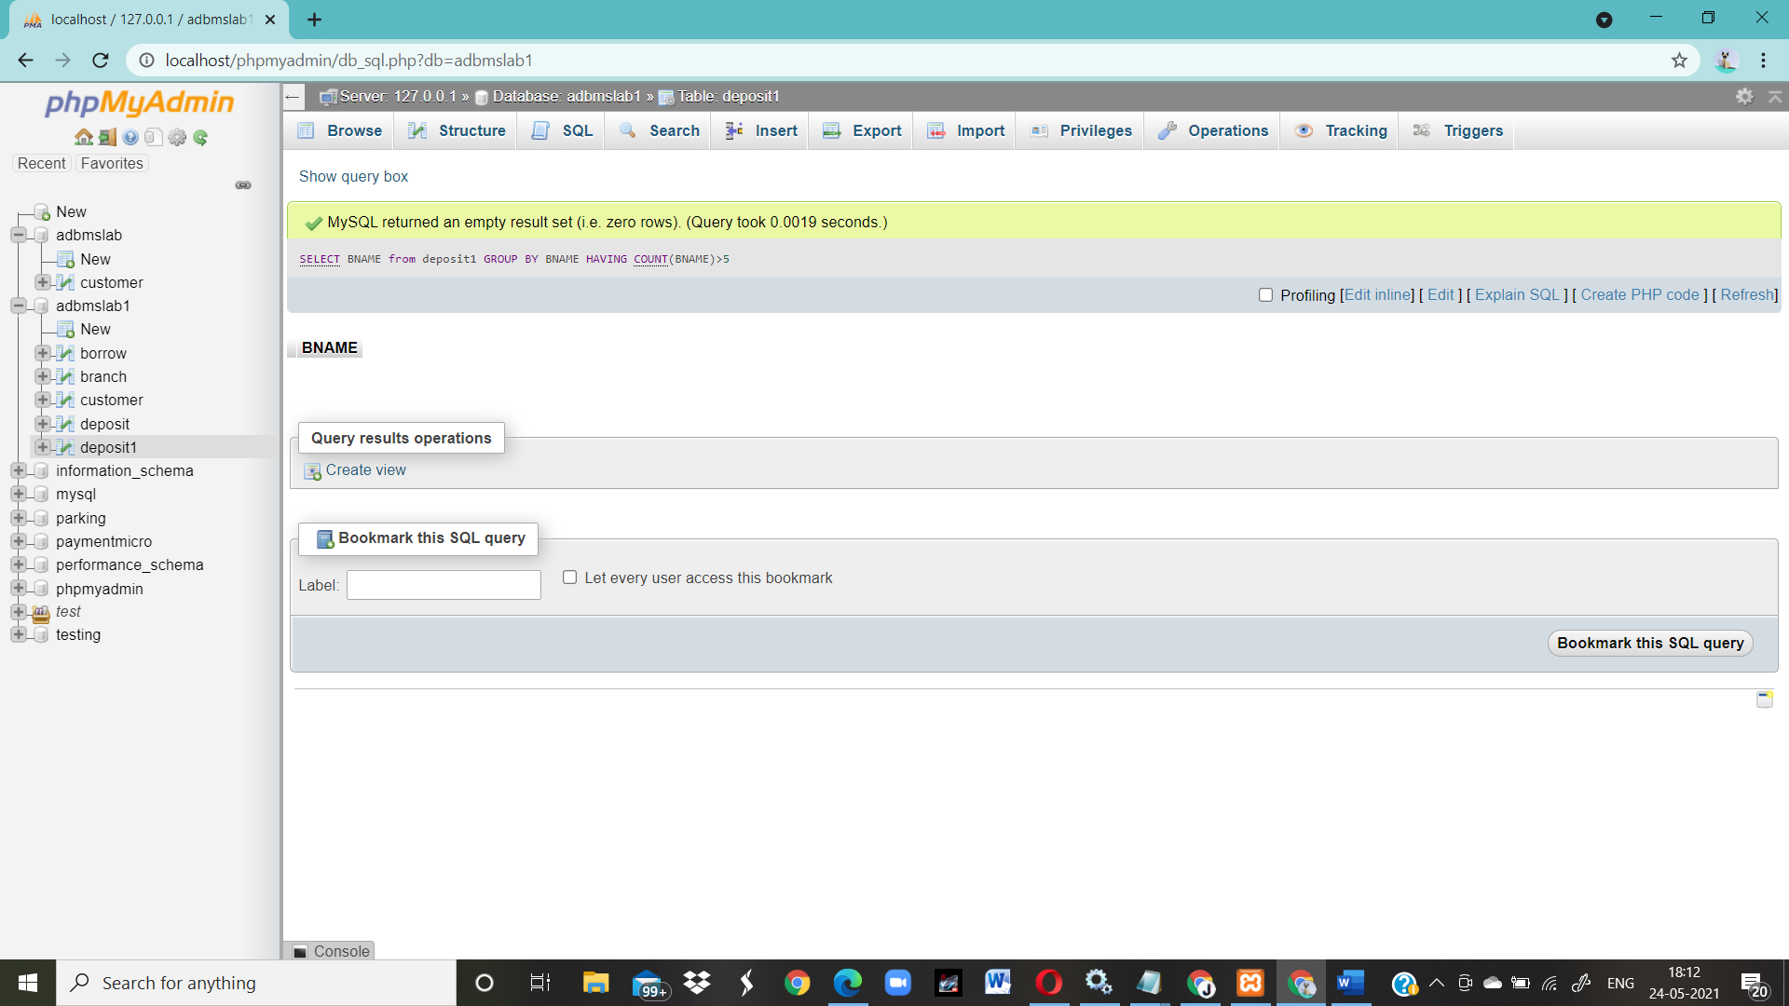

9.Give the names of cities in which the maximum number of branches are located

select C.CNAME ,count(B.BNAME) from CUSTOMER C inner join Branch B on C.CNAME=B.BNAME group by C.Cname order by count(B.BName) DESC;

**OUTPUT**

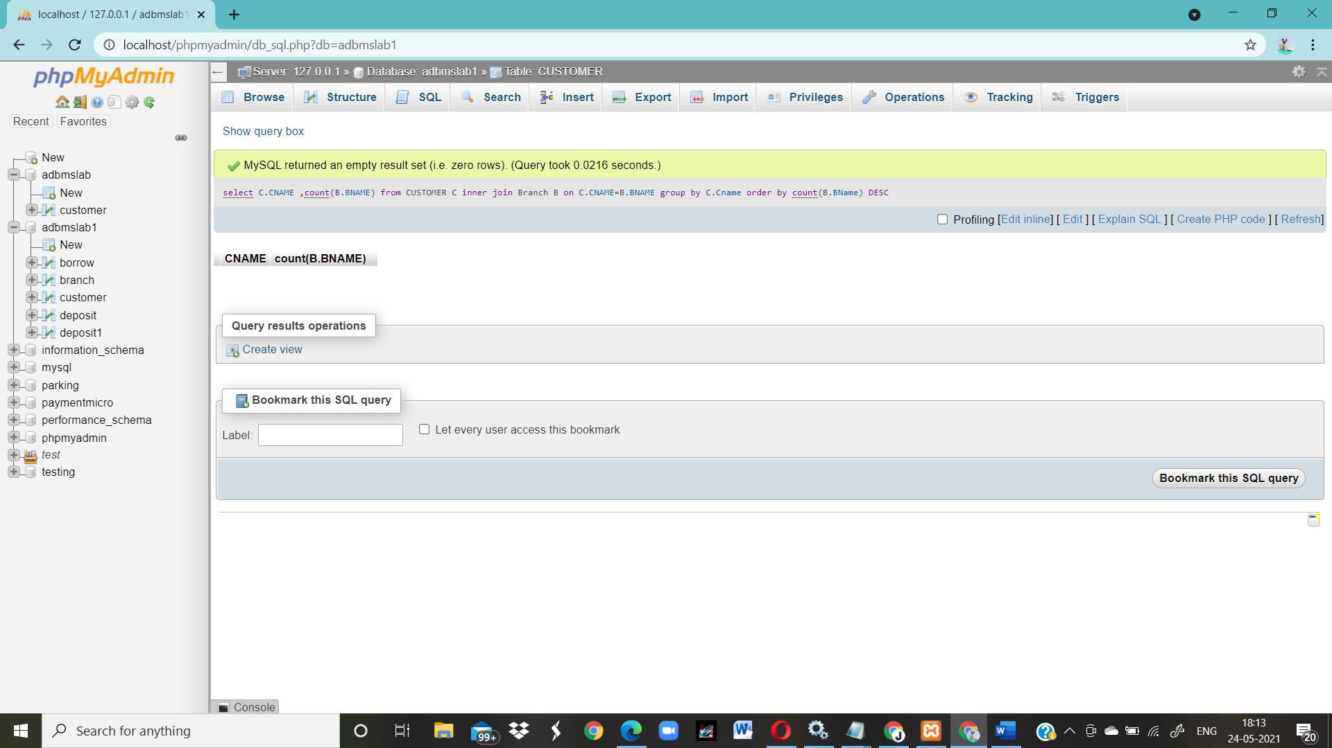

10.Count the number of customers living in the city where branch is located

select count(b1.bname) From deposit1 d1 , borrow b1 , customer c1 Where c1.cname=d1.cname and d1.cname=b1.cname and c1.city in (select city from customer);

**OUTPUT**

