8-12-21:DS & ML_Lab(2) Jeena Mathew

RMCA:A:42

Course_outcome2_Co2: Naïve Bayes Algorithm

AIM: program to implement naïve bayes algorithm using any standard dataset available in the public domain and find the accuracy of the algorithm.

Program

#importing the datasets  
dataset = pd.read_csv('Social_Network_Ads.csv')  
x =dataset.iloc[:, [2,3]].values  
y =dataset.iloc[:, -1].values  
  
#splitting  
from sklearn.model_selection import train_test_split  
x_train, x_test, y_train, y_test = train_test_split(x,y, test_size= 0.20, random_state=0)  
  
#feature scaling  
from sklearn.preprocessing import StandardScaler  
sc = StandardScaler()  
x_train = sc.fit_transform(x_train)  
x_test = sc.transform(x_test)  
print(x_train)  
print(x_test)  
  
#training the naive bayes model  
from sklearn.naive_bayes import GaussianNB  
classifier = GaussianNB()  
classifier.fit(x_train , y_train)  
  
#predicting the test result  
y_read = classifier.predict(x_test)  
print(y_read)

Output

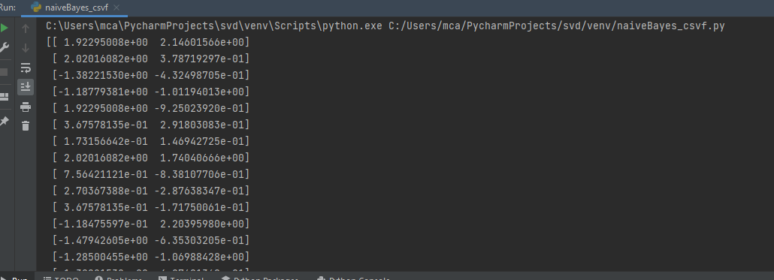

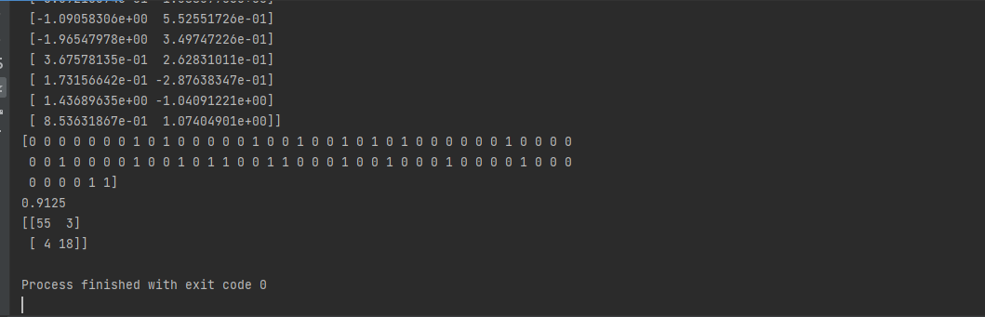

2)plot csv

Program

import numpy as np  
import matplotlib.pyplot as plt  
import pandas as pd  
from sklearn import preprocessing  
from sklearn.model_selection import train_test_split  
from sklearn.naive_bayes import GaussianNB  
from sklearn.metrics import accuracy_score  
  
dataset=pd.read_csv('Social_Network_Ads.csv')  
X= dataset.iloc[:,[2,3]].values  
Y= dataset.iloc[:,-1].values  
  
X_train , X_test, Y_train, Y_test = train_test_split(X,Y, test_size=0.20,random_state=99)  
from sklearn.preprocessing import StandardScaler  
  
sc = StandardScaler()  
X_train =sc.fit_transform(X_train)  
X_test = sc.fit_transform(X_test)  
clf = GaussianNB()  
clf.fit(X_train, Y_train)  
Y_pred = clf.predict(X_test)  
print(Y_pred)  
print(accuracy_score(Y_test, Y_pred, normalize = True))  
  
plt.plot([i for i in range (0,50)],Y_pred[20:70])  
plt.plot([i for i in range (0,80)],Y_test)  
  
  
plt.legend(["train","test"])  
plt.xlabel('X axis')  
plt.ylabel('Y axis')  
plt.title('Accuracy')  
plt.show()

Output

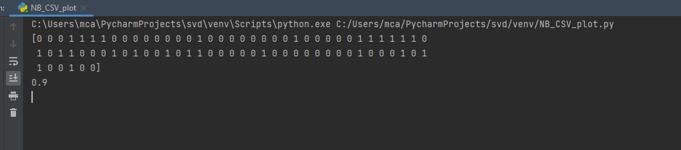

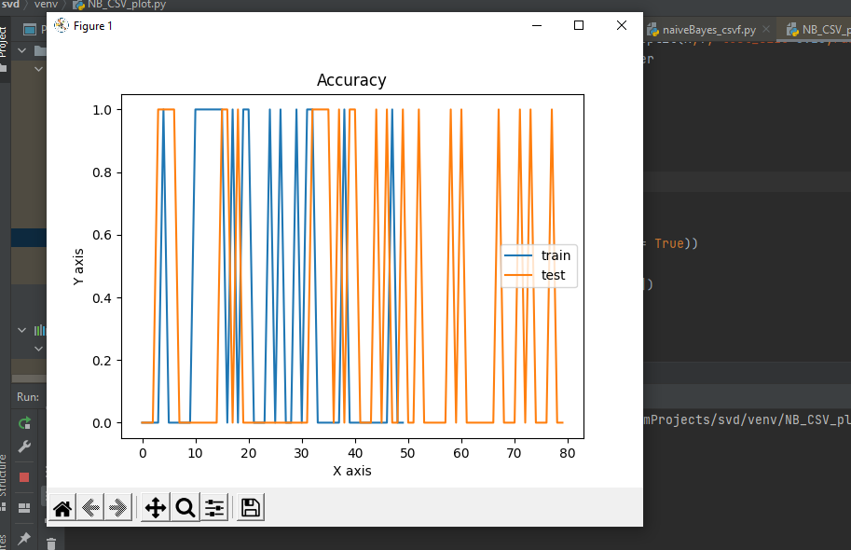

**Program 2)Linear Regression:**

Aim: program to implement linear and multiple regression techniques using any standard dataset available in public domain and evaluating performance.

Program

import numpy as np  
from sklearn.linear_model import LinearRegression  
x=np.array([5, 15, 25, 35, 45, 55]).reshape((-1,1))  
y=np.array([5, 20, 14, 32, 22, 38])  
print(x)  
print(y)  
model=LinearRegression()  
model.fit(x,y)  
r_sq=model.score(x, y)  
print('coefficent of Determination: ',r_sq)  
print('intercept :' , model.intercept_)  
print('slope :' , model.coef_)  
y_pred=model.predict(x)  
print('predicted response :' ,y_pred)

output

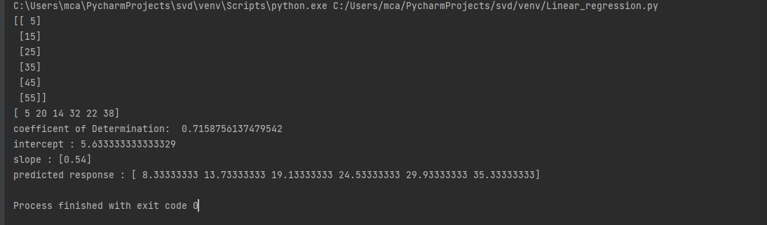

B)plot

Program

import matplotlib.pyplot as plt  
import numpy as np  
from sklearn.linear_model import LinearRegression  
x=np.array([5, 15, 25, 35, 45, 55]).reshape((-1,1))  
y=np.array([5, 20, 14, 32, 22, 38])  
print(x)  
print(y)  
model=LinearRegression()  
model.fit(x,y)  
r_sq=model.score(x, y)  
print('coefficent of Determination: ',r_sq)  
print('intercept :' , model.intercept_)  
print('slope :' , model.coef_)  
y_pred=model.predict(x)  
print('predicted response :' ,y_pred)  
plt.scatter(x, y,color="m",marker = "o" , s=30)  
plt.plot(x, y_pred,color= "g")  
  
plt.xlabel('x')  
plt.ylabel('y')  
  
plt.show()

Output

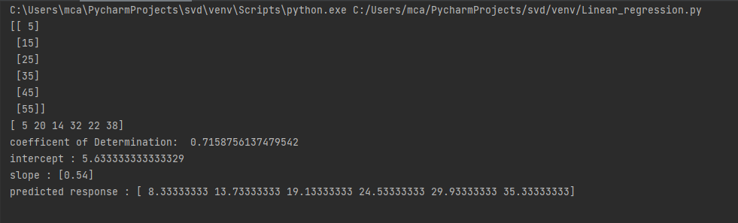

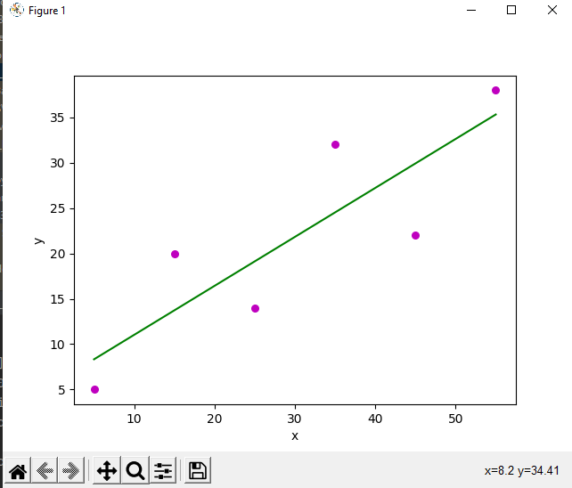

c) liner regression Without using in built function

program

import numpy as np  
import matplotlib.pyplot as plt  
def estimate_coef(x, y):  
 n = np.size(x)  
 m_x = np.mean(x)  
 m_y = np.mean(y)  
 SS_xy = np.sum(y * x) - n * m_y * m_x  
 SS_xx = np.sum(x * x) - n * m_x * m_x  
 b_1 = SS_xy / SS_xx  
 b_0 = m_y - b_1 * m_x  
 #plot_regression_line()  
 return (b_0 ,b_1)  
  
def plot_regression_line(x, y, b):  
 plt.scatter(x ,y , color ="m" , marker= "o" ,s =30)  
 y_pred = b[0] + b[1] * x  
 plt.plot(x, y_pred, color = "g")  
  
 plt.xlabel('x')  
 plt.ylabel('y')  
 plt.show()  
def main():  
 x = np.array([11,16,6,8,10,12])  
 y = np.array([14,25,18,20,22,24])  
 b = estimate_coef(x, y)  
 print("estimated coefficient : \nb_0 ={} \ \nb_1 = {} ".format(b[0], b[1]))  
 plot_regression_line(x, y, b)  
if __name__ == "__main__":  
 main()

output

